Saurabh Tyagi

Product engineer

**AWS Cloud 2022**

|  |
| --- |
| **INDEX** |

**1. Cloud Computing**

* Cloud service providers …………………………………………………………………………………………….…………………………………………………3

**2. AWS (Amazon Web Services)**

* Basics / History …………………………………………………………………………………………………………………………………………………………..20
* **IAM services –** Users Types / User Policies / Security Tools………………………………………………………………………………………..22
* **AWS Account Access Options –** CLI setup / SDK / Direct Console Access……………………………………………………………………25
* **EC2 Services –** Basics / Instance Types / Security Groups / Purchase Guide / Placement Groups / Instance State………27
* **EC2 Instance Storage –** EBS / AMI / Instance Store / Amazon EFS………………………………………………………………………………33
* **Availability and Scalability –** ELB / CLB / ALB / NLB / ASG / TLS/SSL certificates…………………………………………………………36
* **AWS Database Fundamentals –** RDS / Amazon Aurora / Elastic Cache ………………………………………………………………………43
* **Amazon Route 53 –** Basics / Routing Policies / Health Checks…………………………………………………………………………………….48
* **Amazon VPC –** Basics CIDR / IP ranges(Subnet) / NAT Instances-GW / IGW / SG-NACL / Peering / Endpoints / Flow Logs / Site to Site VPN / DX (Direct Connect) / Transit Gateway / Traffic Mirroring / IPv6 VPC / VPC Summary………….53
* **Amazon S3 Buckets –** Encryption / Security / Website / CORS……………………………………………………………………………………62
* **AWS Containers (Docker) –** ECS / ECR / EKS ………………………………………………………………………………………………………………65
* **AWS Integration and Messaging –** SQS / SNS / Kinesis………….……………………………………………………………………………………62

**5. Networking Basics**

* Models – OSI / TCP/IP ………………………………………………………………………………………………………………………………………………..74
* Network Devices / Types / Topology…………………………………………………………………………………………………………………………..77
* MAC / IP Address / DNS servers / DHCP servers / SMTP / IMAP / FTP / HTTP / HTTPs / Wi-Fi …………………………………….79

|  |
| --- |
| **Cloud Computing** |

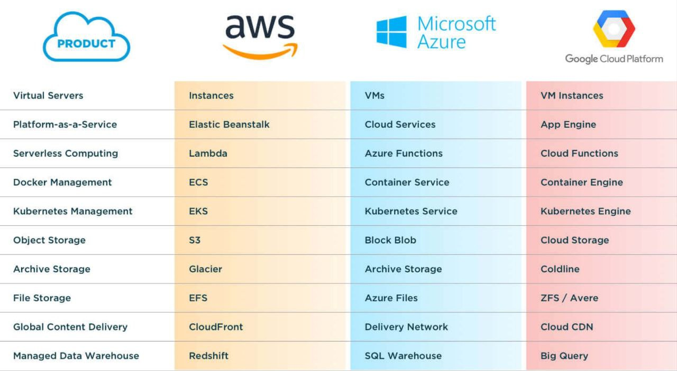

**# Cloud Service Providers –**

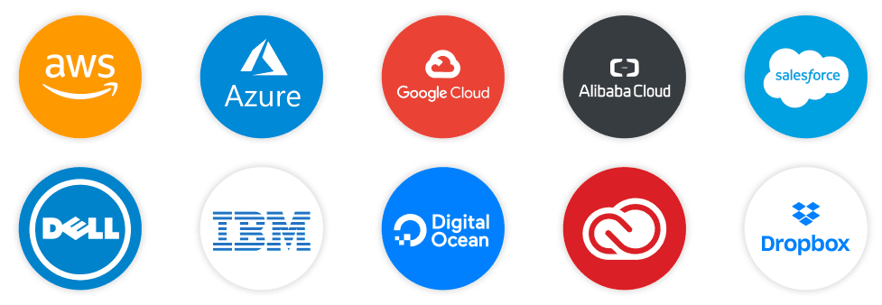

**# AWS Tool chain –**

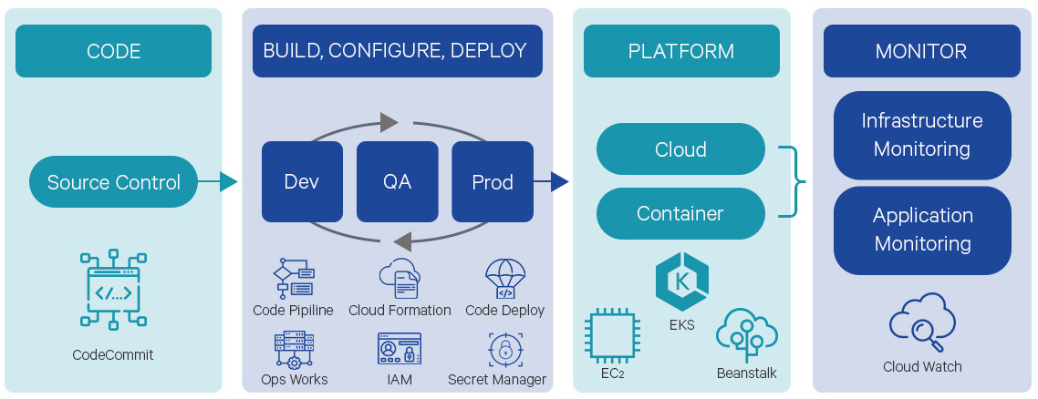

**# Azure Tool chain –**

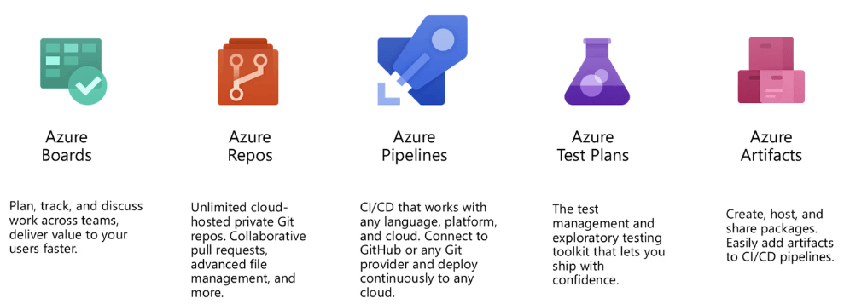

**AWS Certifications Types**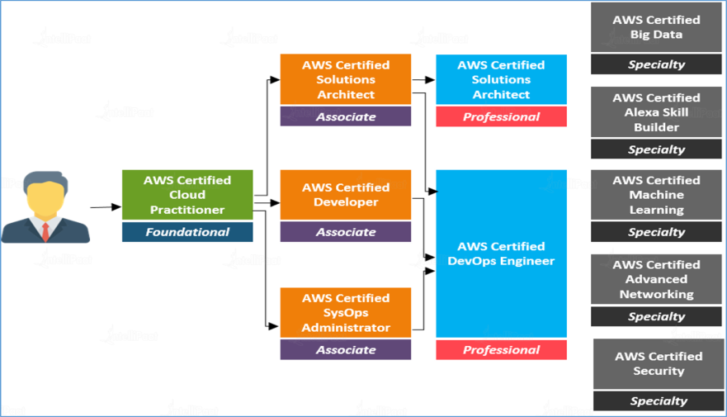

|  |
| --- |
| **AWS** |

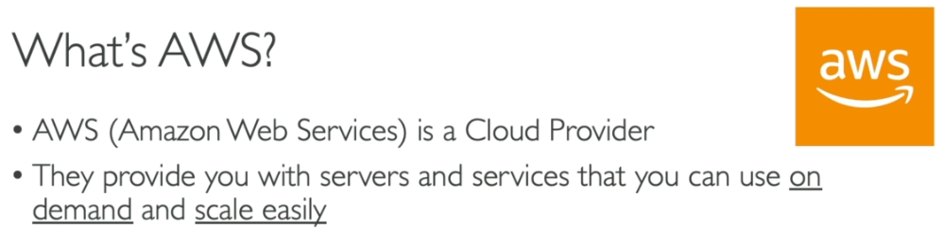

**AWS Services -**

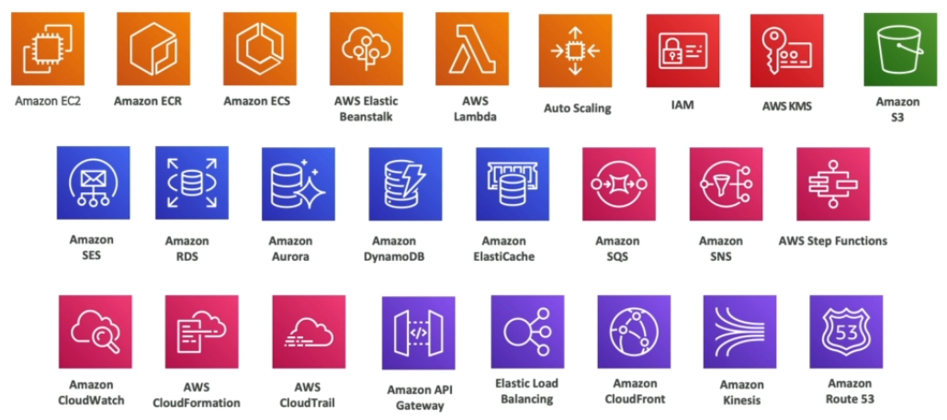

**# AWS History –**

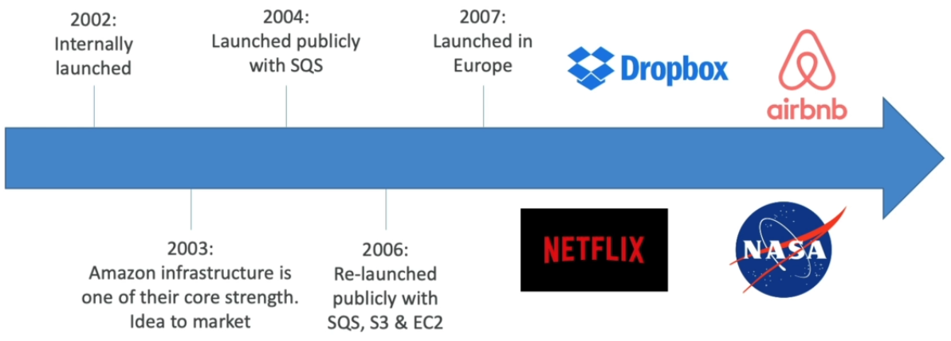

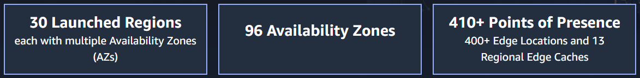

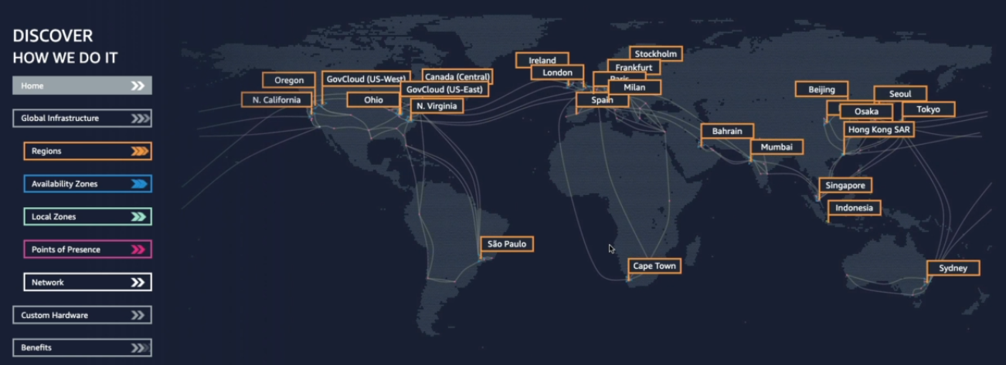

**Region selection rules**

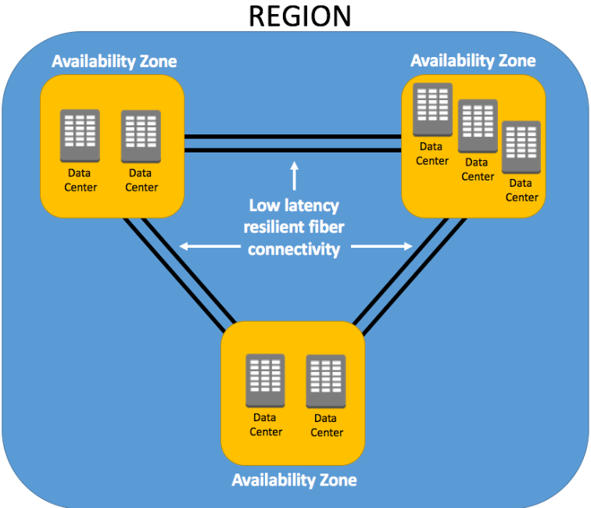 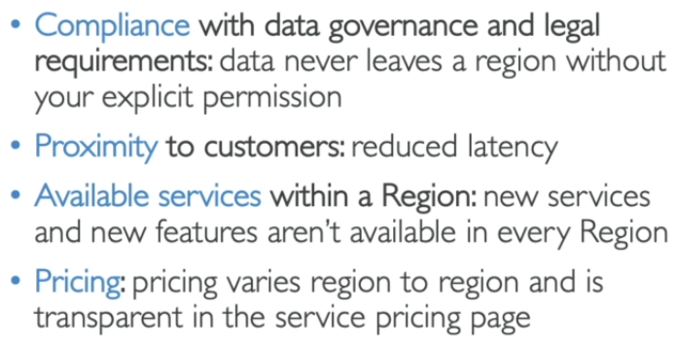

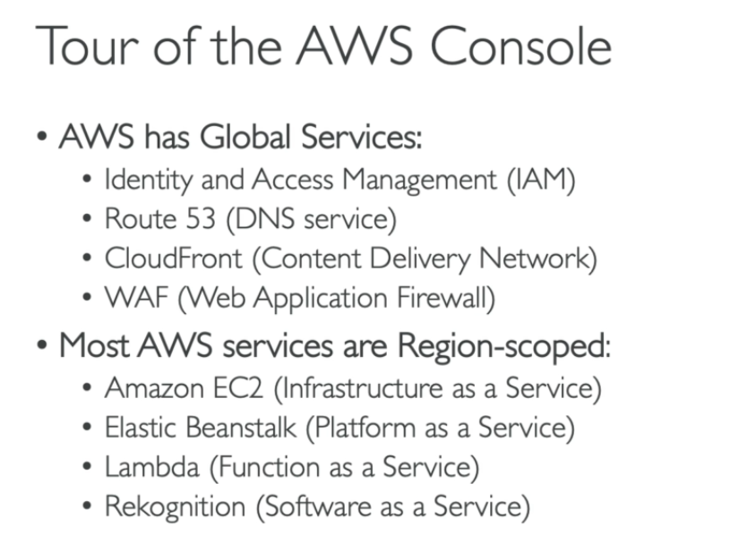

**# IAM services (Users and Groups) –**

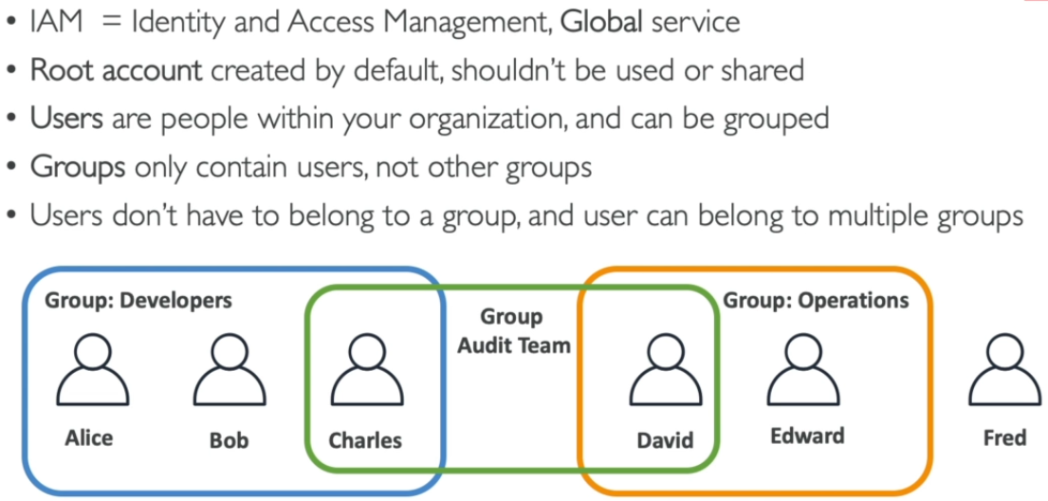

* Every company have only one AWS account (root user account)
* Groups and Users can be assigned JSON documents (policies) for allowing access as per requirement(permission controlling)
* Apply least privilege principle to minimize cost and chances of errors.

**1. Root Users and other users –**

* **Using IAM – Users / Groups can be created and permissions can be granted to these users / groups.**
* **IAM polices are assigned to these users and groups to give specific permissions.**

Root user 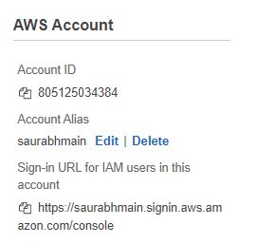 IAM User 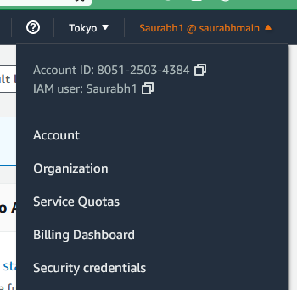

**2. IAM Policies Inheritance –**

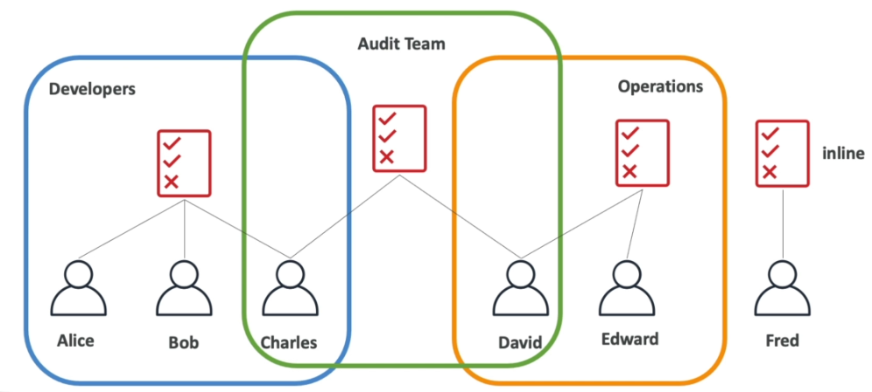

**3. IAM Policies Structure (JSON Document) –**

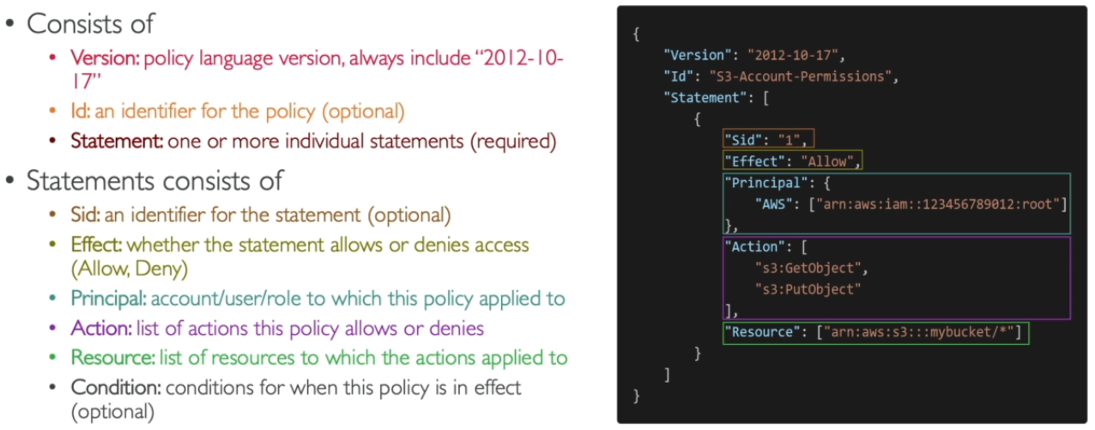**\* New policies can be generated using Console GUI mode or JSON codes. This link can be used to create new policies –** [**https://awspolicygen.s3.amazonaws.com/policygen.html**](https://awspolicygen.s3.amazonaws.com/policygen.html) **, JASON code can be copied from here and used.**

**Dummy policy simulation can be done here -** [**https://policysim.aws.amazon.com/home/index.jsp?#users**](https://policysim.aws.amazon.com/home/index.jsp?#users)

**3. IAM Password Policies –**

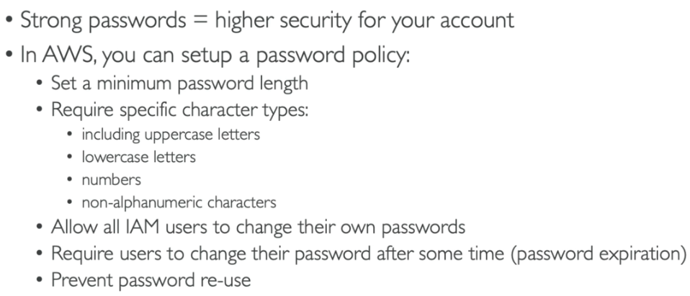

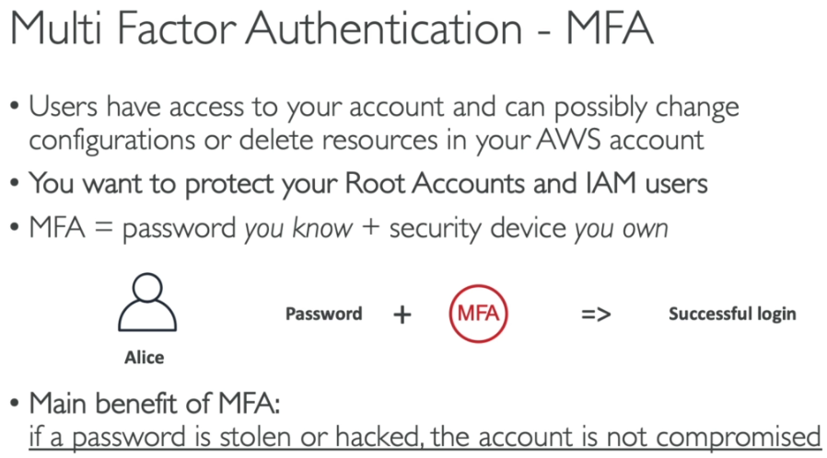

>>> MFA devices options >>>

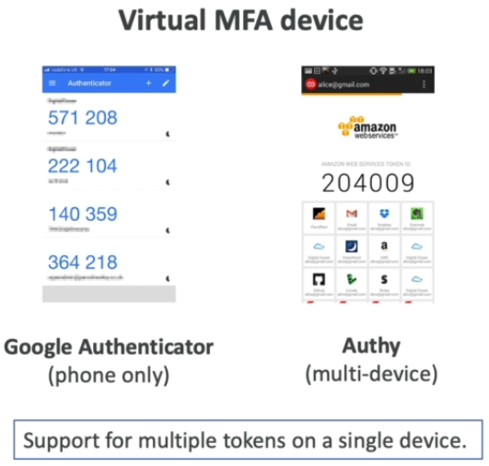 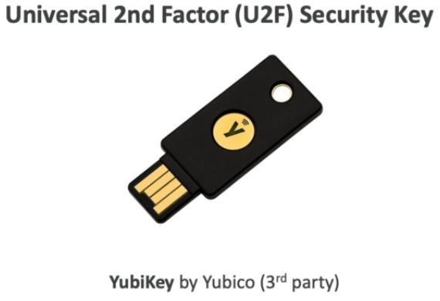  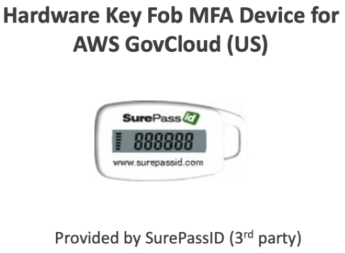

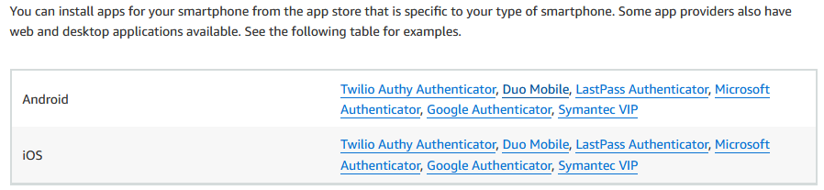

**4. IAM Role for services – (To give Permissions to AWS services & resources – Inline Policies)**

* **Roles are the replacement of credentials i.e. without key pair credentials we can manage AWS services.**
* **IAM role is similar to IAM user – attach roles to EC2 instance and use directly without key pair details.**
* **Trust entities is buildup between EC2 and services.**

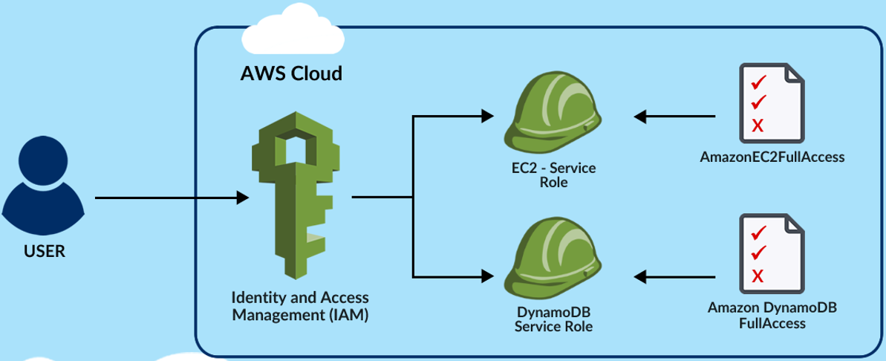 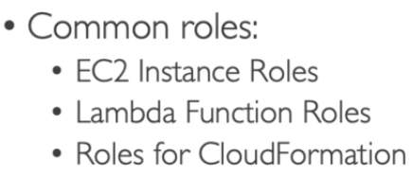 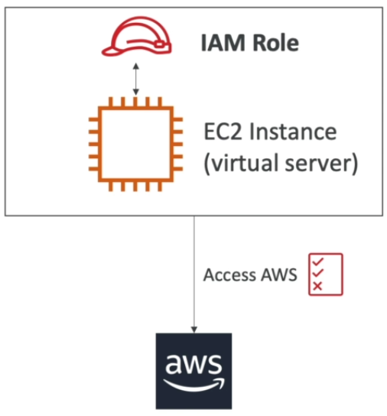

**5. IAM Security Tools – (To give Permissions to AWS services)**

* **Don't use the root account except for AWS account setup > One physical user = One AWS user**
* **Assign users to groups and assign permissions to groups**
* **Create a strong password policy > Use and enforce the use of Multi Factor Authentication (MFA)**
* **Create and use Roles for giving permissions to AWS services**
* **Use Access Keys for Programmatic Access (CLI/ SDK) > Download at time of creation**
* **Audit permissions of your account with IAM Credentials Report and IAM access advisor (to remove unused service)**

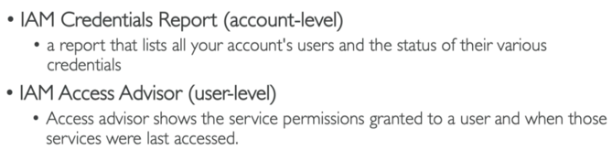

**# AWS account access options –**

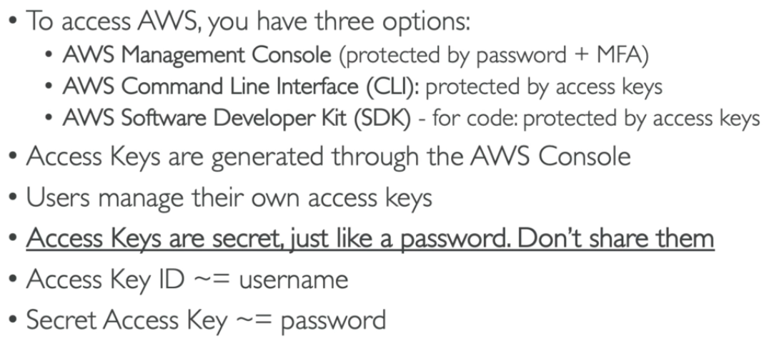

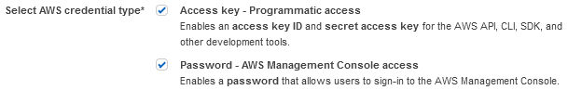

**1. AWS CLI setup –**

* **To configure AWS CLI we need to configure first using Key ID + Secret Key + Region**

Install AWS CLI2 > check version details after installation > configure AWS account (use user ID key & access key)

* AWS console CLI is available is few regions only with AWS CLI access Options –
  + AWS Console CLI: simple access without key pair access.
  + cmd or PowerShell AWS CLI: Cli access on windows using key pair access (aws cli software must be installed)
  + Linux AWS CLI: Connect using putty > aws configure
  + SSM agent can be used to access server (assign SSM role > install SSM agent > select instance > connect)

To download AWS CLI - <https://docs.aws.amazon.com/cli/latest/userguide/getting-started-install.html>

General CLI Commands - <https://docs.aws.amazon.com/cli/latest/reference/>

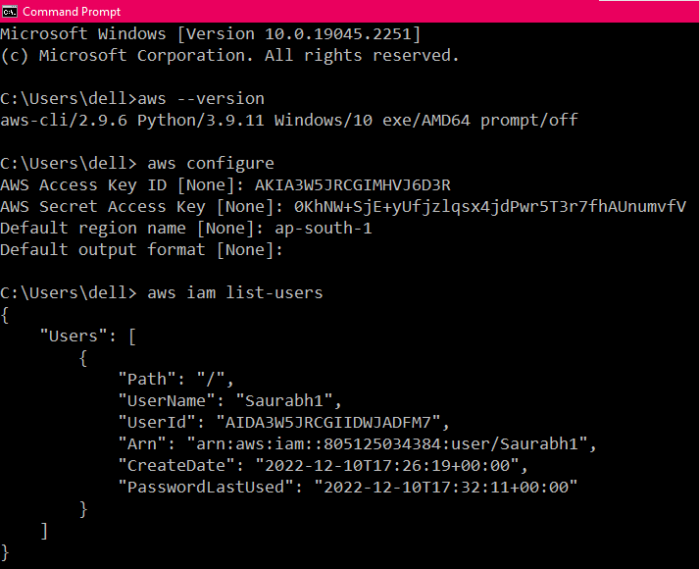 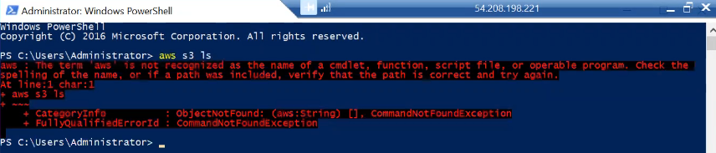

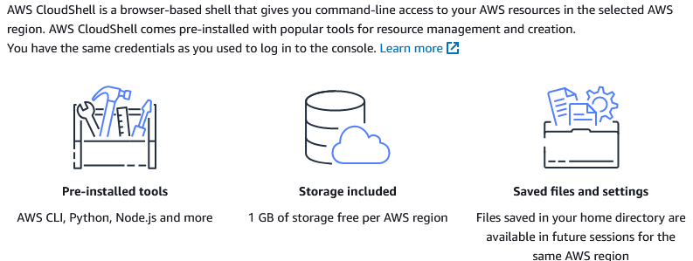

**2. AWS SDK setup –**

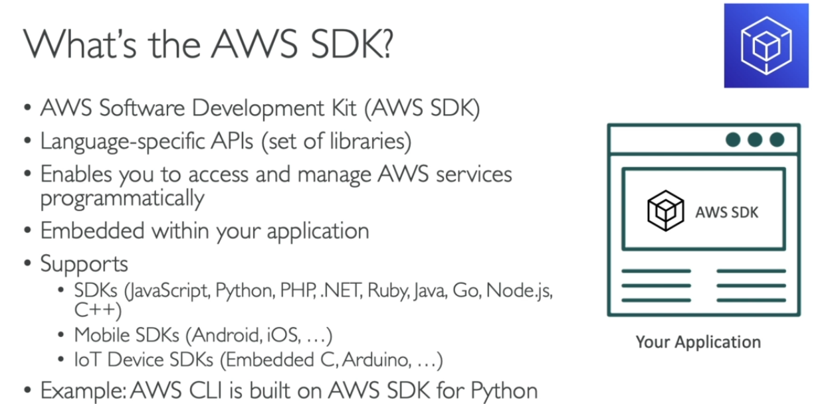

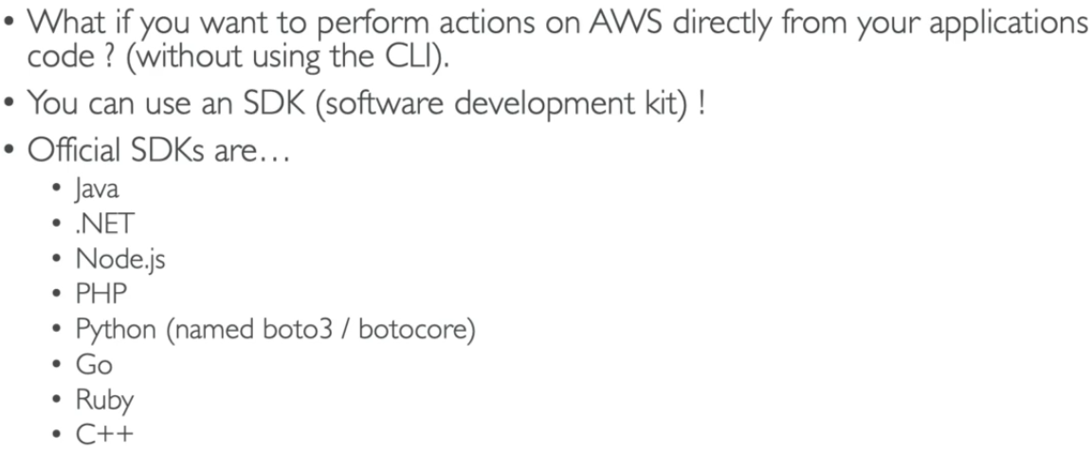 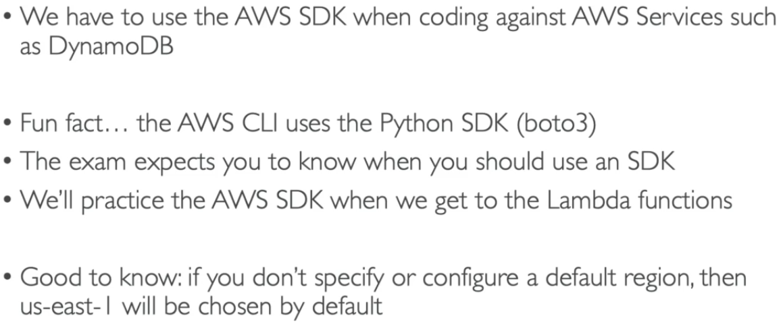

**3. SSM Agent on AWS console –**

* SSM agent can be used to access VM using CLI.

**\* Summary of IAM users and Groups**

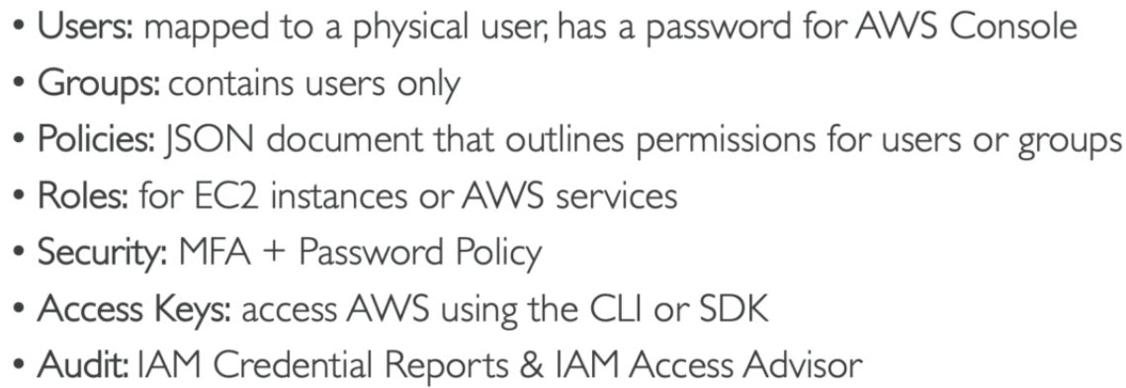

**\* Budget management is important**

**Create a budget and set reminders as per requirement in AWS console.**

**# EC2 Services – (Elastic Compute Cloud Iaas - Infrastructure as a Service)**

Main facilities of EC2 consists of:

* Renting virtual machines (EC2)
* Storing data on virtual drives (EBS)
* Distributing load across machines (ELB)
* Scaling the services using an auto-scaling group (ASG)

**1. EC2 Sizing and configuration options –**

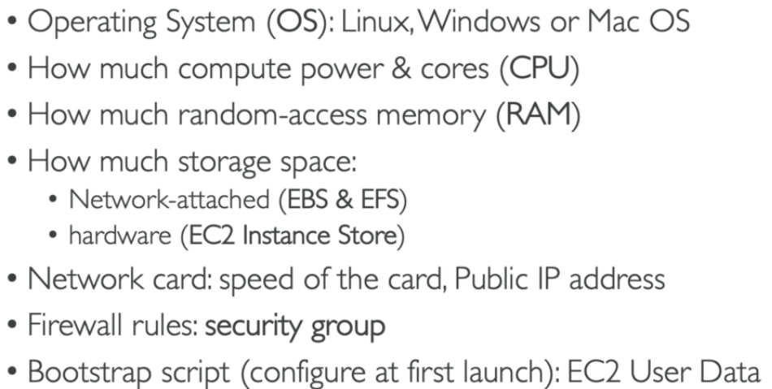 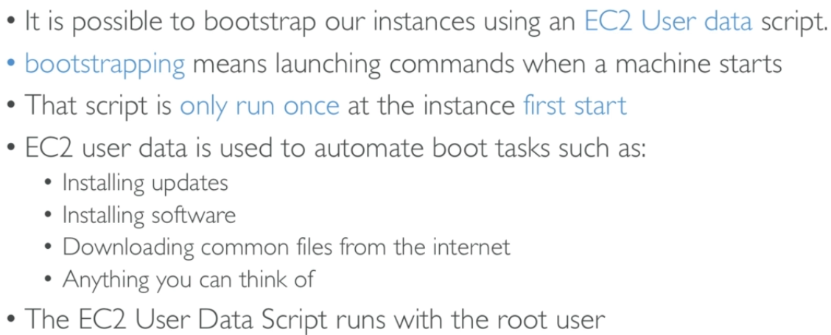

**\* While launching an instance ‘boot task’ can be added in ‘User Data’ in advanced details section.**

**2. EC2 Instance types and examples – (High Memory + Previous Generation not included here)**

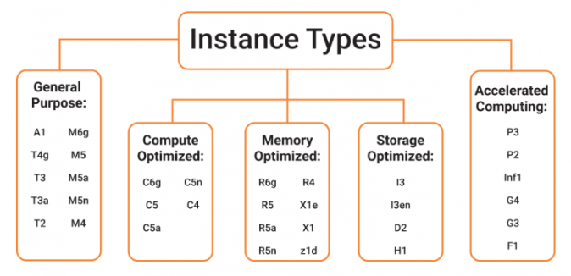

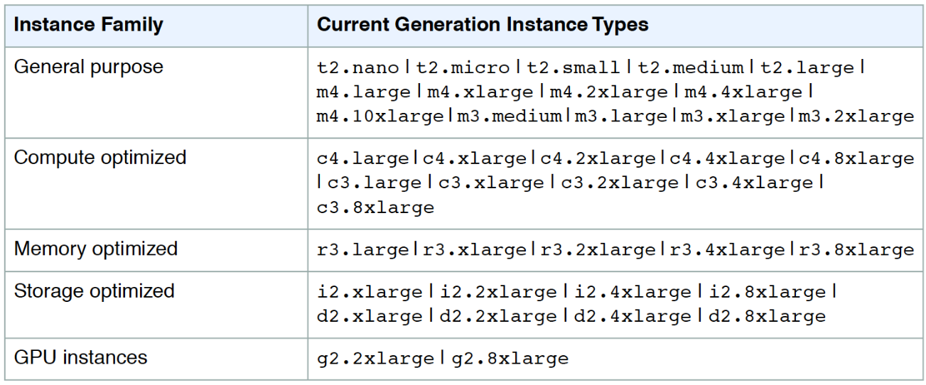

**Can use this link for more details -** [**https://instances.vantage.sh/**](https://instances.vantage.sh/)

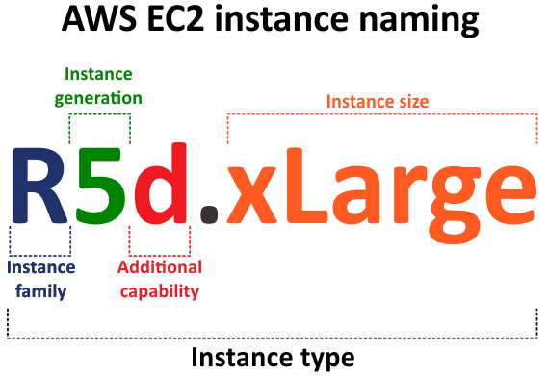 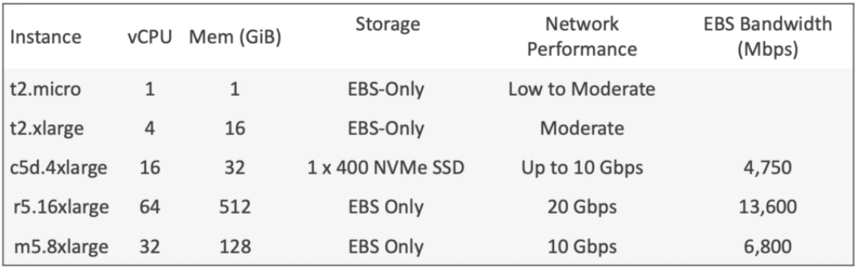

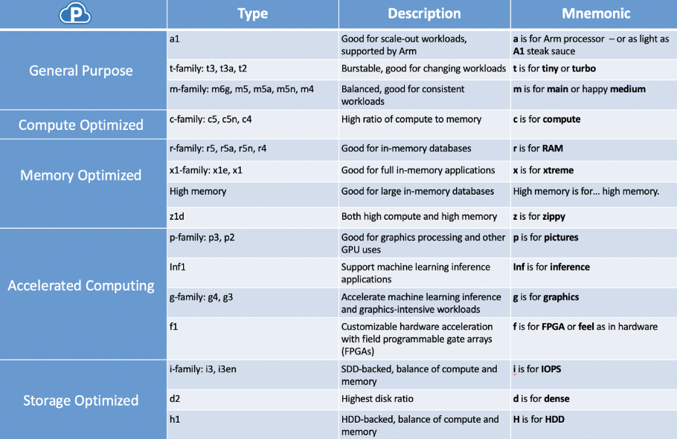

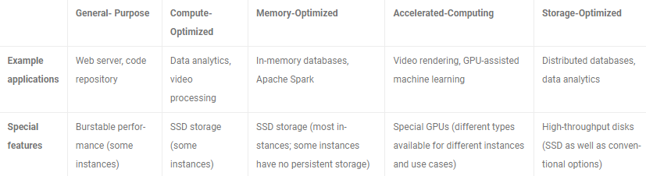

**3. EC2 Security Groups –**

Security Groups are fundamental of network security in AWS, control how traffic is allowed into or out of our EC2 Instances.

These only contain allow rules and can be reference by IP or by other security groups.

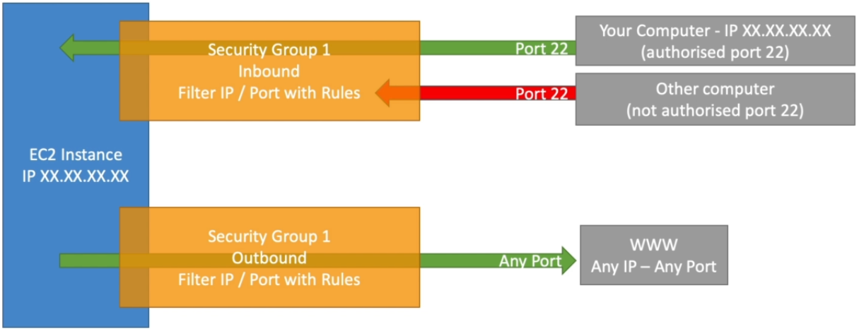 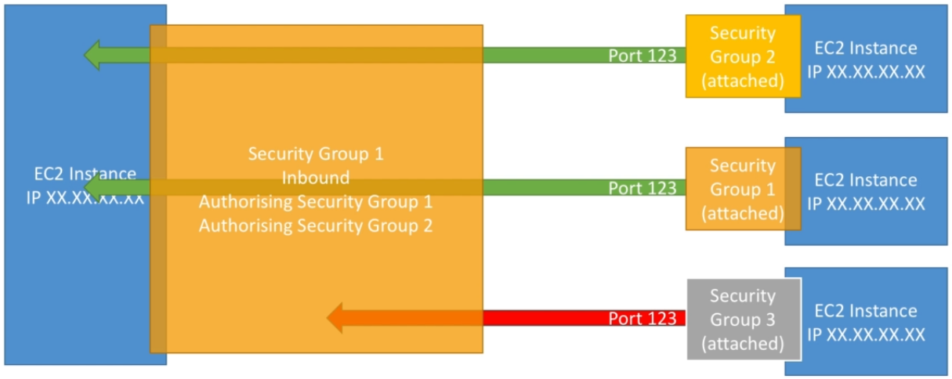

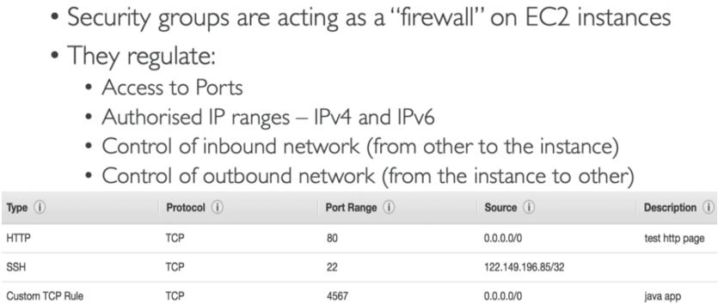

**>>> Classic Ports –**

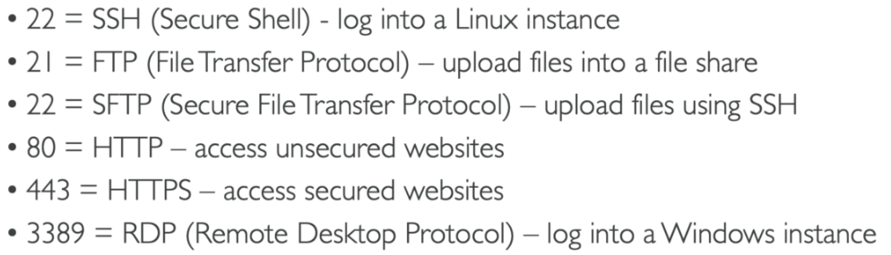

**4. EC2 Instances connect – (Connecting to Linux server machine using private Key-pair)**

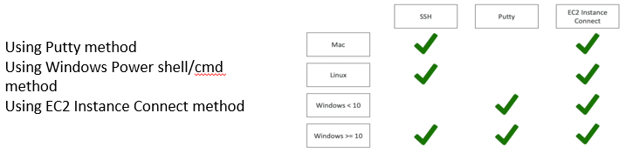

**5. Instances Purchase Guide – (Options/usage/benefits)**

* **On-Demand Instances -** short workload, predictable pricing, pay by second
* **Reserved (1 & 3 years) -** Reserved Instances (long workloads), Convertible Reserved Instances - long workloads with flexible instances
* **Savings Plans (1 & 3 years) -** commitment to an amount of usage, long workload
* **Spot Instances -** short workloads, cheap, can lose instances (less reliable)
* **Dedicated Hosts -** book an entire physical server, control instance placement
* **Dedicated Instances -** no other customers will share your hardware

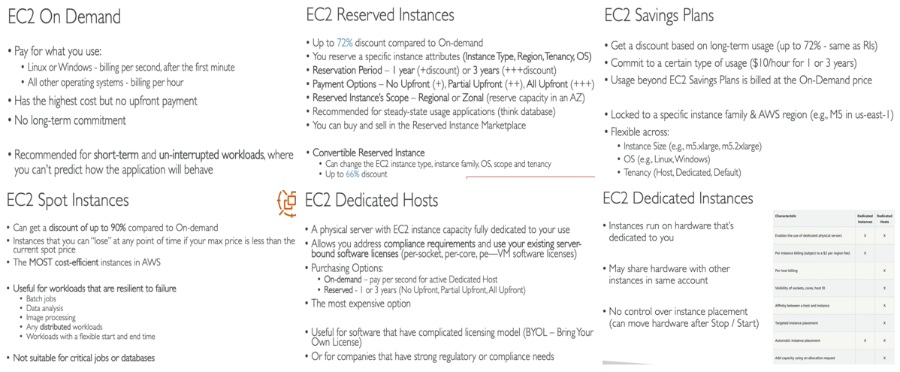

>>> Spot Instances – (Benefits/how to terminate)

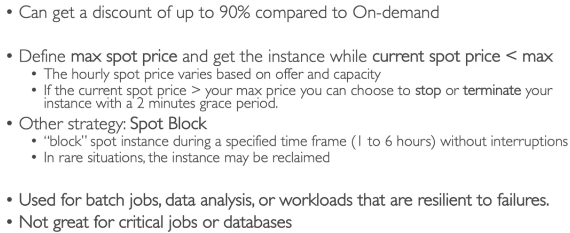 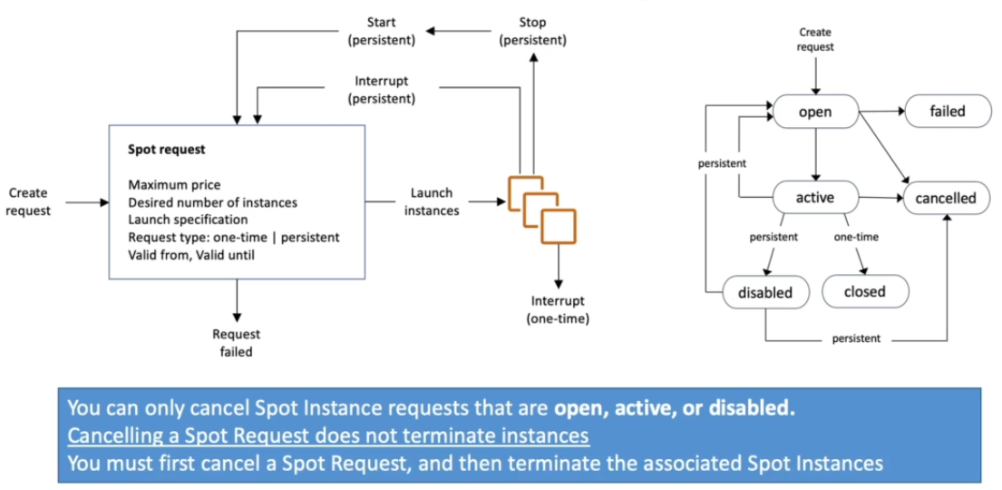

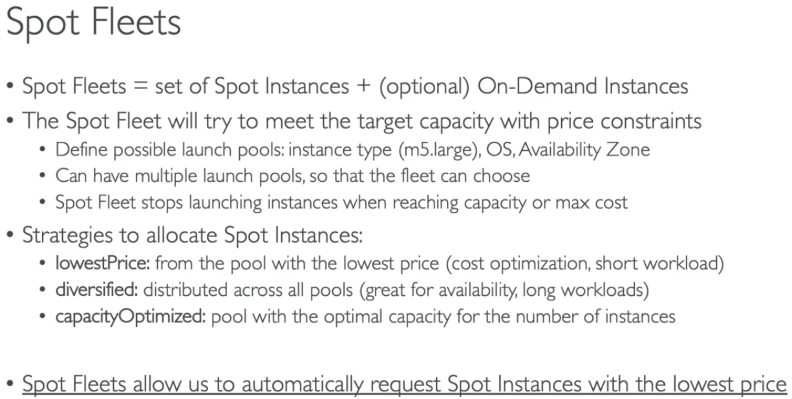

>>> Private/Public/Elastic IP –

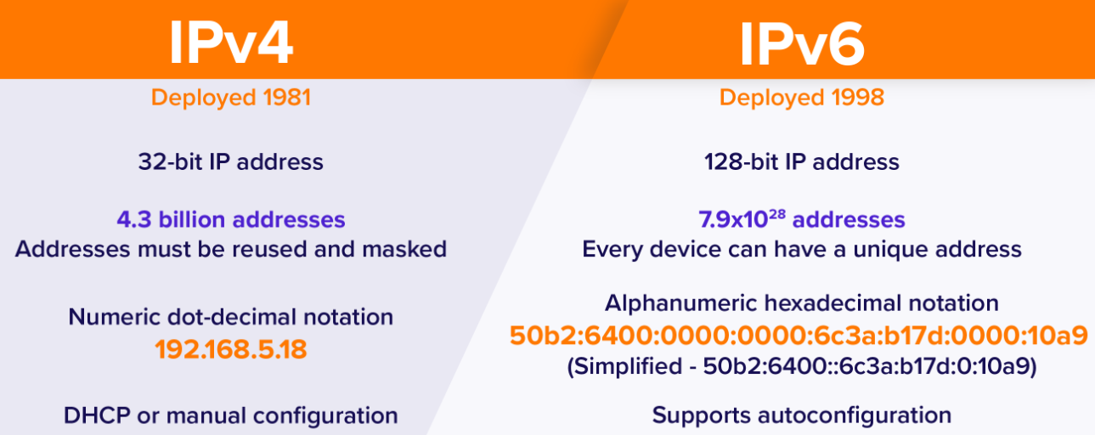 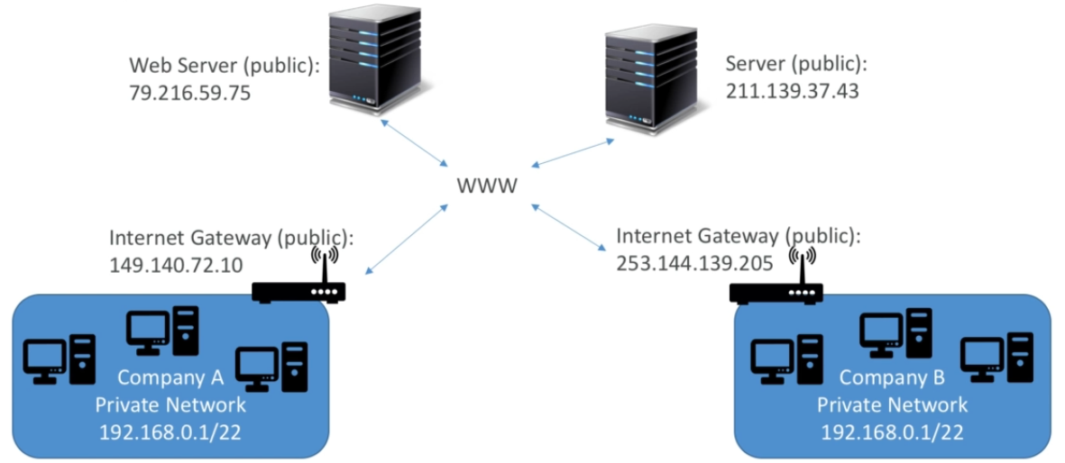

**\*Elastic IP can be used instead of public IP by creating and assigning elastic IP to an Instance (at start/stop IP won’t change)**

>>> EC2 Placement Groups – (Strategy to control EC2 Instances)

* **Cluster-** clusters instances into a low-latency group in a single Availability Zone
* **Spread-** spreads instances across underlying hardware (max 7 instances per group per AZ) - critical applications
* **Partition-** spreads instances across many different partitions (which rely on different sets of racks) within an AZ.

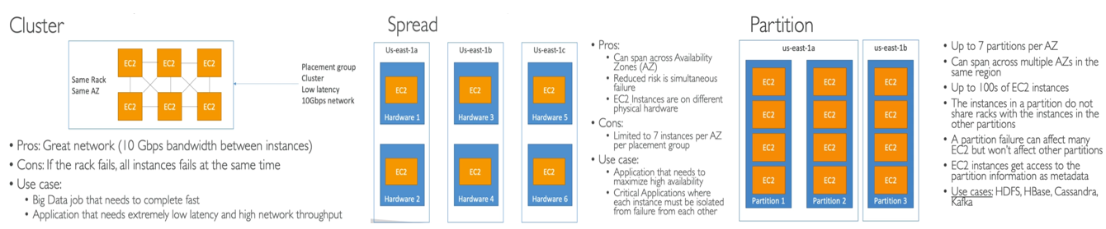

>>> Elastic Network Interface (ENI) – (create n/w interface –virtual n/w card and assign to instances)

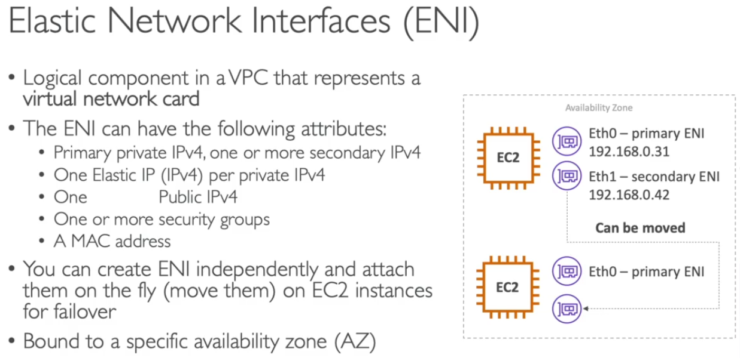

>>> EC2 Instance access options –

1. **SSH using Putty.**
2. **SSM (session manager connect) using SSM roles assigned to instance.**
3. **EC2 Instance connect using AWS console.**

**6. EC2 Instances States and Status check – (START + STOP + HIBERNATE + TERMINATE)**

**START:** OS Boots > User data scripts run > apps start > caches gets ready…. [Storage + Instances charges are added]

**STOP:** OS shutdown > Disk data/EBS remain intact [Only Storage charges are added]

**TERMINATE:** OS shutdown > Disk data/ Root EBS is lost [Only additional Storage/volumes charges are added]

**HIBERNATE:** OS remains in ON state > RAM data is preserved in root EBS > [Applicable for some instance type only]

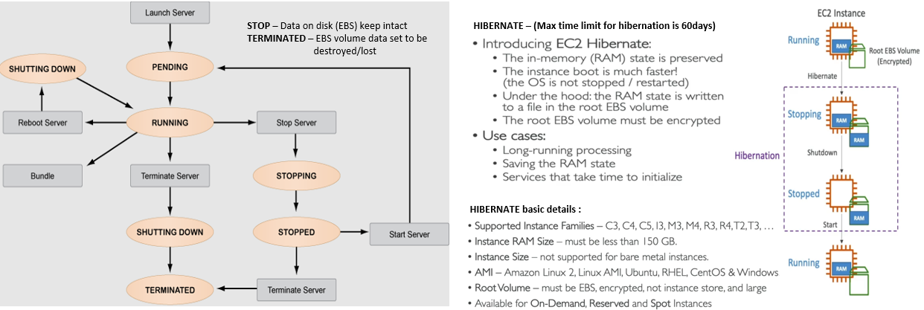

**\*While using Hibernation mode Root EBS must have enough space to store user RAM data in EBS (must be encrypted).**

>>> Status Check –

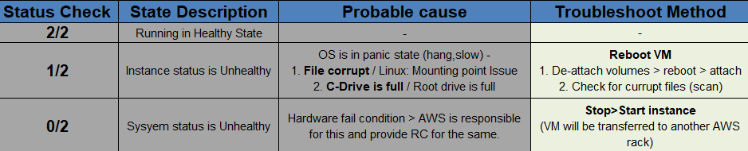

* It is used to monitor the server health.
* **EC2 serial console is used to access BIOS of VM.**

>>> EC2 Instance Metadata access –

* This IP address is used to access basic details of any instance.
* **Start a Linux m/c – server**
* **Use cmd – curl http://169.254.169.254/latest/meta-data/**

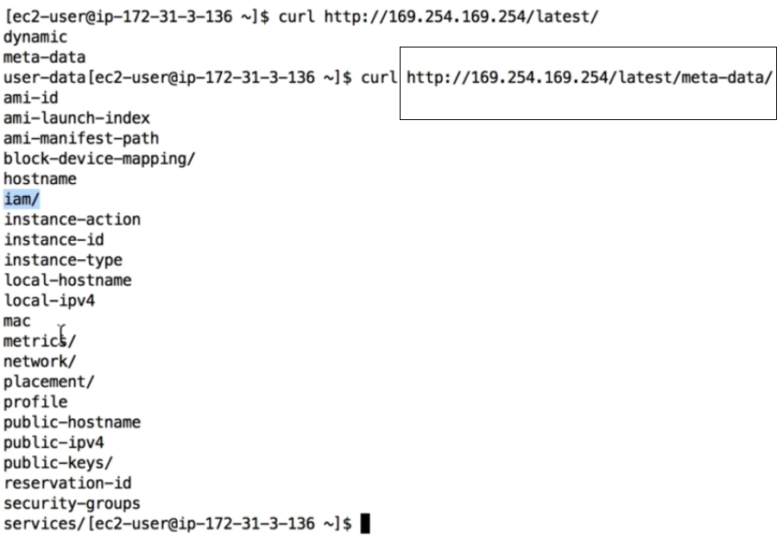

**# EC2 Instance Storage – (EBS/EFS/AMI/Instance store)**

**1. EBS Volumes (Elastic Block Store) – (**virtual network USB stick**-**30GB free EBS of General Purpose (SSD) or Magnetic/month**)**

* An EBS (Elastic Block Store) Volume is a network drive you can attach to your instances while they run
* It allows your instances to persist data, even after their termination
* Can be mounted to **one instance** at a time (at CCP level) & are **bound to a specific availability zone(AZ)**
* To move a EBS volume across AZ > **EBS Snapshot** > **Restore** > then use in other AZ
* EBS can be detach from one instance and attach to another instance

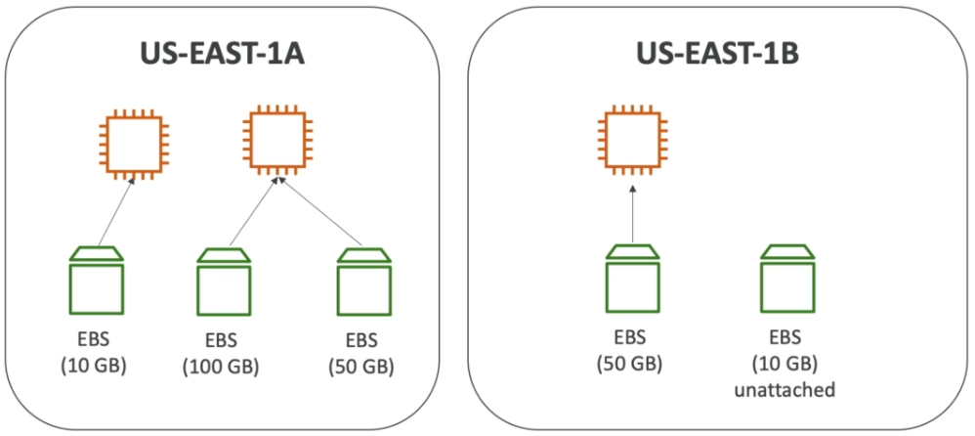 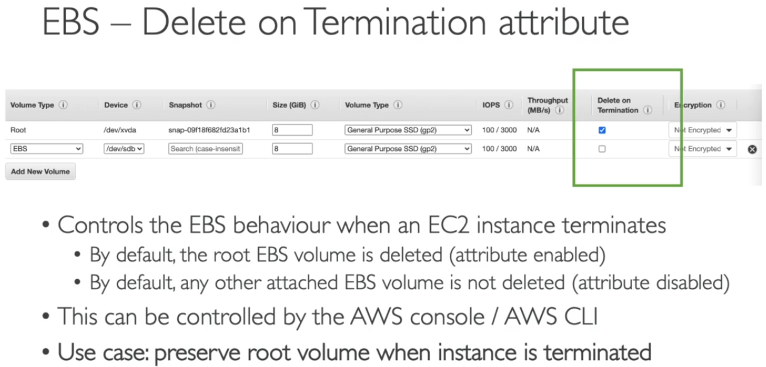

>>> EBS Snapshots –

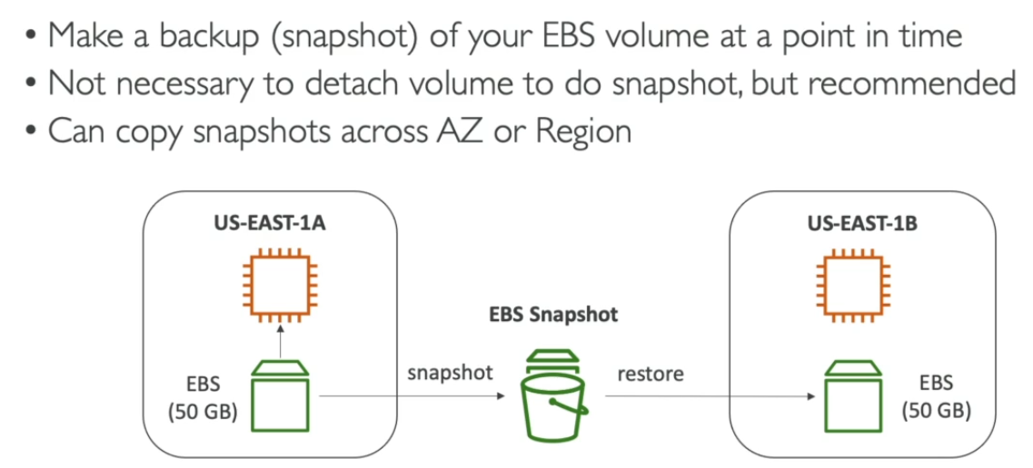 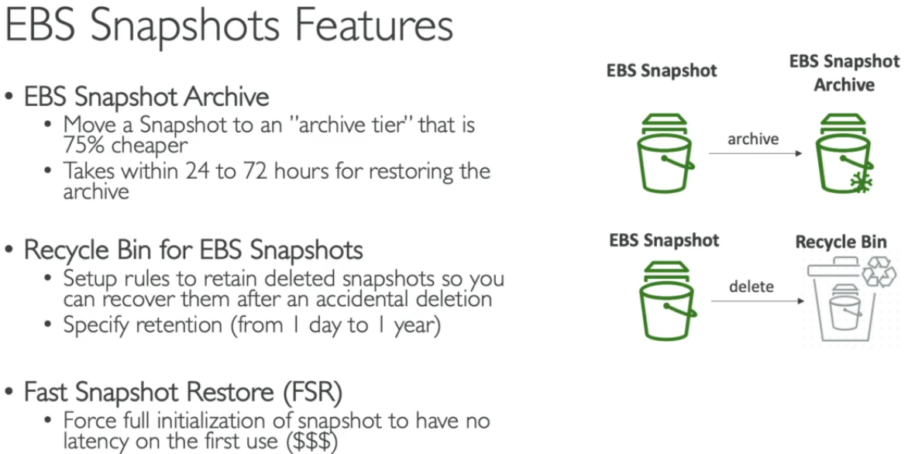

* Snapshots are taken of individual drive / Root / Data Drive **(used to take backup of volumes)**

**Process: Select volume > Create Snapshot > add description > create [this snap can be used to move volume from one region to other]**

>>> EBS Multi-Attach Volumes – (io1 and io2 family)

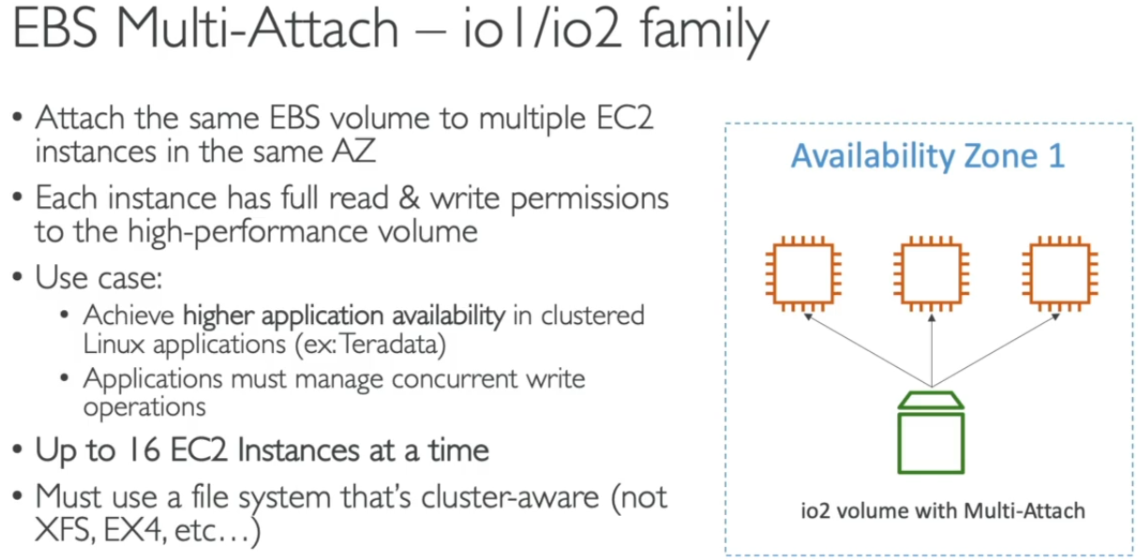

>>> EBS Encryption – (Encryption and decryption are handled transparently-no user intervention)

1. Data at rest is encrypted inside the volume
2. All the data in flight moving between the instance and the volume is encrypted
3. All snapshots are encrypted
4. All volumes created from the snapshot
5. Encryption has a minimal impact on latency + EBS Encryption leverages keys from KMS (AES-256)

**Create EBS snapshot of volume > encrypt it using copy > create new EBS volume using this snapshot (this will be encrypted automatically) > attach it to the original instance.**

**2. AMI (Amazon Machine Image) – (Used to take backup of complete server)**

* AMI are a customization of an EC2 instance - add your own software, configuration, operating system, monitoring... Faster boot/configuration time as all software are pre-packaged
* AMI are built for a specific region - can be copied across regions also
* EC2 instances can be launched from : Public AMI (AWS provided), Own AMI (we make and maintain),

AWS Marketplace AMI (AMI someone else made (and potentially sells))

**Process: Select Instance > Create image > select No reboot [to avoid any downtime] > create [this snap can be used to move volume from one region to other using copy operation]**

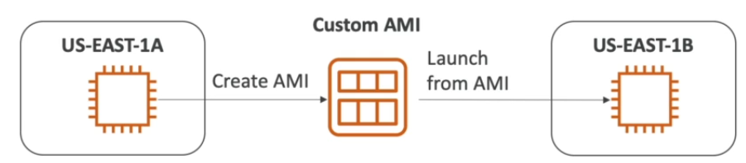

**\*Start a instance > install s/w package > create image > AMI created > Create new instance using this AMI**

**3. EC2 Instance Store –**

* These are used for high-performance hardware disk (EBS volumes are network drives with good but “limited” performance)
* Have Better I/O performance but **lose their storage if they're stopped.**
* Good for buffer / cache / scratch data / temporary contents as Risk of data loss is high if hardware fails.

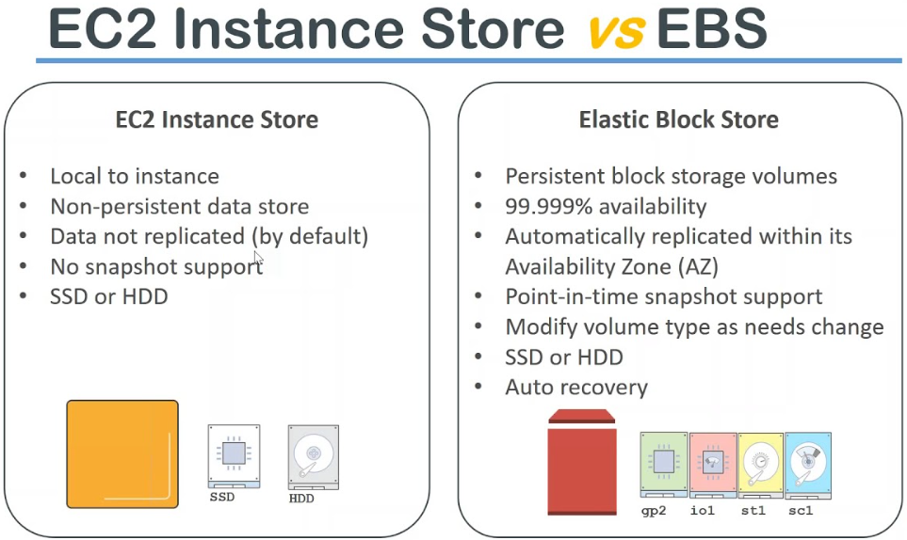

**4. Amazon EFS (Elastic File System) – (Managed network file system can be mounted on multiple EC2)**

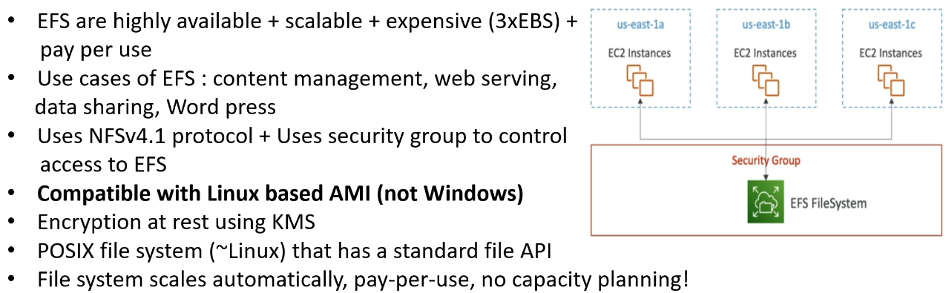

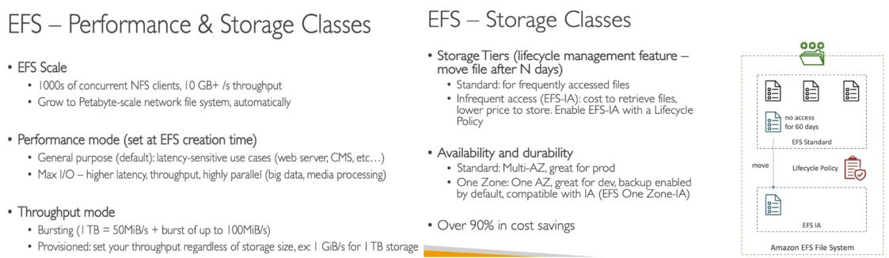

>>> EBS vs. EFS -

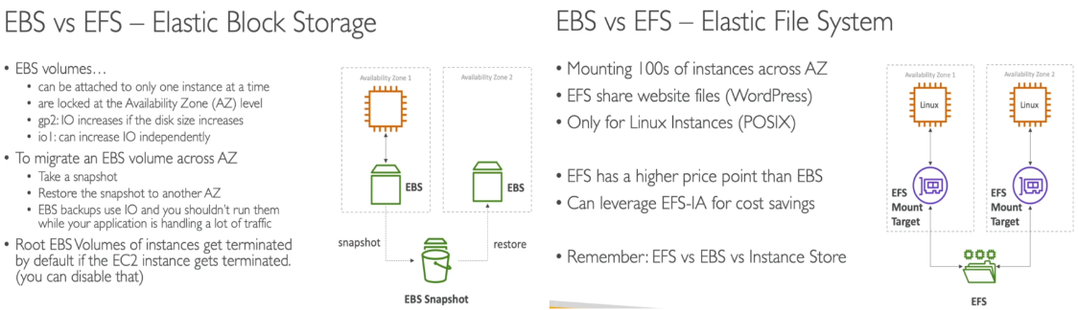

**# High Availability and Scalability ELB & ASG –**

**1. High availability and Scalability (application/system can handle greater loads by adapting) –**

>>> Scalability are of 2 types = vertical scalability + Horizontal scalability (elasticity)

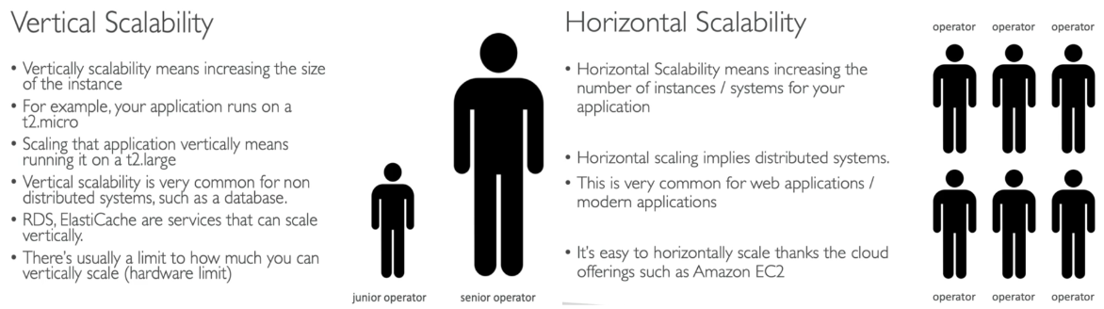

>>> High Availability –

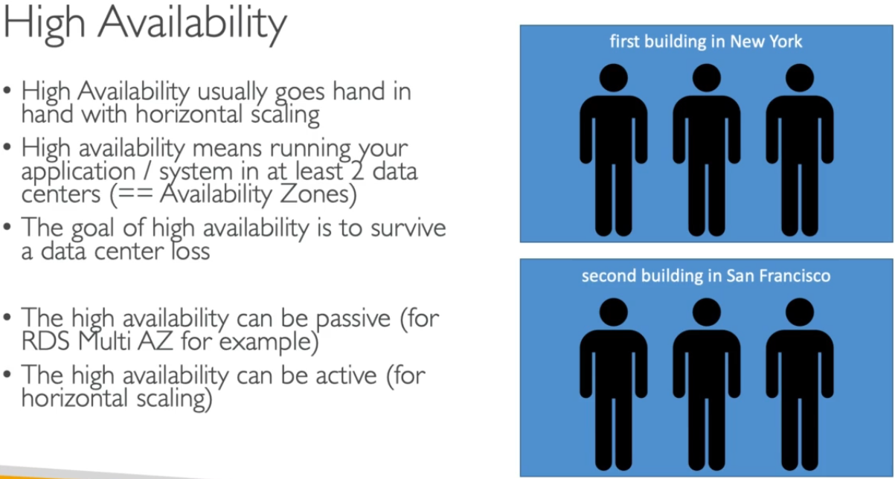 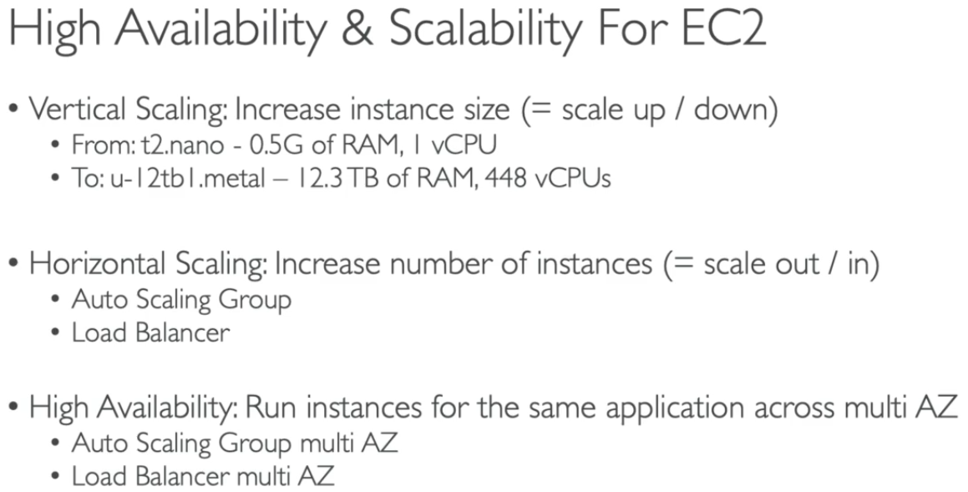

**2. Elastic Load Balancing (ELB) –** (LB are servers that forward traffic to multiple servers-EC2 and use for following features)

* ﻿Spread load across multiple downstream instances
* Expose a single point of access (DNS) to your application Seamlessly handle failures of downstream instances
* Do regular health checks to your instances
* Provide SSL termination (HTTPS) for your websites
* Enforce stickiness with cookies
* High availability across zones
* Separate public traffic from private traffic

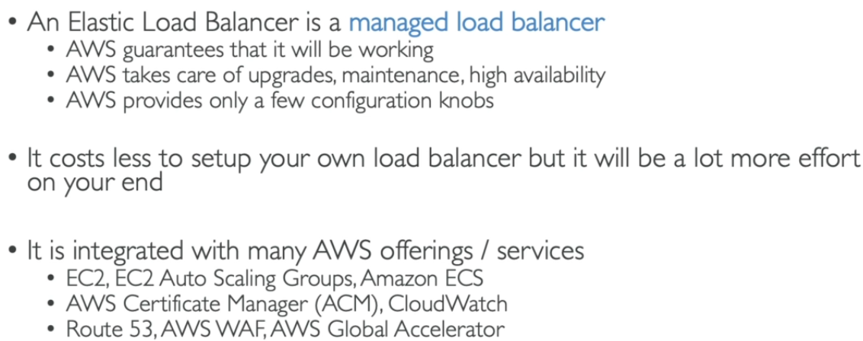 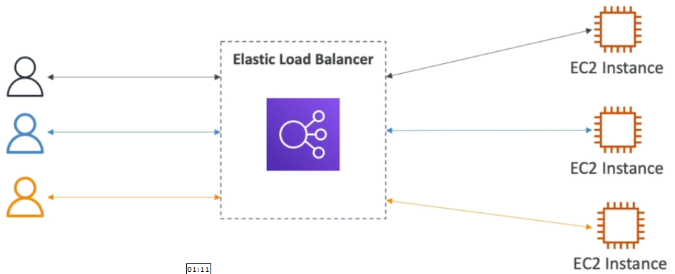

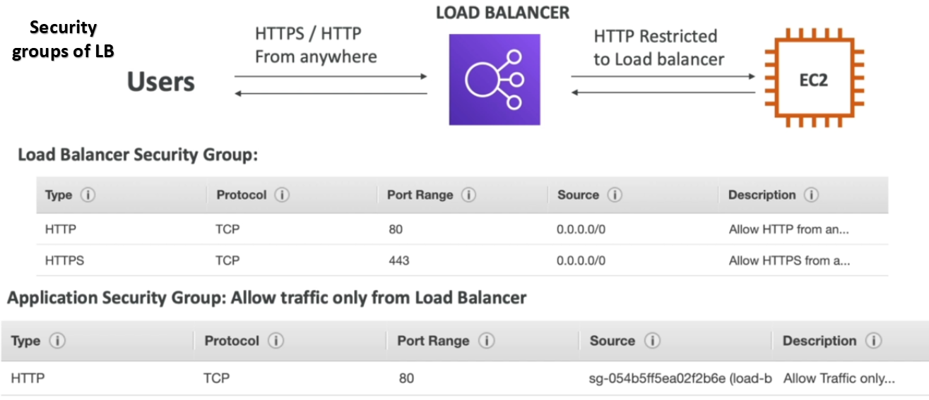

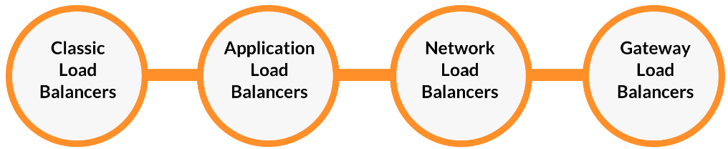

>>> Classic Load Balancer (CLB) –

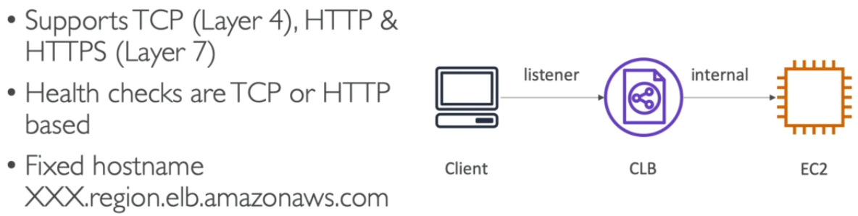

**Process: Create multiple instances > Allow as webserver (httpd) > create CLB > assign SG > Do health check setup > create**

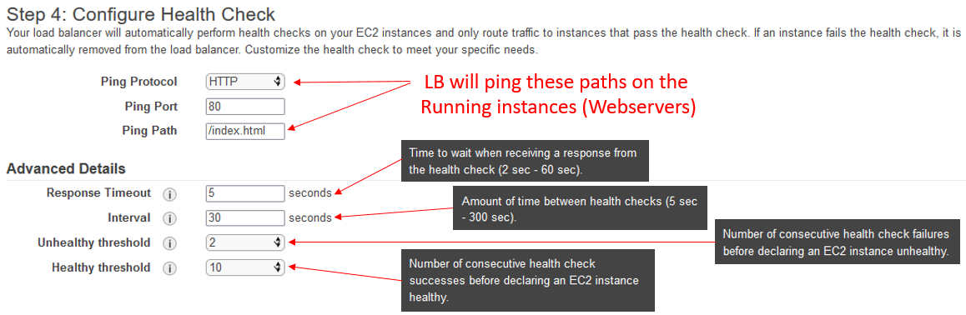

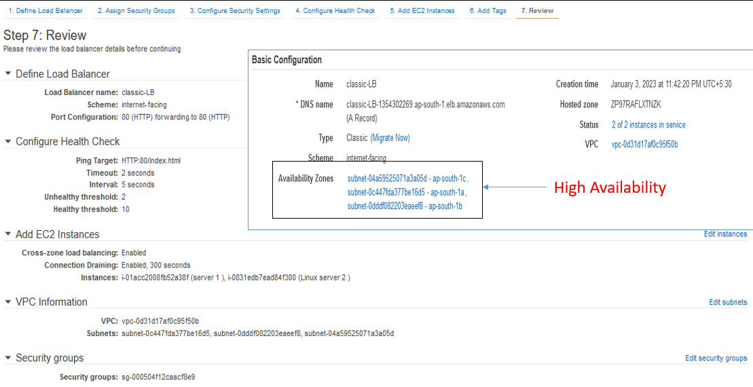

* LB have two schemes - internet-facing (for outer world comm.) and internal-facing (for instances comm.)

>>> Application Load Balancer (ALB) – (ALB is Layer 7 (HTTP))

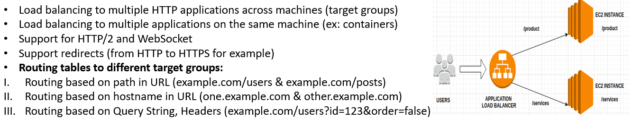

* ALB are a great fit for micro services & container-based application (example: Docker & Amazon ECS)
* Has a port mapping feature to redirect to a dynamic port in ECS
* In comparison, we'd need multiple Classic Load Balancer per application
* Health check facility of EC2 instances and target groups.
* **Target Groups** can be used to route incoming traffic of ALB to EC2 instances as per assigned rule.

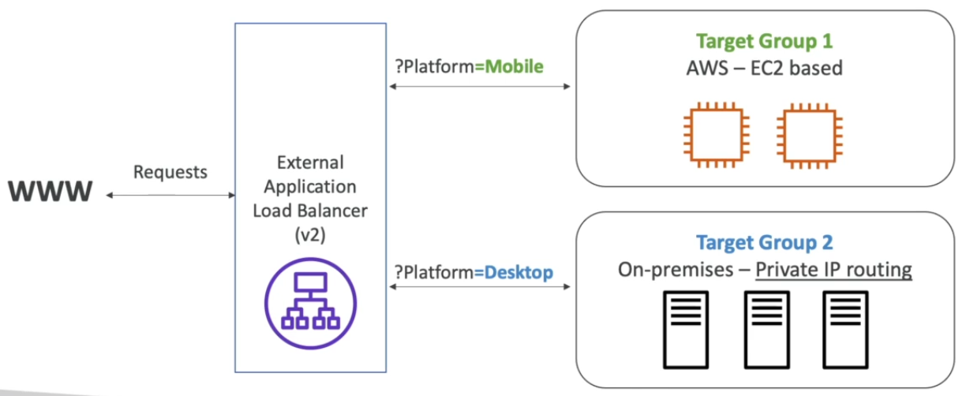 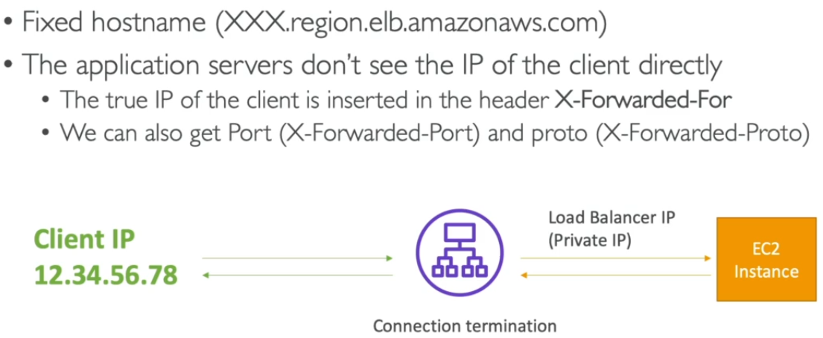

>>> Network Load Balancer (NLB) – (Layer 4 (TCP, UDP) used for high performance) – Not in free tier + practice not possible

* NLB can handle millions of requests/sec with less latency ~100ms (vs. 400ms of ALB)
* NLB has one static IP/AZ and support Elastic IP also.

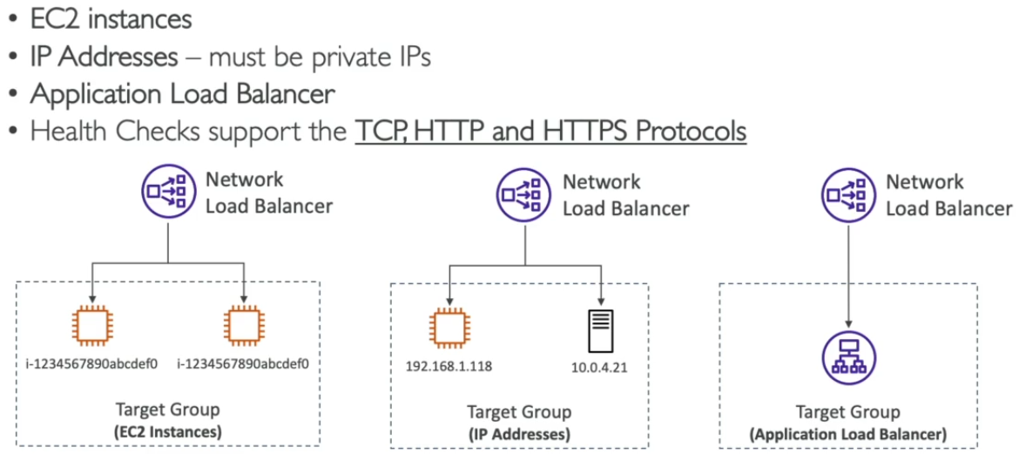 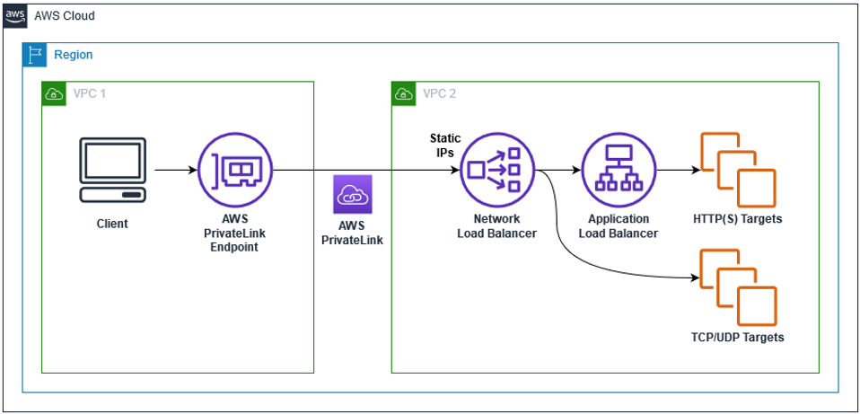

>>> Gateway Load Balancer (GWLB) – (GWLB is Layer 3 (IP Packets)) - Not used at our level

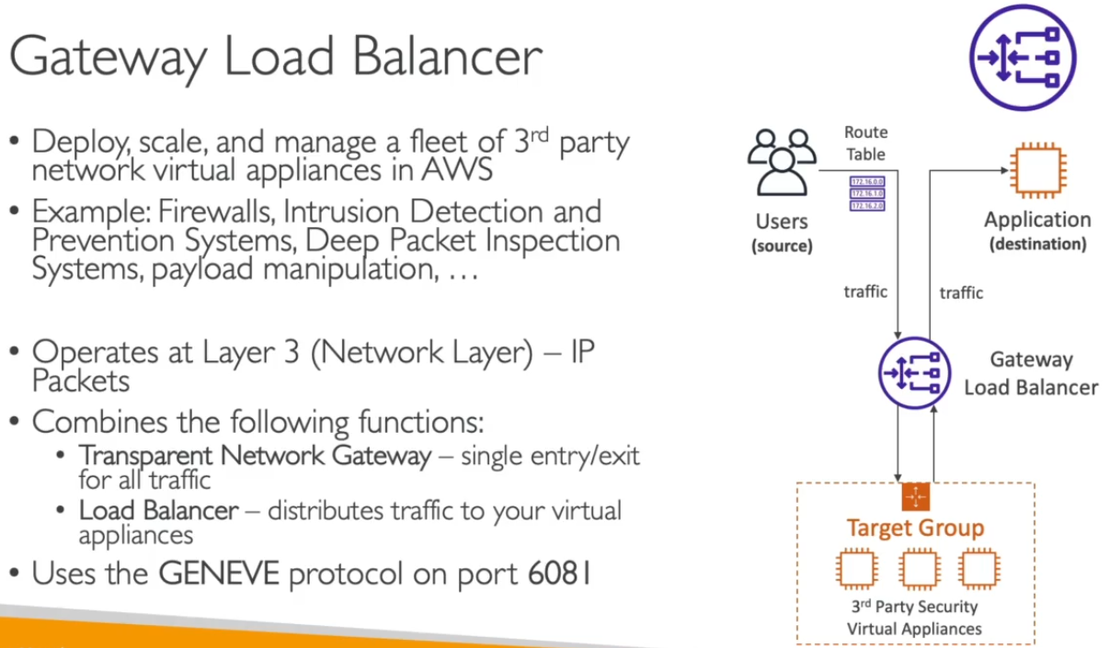 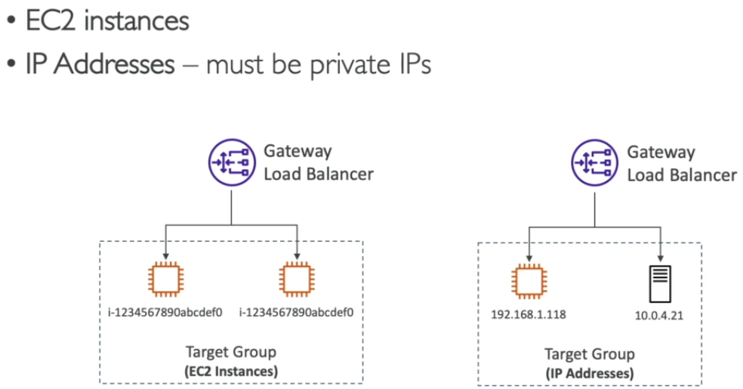

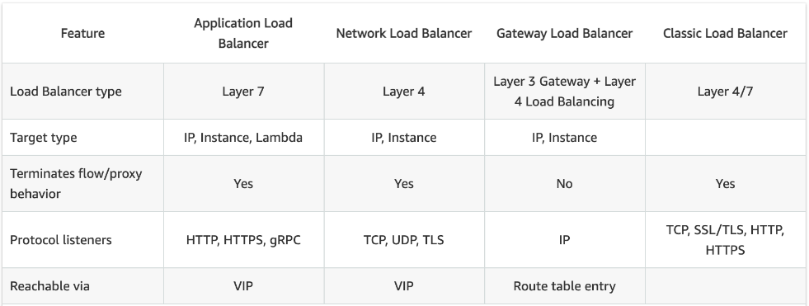

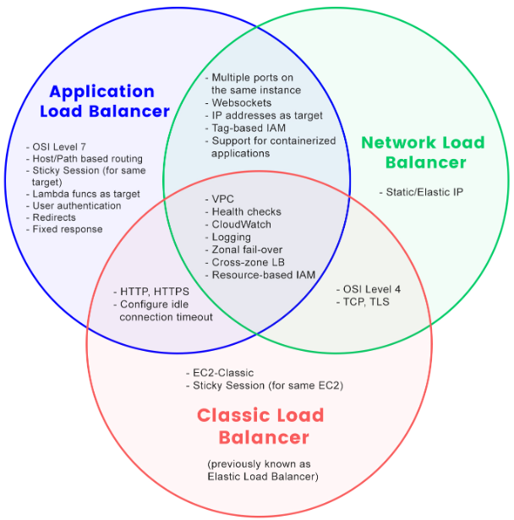

>>> Sticky Sessions (Session Affinity) –

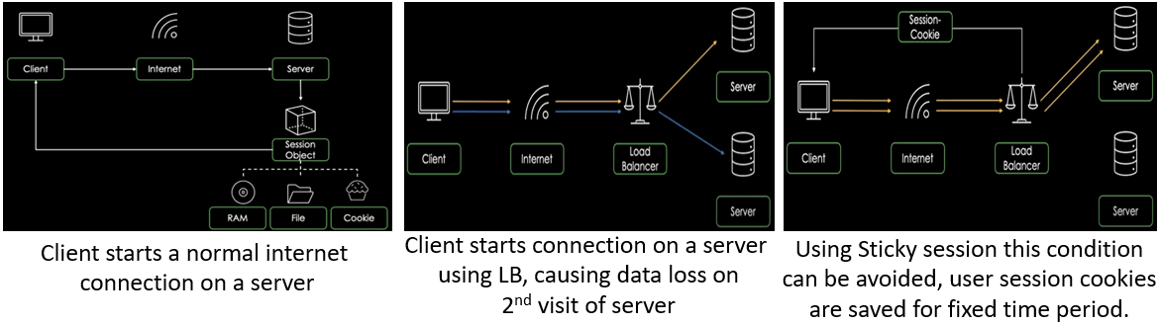

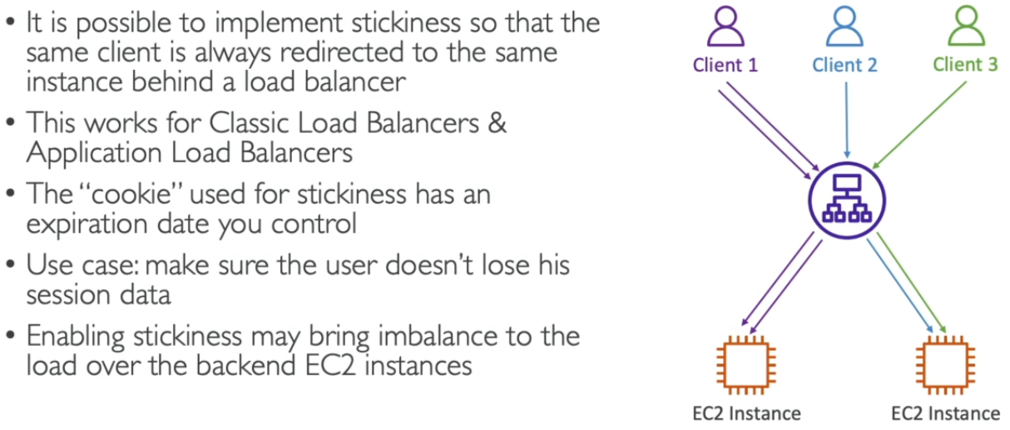 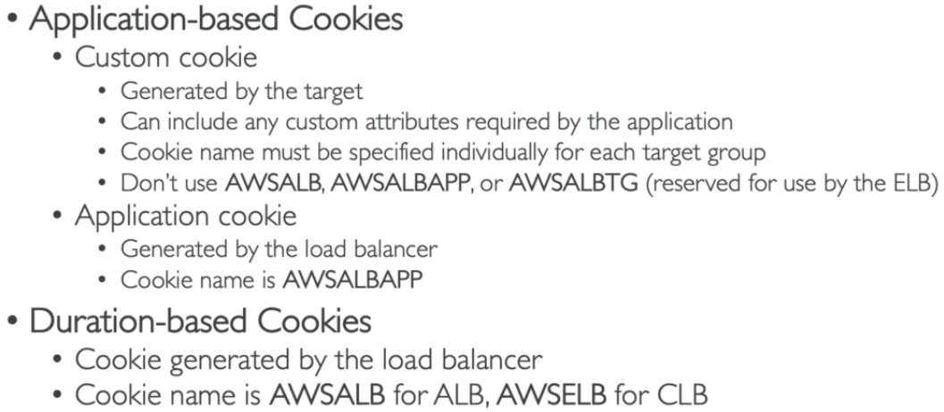 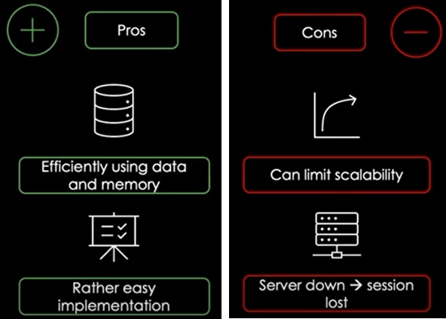

>>> Cross-Zone Load Balancing (Distributing Load Evenly on EC2 servers in each AZ) –

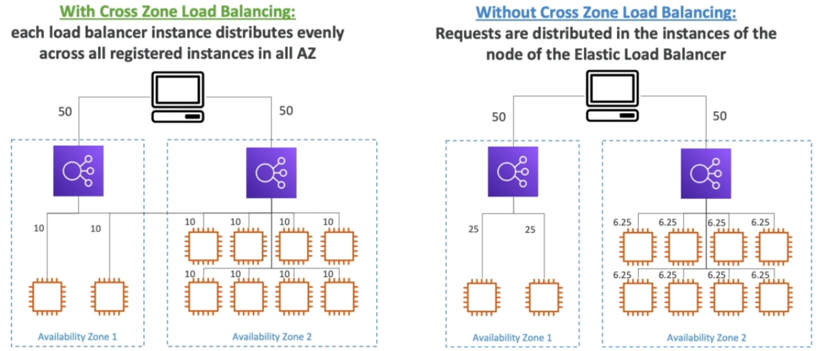

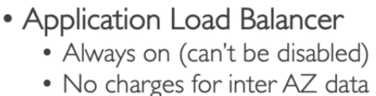 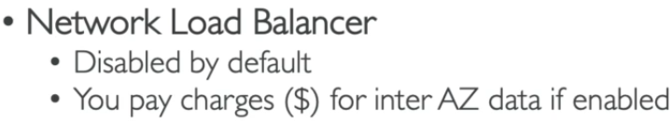 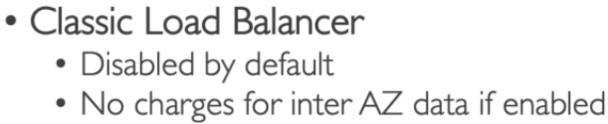

>>> Connection Draining (Deregistration delay) – (Time period to complete ongoing tasks of unhealthy instances)

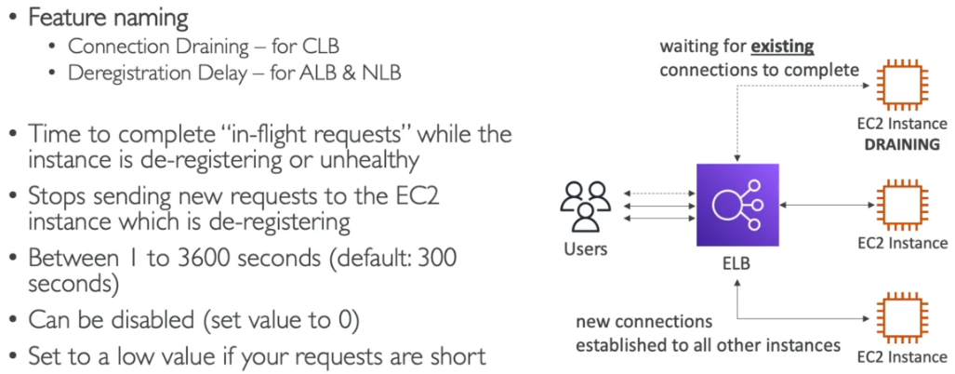

**3. Auto Scaling Group (ASG) – (To ± servers’ capacity as per real time load of website/application)**

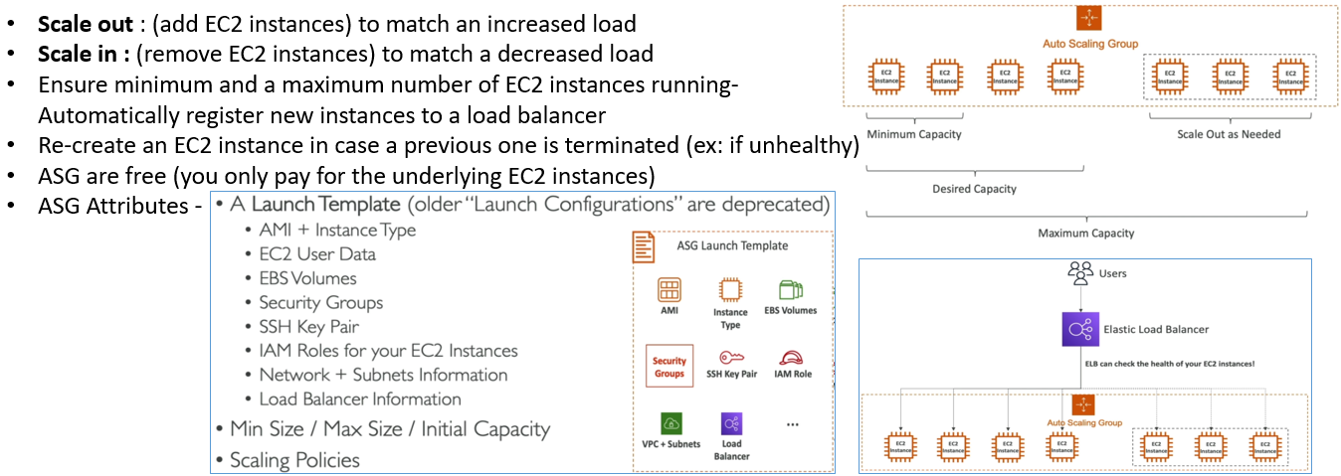

* Auto Scaling helps to ensure the correct number of EC2 instances available to handle load for application/servers.
* Min. and Max. Limit of servers must be assigned to auto scaling group.
* **Horizontal Scaling** - scale out (to add servers) and scale in (to remove servers) terminology is used.

**Process: 1.Create ALB > 2.Create Launch configuration > 3.Create ASG > 4.Create Topic in SNS > 5.Create Cloud Watch alarm > 6.Add Policy in ASG & Create ALB > Done**

1 > Naming > **Create SG** (SSH+HTTP outbound) > create target group (add health check rules) > create **ALB**

2 > Naming > AMI (VM Image) > Instance Size > User Data > **Assign SG** > create new key-pair > **launch config**

3 > Naming > **launch config** > select AZ > select **ALB** > assign no. of instances > **create ASG**

4 > Create SNS > create topic > add subscriptions > create

5 > Cloud watch Alarm > set CPU utilization limits (EC2 average is considered) > **add SNS topic** > create > **ADD POLICY IN ALB**

>>> Dynamic Scaling Policies –

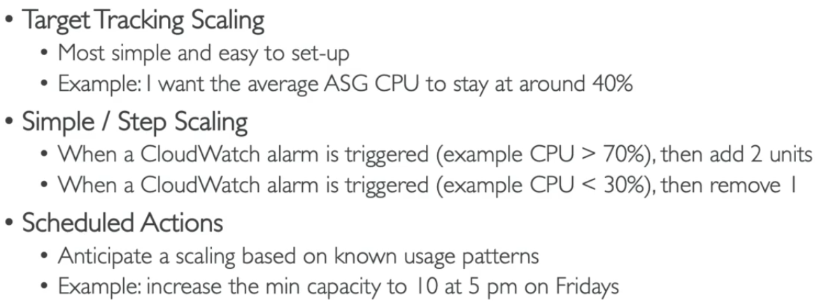

>>> Predictive Scaling Policies –

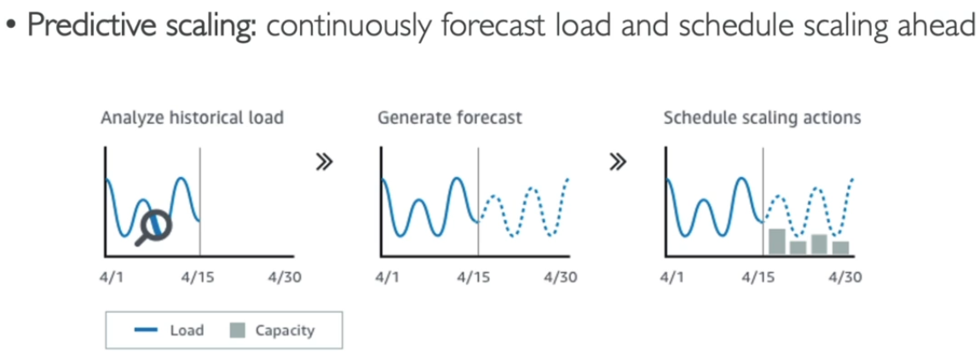

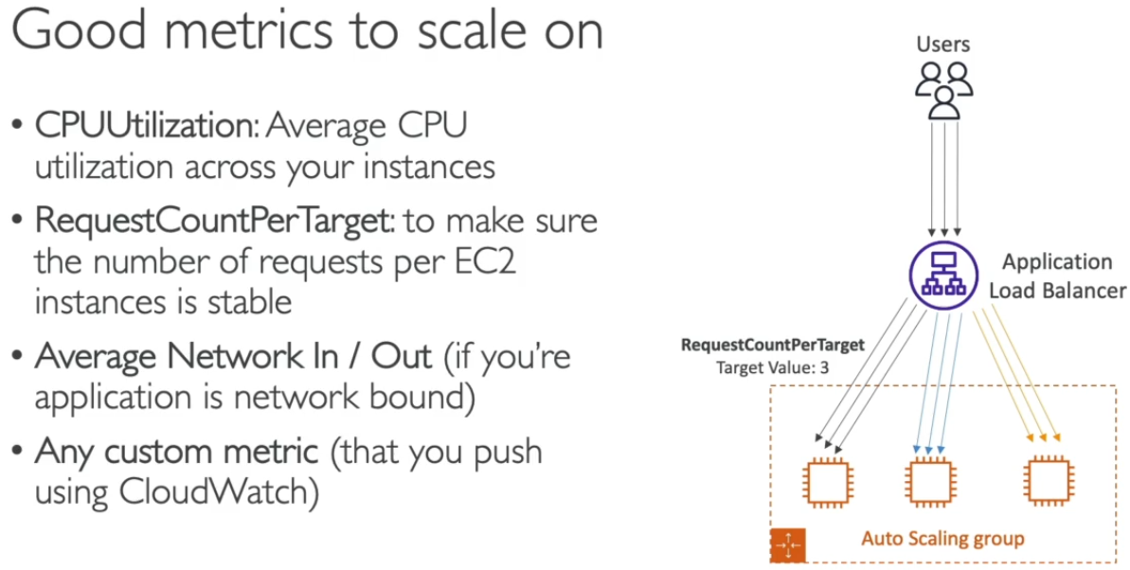 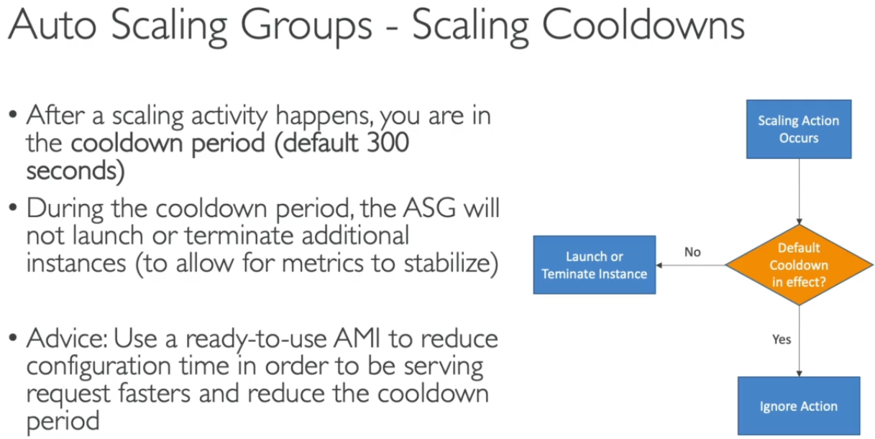

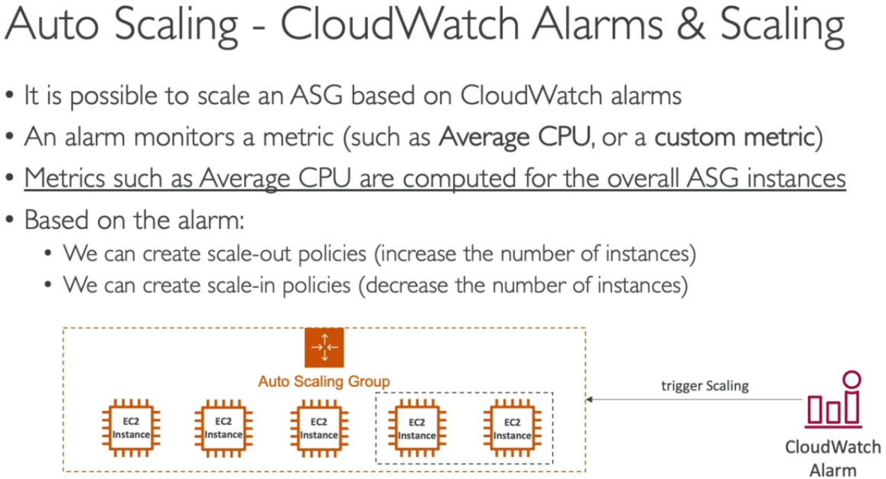

>>> Vertical Scaling of servers – (It is done manually – scale up (to add memory) and scale down (to detach memory) Terminology is used)

* Console Side – (OS Drive Name: /dev/xvda)
  1. **Increase size of the OS storage:** From console [Storage will be in Optimize state for 24hr after update and can’t be used – No Downtime require for this]
  2. **Change Instance Type:** Stop VM > change instance type as per requirement of RAM / storage[Downtime is required for this]
* OS Side memory updates – (Scale IN or Scale OUT OS / Drive Storage)
  1. **Windows OS:**
  2. **Linux OS:**

**\*New volumes must be created in same region as instance otherwise it won’t be attached to instance.**

**4. SSL/TLS Certificates (Secure Socket Layer/Transport Layer Security- inflight encryption) –**

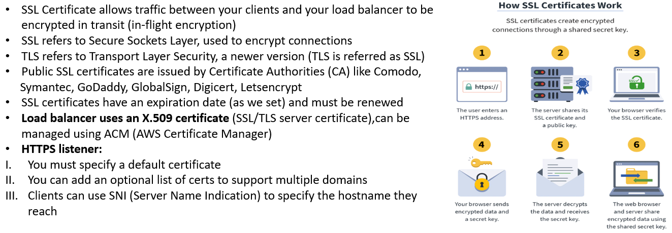

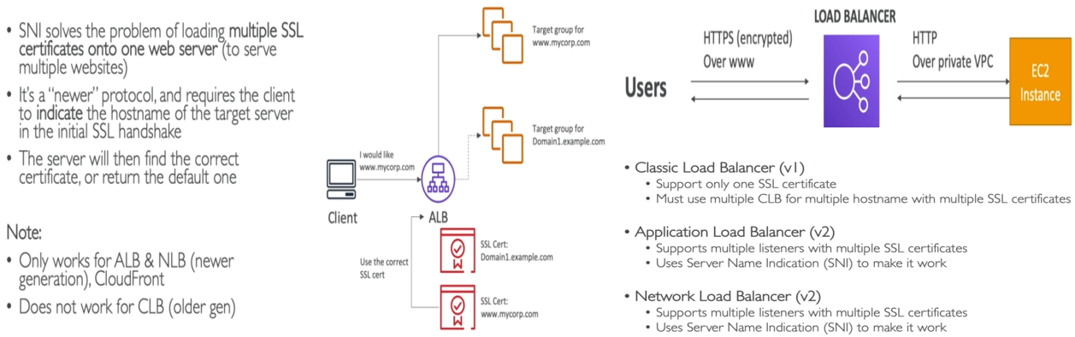

**#** **AWS RDS + Aurora + ElastiCache –**

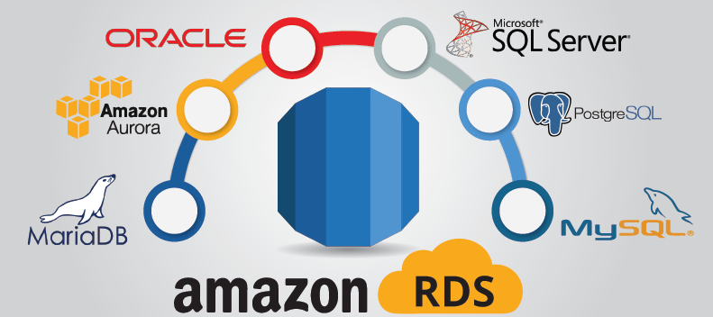

1. **RDS Services –**

* RDS stands for **Relational Database Services** – managed DB service for DB use, SQL as query language.
* Allow us to create DB in the cloud that are managed by AWS.

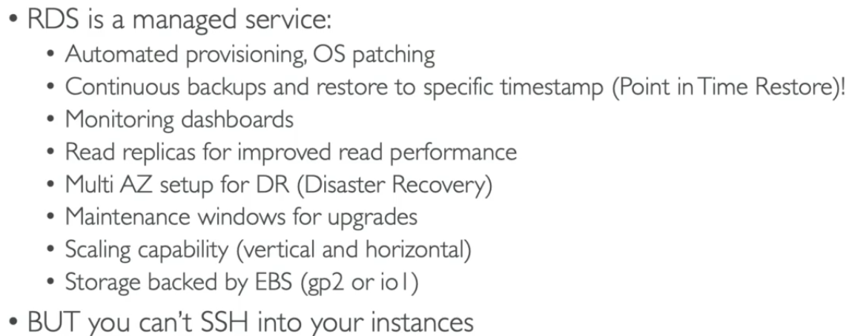

>>> RDS Backups –

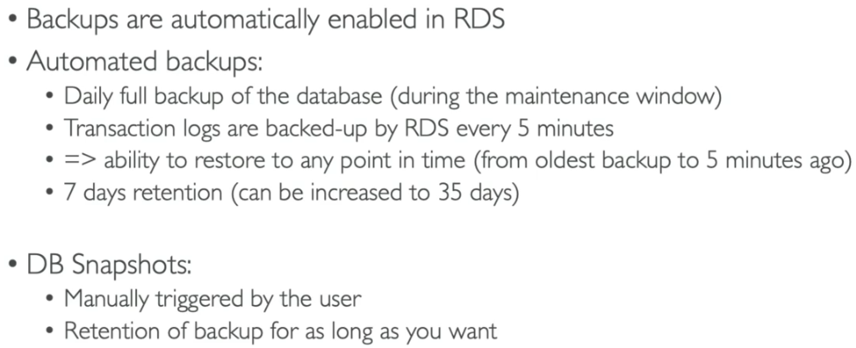

>>> RDS Storage Auto Scaling –

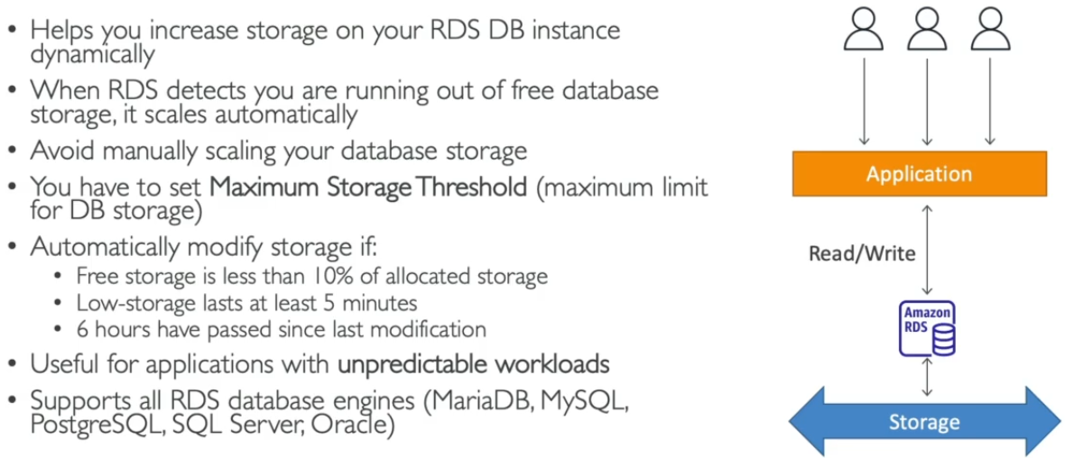

>>> RDS Read Replicas – (Read Scalability + use case of production data analysis)

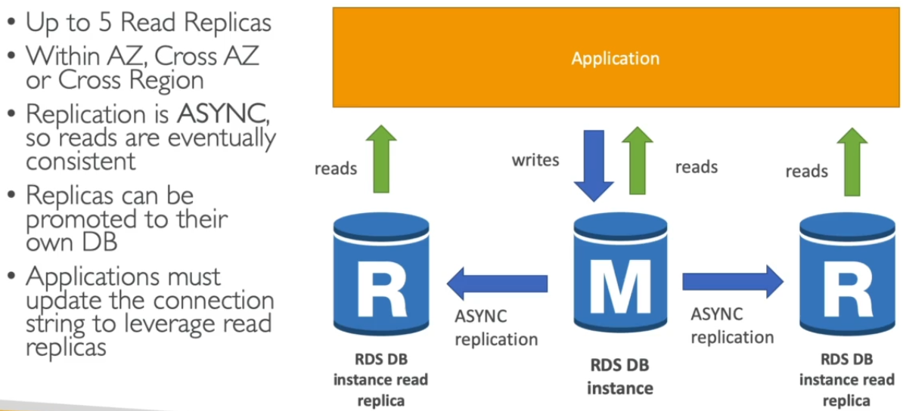 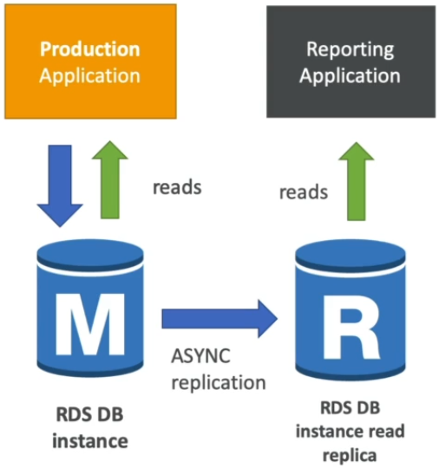

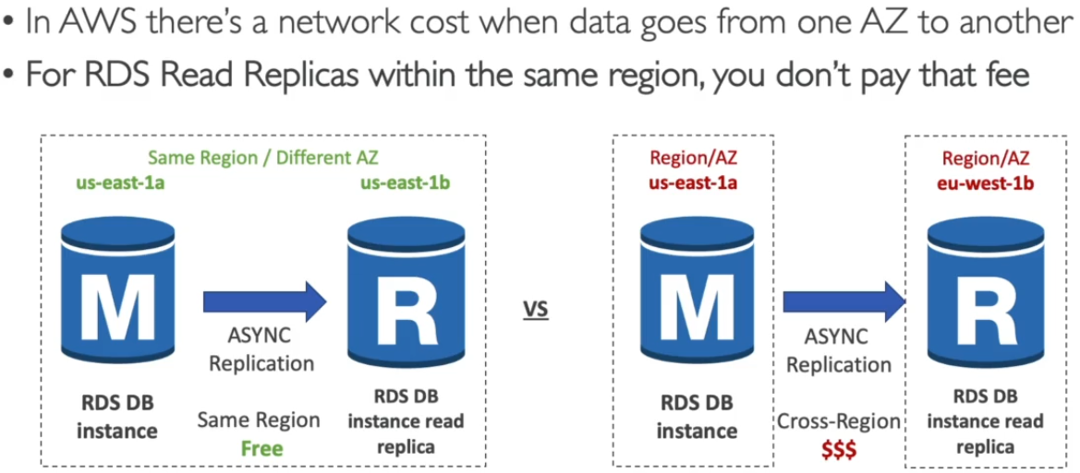

>>> RDS Multi AZ – (Disaster recovery)

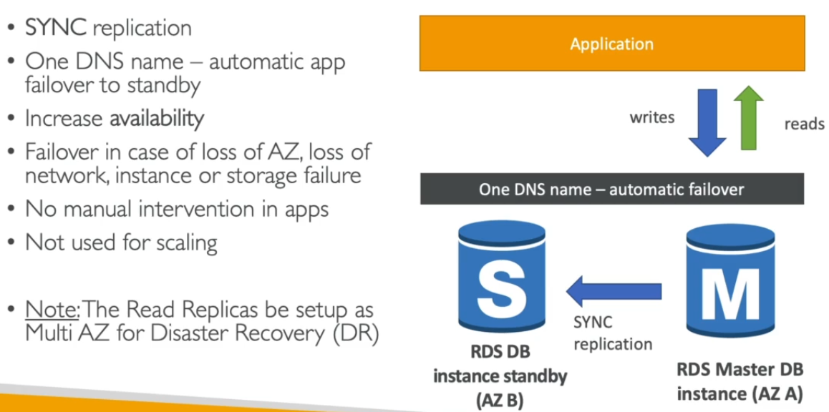 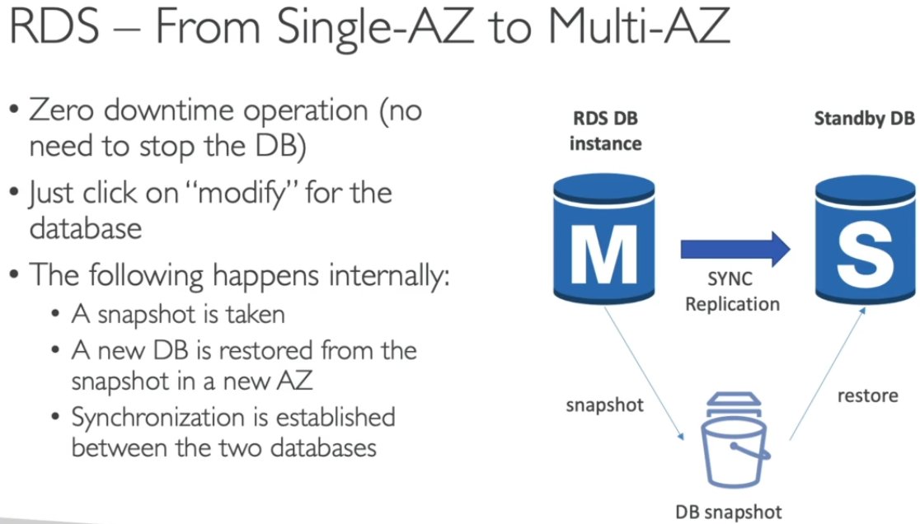

>>> RDS Custom –

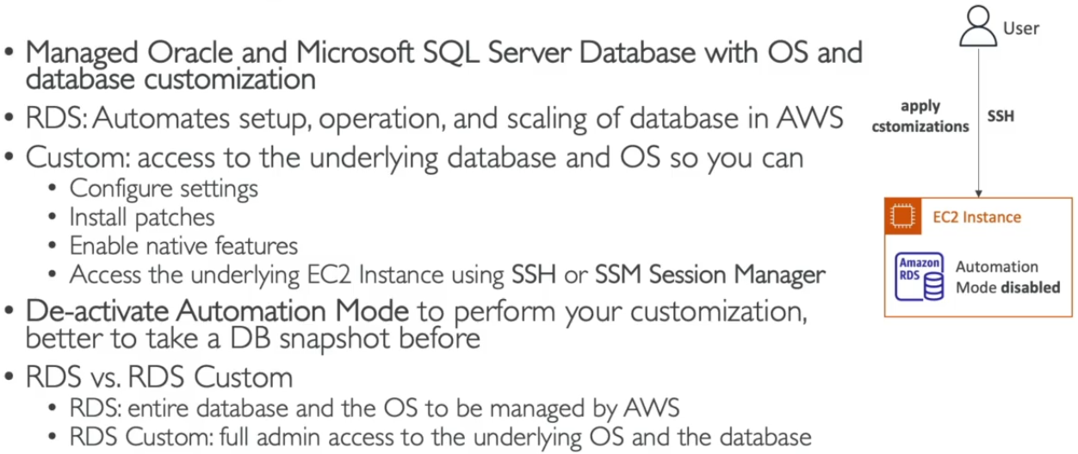

**2. Amazon Aurora – (It is a proprietary technology from AWS-not open sourced)**

* Postgres and MySQL are both supported as Aurora DB (drivers will work as if Aurora was a Postgres/MySQL database)
* Aurora is "AWS cloud optimized" and claims **5x performance improvement over MySQL on RDS**, **over 3x the performance of Postgres on RDS.**
* Aurora storage automatically grows in increments of **10GB, up to 128 TB**
* Aurora can have 15 replicas while MySQL has 5, and replication process is faster (sub 10 ms replica lag)
* **Aurora costs more than RDS (20% more)** - but is more efficient + High availability & read scalability

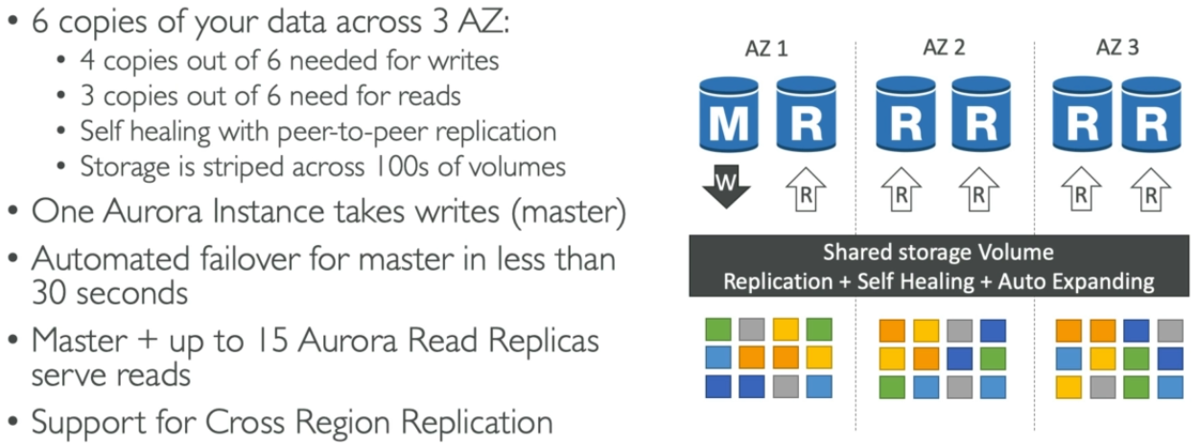 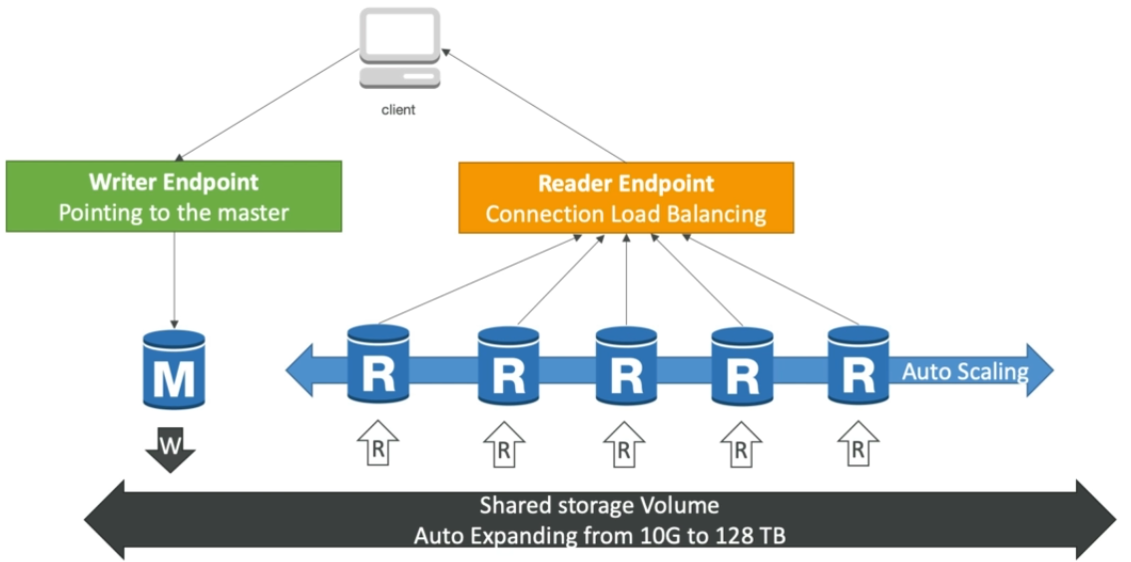

**\*Aurora cluster have one master to write and multiple endpoints to read.**

>>> Aurora Features –

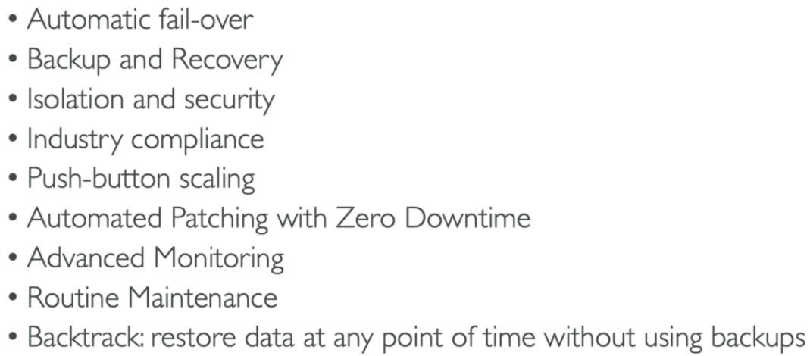 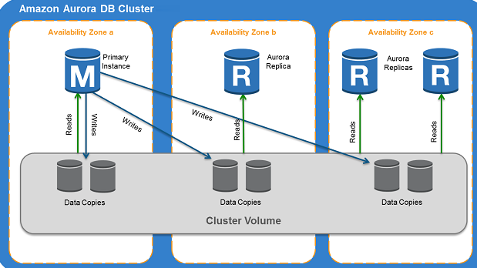

>>> Aurora Advanced Features –

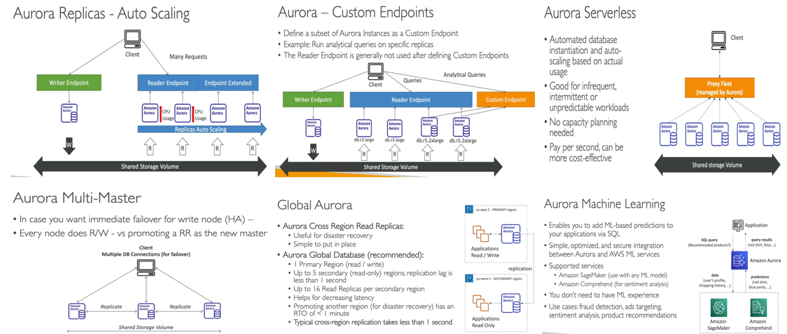

**>>> RDS / Aurora Backups and Restores + Security –**

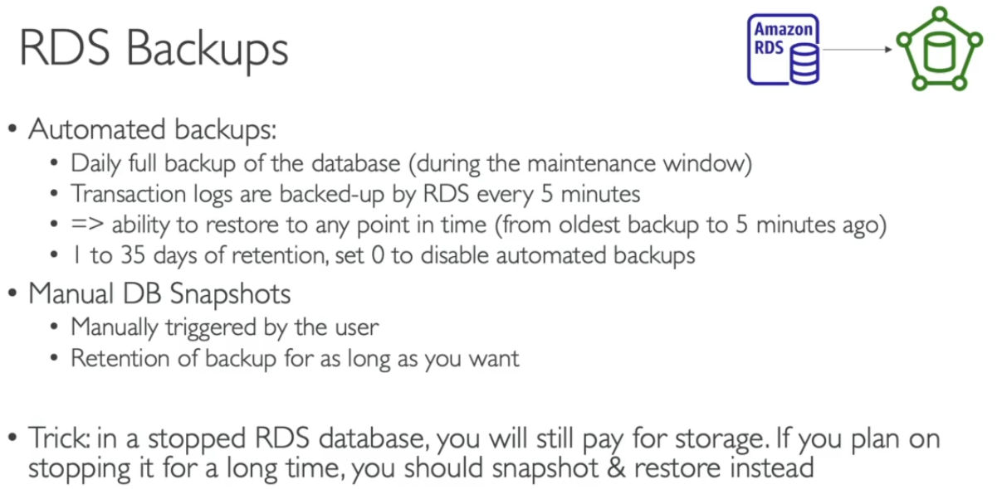 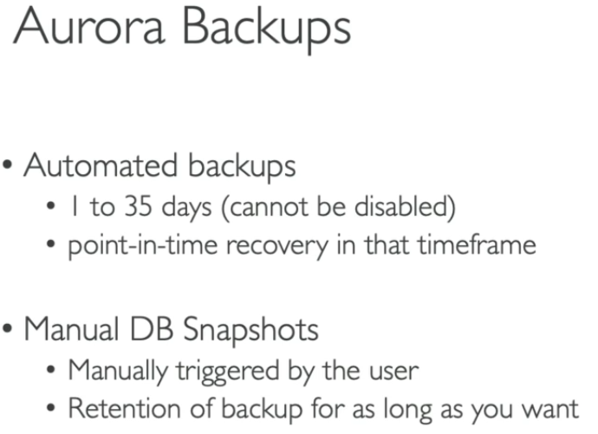 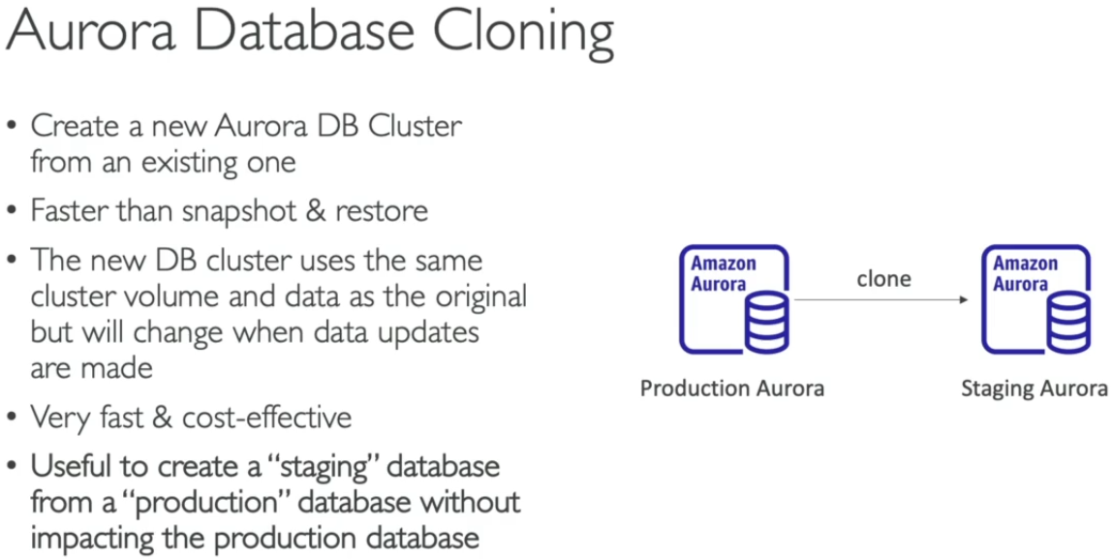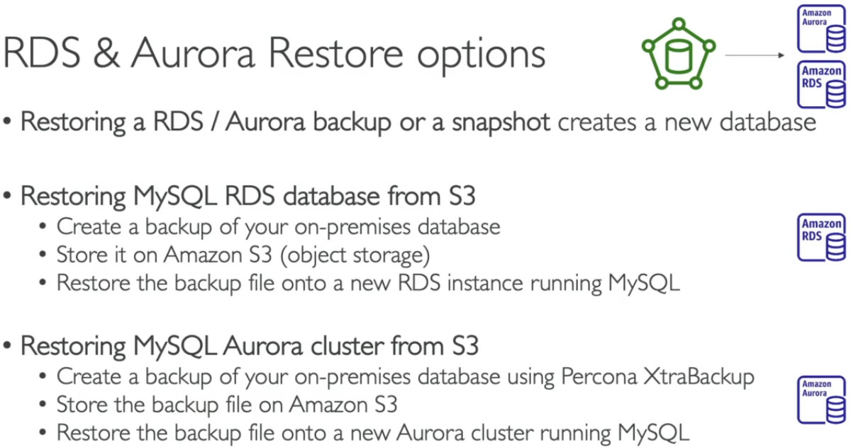 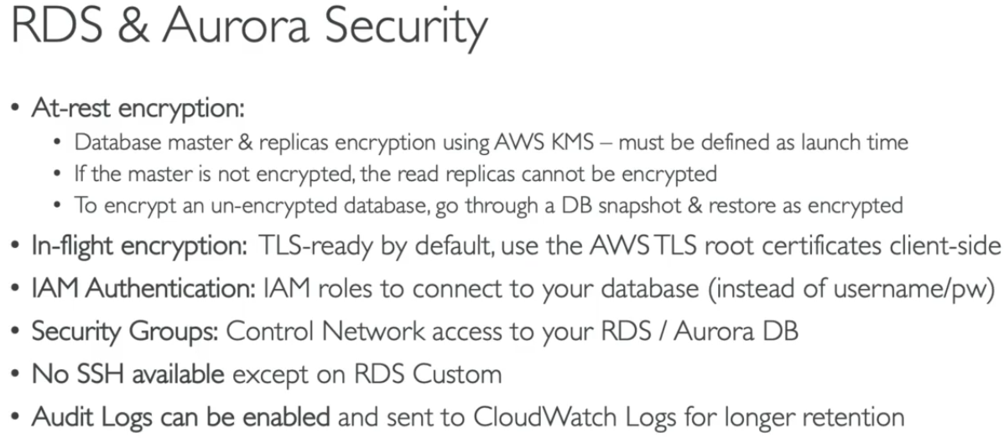

**>>> Amazon RDS Proxy –**

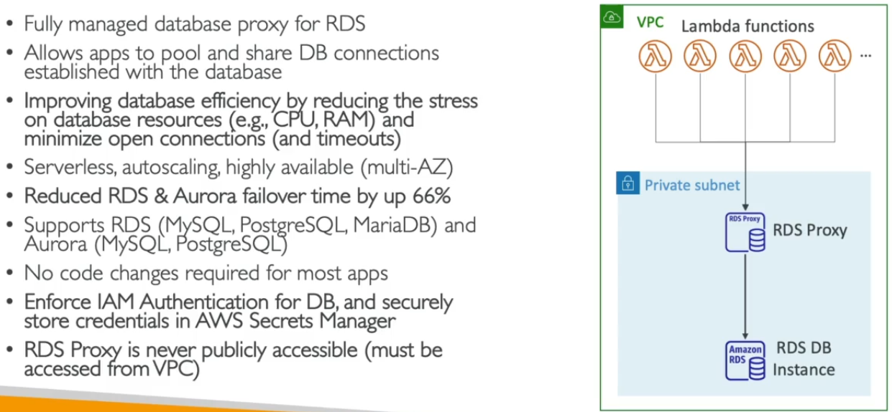

**2. Elastic Cache –** (It is to manage Redis / Memcached- involves heavy application code changes)

* Caches are in memory DB with high performance & low latency.
* Reduce load of RDS DB and helps to make application stateless.
* AWS controls OS maintenance/patching/optimization/setups/confg./monitoring/failure recovery/backups.

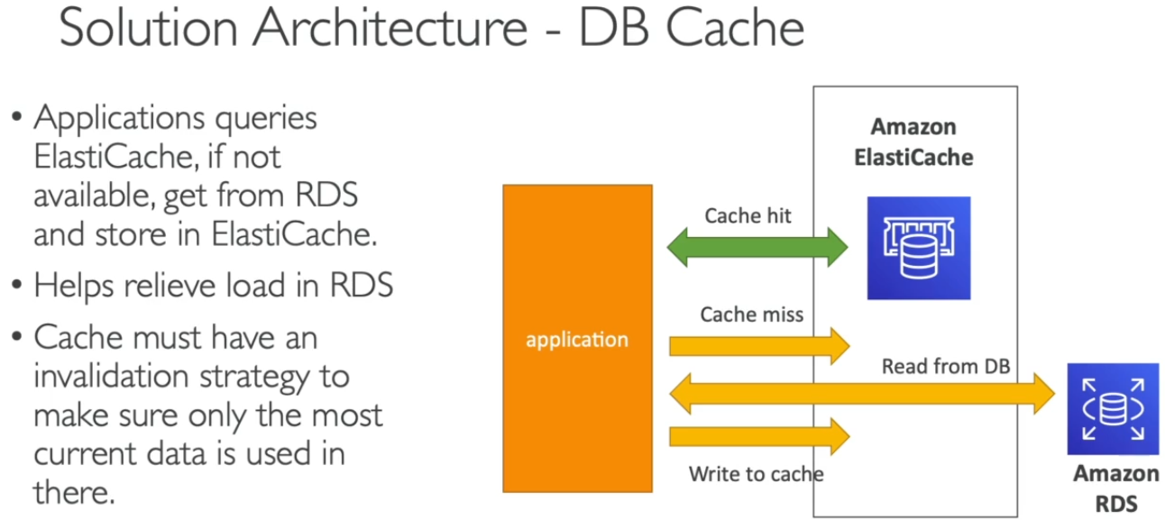 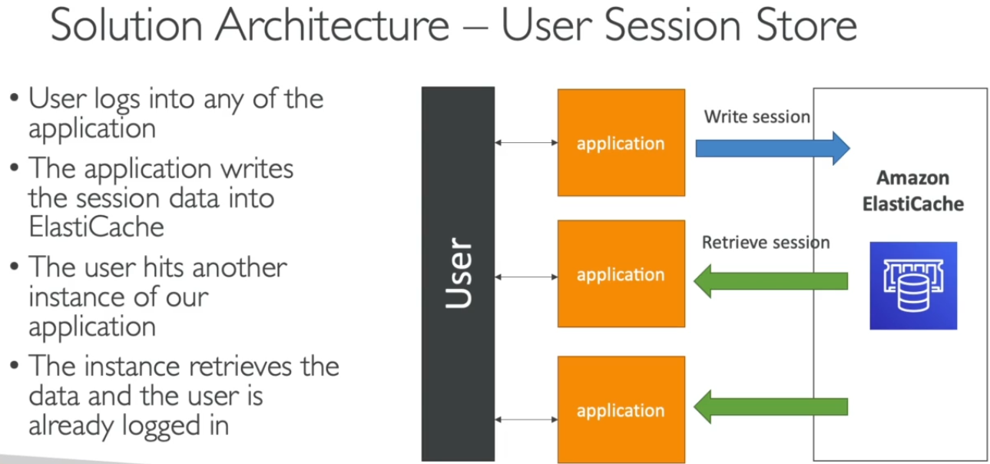

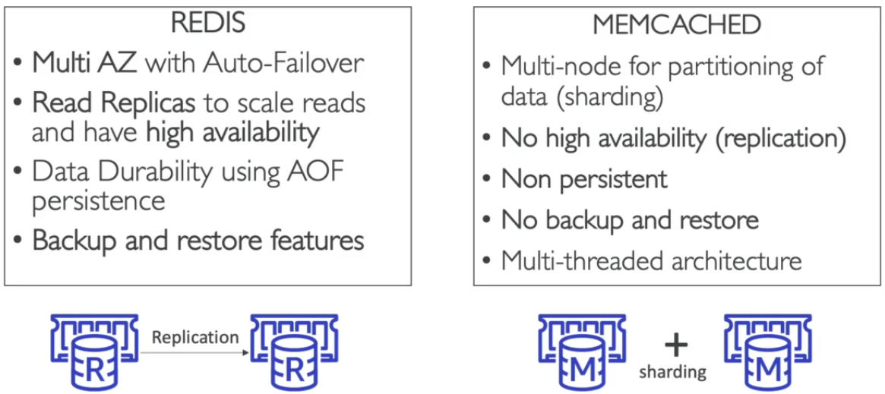 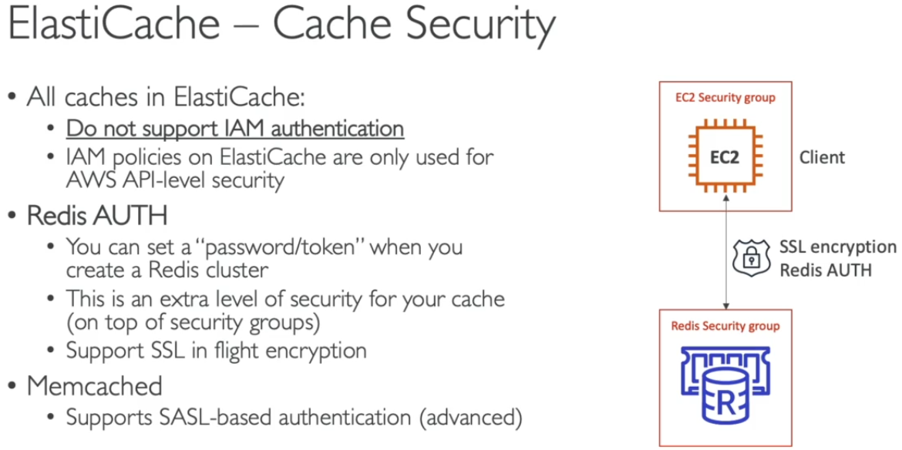

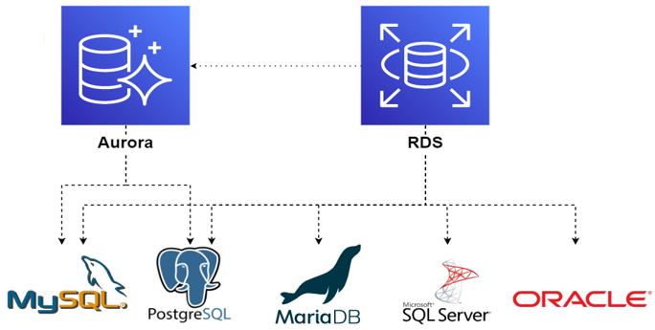

**>>> Choosing a correct Database for services – (Database Types)**

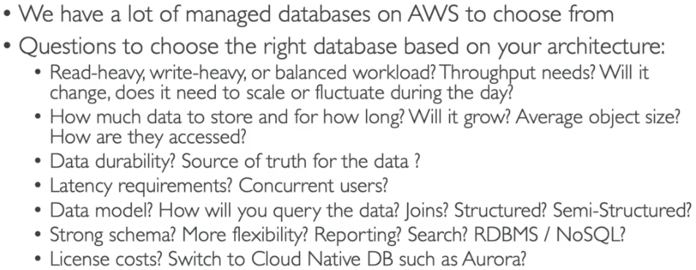 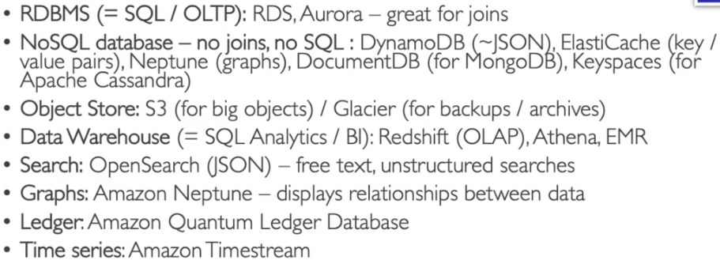

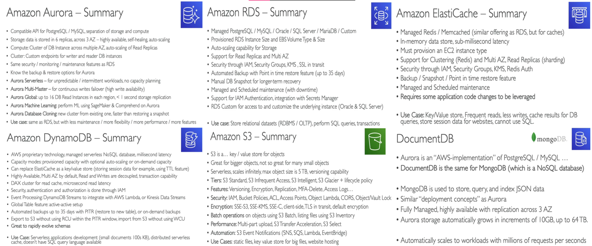

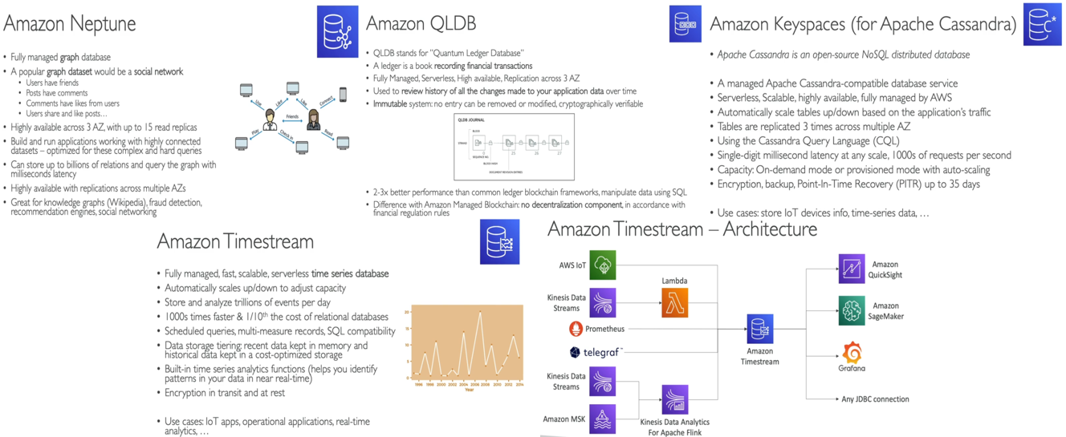

**# Amazon Route 53 – (Domain Registrar)**

* It is highly available, scalable, fully managed Authoritative DNS (user can update DNS records)
* 53 is traditional DNS port > Route 53
* **DNS Servers** – (Domain Name System servers – Backbone of internet)

1. Translates domain names to machine IP Address (eg. [www.google.com](http://www.google.com) > 172.217.18.36)
2. DNS terminologies -

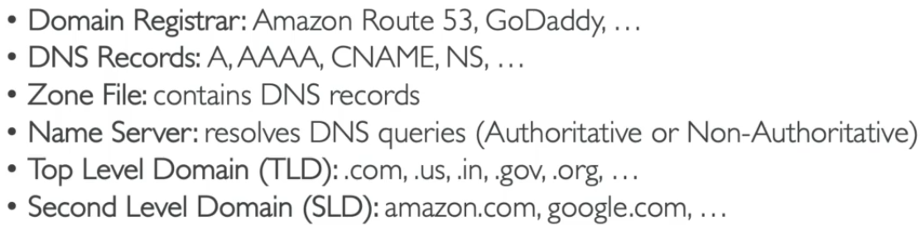 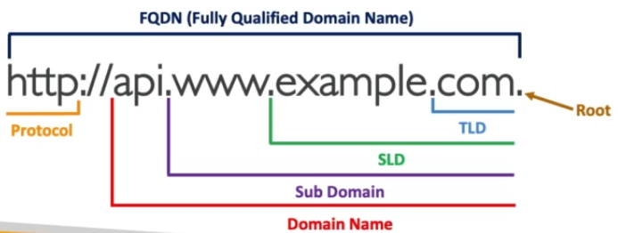

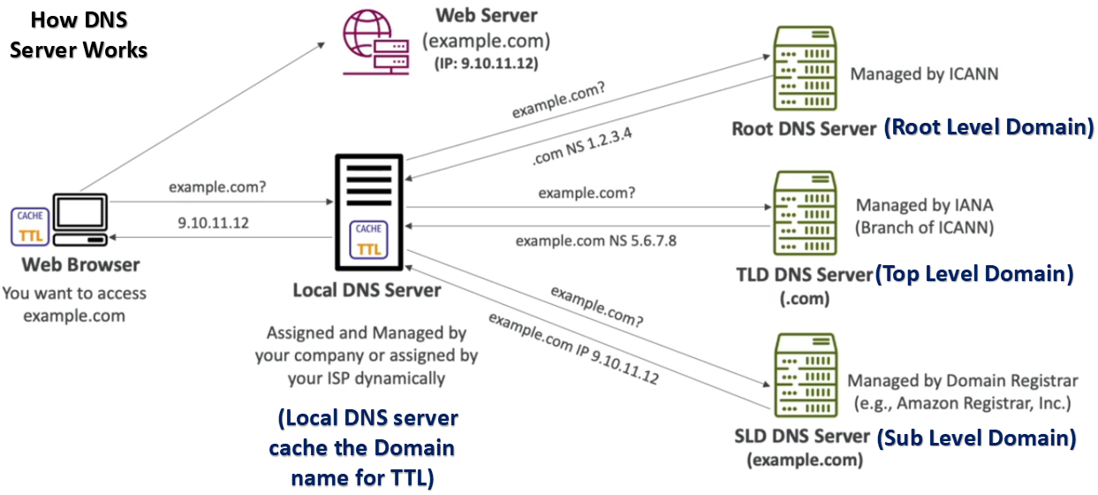

* **Route 53 Records** – How to route a traffic for a domain.
* Creation of domain names costs $12 per year.

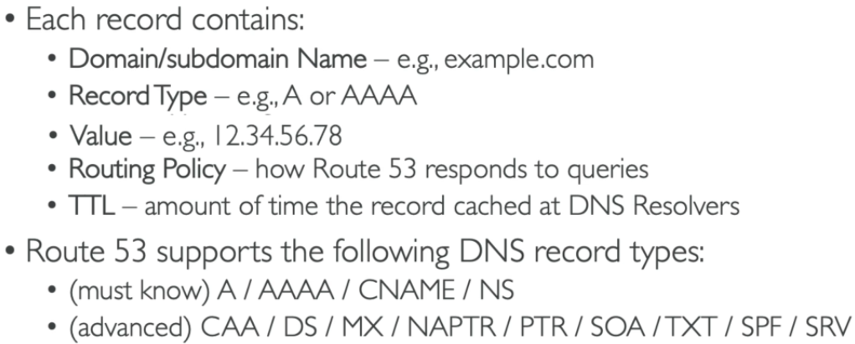 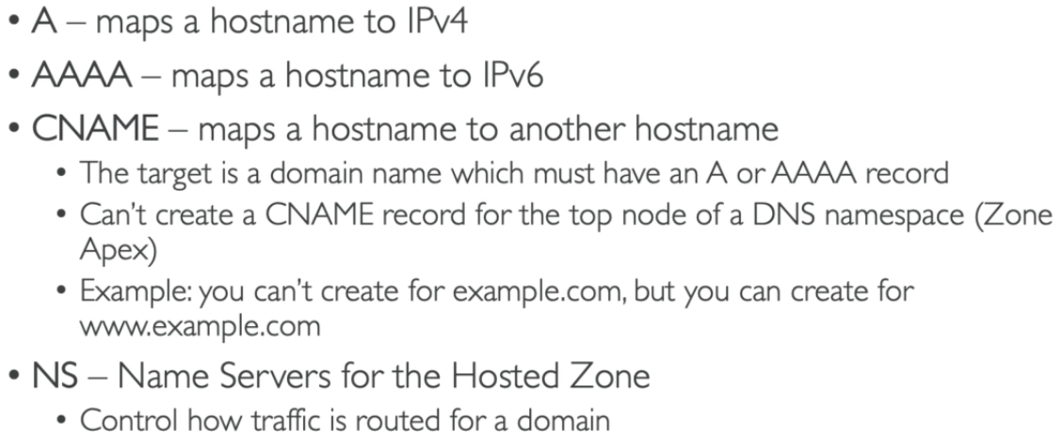

>>> Amazon Route 53 Hosted Zones –

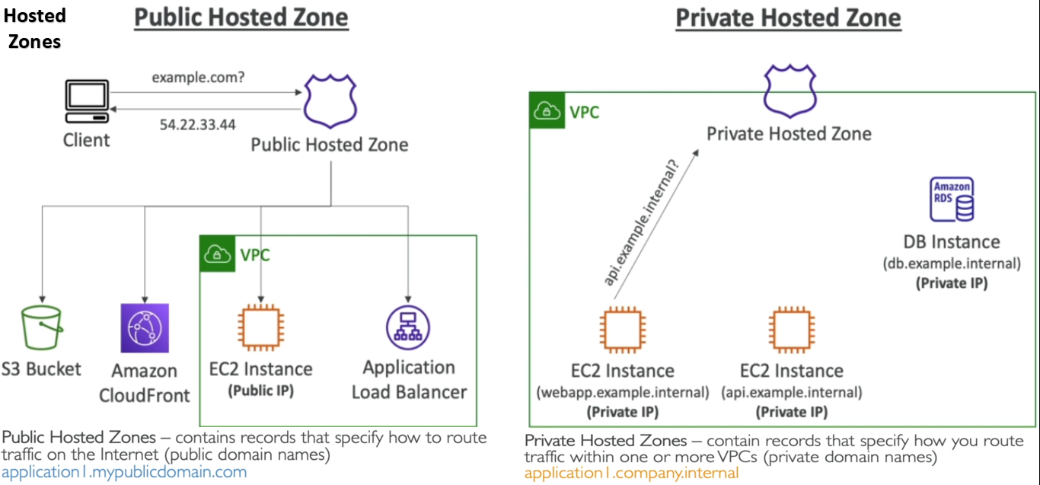

>>> Amazon Route 53 – Records TTL (Time to Live) –

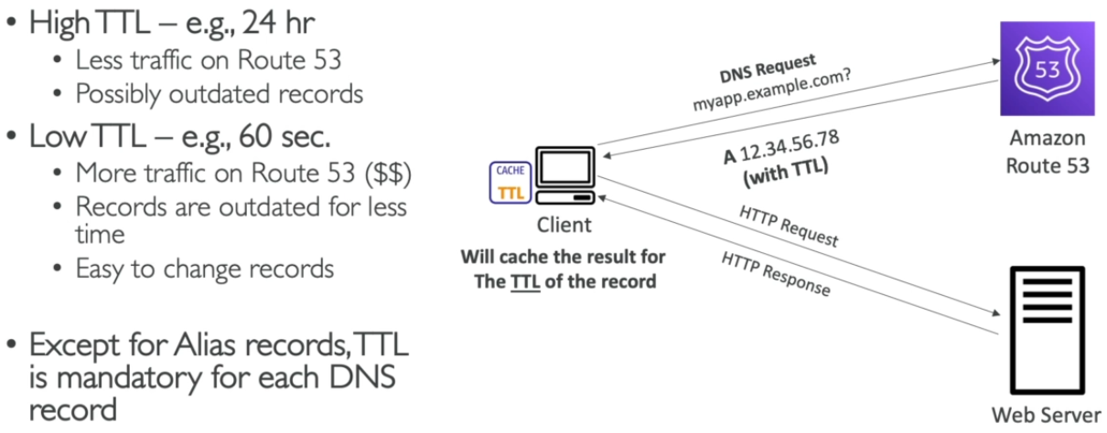

>>> Amazon Route 53 – CNAME and Alias Records –

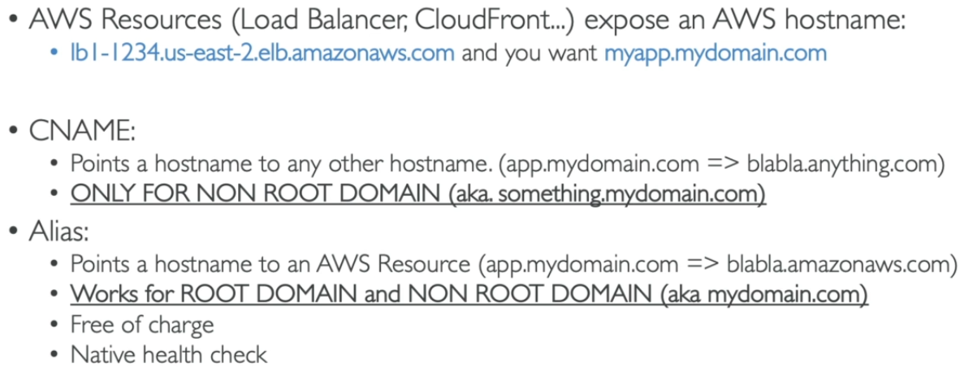

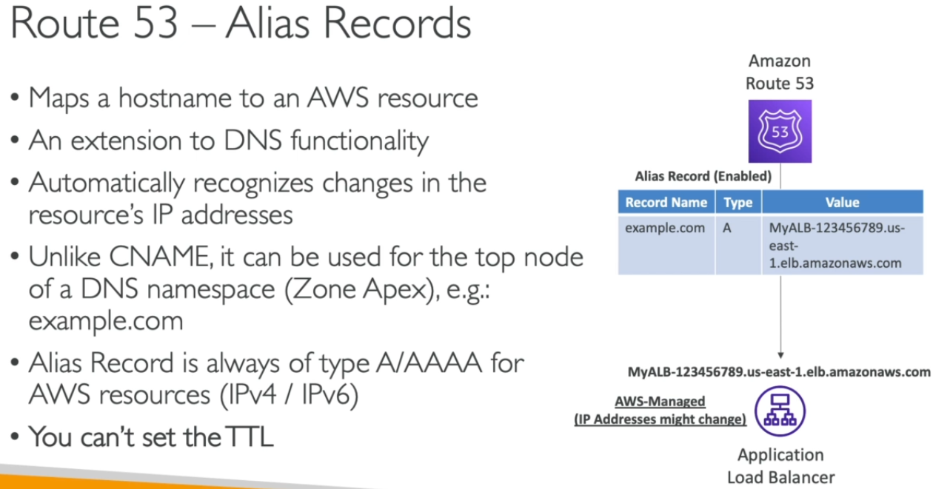 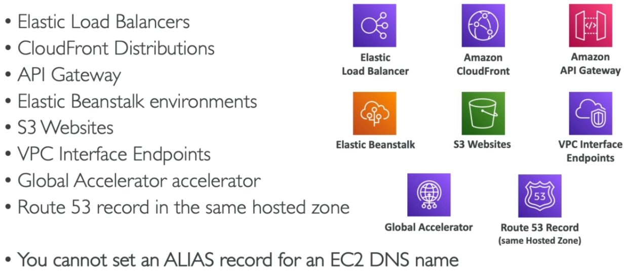

**1. Route 53 – Routing Policies –**

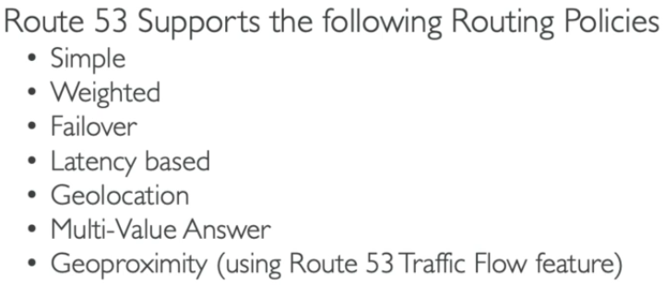 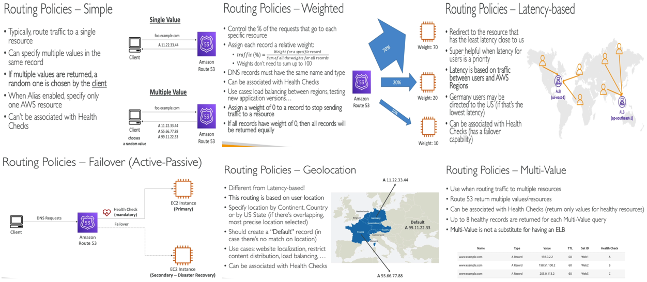

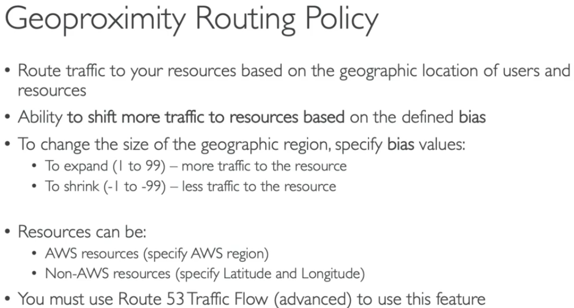 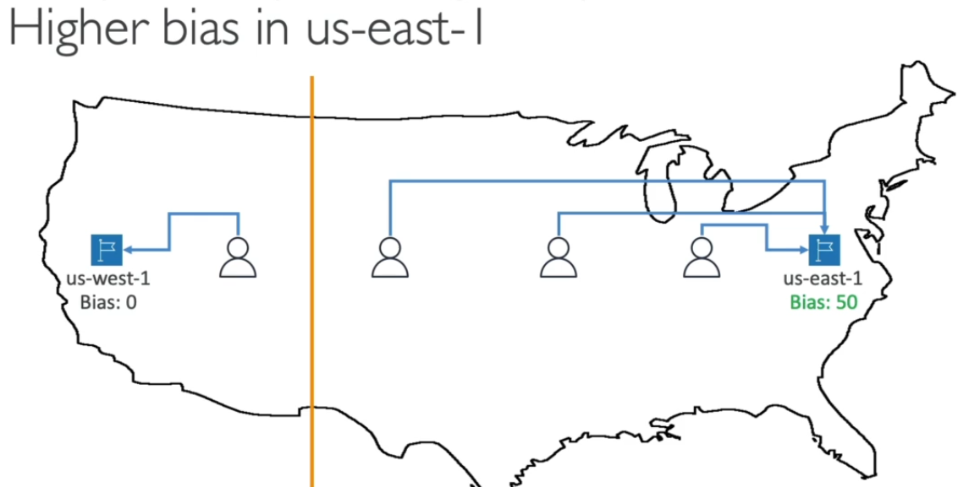

**2. Route 53 – Health Checks –**

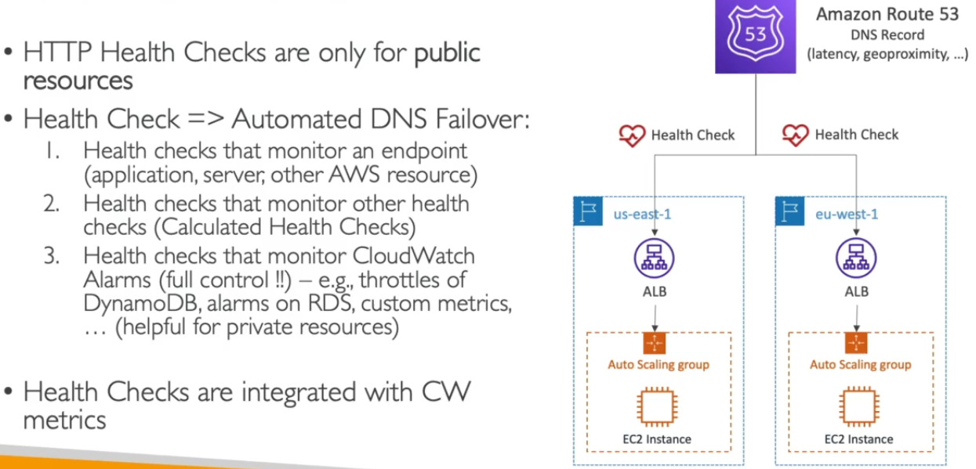 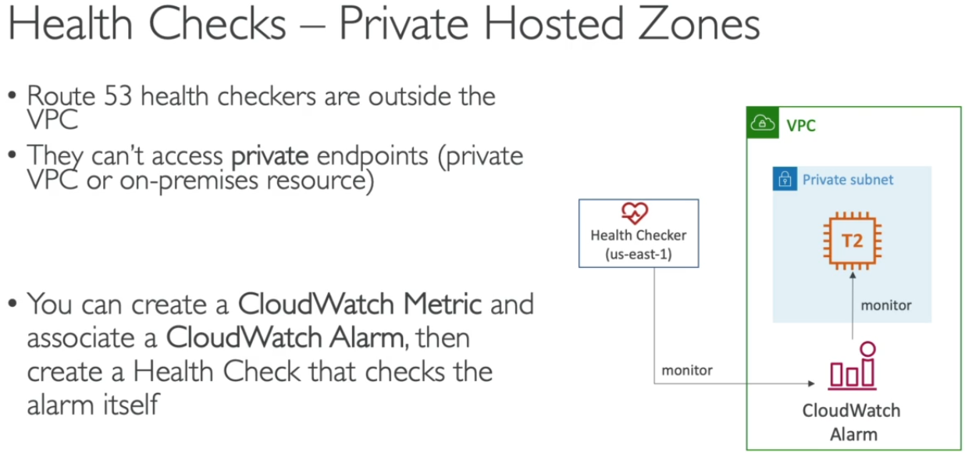

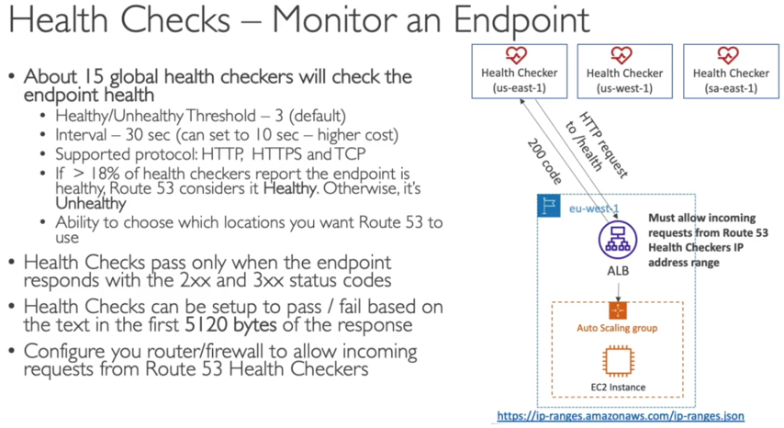 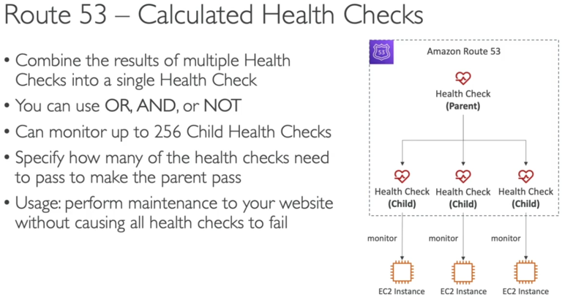

>>> Domain Registrar vs. DNS service –

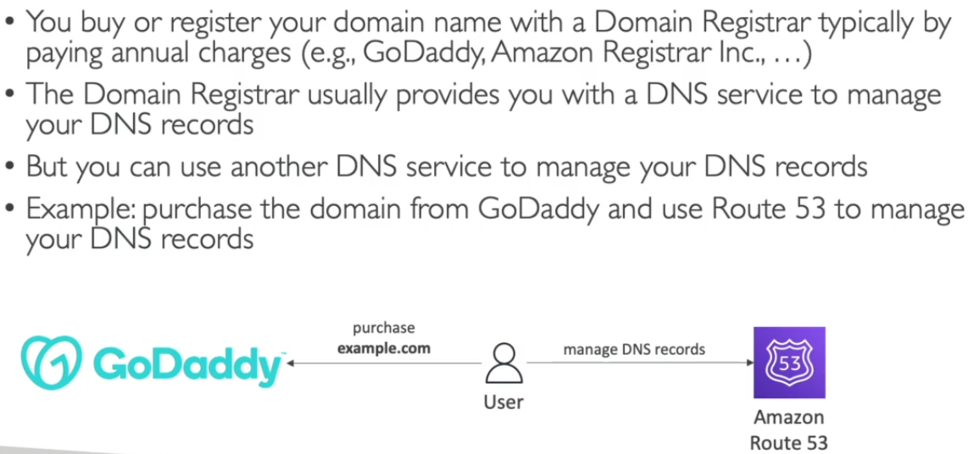 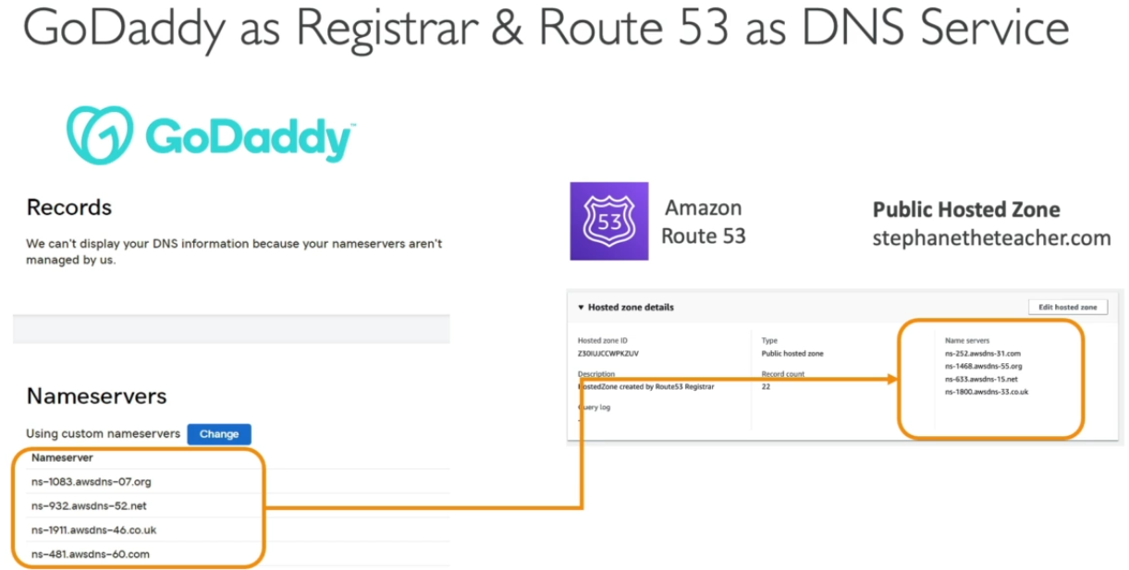

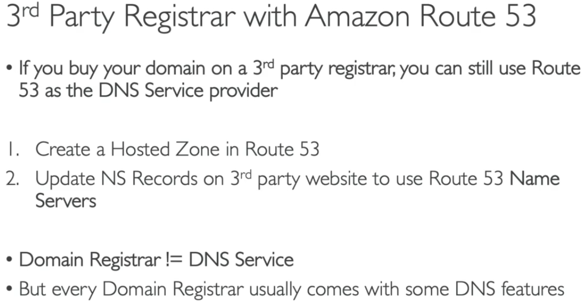

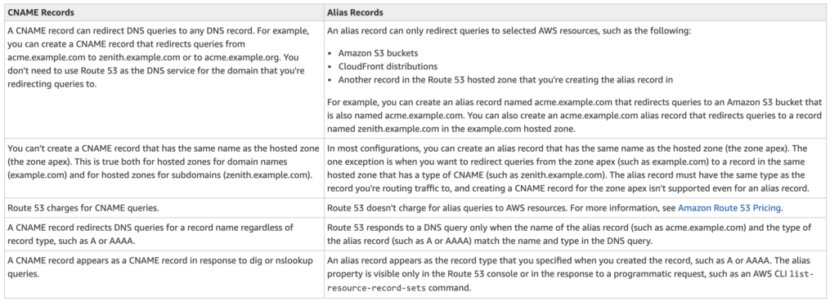

**# Amazon VPC (Virtual Private Cloud) - VNet**

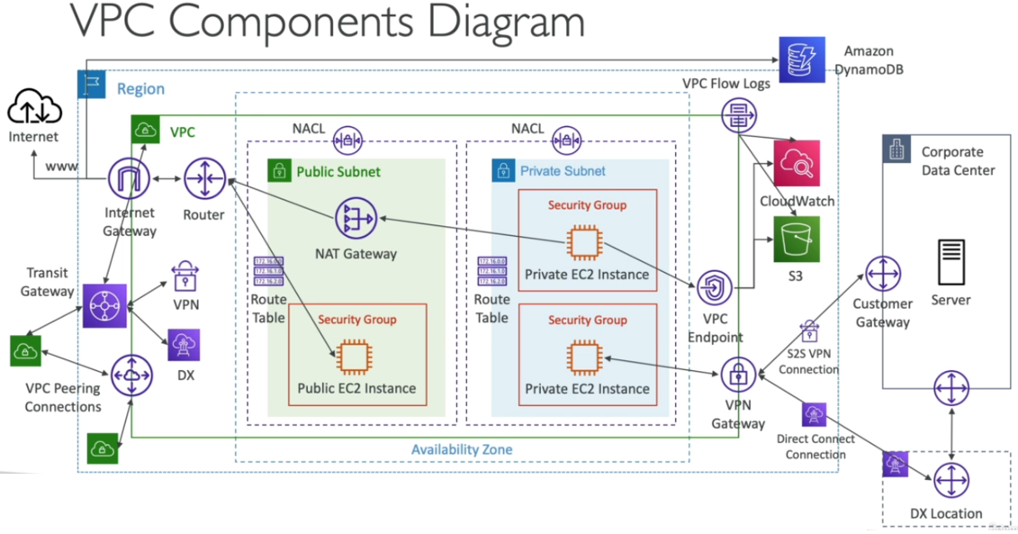

**1. CIDR (Classless Inter-Domain Routing) and IP Ranges – (Sub netting)**

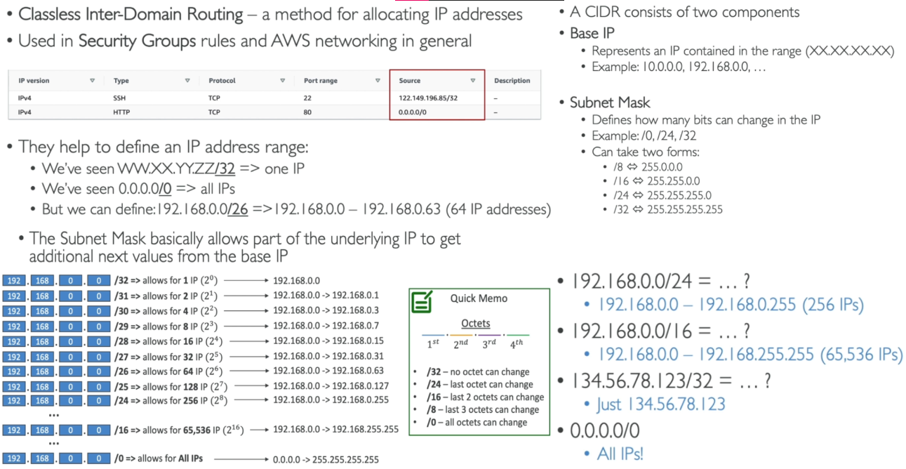

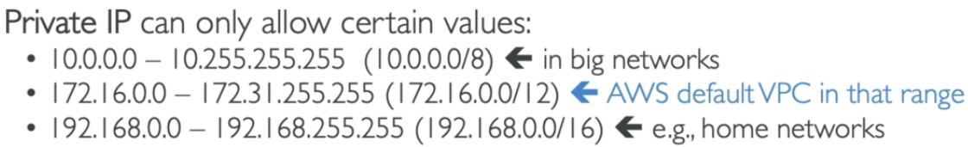

**CIDR to IP Conversion and vice versa -** <https://www.ipaddressguide.com/cidr>

* Multiple VPC can be managed by AWS account (max. limit of VPC is 5 per region)
* Maximum 5 CIDR can be there in one VPC – Min [/28 – 16 IPs], Max [/16 – 65536 IPs]
* Public IP we can’t manage – only private IPs we can manage.
* Default VPC of AWS account is not recommended to use.

>>> VPC Subnet – [Default nature of all subnet is private – we make them public using IGW]

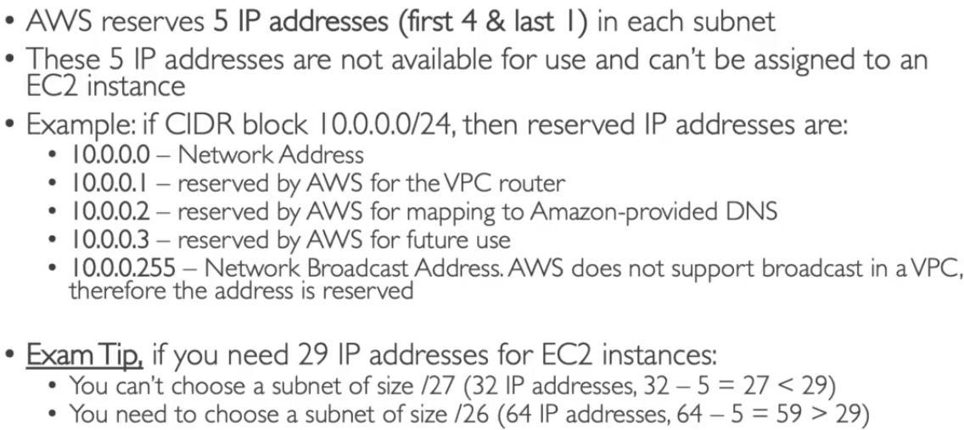 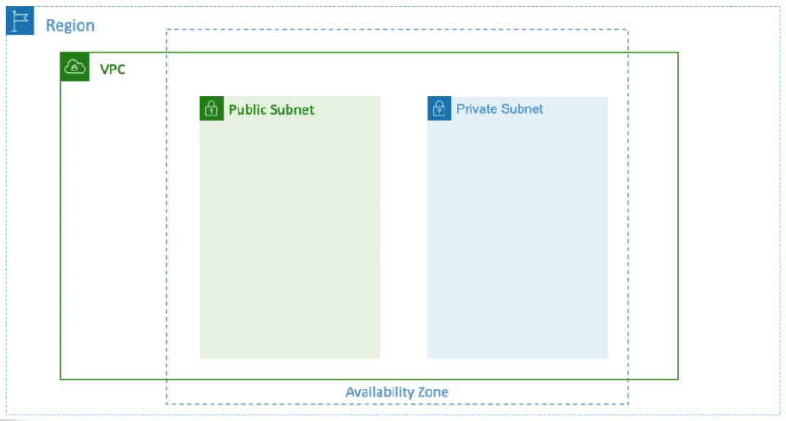

* From one CIDR range multiple subnets can be created.
* In VPC only private IP range is allowed and VPC CIDR must not overlap with other CIDR range.
* In each subnet 5 IPs (4 from start+1from end) are reserved by AWS and Subnets can be shared with other subnet.
* **All subnet in a VPC can communicate with each other.**
* **Public/Private subnets – (public subnet have access to IGW through RT and contains NATGW)**
* **No public IP are required in private subnet instances.**

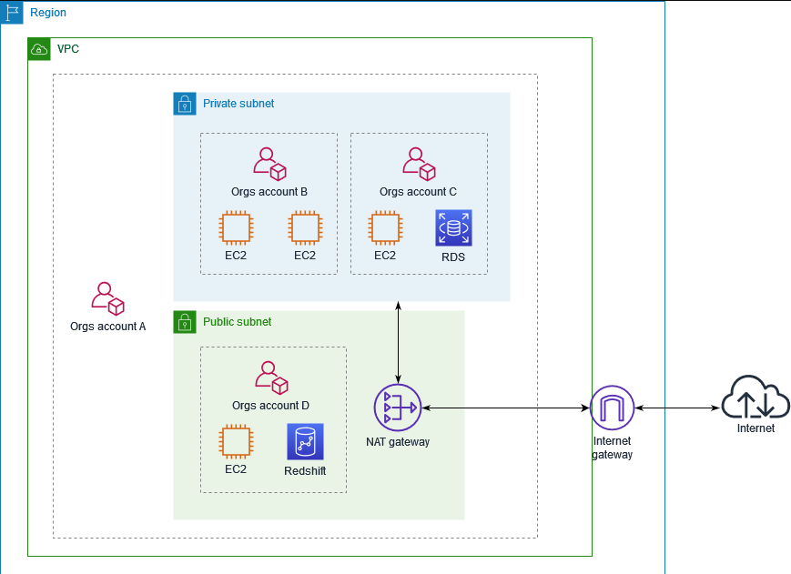 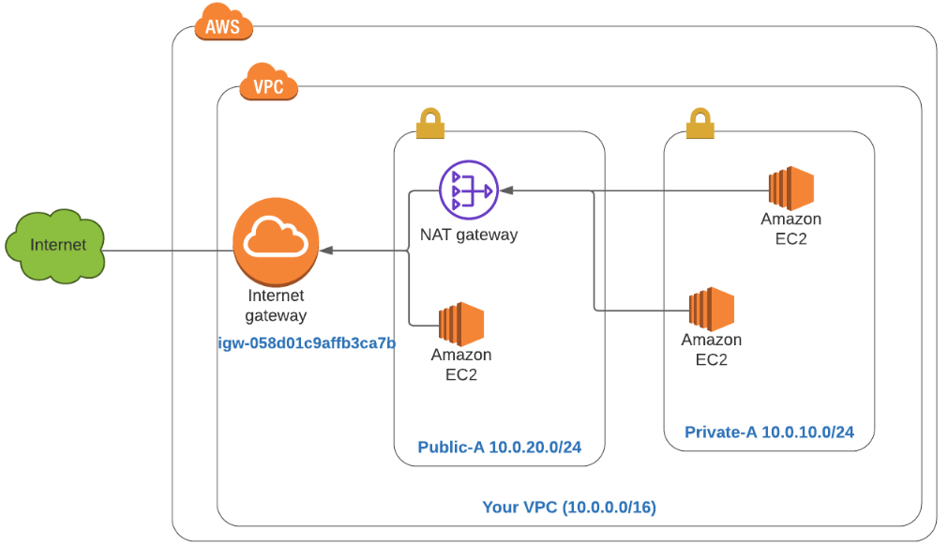

>>> Route Tables – [Used to route traffic of VPC- perform central routing function]

* By default main route table is created.
* 200 RT can be assigned per VPC and each RT can have 50 Routes.
* Each IGW and NATGW must be associated with subnets using RT.

>>> IGW (Internet Gateway) – [Used to provide internet connection to VPC]

* Initially No VPC or Subnet have internet access, for this we’ve to use IGW.
* IGW will make use of Router Table to route all traffic as per requirement.
* For each VPC route table will be created automatically – not use recommended

**Internet > IGW > Router > Router Table > EC2 Instances**

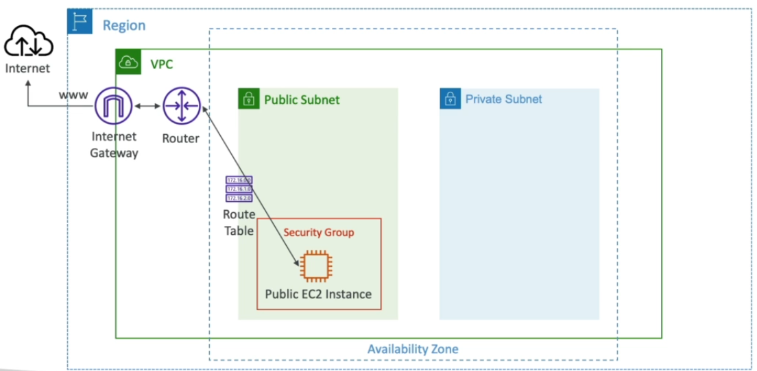 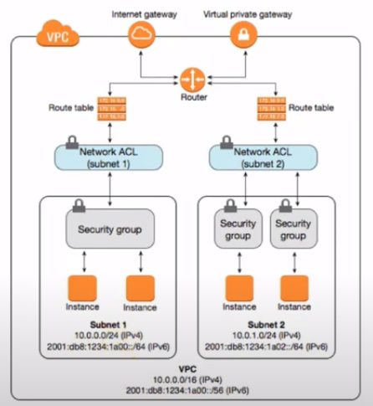

**Create VPC > Create Subnets (Private/Public) > Start EC2 with VPC and Subnet (No Internet Conn.) > Start IGW & attach VPC > Create Route tables for Private/Public & assign subnets > Link route table to IGW (Internet Conn.)**

>>> Bastion Hosts – (It’s a simple VM Used to access Internet in private Subnet)

* EC2 Instance of public subnet can be used as **Bastion Host** to SSH into Private Subnet.

**Process: Create new EC2 with VPC & public subnet > Select SG of public subnet EC2 > start CLI of bastion host > SSH to private IP using key-pair (pem format) > connection done but (No Internet Conn.)**

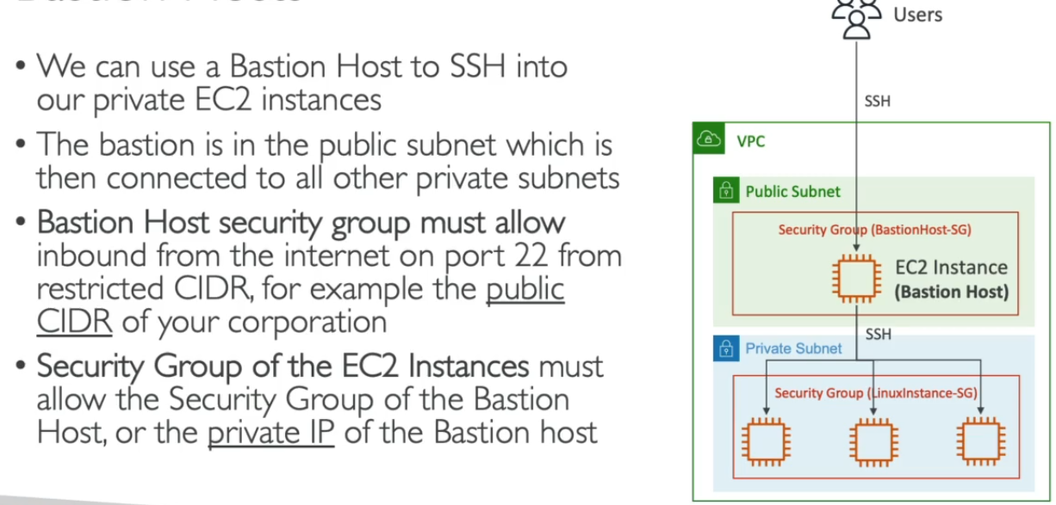 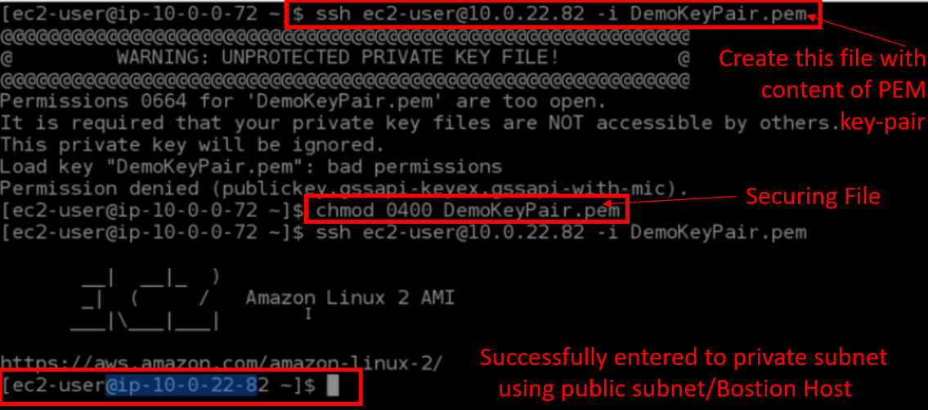

**2. NAT Instances (Network Address Translation) – (Allows Private Subnets to connect to Internet) Most costly service**

* NAT Instances must be launched in public subnet (Source/Destination check must be disabled)
* It must have Elastic IP attached to it.
* Route table must be configured to route traffic from private subnet to NAT instances.

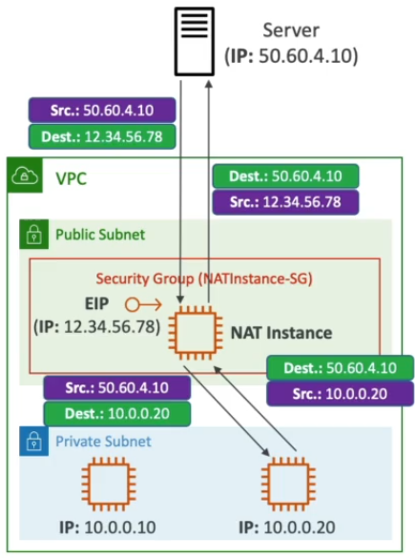 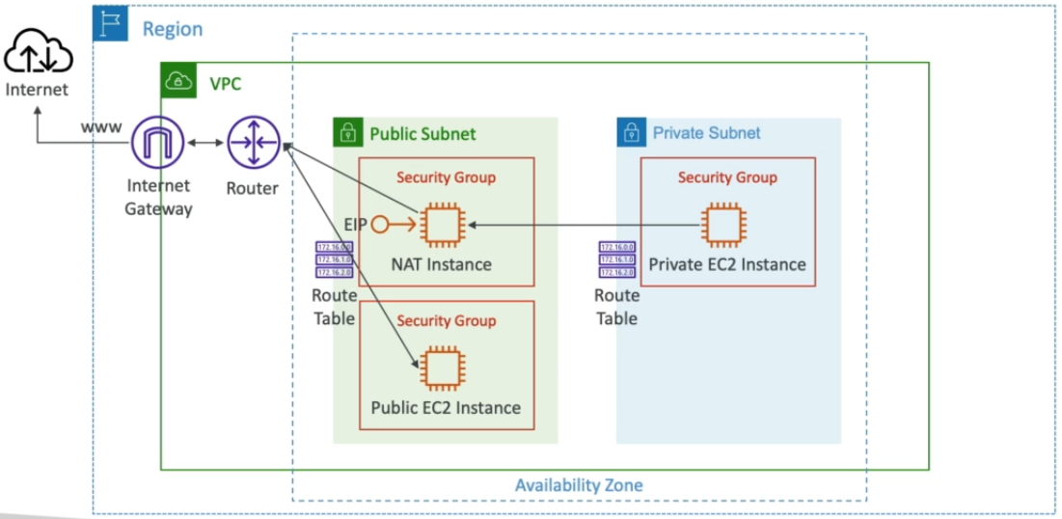

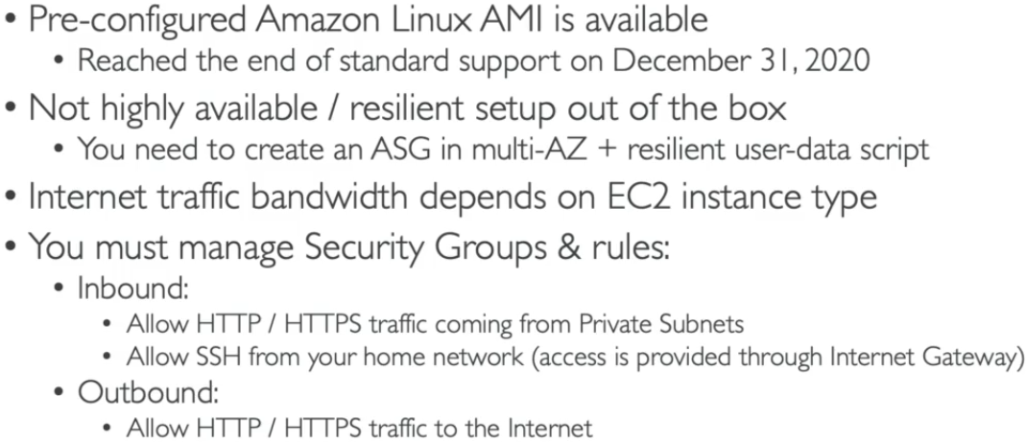

**Process: Create new NAT instance by searching ‘Nat’ on console > choose AWS AMI > select VPC & Public subnet > add SG with SSH + HTTP/HTTPS access with source VPC CIDR > done > Stop source/destination check**

**Connect to public subnet/Bastion Host (as above-No Internet Conn.) > Set NAT instance in private route table for anywhere > in NAT instance SG add ‘ALL ICMP – IPv4’ inbound rule for VPC CIDR > (Internet Conn.)**

>>> NAT Gateways – (NATGW)

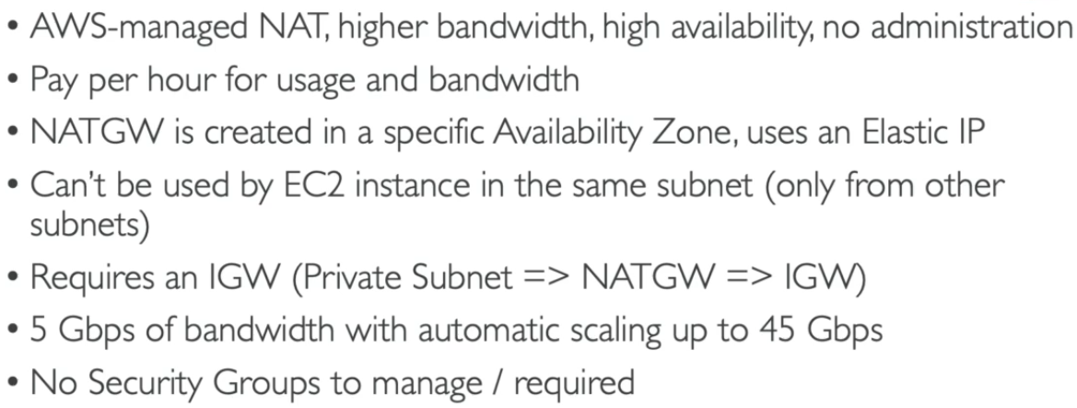 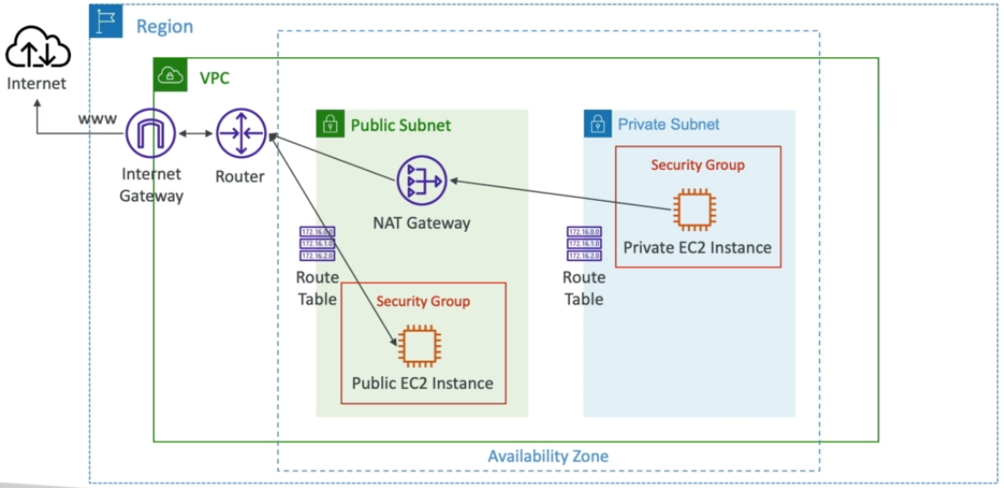

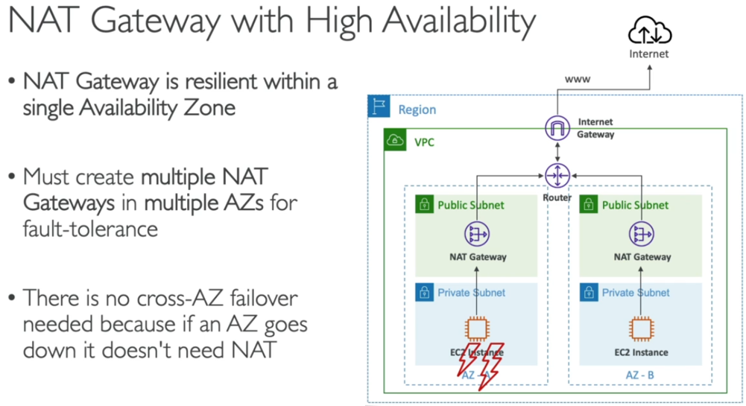 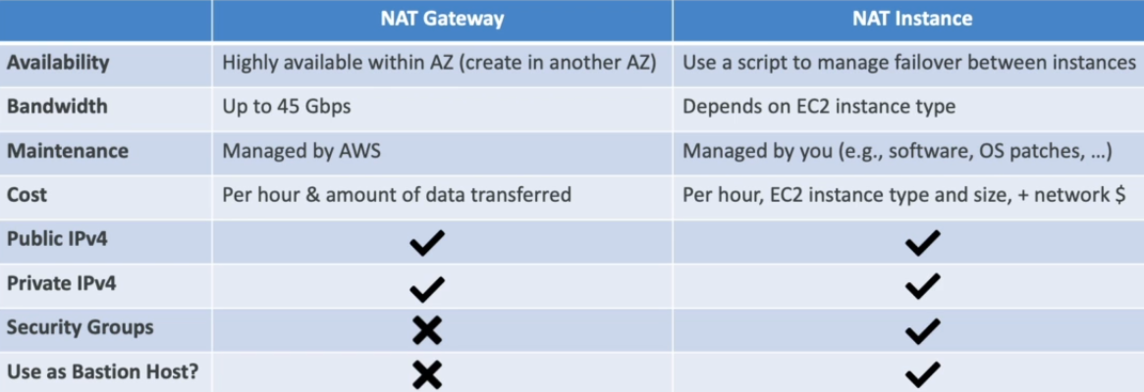

**Process: Create new NATGW > choose Public Subnet > Allocate Elastic IP > done > Edit private route table and select NAT GW instead of NAT Instance > select VPC & Public subnet > (Internet Conn.)**

**3. Security Groups and NACL (Network Access Control Lists) - (Allows and control network traffic -firewall)**

* NACL are Stateless (checks at every transition) and SG are Stateful (checks only once- inbound/outbound)
* Each subnet is associated with separate NACL.
* NACL are like firewall – control traffic To and From Subnets (One NACL/Subnet- **default allow any in/outbound**)
* NACL Rules –
  + Rules have numbering from (1-32766), lower no. will have high precedence
  + **First rule match will drive the decision -** if you define #100 ALLOW 10.0.0.10/32 and #200 DENY 10.0.0.10/32, IP address will be allowed because 100 has a higher precedence over 200.
  + The last rule is an asterisk (*) and denies a request in case of no rule match.
  + AWS recommends adding rules by increment of 100 + newly created NACLS will deny everything.
  + 1 NACL can be associated with multiple subnet but subnet cannot be associated with multiple NACL.

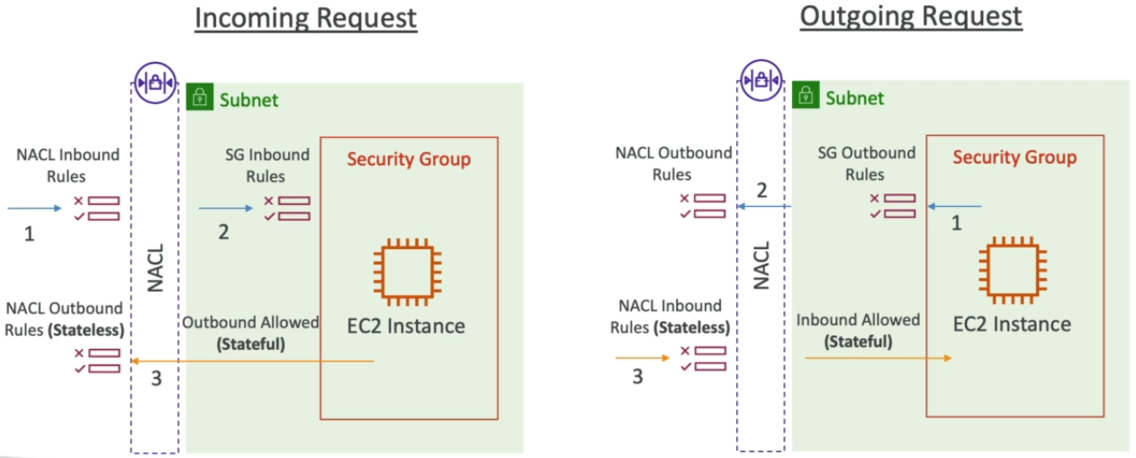 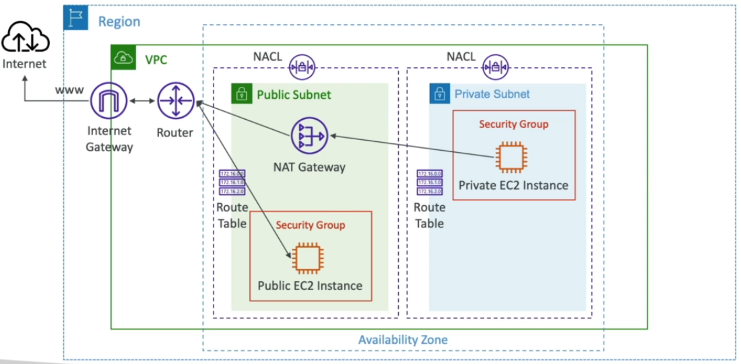

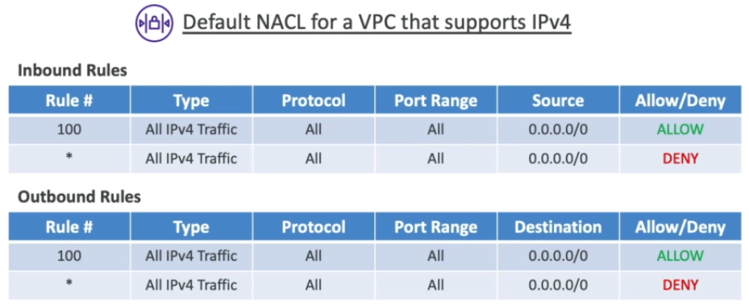

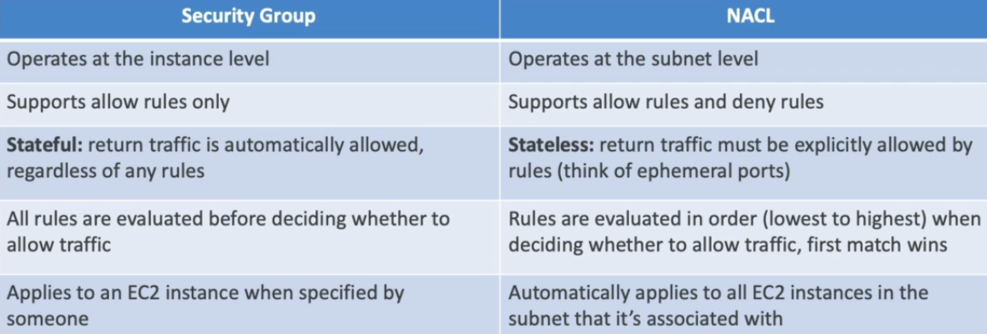

>>> Ephemeral Ports – (Used for client-server connection)

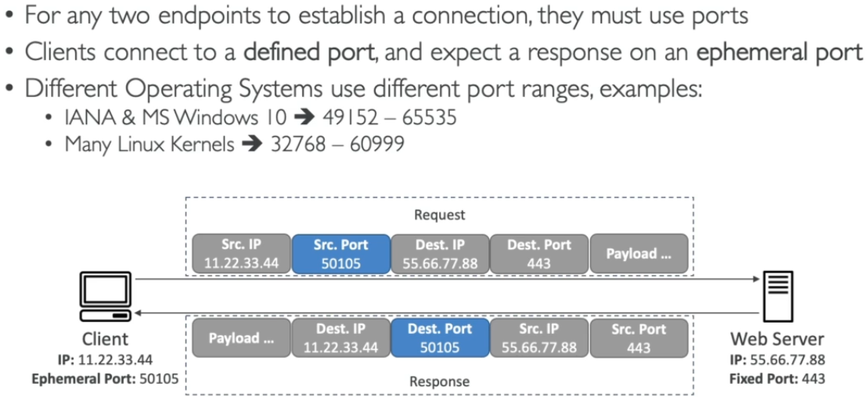 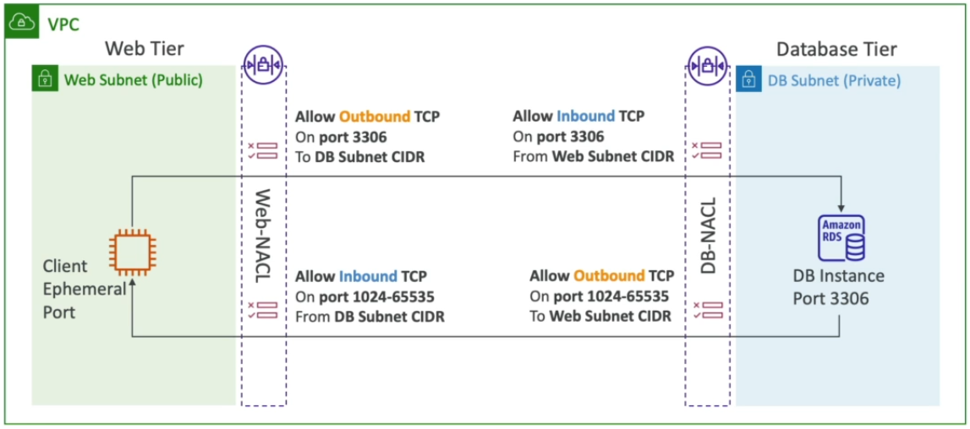 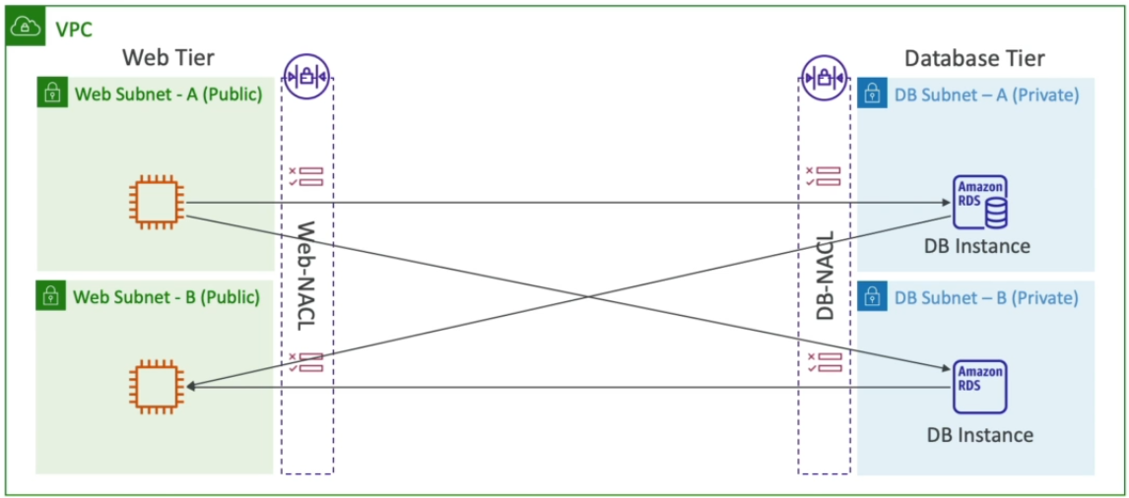

* Port range [1024-65535] is assigned in NACL for communication.
* If due to any reason HTTP port-80 is not functional of any webserver – AWS NACL will assign new port from this range & communication will be working fine.
* **NACL Rules for RDP + Http services.**

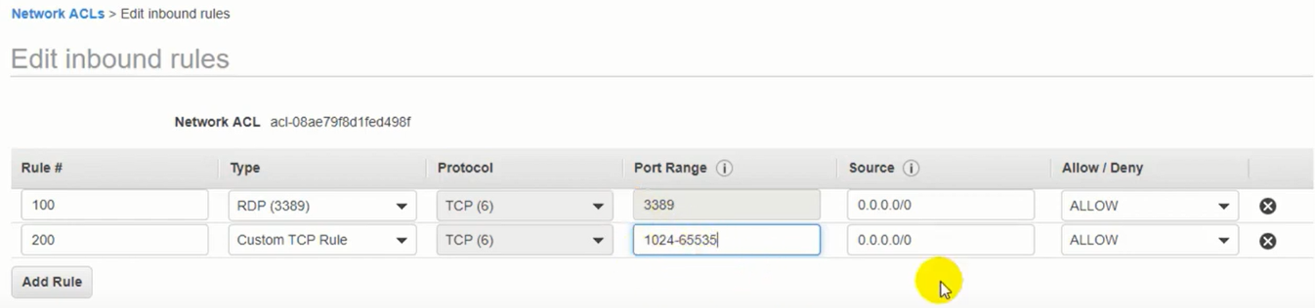

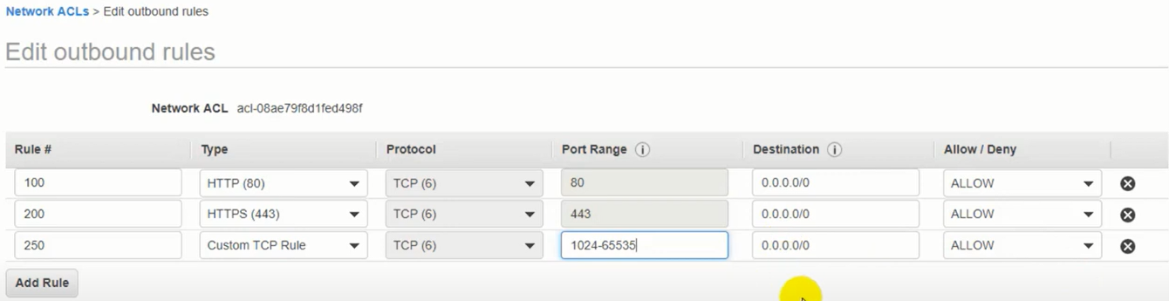

**4. VPC Peering / Endpoints / Flow Logs -**

>>> VPC Peering - (Used to connect multiple VPC using AWS – as same network)

* All VPC must have different CIDR (with overlapping CIDR VPC Peering can’t be done)
* Communication can be done using private IP b/w two VPC.
* Route table must be updated of each VPC to communication with each other.
* VPC Peering can be done between **VPCs in different AWS account/regions.**
* SG of a VPC can be referenced in peered VPC – **to work across accounts of same region.**

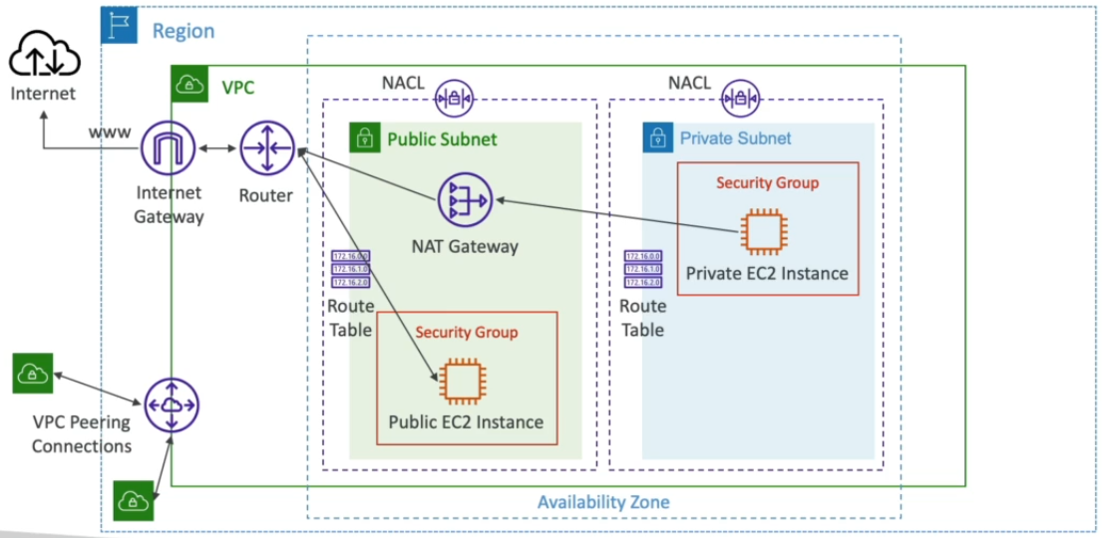 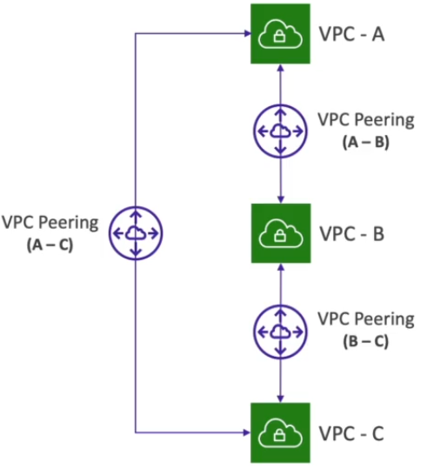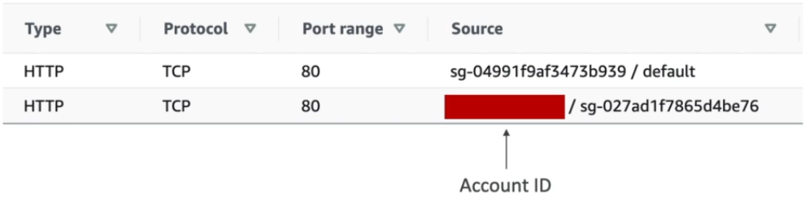

**Process: Create VPC Peering > Select account & region > Select requester VPC & accepter VPC > done > accept request > make changes in route table of each VPC (VPC CIDR to peer-connection) > (VPC Conn. OK)**

>>> VPC Endpoints - (Used to connect to AWS services using private network – as same network)

* These are redundant and scale horizontally.
* With these there is no need of IGW or NATGW
* **In case of any issue:** Check DNS setting resolution + Route Tables

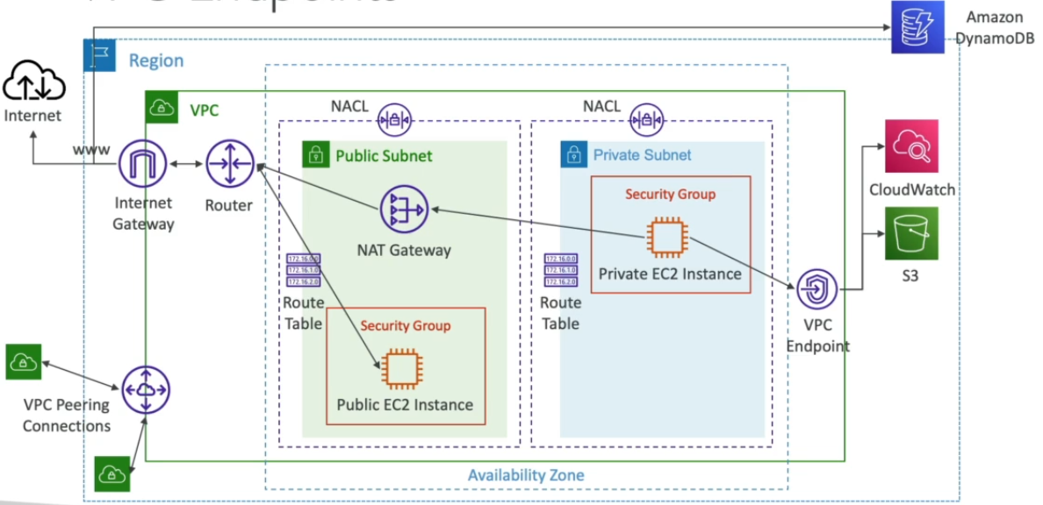 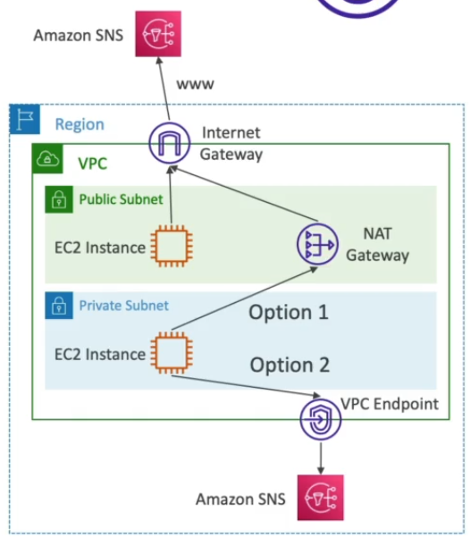

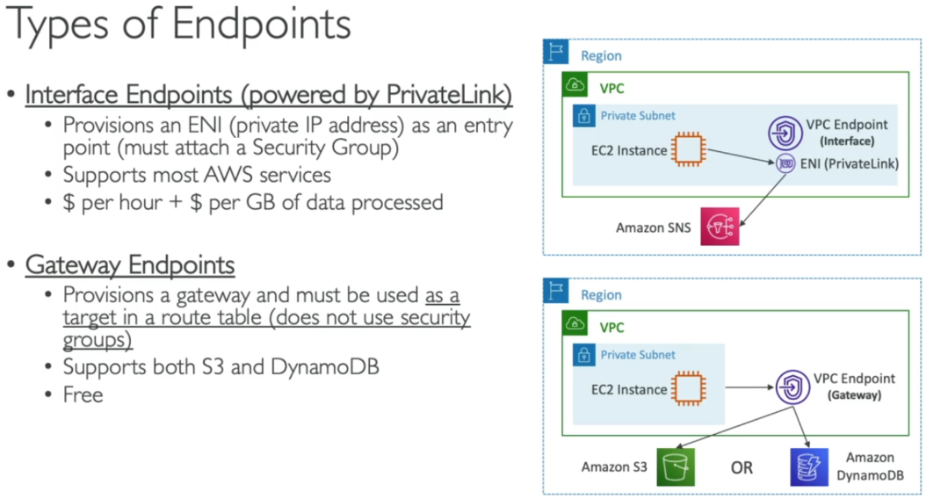 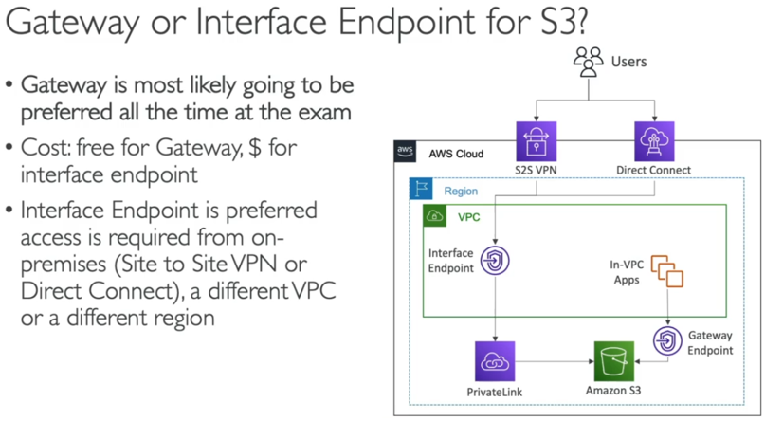

>>> VPC Flow Logs - (Used to capture info. Of IP traffic going into interfaces – VPC/SUBNET/ENI Flow Logs)

* Helps to monitor/troubleshoot connectivity issues. (log data > cloud watch or S3 bucket)
* Captures network info of – ELB, RDS, Elastic cache, redshift, workspaces, NATGW, transit GW……
* Syntax -

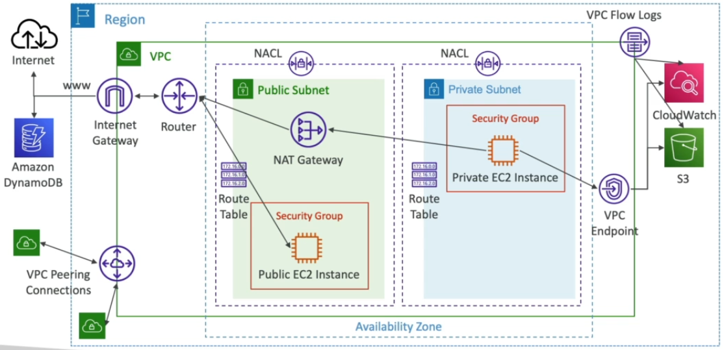 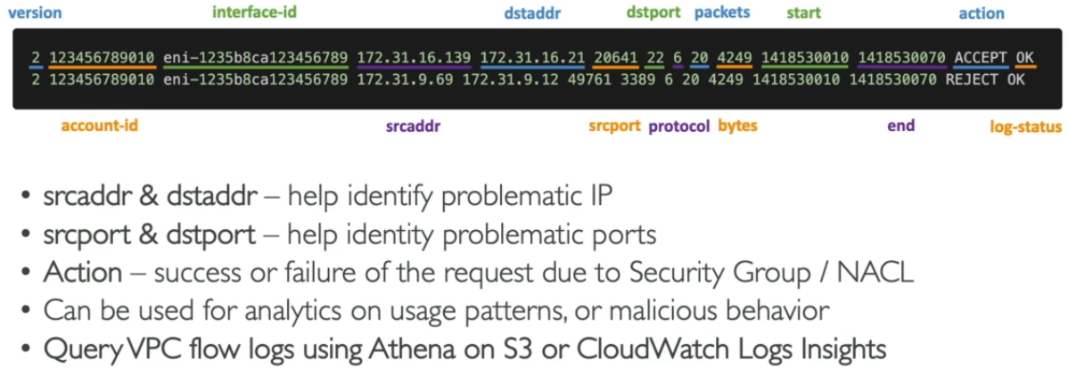

* Troubleshooting SG & NACL Issues + VPC Flow log architectures –

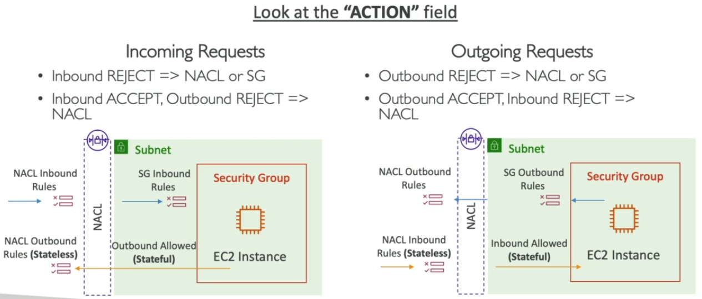 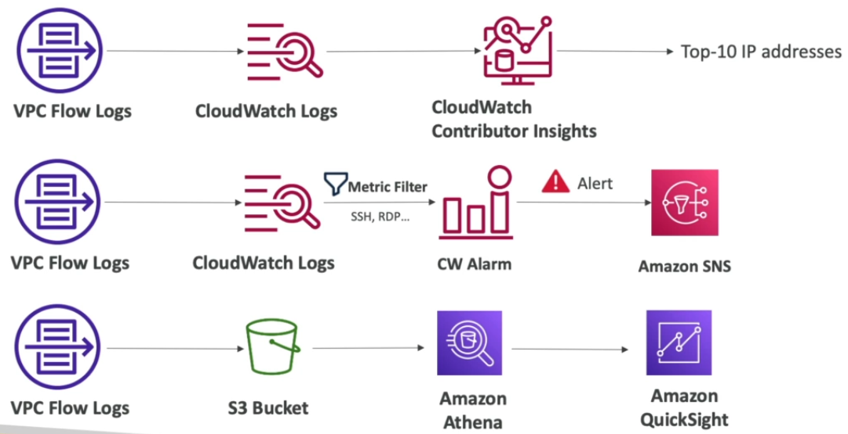

**5. Site to Site VPN / DX (Direct Connect) Connection –**

>>> Site to Site VPN Connection - (Used to connect to Data Center through virtual private network)

* This connection make use of-
  + VGW (Virtual Gateway): At AWS side VGW is created and attached to VPC of interest.
  + CGW (Customer Gateway): Software application/physical device at customer side.

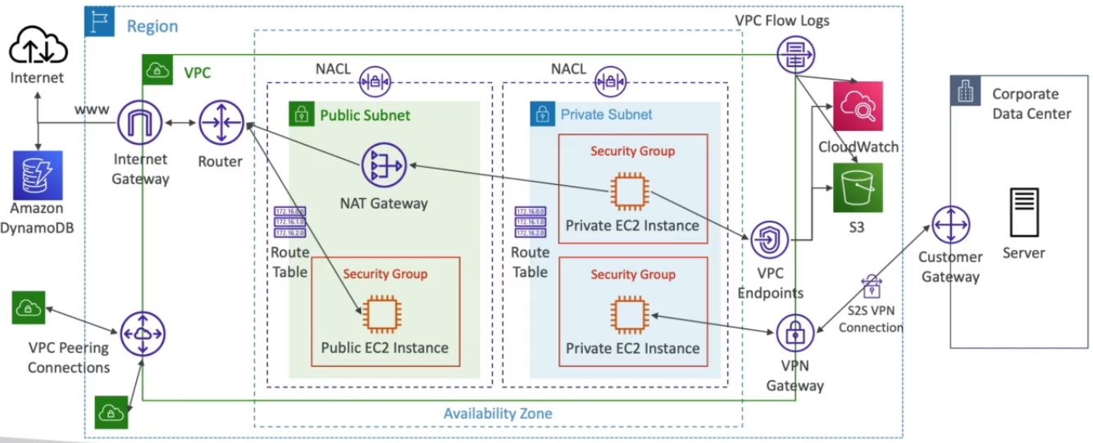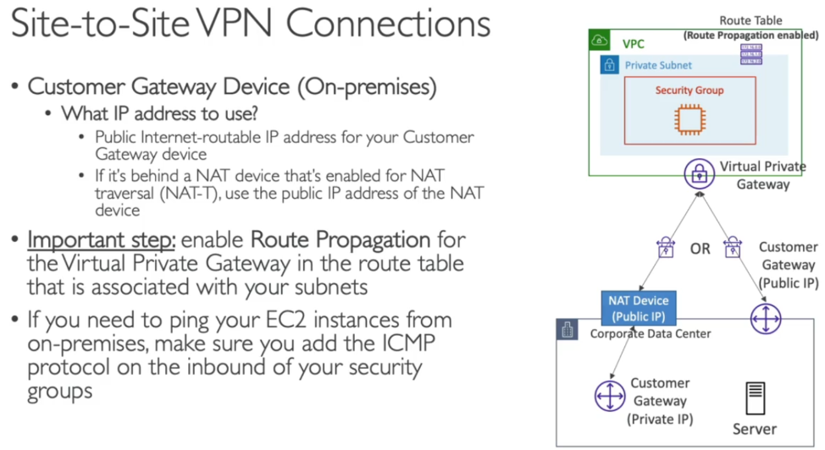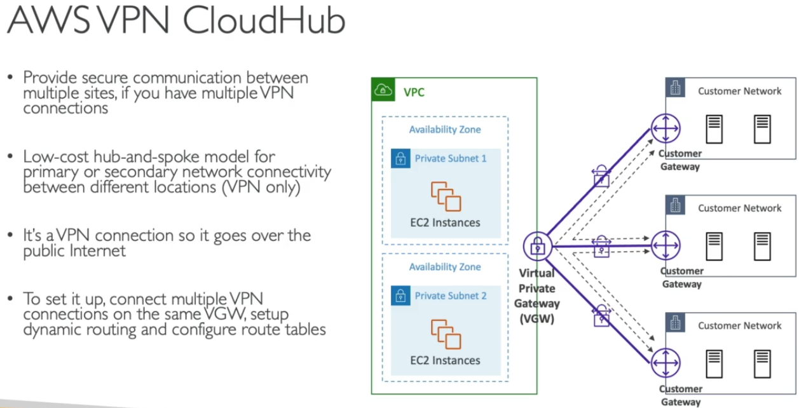

>>> Direct Connect (DX) - (Used to connect to Data Center through VPN)

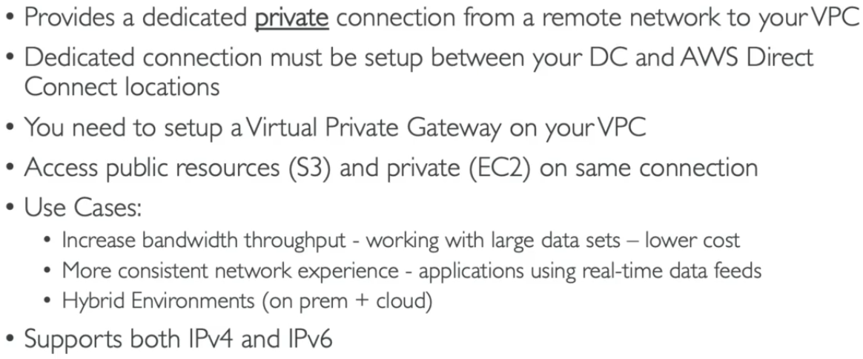 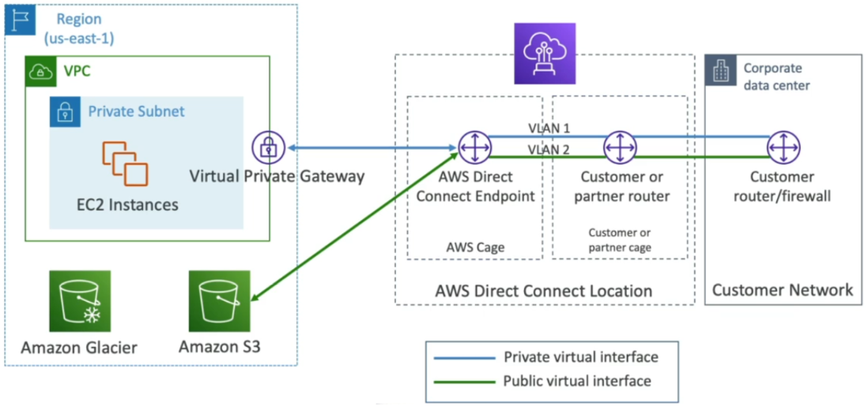 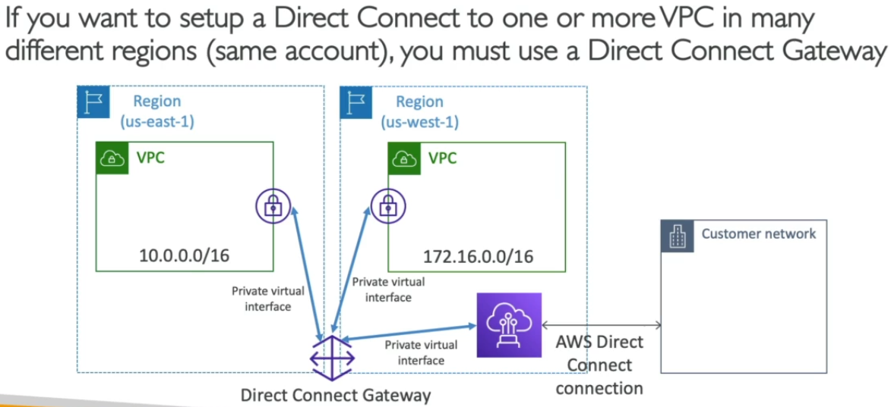

* Connection Types, Encryption, Resiliency –

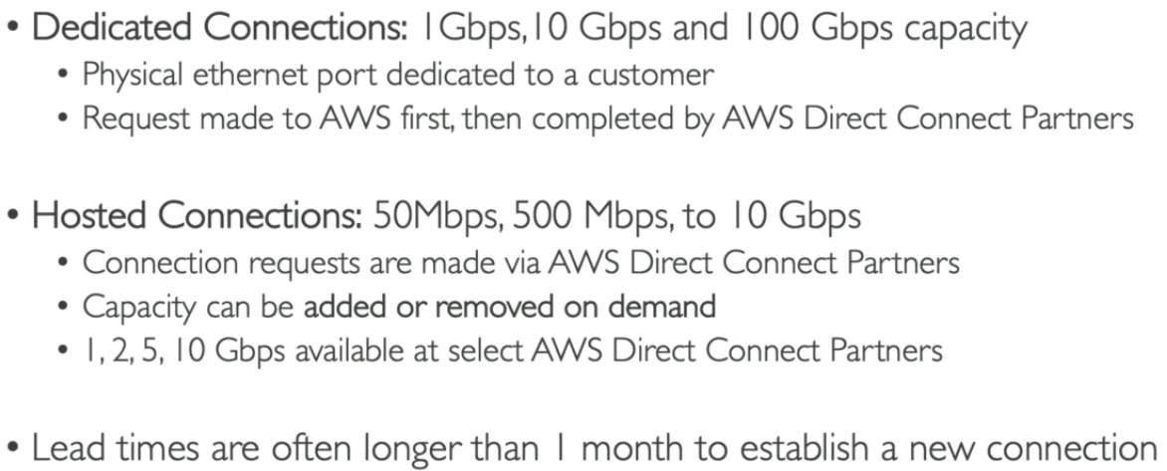 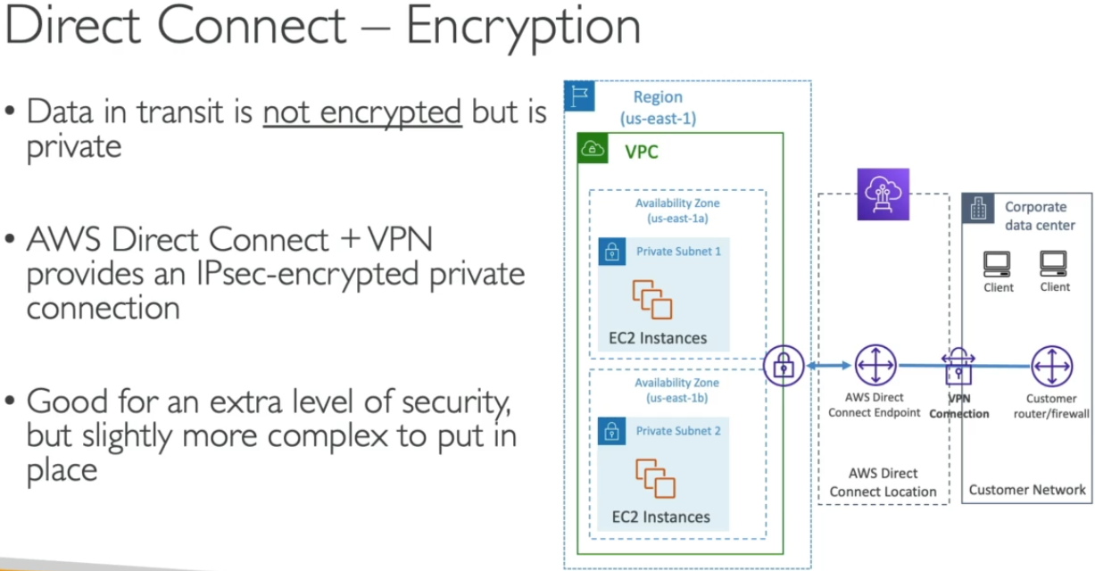 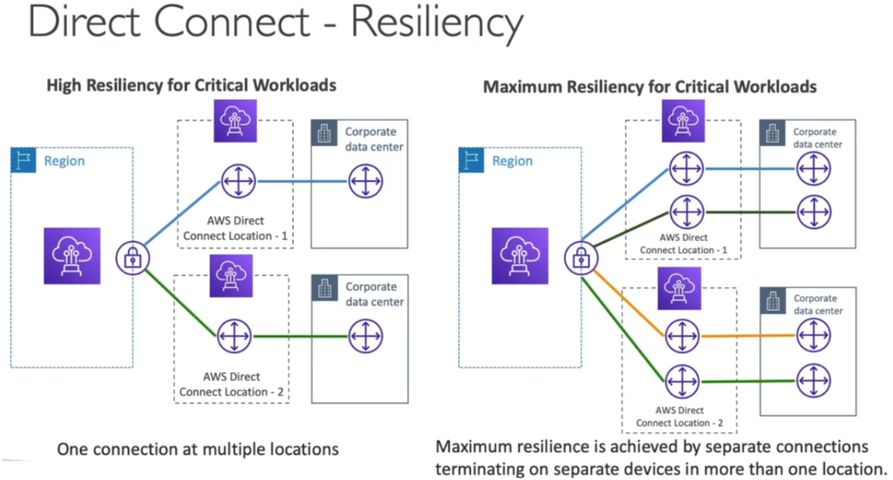

**6. Transit Gateway / VPC Traffic Mirroring / IPv6 VPC –**

>>> Transit Gateway - (Used to solve complex Network topology issue on cloud)

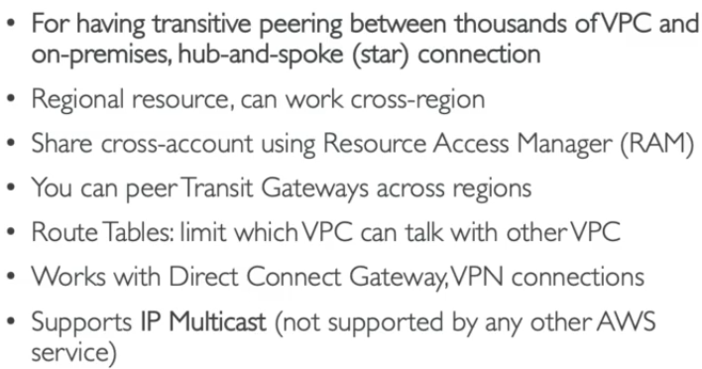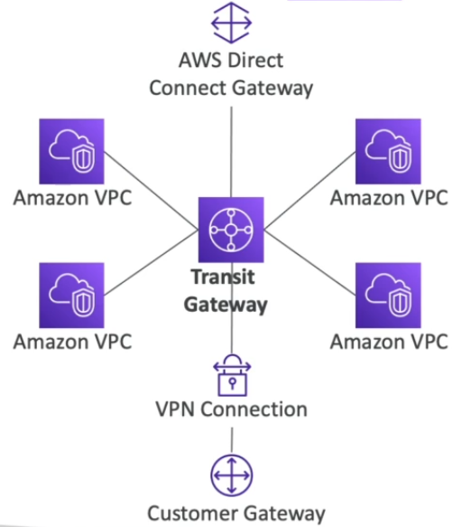 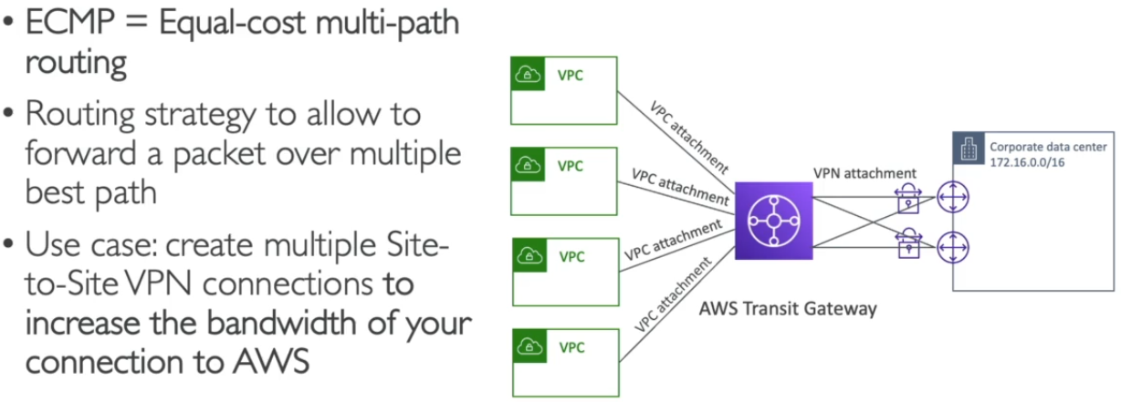

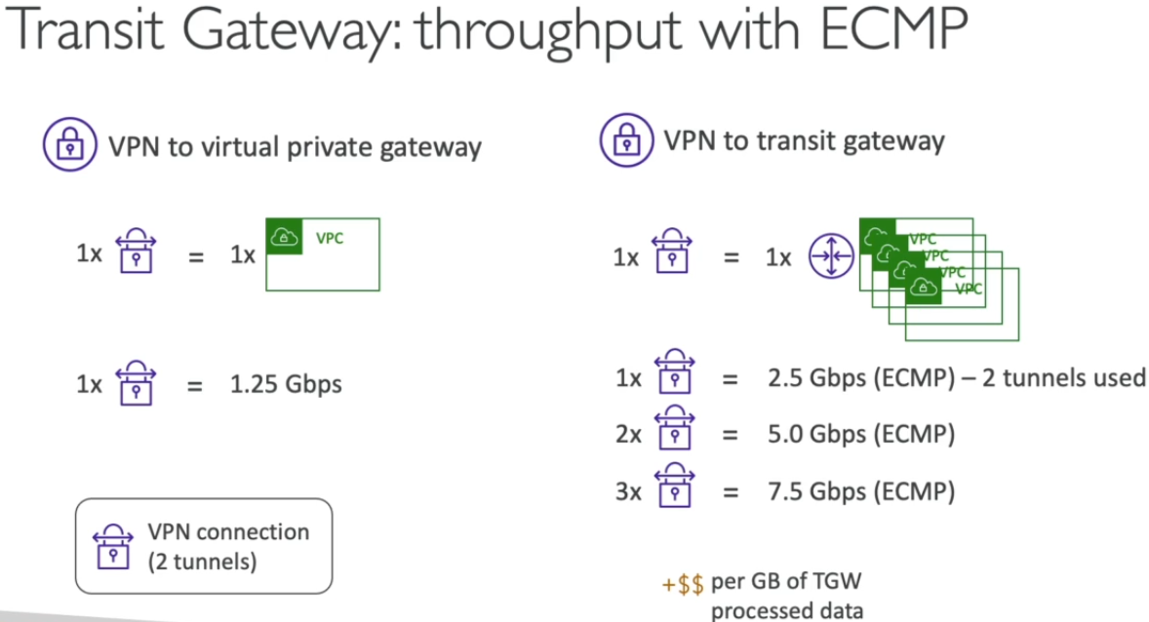 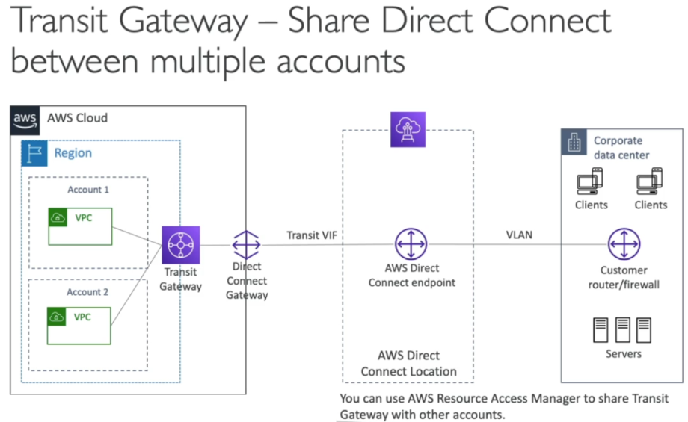

>>> Traffic Mirroring -

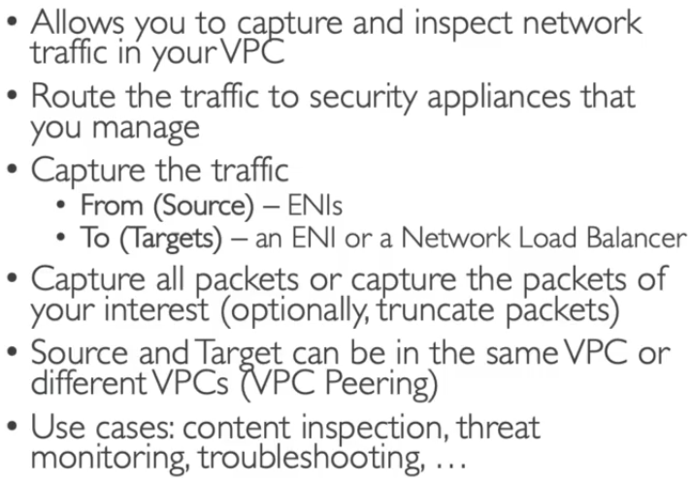 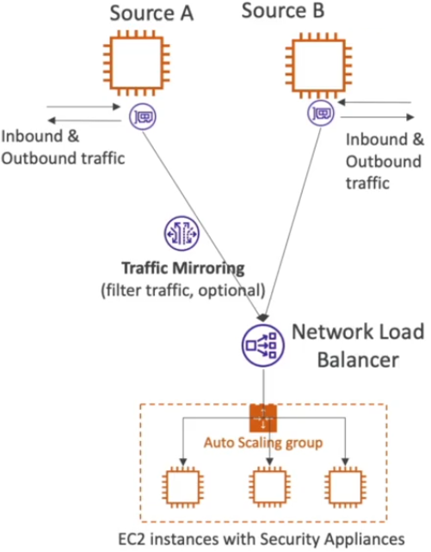

>>> IPv6 VPC -

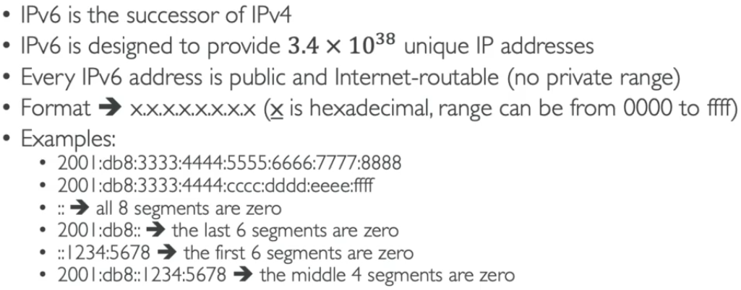 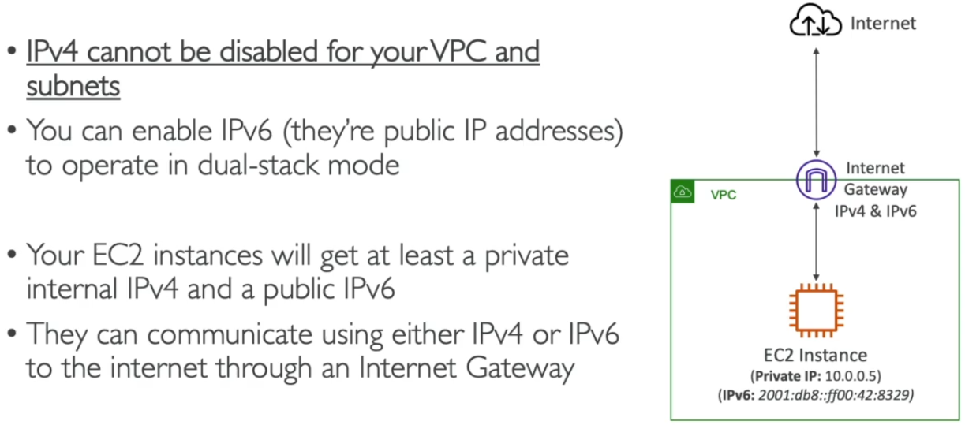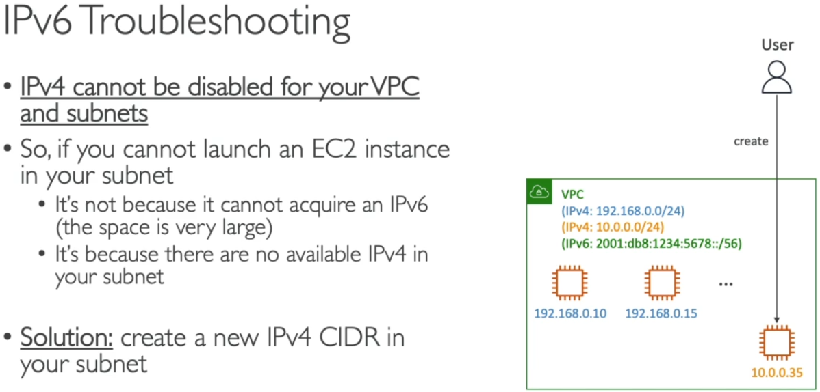

* Use IPv6 IP suggested by AWS console.
* New CIDR values can be attached to VPC when no of subnet exceeds the limit.
* Egress Only Internet Gateway is used instead of NATGW for IPv6 IPs.

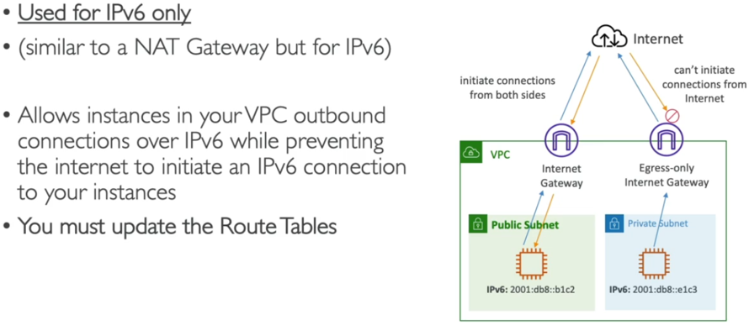 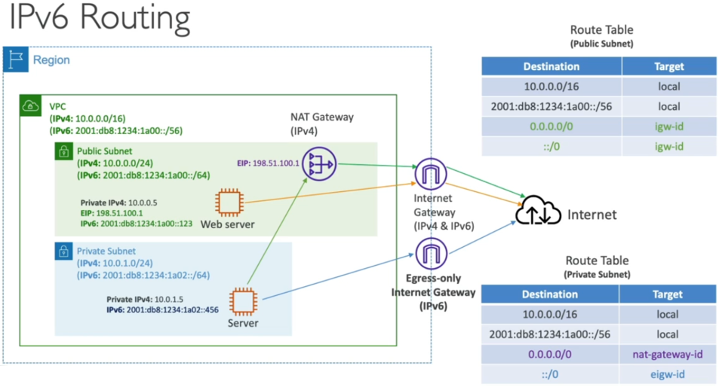

**# Summary of VPC section**

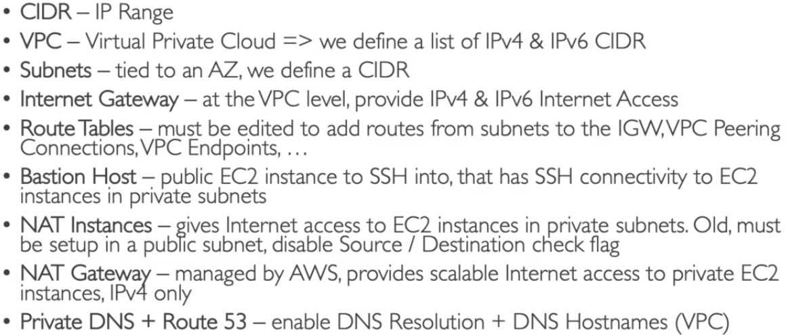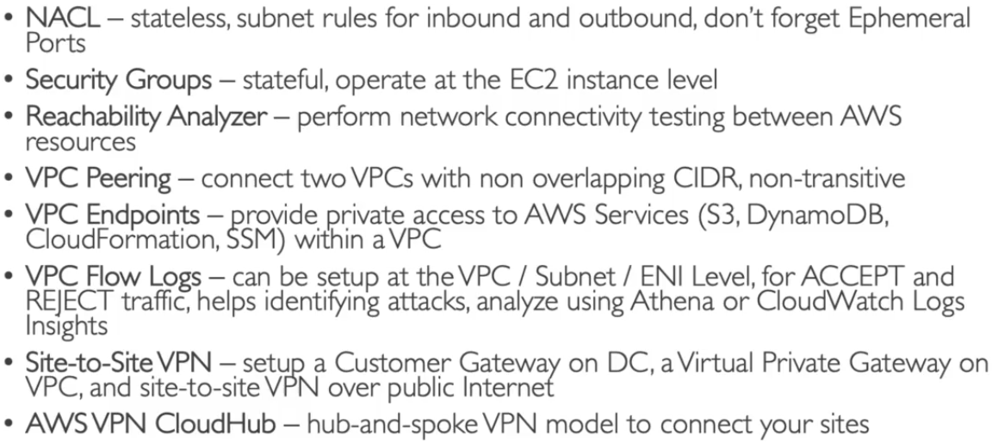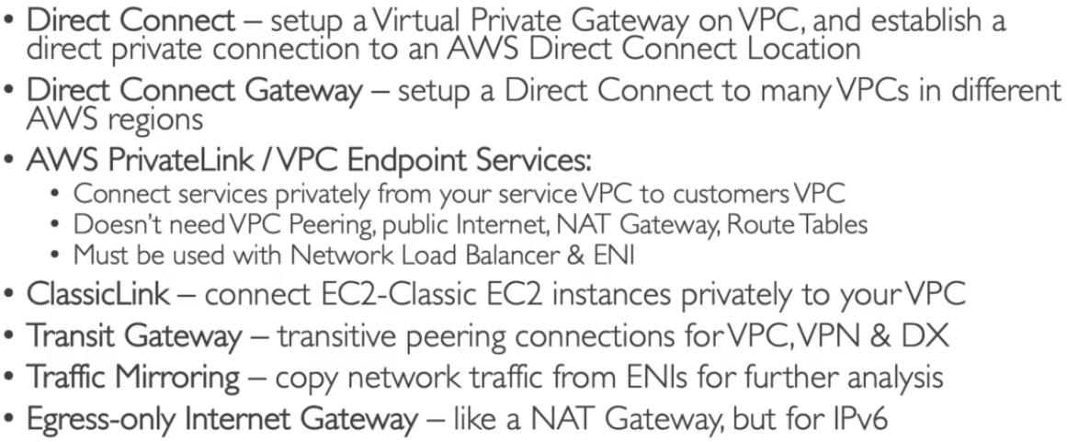

**# Networking Cost Analysis**

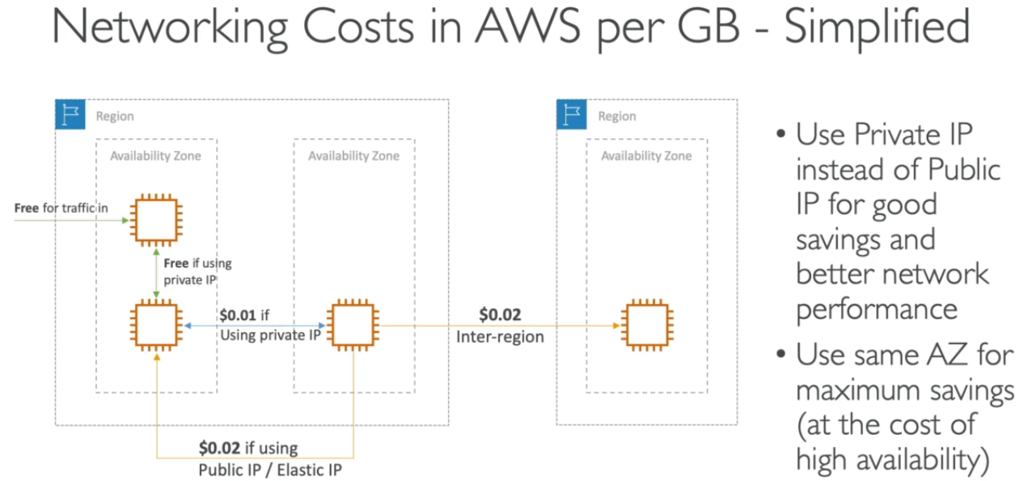

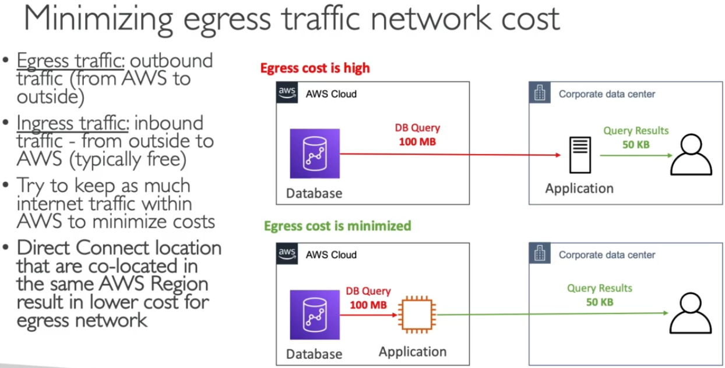 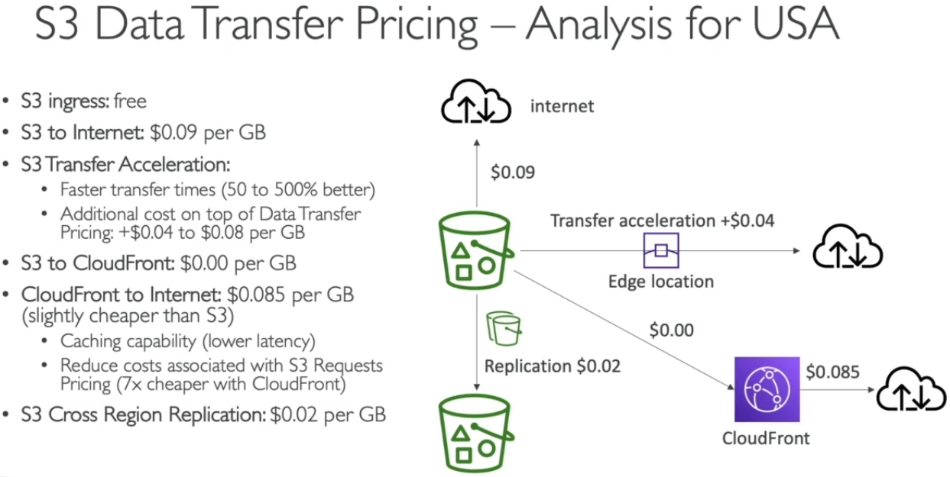 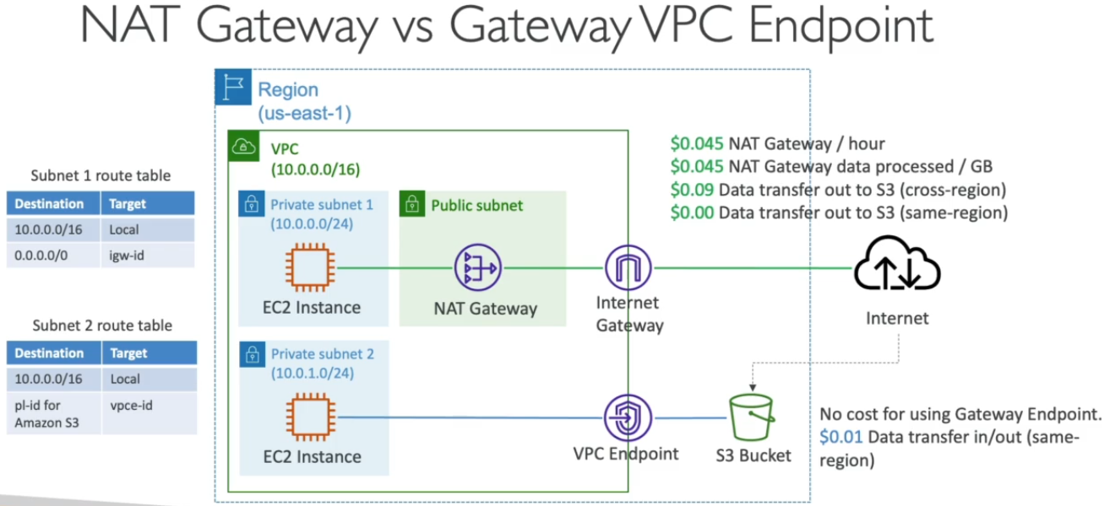

**# VPC Security**

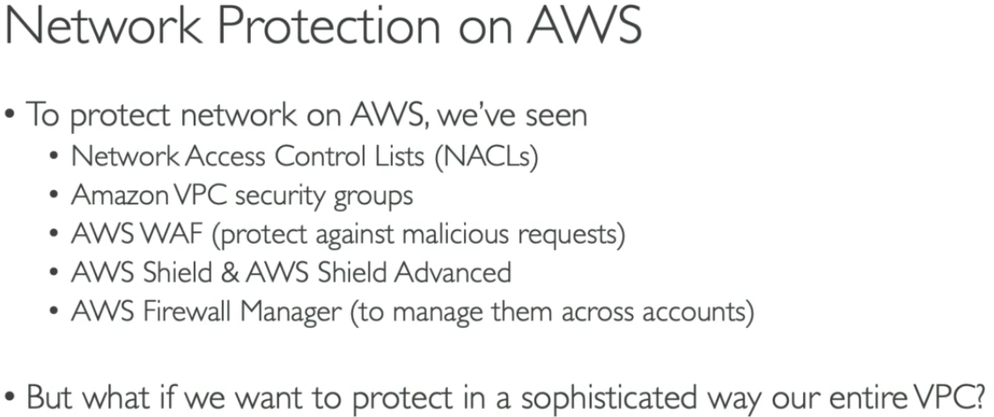 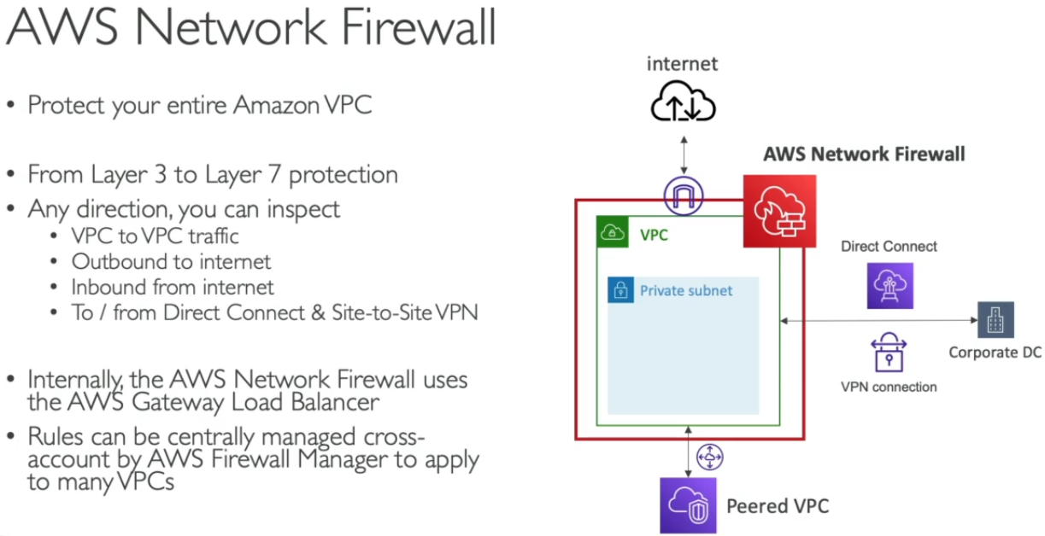 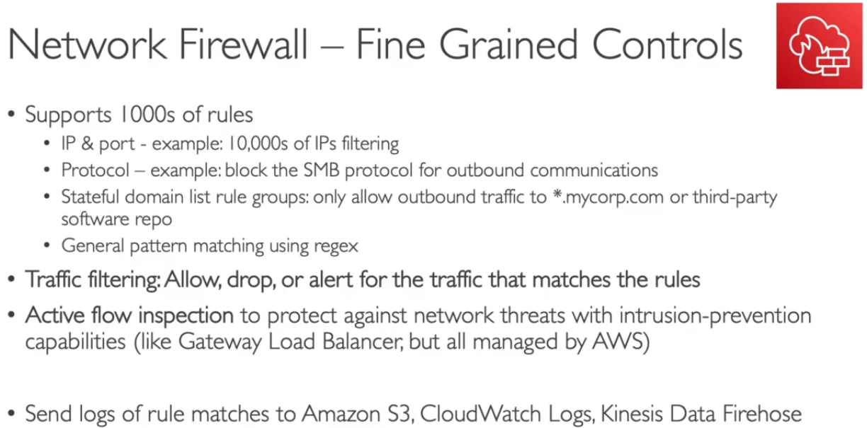

**# Amazon S3 – (Allow users to store ‘objects = files’ and ‘Buckets = Directories’)** **– Global service**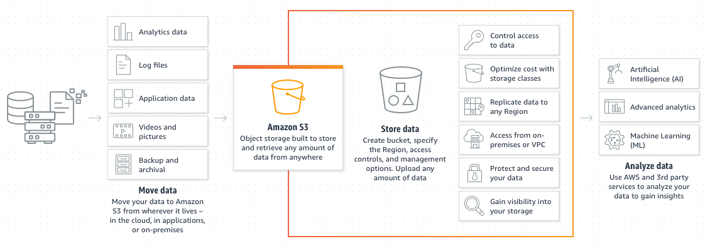

* Buckets are defined at regional level and must have **unique name globally**.
* These S3 can be easily accessed using HTTP (like Google Drive)
* Unlimited Storage + file size [0 to 5TB] + Versioning & Encryption facility+**Public Access(URL) for files after permission**
* Naming Convention – No uppercase/underscore, 3-36 character long, starts with lowercase letter/no
* Tags are used mention bucket owner name / purpose of bucket etc.

Naming rules - <https://docs.aws.amazon.com/AmazonS3/latest/userguide/bucketnamingrules.html>

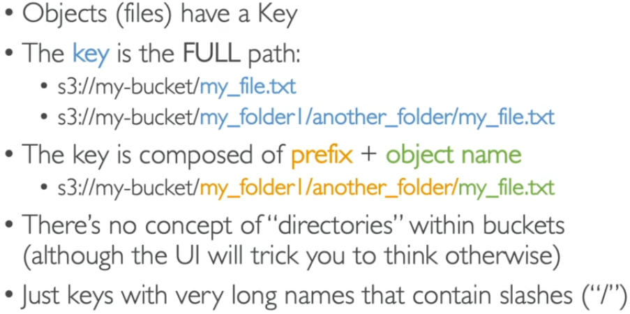 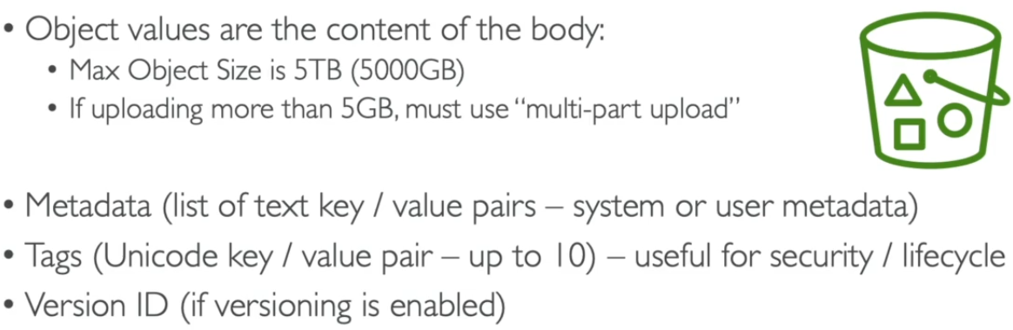

**Process: Create Bucket in console > Select name & region > Uncheck block public access > done > open > upload a file/create folder > upload file in folder**

>>> Bucket Versioning – (To maintain the versions of files saved in bucket)

* Versioning of files – If one file is uploaded multiple times in bucket, it doesn’t get overwrite & saved in versions.
* It is done at Bucket level and can be activated from Bucket properties.
* Adv. – Protects unintended deletes and easy to roll back previous versions
* When we delete any file from bucket > only delete marker is assigned to file > previous version can be retrieved easily from console > can be deleted permanently from console.

**1. S3 Encryption of Objects –**

* AES-256 (Advanced Encryption Standard) – Single
* AWS-KMS (Key Management Service) – Double encryption

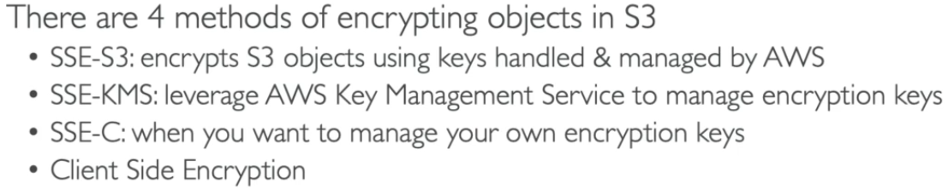

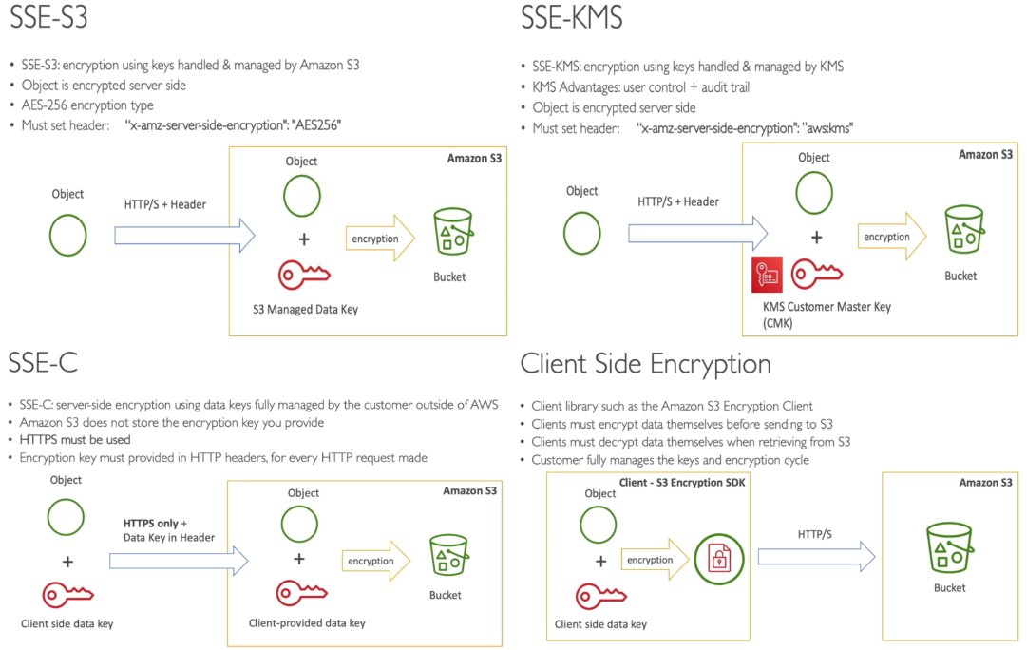

* Default encryption option can be **turned on** in S3 bucket for simple encryption of all objects.

**2. S3 Security –**

* These security can be user based (IAM Jason policies) and Resources Based (ACL-access control list).

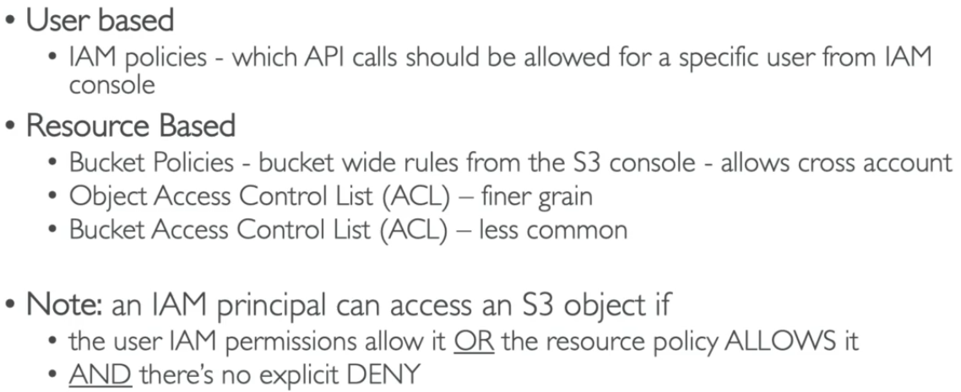 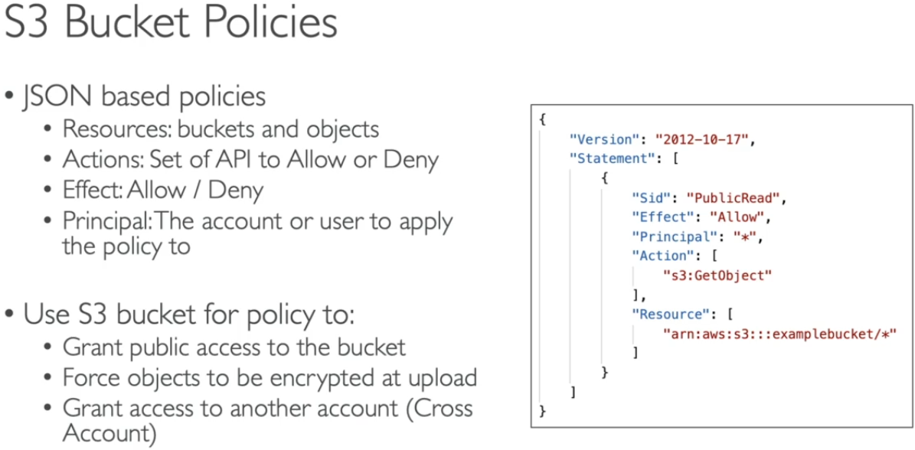

* Bucket Settings to block Public Access –

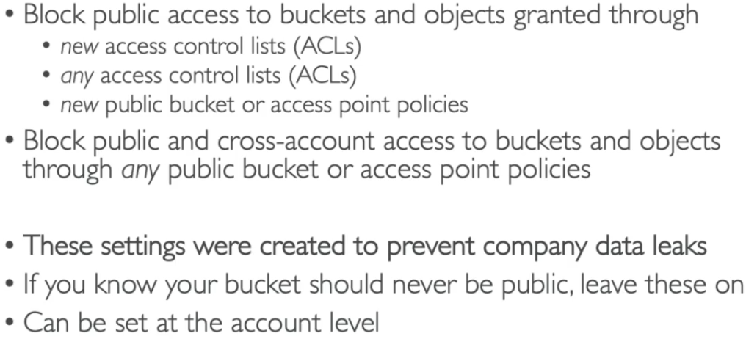 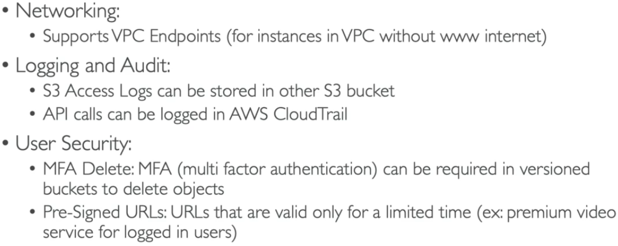

**3. S3 Website –**

* S3 Bucket can host **static websites(simple HTML file hosting)** & make them available on WWW
* If we get 403(Forbidden) error – bucket policy must allow public reads.
* URL will be -

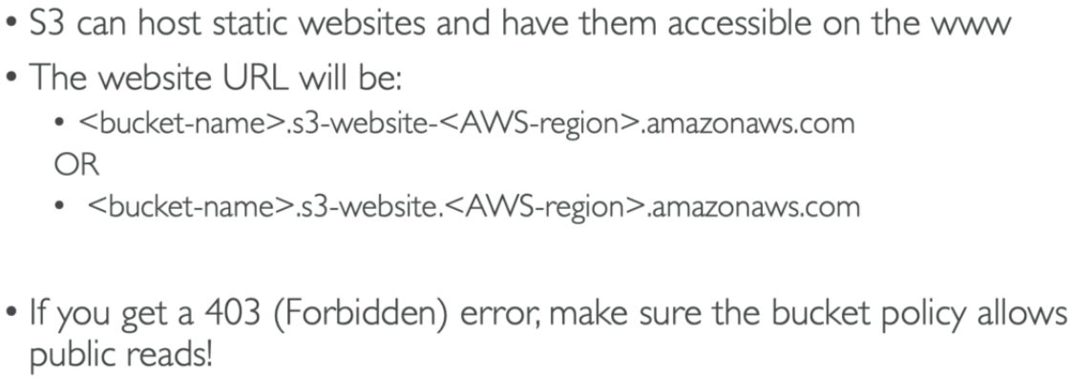

**Process: select bucket > properties > static website hosting > Upload HTML and Error file in bucket (both files must have public access) > Enable Static Host option > select documents > in permissions- Disable Block Public Access > Generate bucket Jason policy for access > done (Open Endpoint Link to access website)**

**4. CORS (Cross Origin Resource Sharing) –**

* If one website (HTML file 1) wants to access other website (HTML file 2) through web browser, then 2nd website must have CORS settings for successful access.

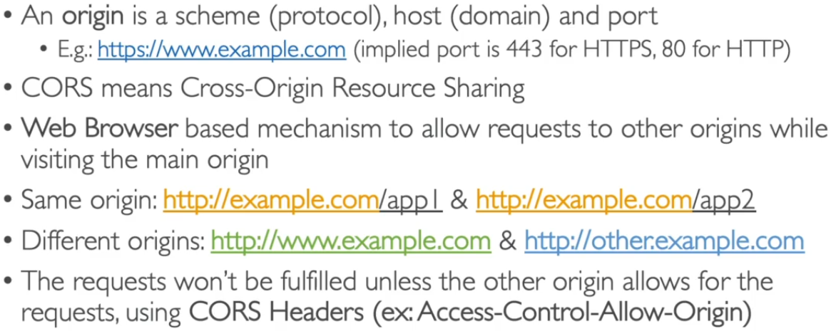

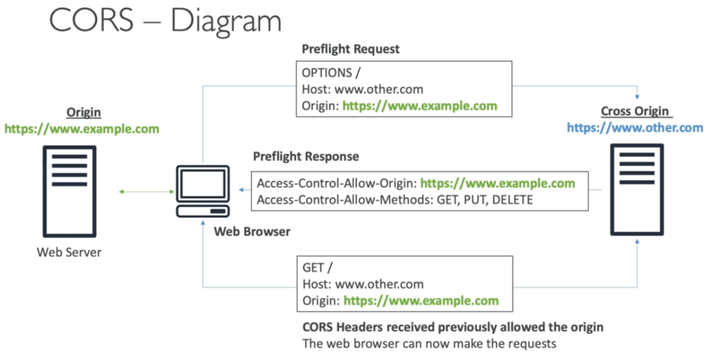 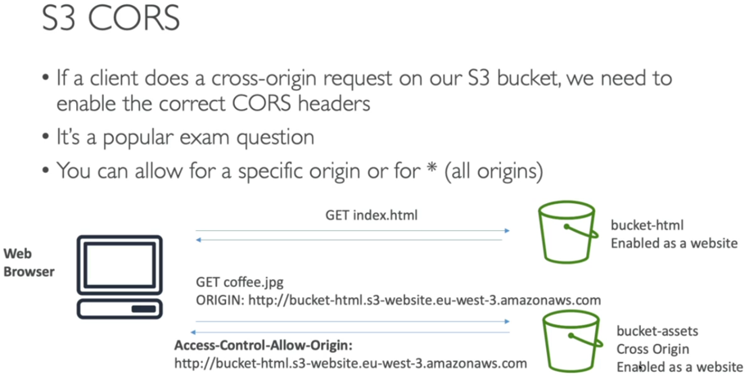

>>> AWS S3 storage class – (To maintain type of data and usage accordingly charges will be applied)

* To manage data and cost – how frequently we’re using this data.
* **Lifecycle rules** can be used to manage bucket data in cost effective manner.

**Process: select bucket > management > create lifecycle rules > apply to all objects in bucket > select classes & time period > create > done**

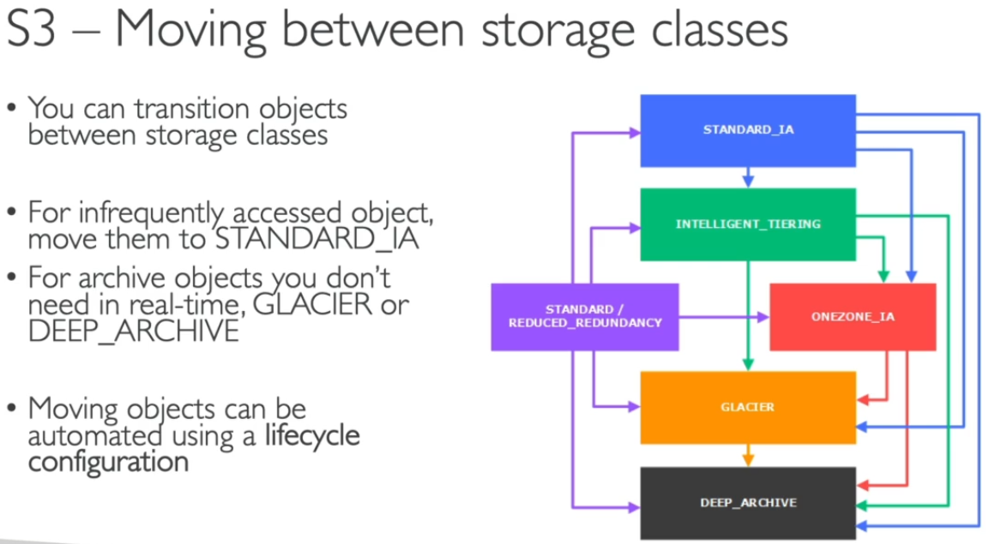 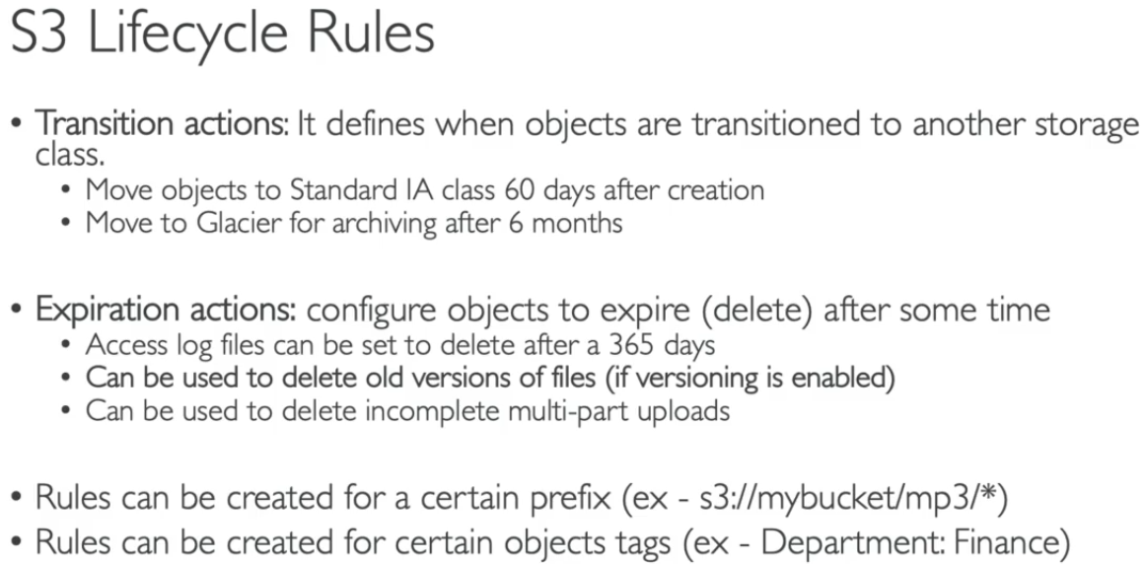

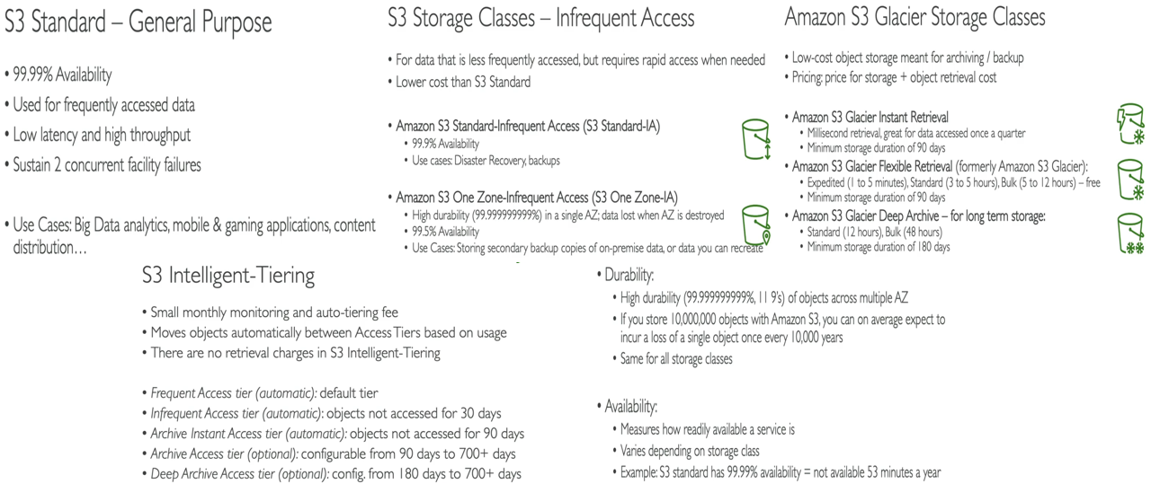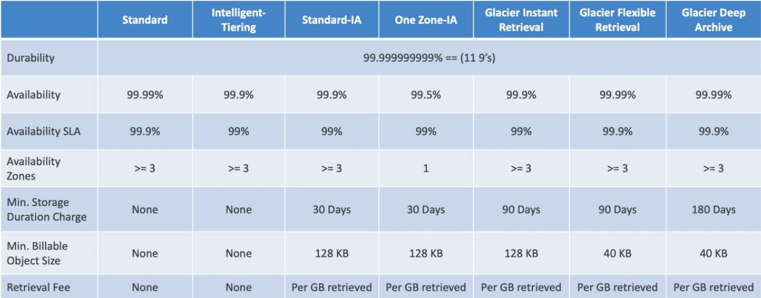

>>> AWS S3 storage MFA Delete – (To maintain high security of objects in bucket – MFA code is required)

* It is managed by bucket account (root owner)
* It can only be done through **AWS CLI** not through AWS console (this can be updated in future)
* ARN (Amazon Resource Names) can be accessed once we configure our MFA device.

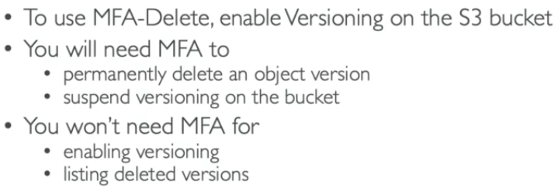 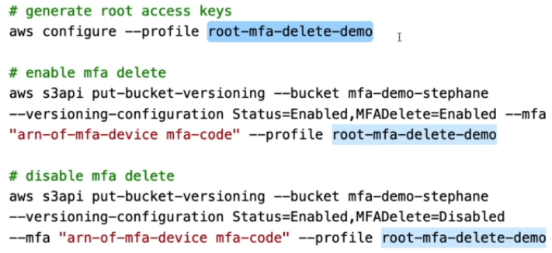

>>> AWS S3 Access Logs – (To mainta in activity logs of all access/denied requests for auditing purpose)

* Do not set the logging bucket to be monitored bucket > endless loop > huge data & bills.

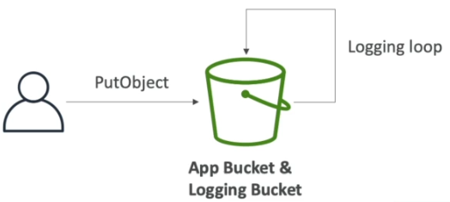 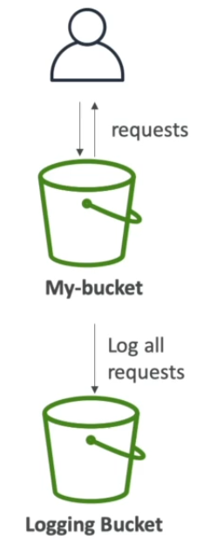

**Process: create 2 buckets > select app bucket > enable - server access logging > select log bucket as target bucket > done (these logs can be further checked for auditing/analysis purpose)**

>>> AWS S3 Replication – (**SRR**-Same region replication and **CRR-cross region replication**)

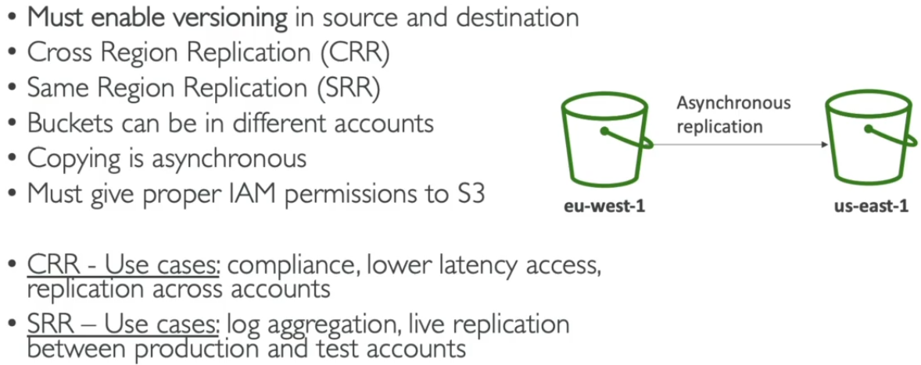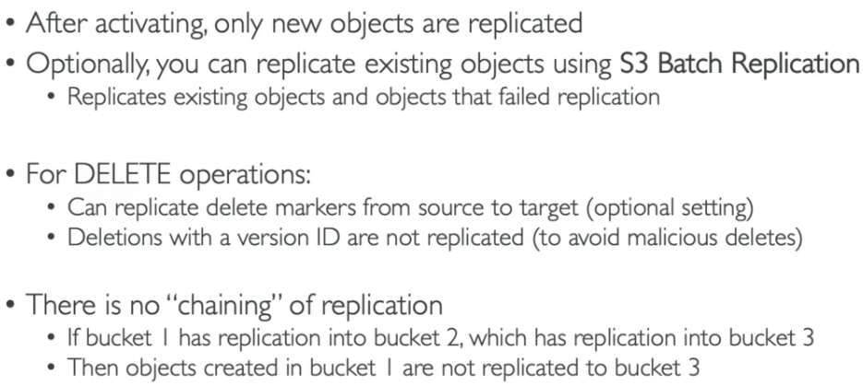

* CRR (Cross Region Replication) – (**data is uploaded in one region and visible is other region too**)
  + Create 2 buckets in different regions > enable CRR in 1st bucket
  + Data is transferred from source to destination only not vice versa.



* Pre-signed URL can be given to anyone to access objects from the bucket - for a limited time period, this can be done through console or CLI. 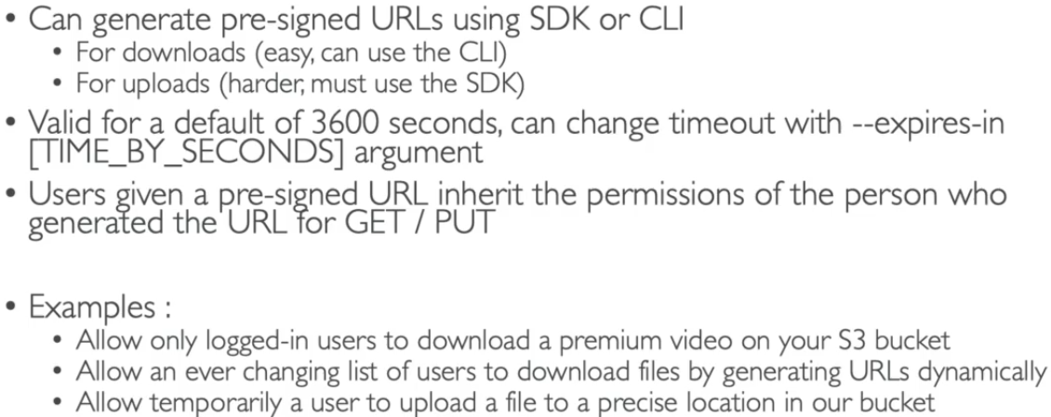

>>> AWS S3 Event Notifications – (To get notified when some action is being performed on bucket/files)

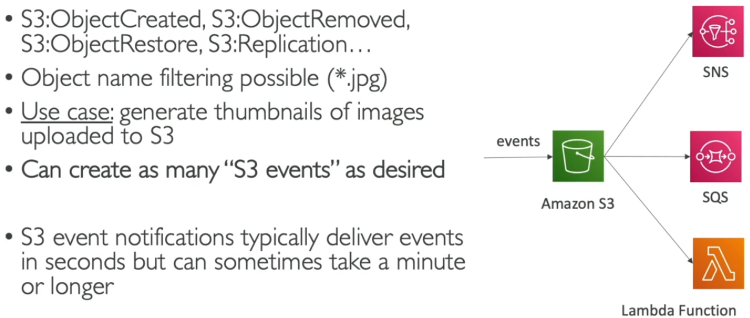 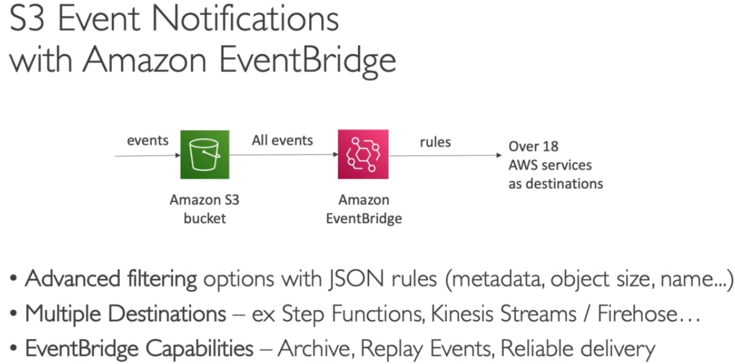

**Process: 1) Create bucket > turn ON amazon event Bridge**

**2) Create bucket > create event notification > select event types > turn ON SQS (allow send msg in SQS policy) > done**

**# Containers (****Docker) on AWS ECS, Fargate, ECR & EKS -**

* **Docker** is an s/w development platform to deploy apps, packaged in **Containers** that can run on any OS.
* Multiple Docker container can be implemented on a server.
* Docker Images are stored in Docker Repositories

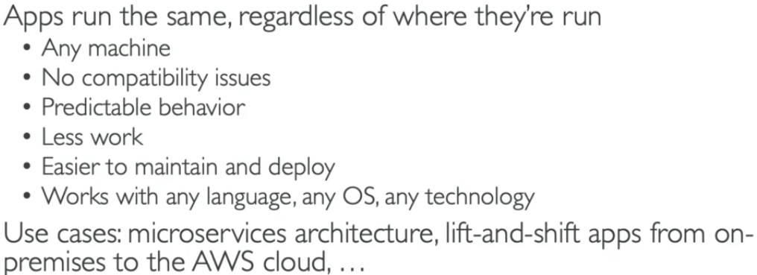 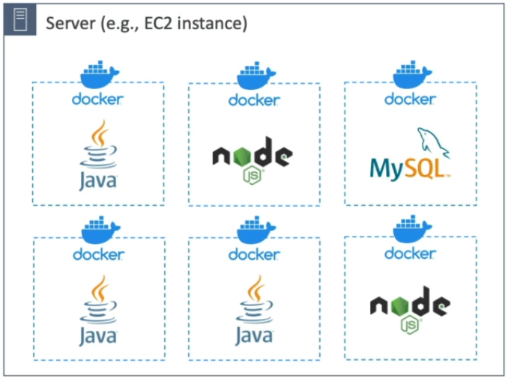 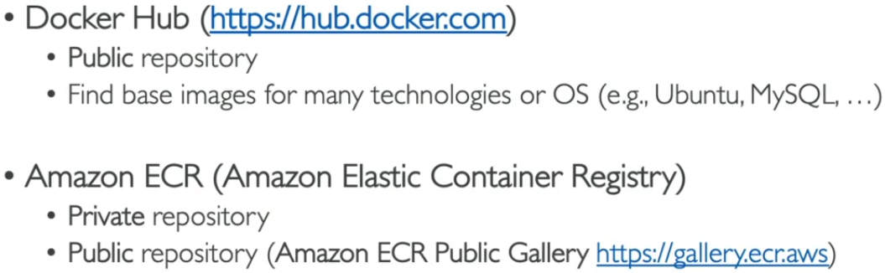

* Docker vs. Virtual Machines – (In Docker resources are shared with Host, many containers on one server)
* Docker File > Build > Docker Image > Push Docker Repository > Pull Docker Repository > Run Docker container

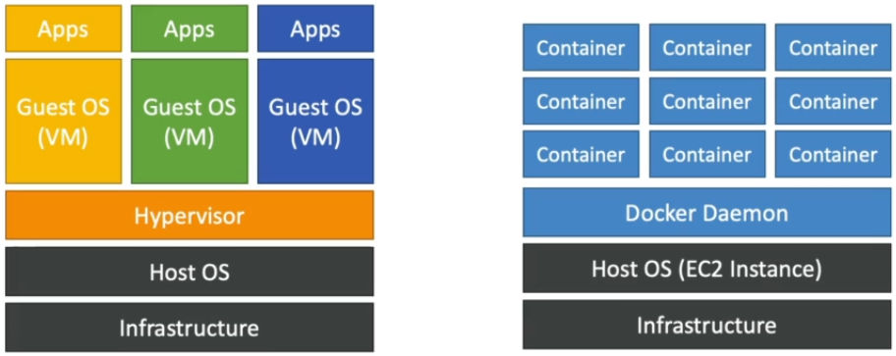 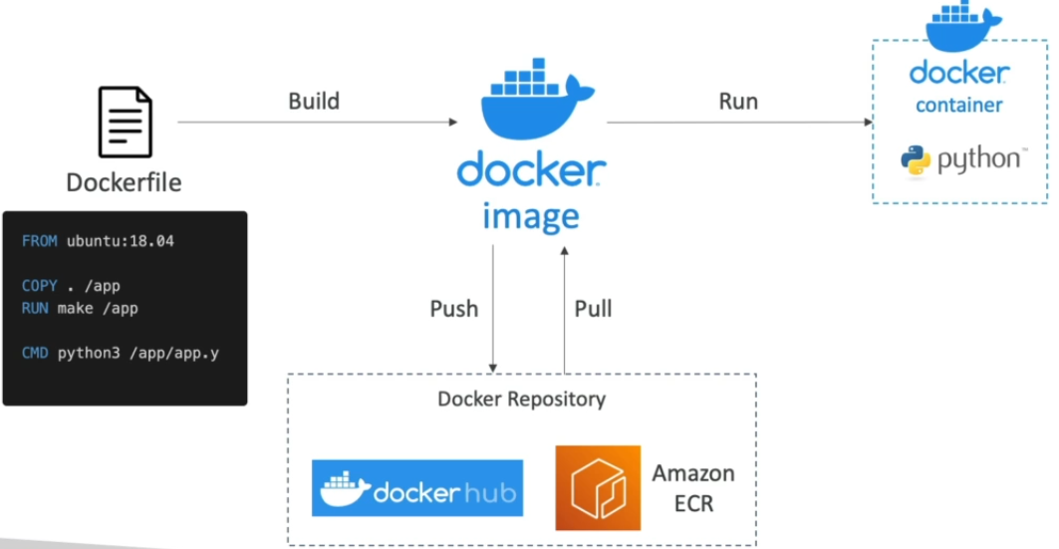

* Docker management on AWS -

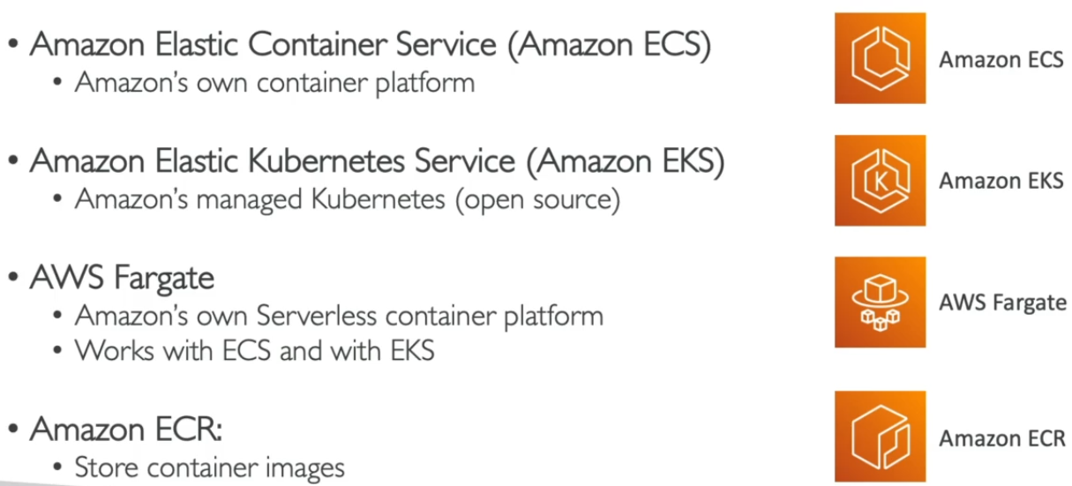

**1. Amazon ECS (Elastic Container Service) –**

* ECS Launch Types-

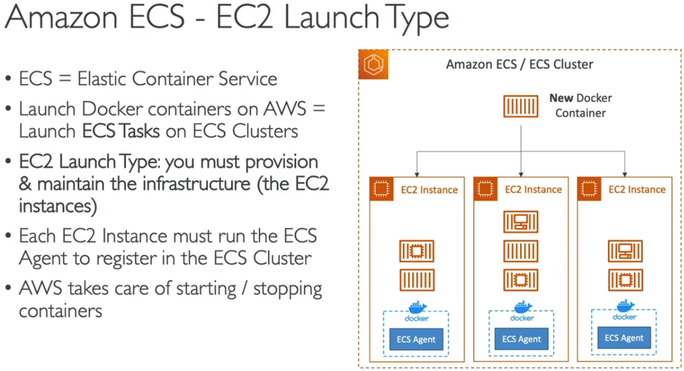 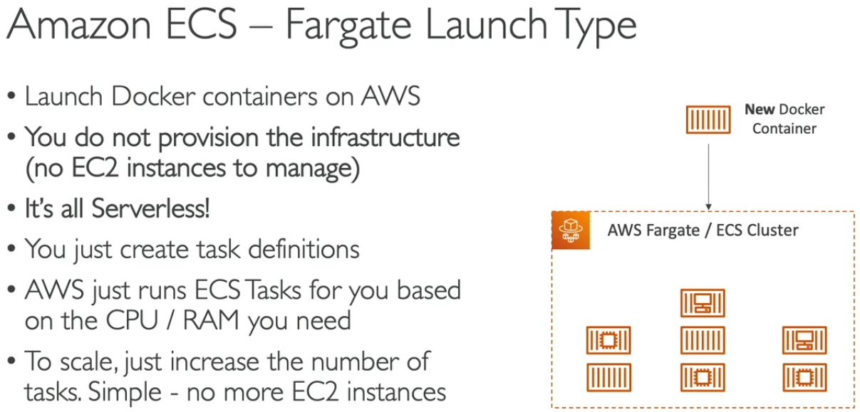

* ECS IAM roles, Load Balancers, Data Volumes(EFS)

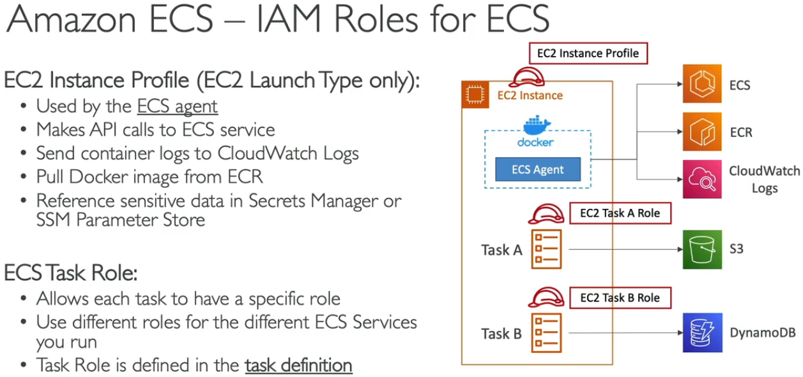 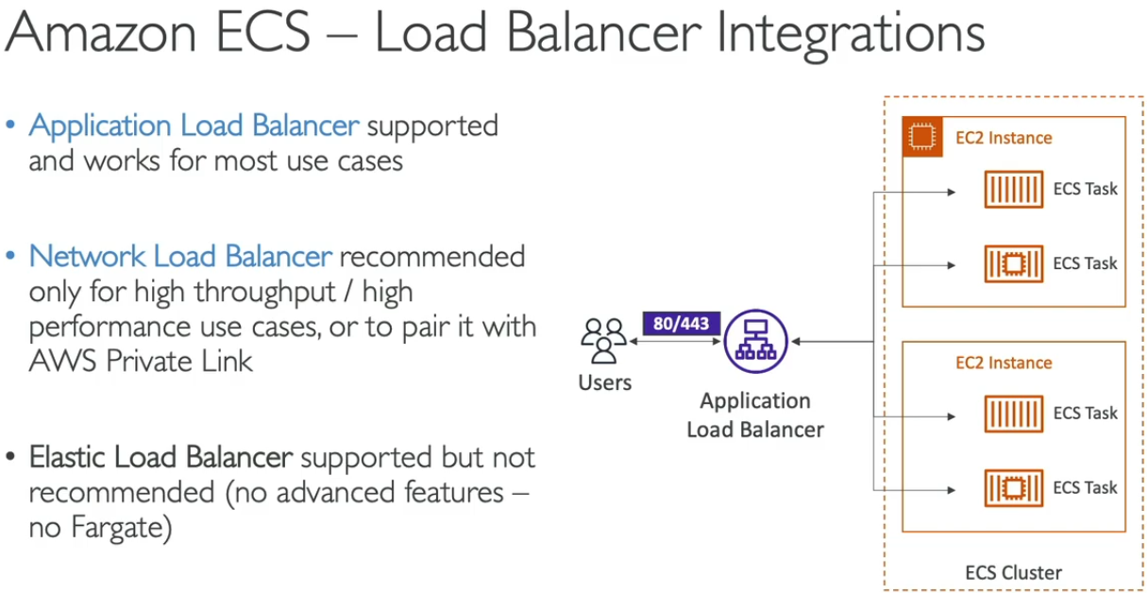

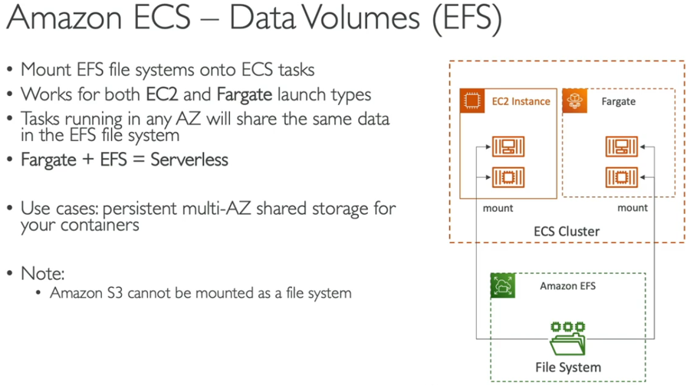

**Process: Open ECS and create cluster > select VPC and Subnet > select EC2 type-ASG-OS-Instance type-capacity > create > Open cluster and start EC2 instances in container**

**Create Task definition > provide name and repository URL-URI (nginxdemos/hello) > select environment (AWS fargate) + Task size > done > open cluster > start service > select ALB + add SG > deploy > Use DNS link and launch**

>>> ECS Auto Scaling Service – (Automatically increase/decrease no of ECS tasks)

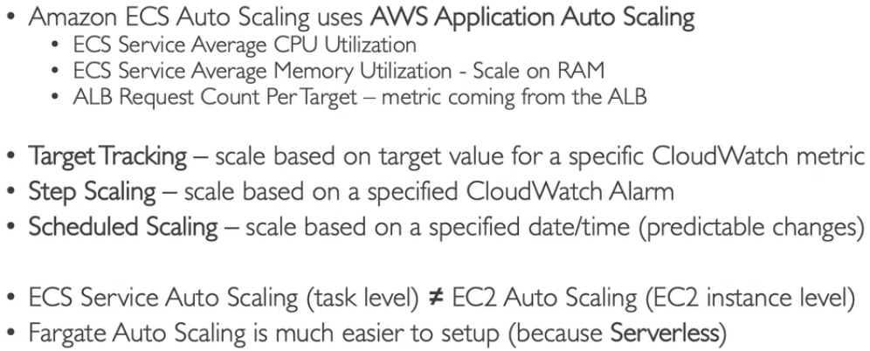 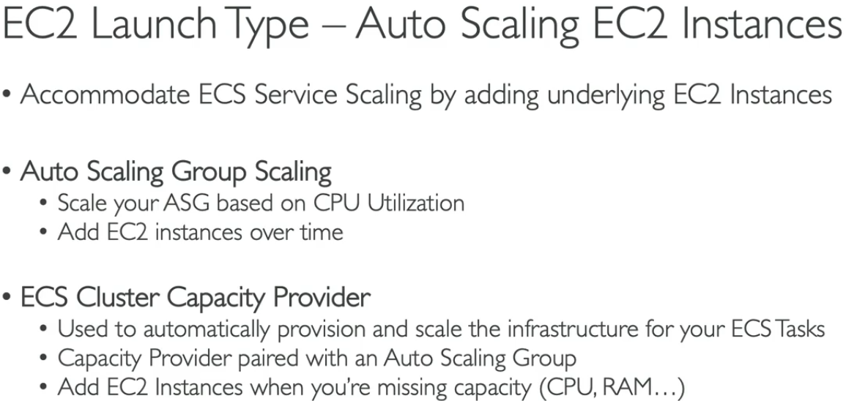

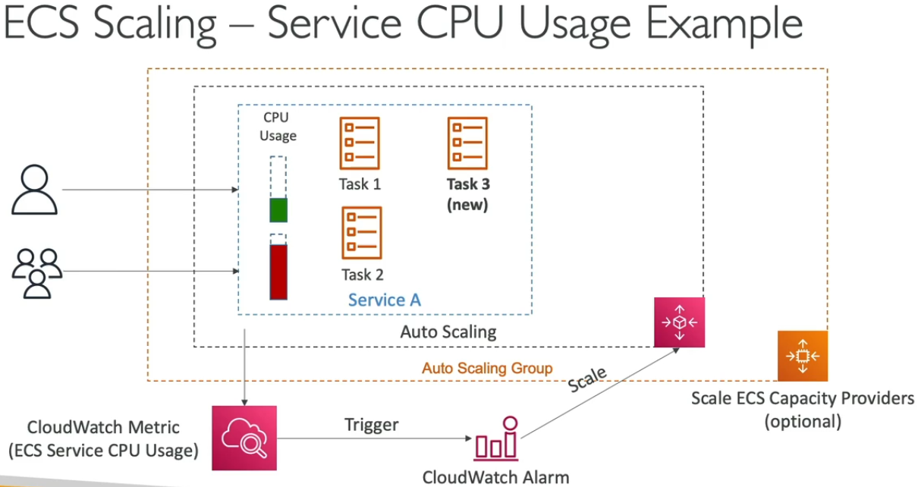

>>> ECS Tasks Invoking methods –

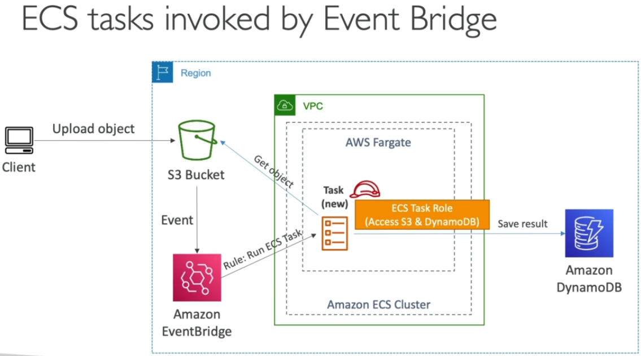

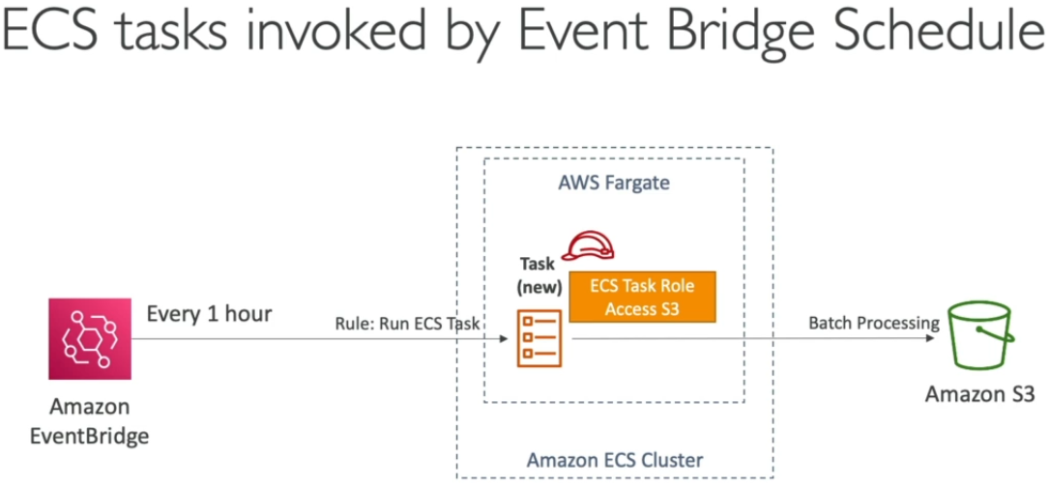 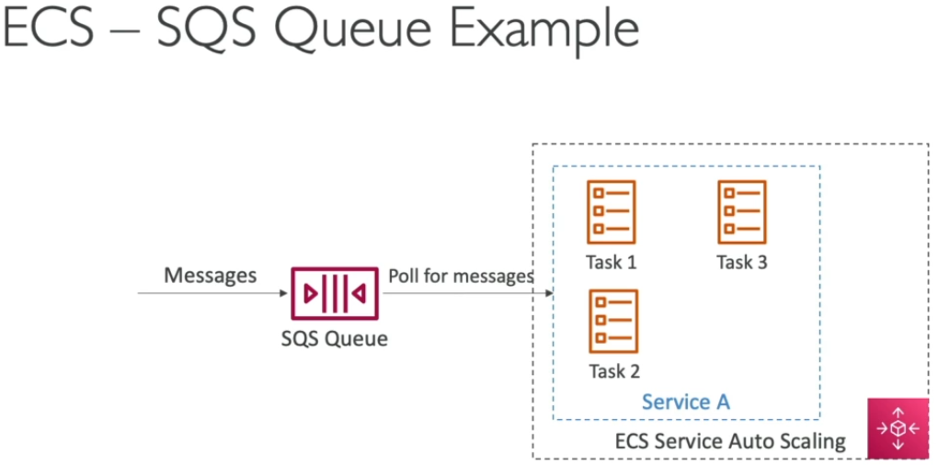

**2. Amazon ECR (Elastic Container Registry) –**

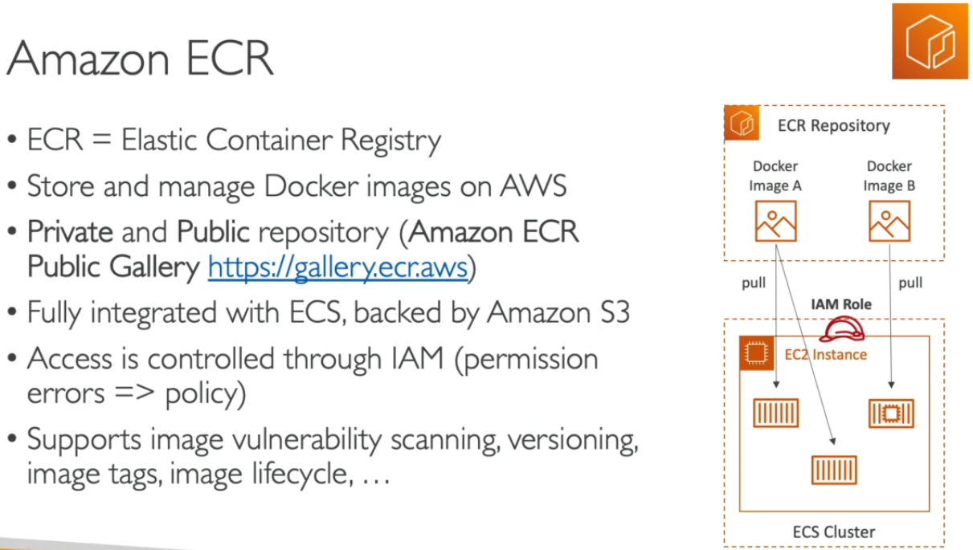

**3. Amazon EKS (Elastic Kubernetes Services) – (Alternative to ECS)**

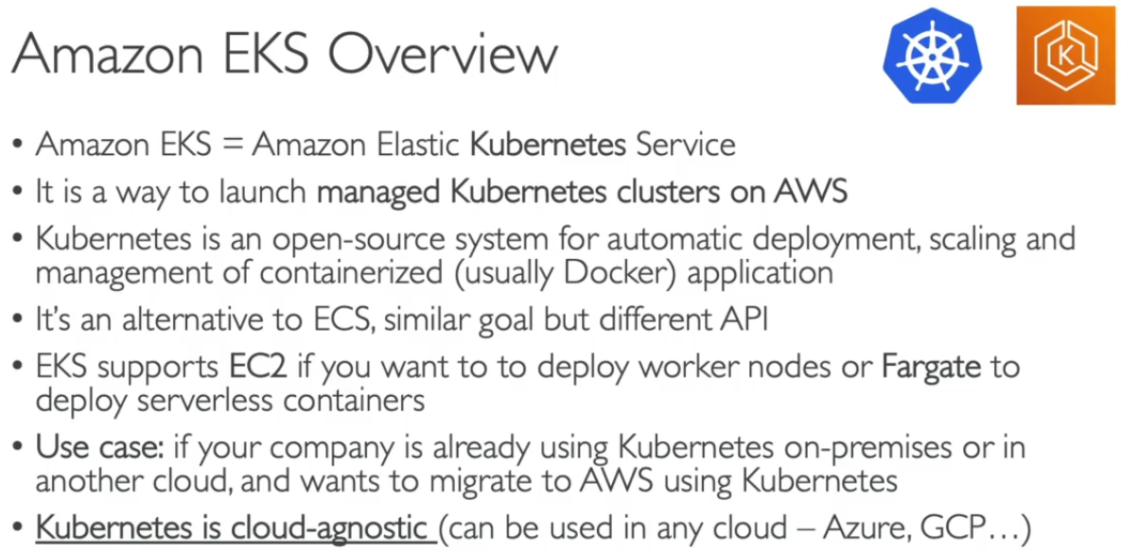 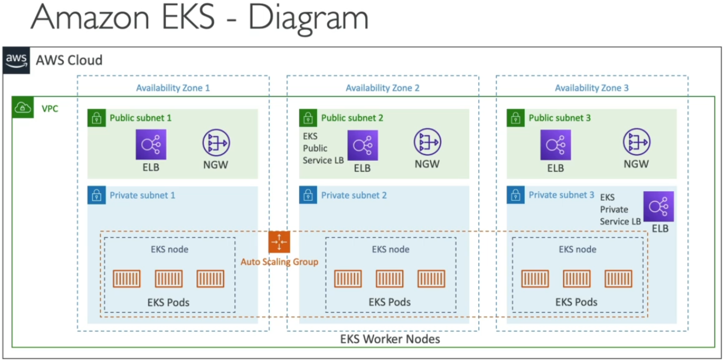

* EKS Node Types and Data Volumes -

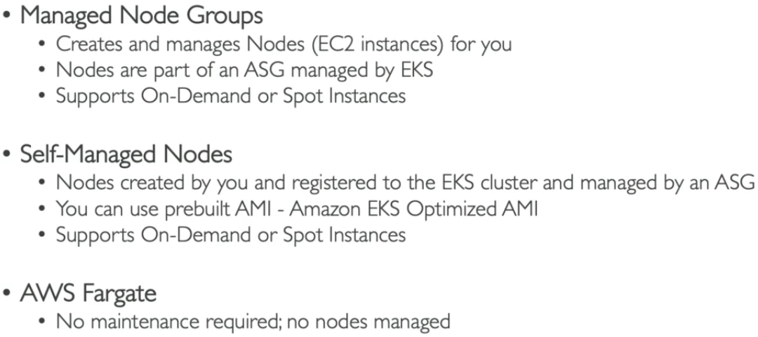 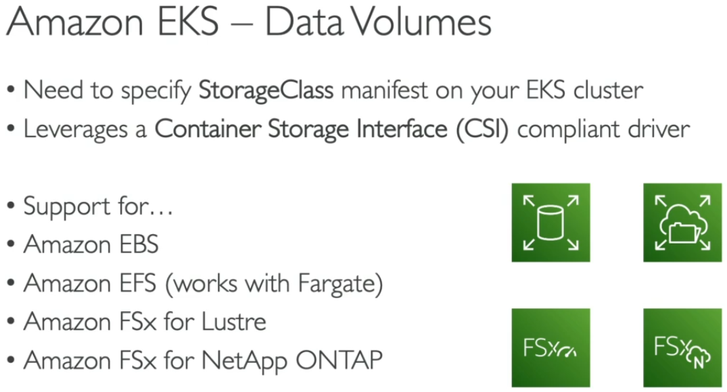

**# AWS App Runner Service (AWS managed service)**

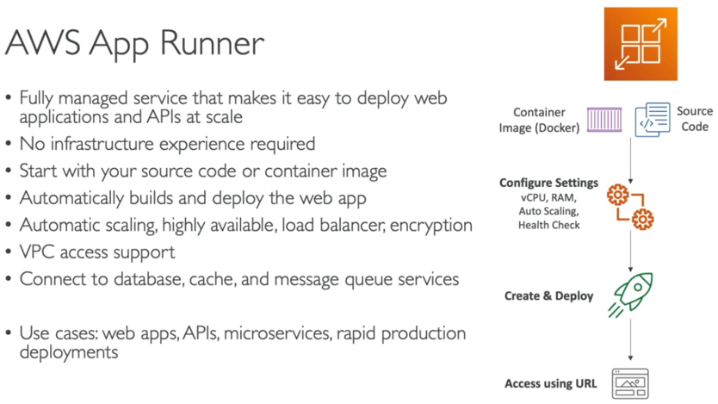

**#** **AWS Integration and Messaging – (SQS, SNS, Kinesis)**

* This is used for communication between multiple applications, types – Synchronous & Asynchronous
* Asynchronous is preferred over synchronous comm. As it can’t handle sudden spikes in traffic [Eg. generally 10 videos are required to encode but due to high traffic there is requirement of 100 encoded videos]
* To prevent this applications are **decoupled**, methods – SQS, SNS, Kinesis

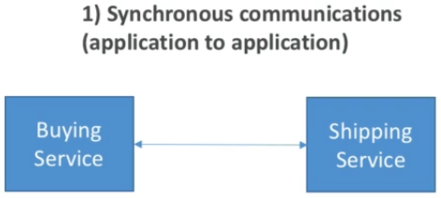 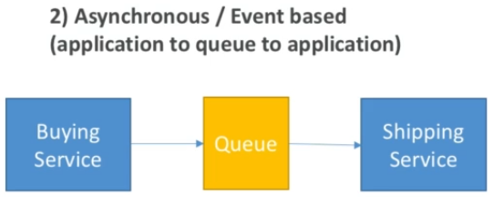 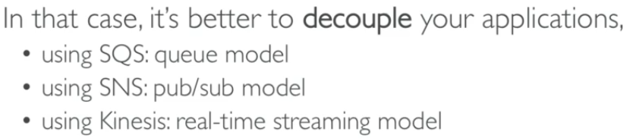

**1. Amazon SQS – (Standard Queues- used to decouple applications and store messages in database efficiently)**

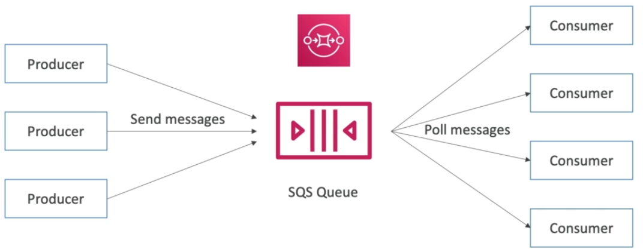 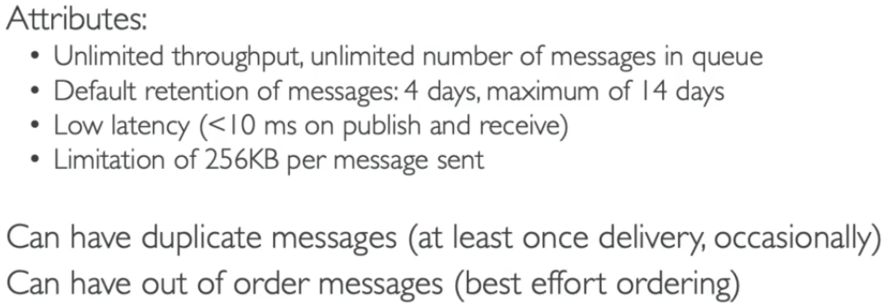

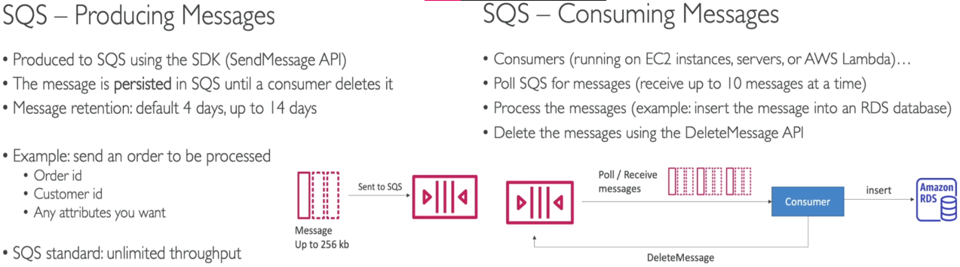

**Process: Open SQS and create queue > select retention period > select access policies (AWS account, IAM users, owner) > create > Send message > Poll message > Receive message (metadata, body, attributes)**

Delete message after opening to prevent multiple time receive due to polling and signal SQS that message has been processed.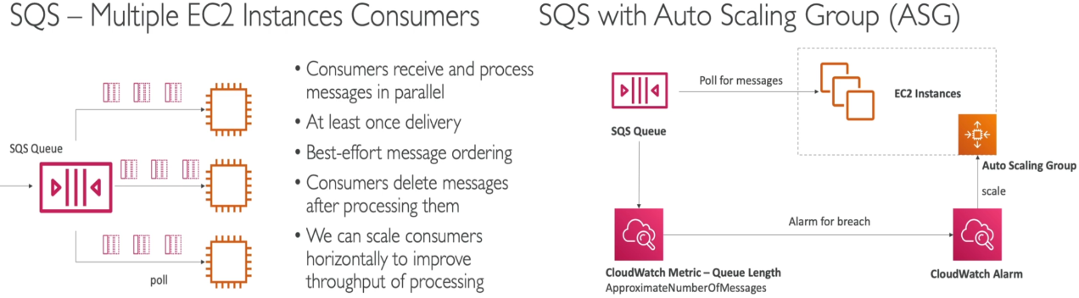

>>> SQS Decouple between application tiers – (Security)

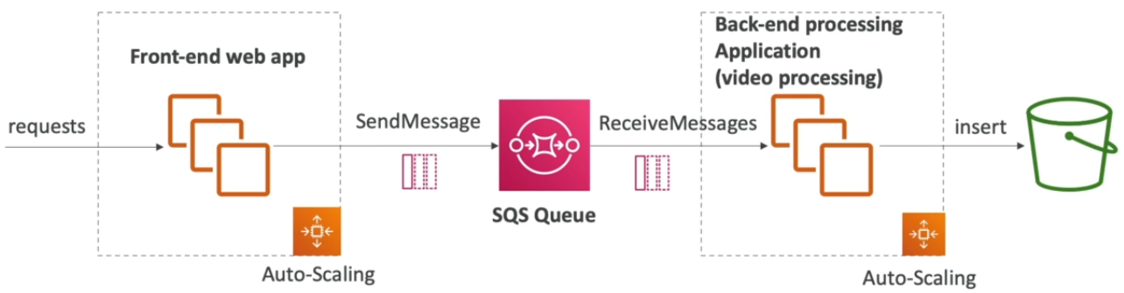 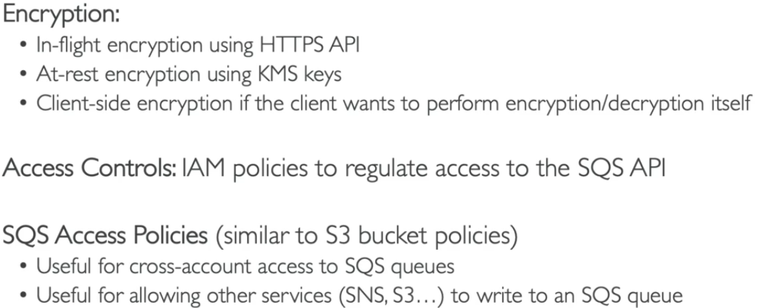

>>> Amazon SQS Message Visibility Timeout, Long Polling, FIFO Queue –

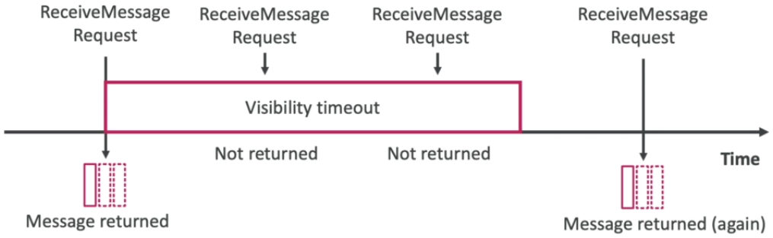 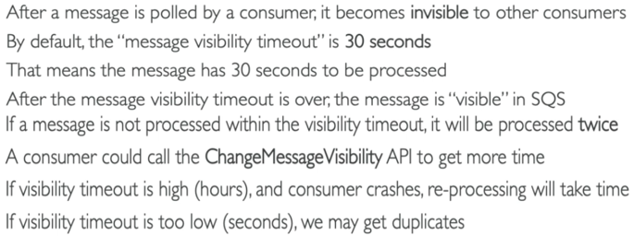

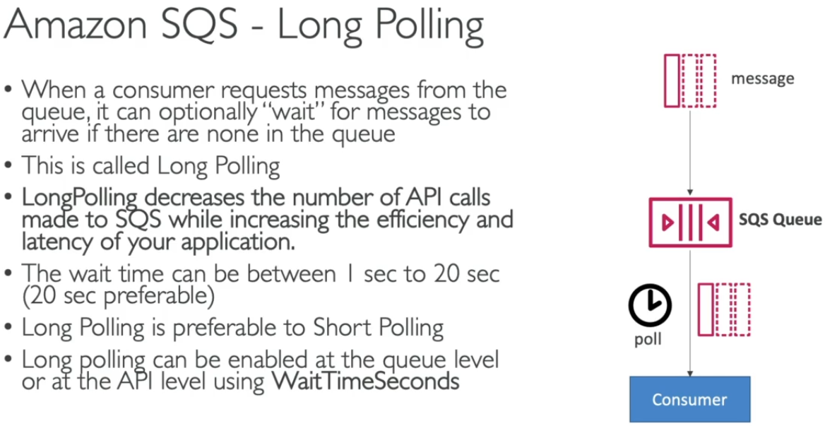 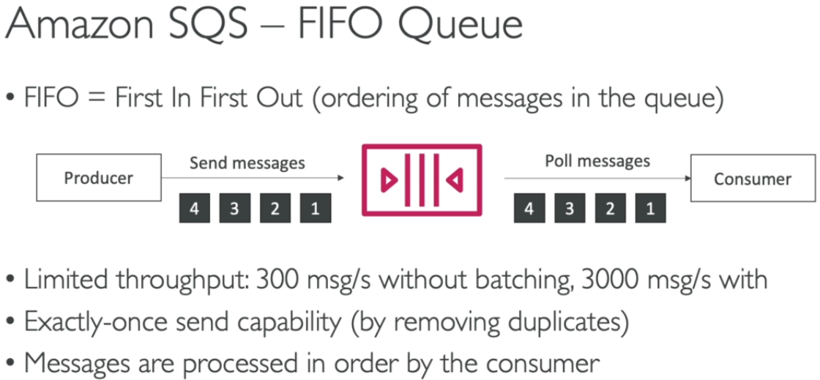

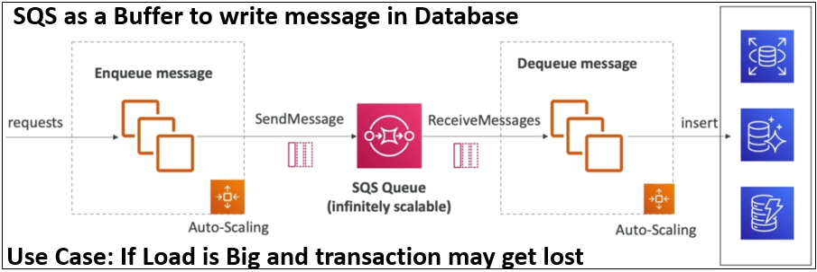

**2. Amazon SNS – (Simple Notification Service- used to send notifications to users/subscribers of multiple applications)**

* SNS is basically used to send one message to many receivers.
* SNS is integrated with a lot of AWS services.

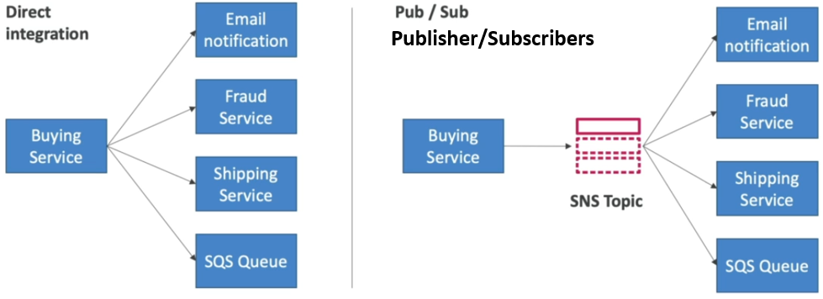 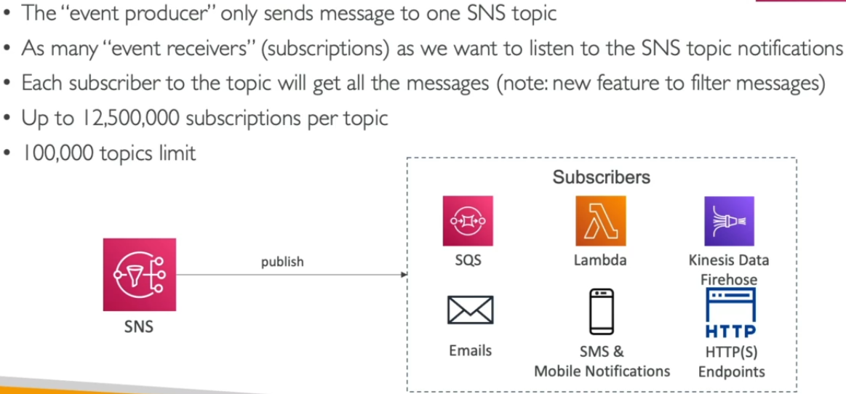

* Message publishing types -

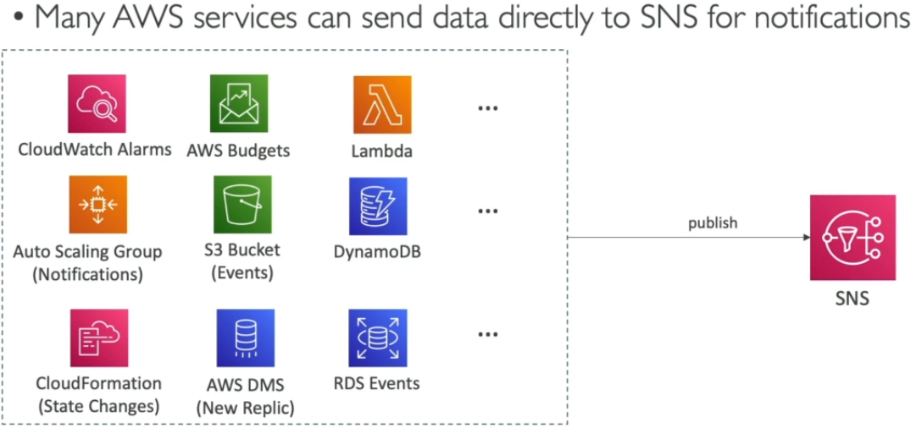 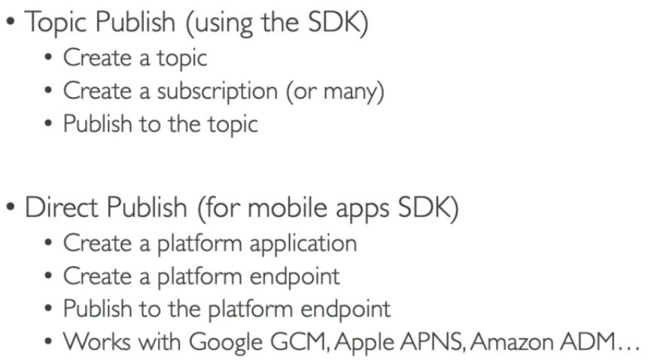

**Process: Open SNS and create topic > select standard type > select access policies (AWS account, IAM users, owner) > create > create subscriptions (SQS, Lambda, Email, HTTP, HTTPS, SMS, Kinesis) > confirm subscription at other end > Publish message > Receive notifications at other end.**

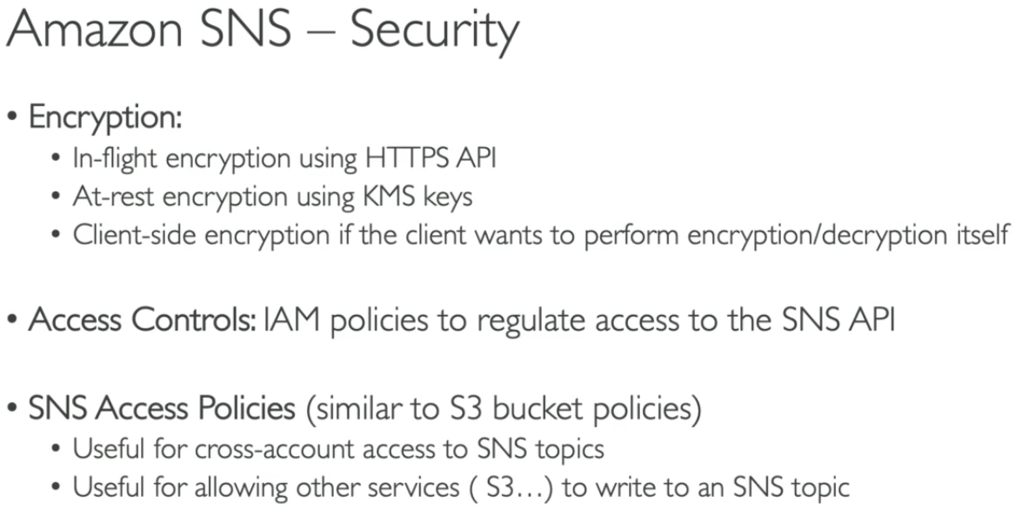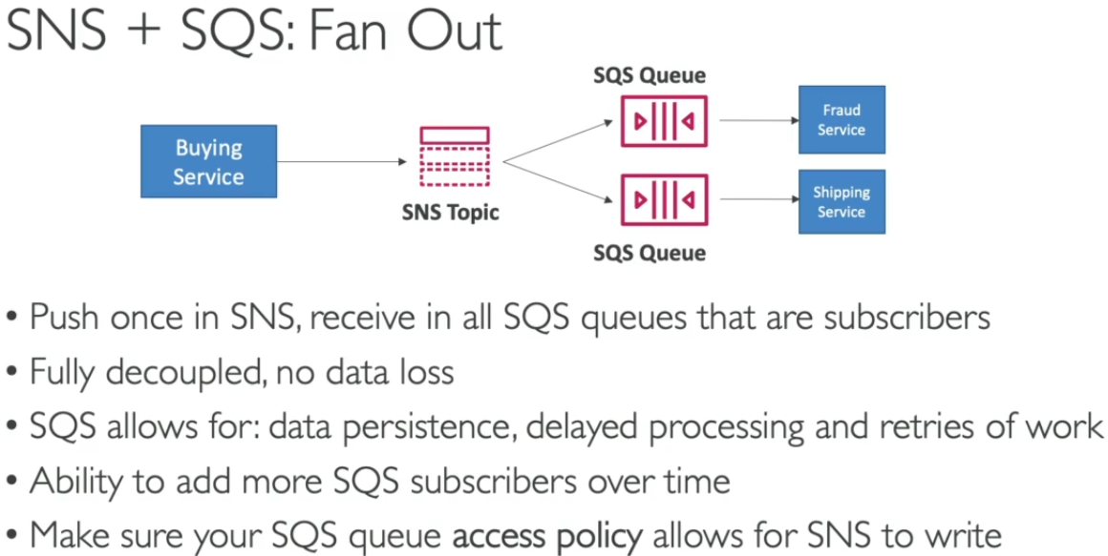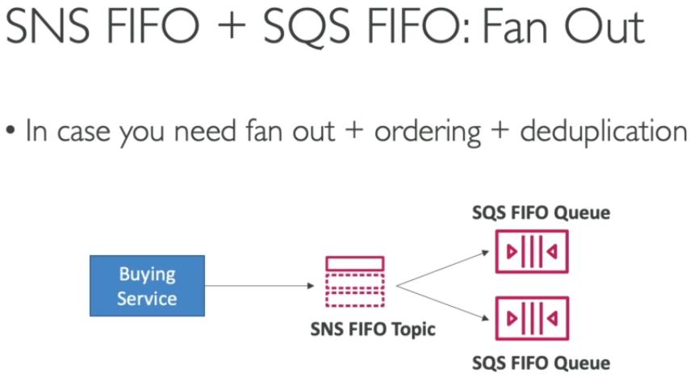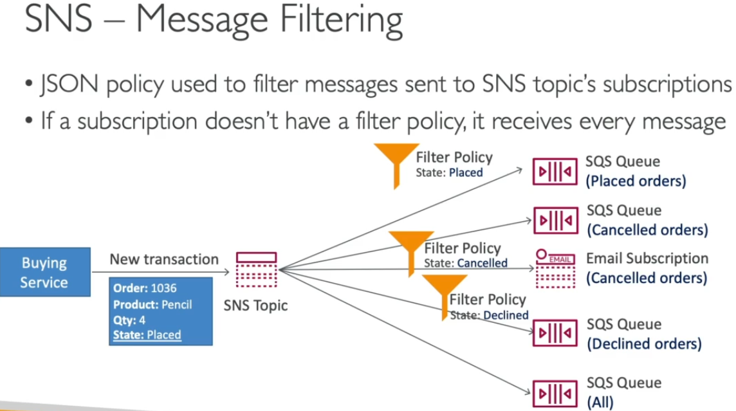

**3. Amazon Kinesis – (Used to collect, process, analyze streaming data in real-time)**

* Data can be Application logs, Metrics, Website clickstreams, IoT Telemetry data.
* Types of data streams services – Data streams, Data Firehose, Data Analytics, Video Streams
* Kinesis Data Analytics – (Analyze Data streams with SQL or Apache Flink)
* Kinesis Video Streams – (Capture, Process, Store video streams)

>>> Kinesis Data Streams – (Capture, Process, Store Data Streams)

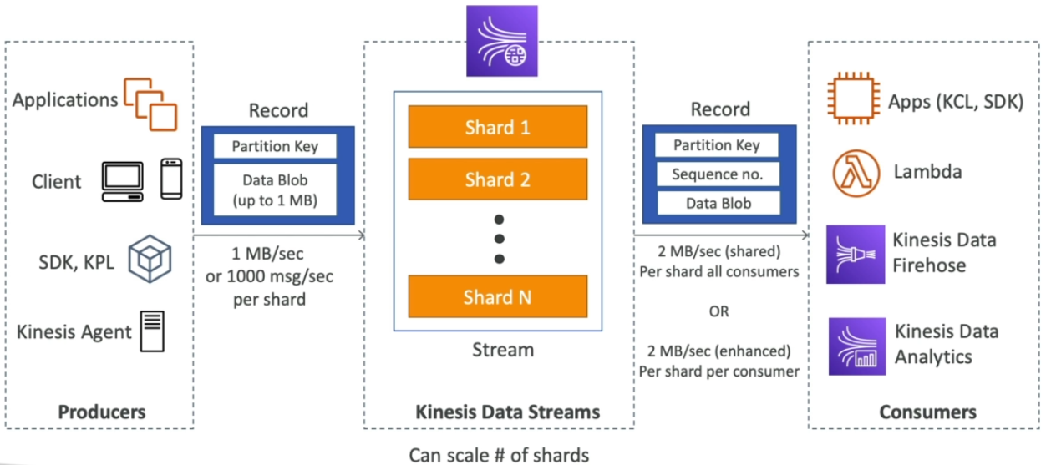 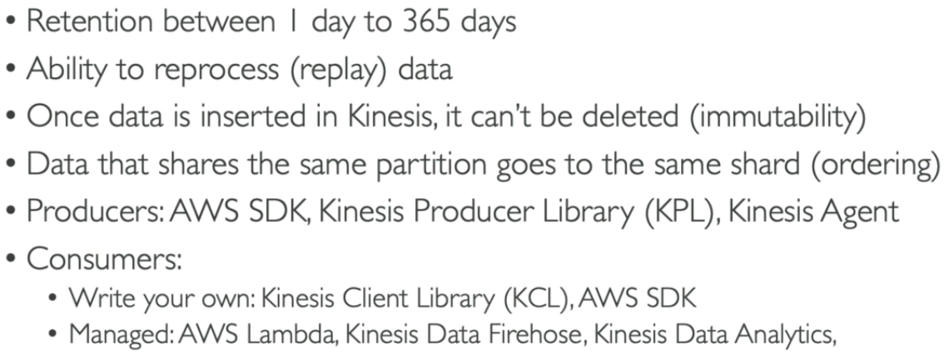

* Capacity Modes and Security

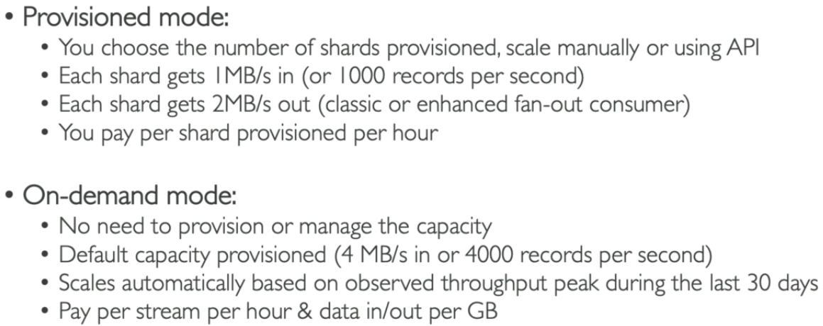 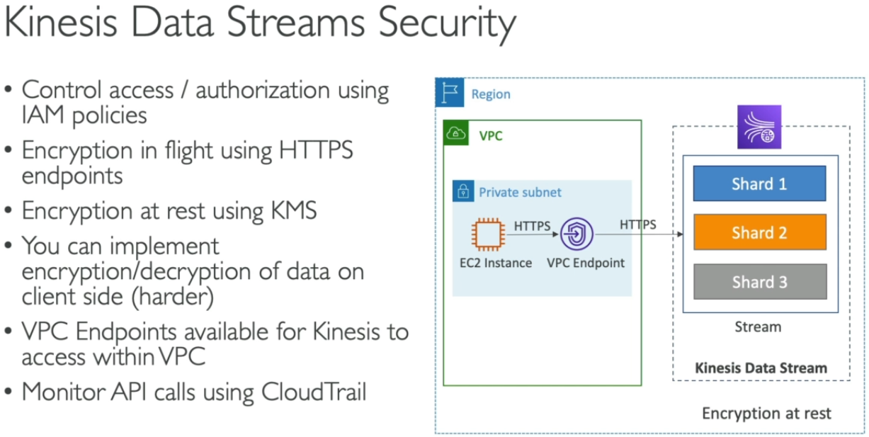

>>> Kinesis Data Firehose – (Load Data streams into AWS data stores)

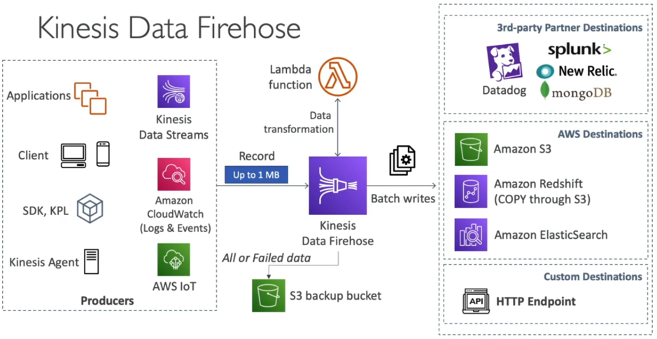 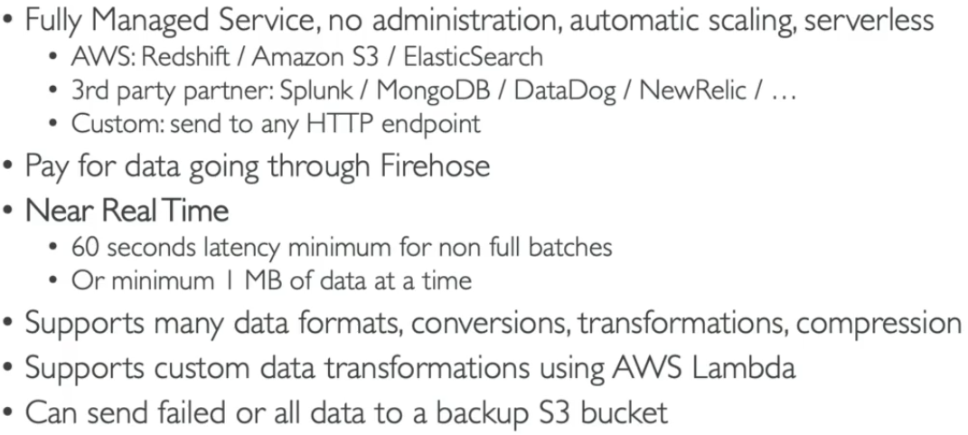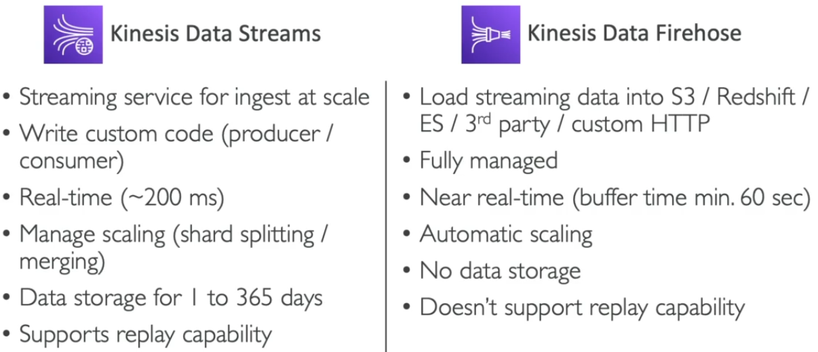

**# SQS vs. SNS vs. Kinesis** 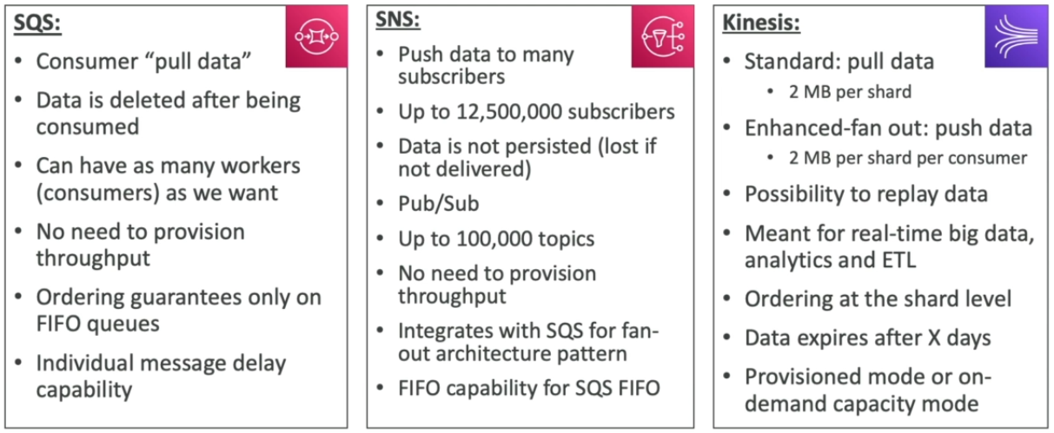

**# Amazon MQ can be used when migrating data from open source platforms (MQTT, Openwire, WSS….)**

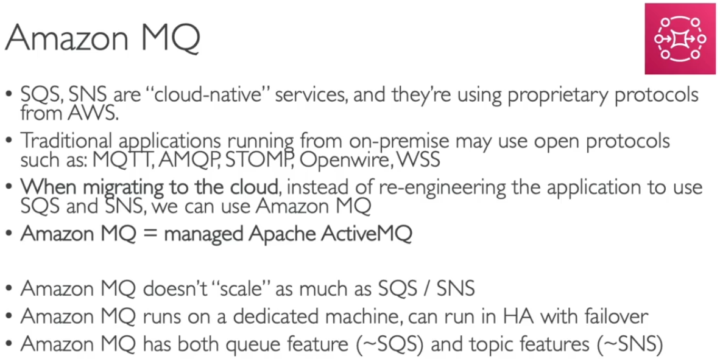 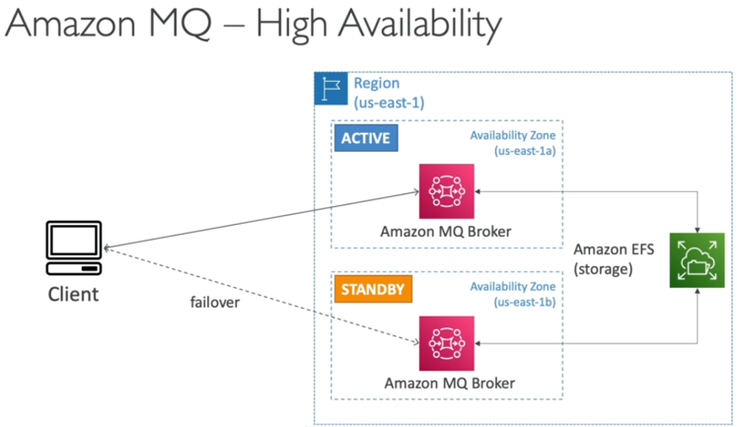

**#** **Cloud Front – (Content Delivery Network-CDN) Global Service**

* Improve read performance – content is cached at edge locations (216 points at present)
* DDoS protection, Integration with Shield, AWS web application Firewall
* Cloud front origins -

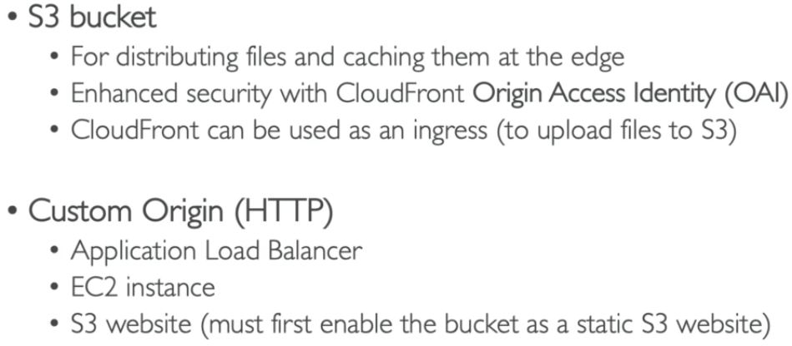 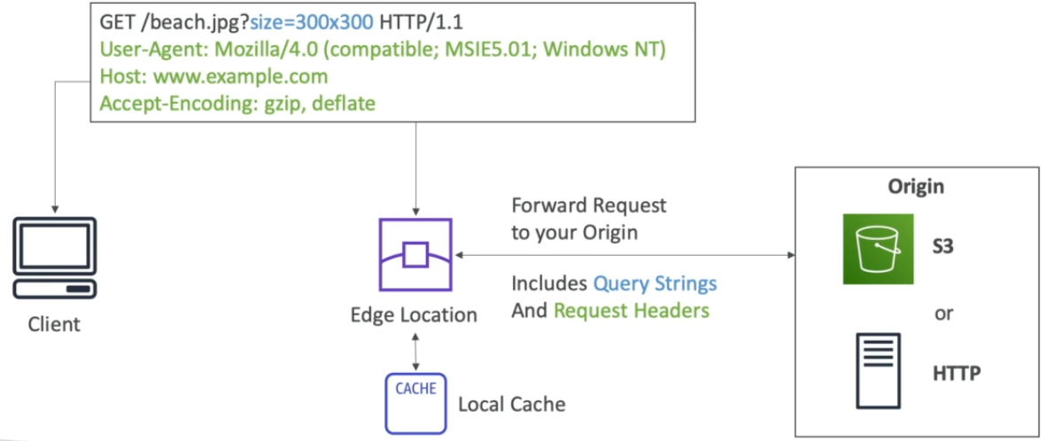

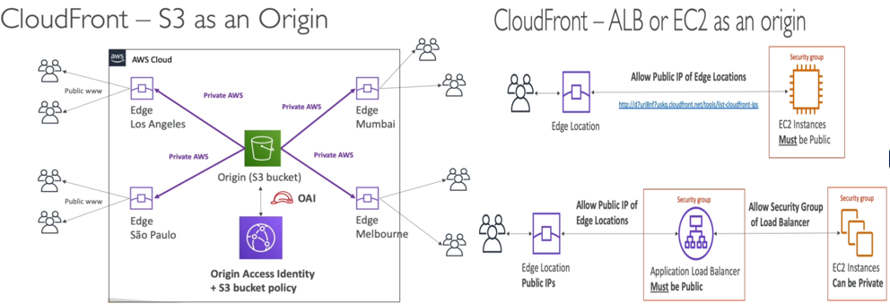

**Edge locations -** [**https://aws.amazon.com/cloudfront/features/?whats-new-cloudfront.sort-by=item.additionalFields.postDateTime&whats-new-cloudfront.sort-order=desc**](https://aws.amazon.com/cloudfront/features/?whats-new-cloudfront.sort-by=item.additionalFields.postDateTime&whats-new-cloudfront.sort-order=desc)

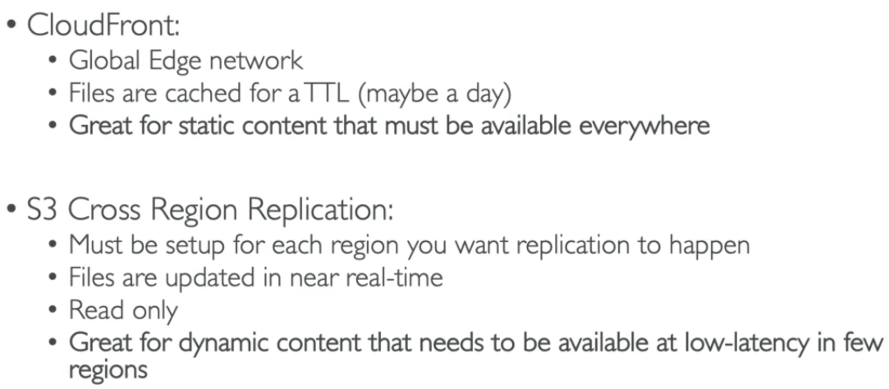 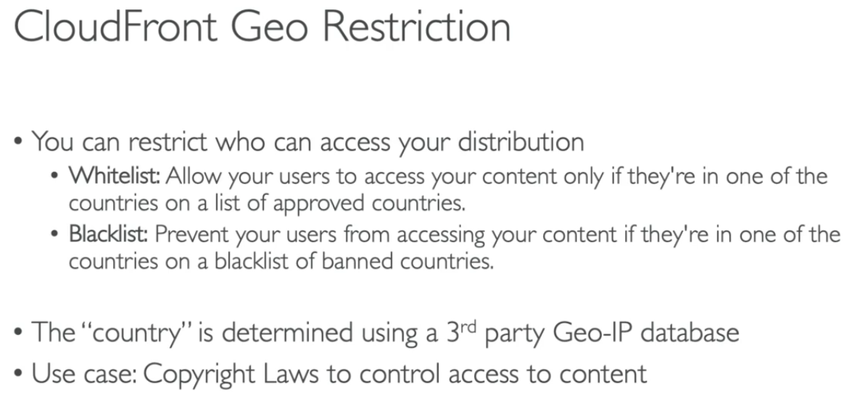

**Process: Create a bucket > upload html files & content > create cloud front distribution > select Origin Domain (S3) > create OAI (origin access Identity) & attach > select html file as root object > create > Use Distribution Domain Name to access the website content > Now this content is stored in edge location (as per TTL settings) & will be accessed from here itself.**

* When we access a global service through internet it can cause latency due to many hops.
* **Unicast IP:** One server hold one IP address
* **Anycast IP:** All server hold same IP address & request is redirected to nearest server

**>>> Cloud front charges & Price classes – (Catch refresh/invalidation can be set for edge location using TTL)**

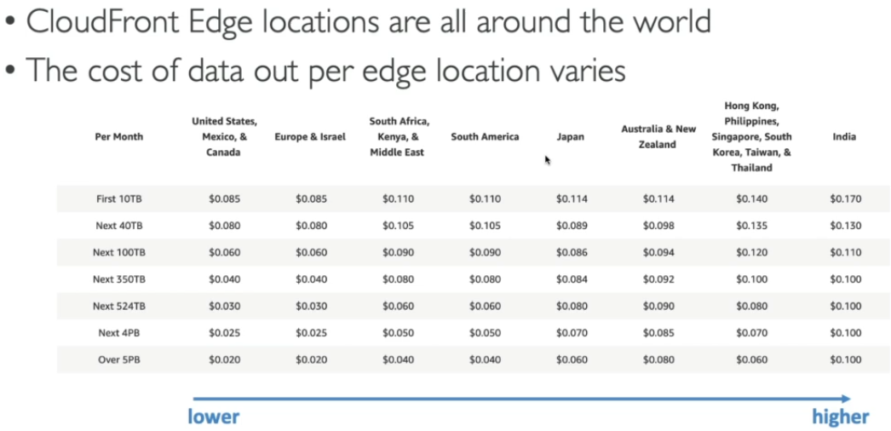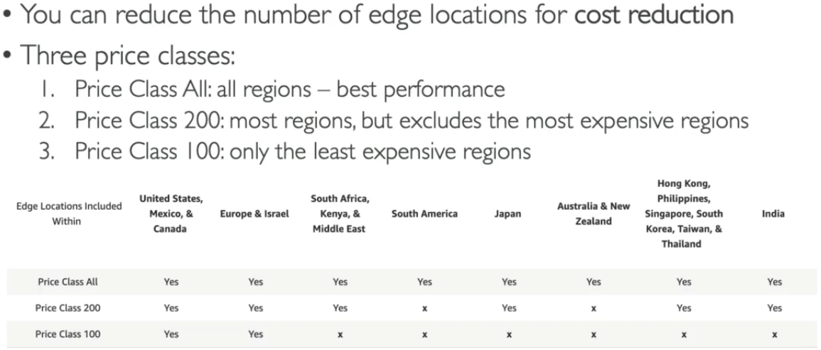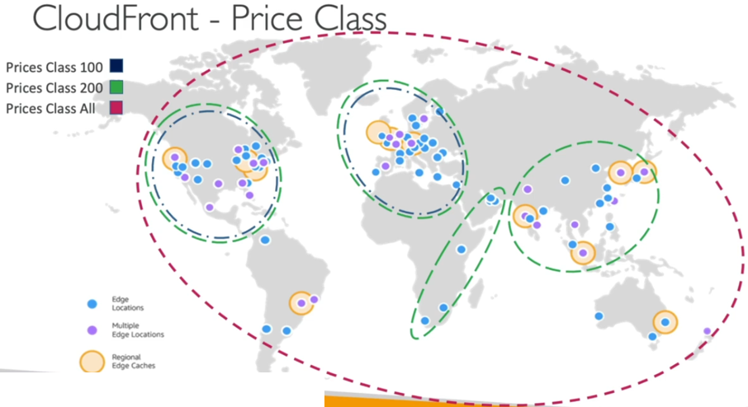 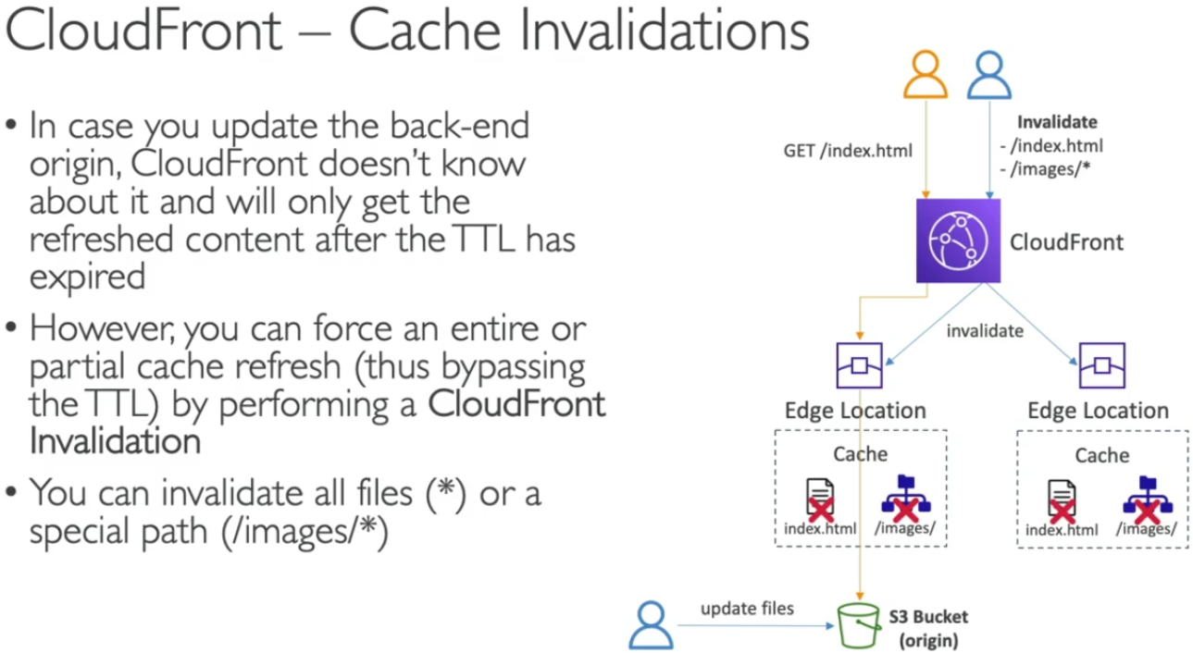

**>>> AWS Global Accelerator – (Catch refresh/invalidation can be set for edge location using TTL)**

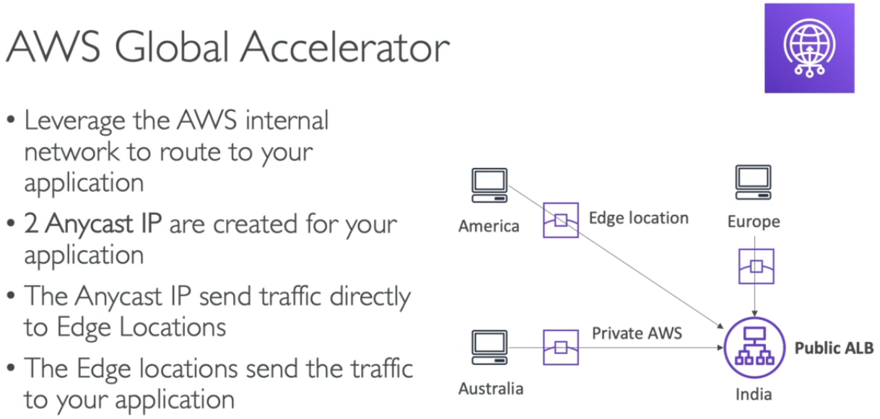 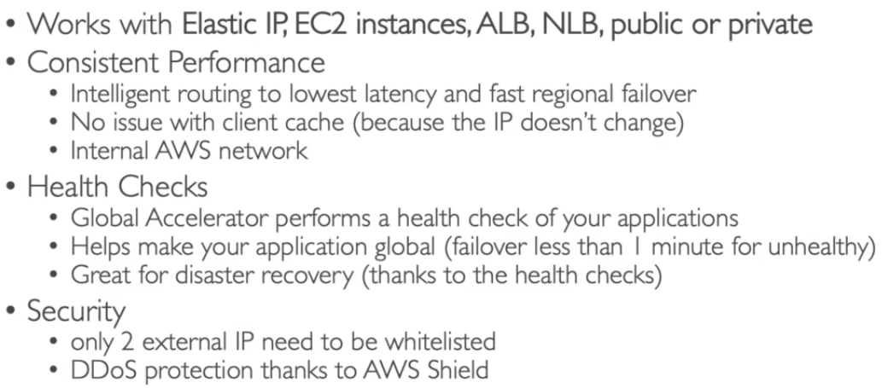

**Process: Create 2 EC2 in different regions (allow http) > create AWS global accelerator > assign name > set ports (80-TCP) > set Endpoints (ALB, NLB, EC2, Elastic IP) > create > Use Static IP or DNS name to access servers**

**Link to check pricing details -** [**https://aws.amazon.com/global-accelerator/pricing/**](https://aws.amazon.com/global-accelerator/pricing/)

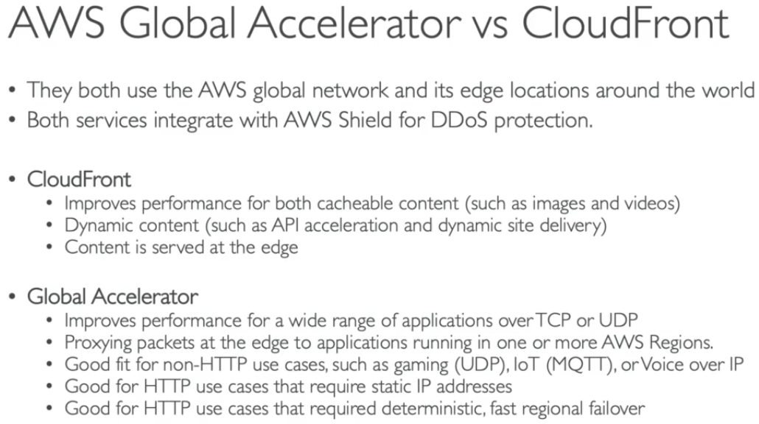

**# AWS Lambda Function – (Serverless Concept)**

|  |
| --- |
| **Infrastructure as a Code [IaaC]** |

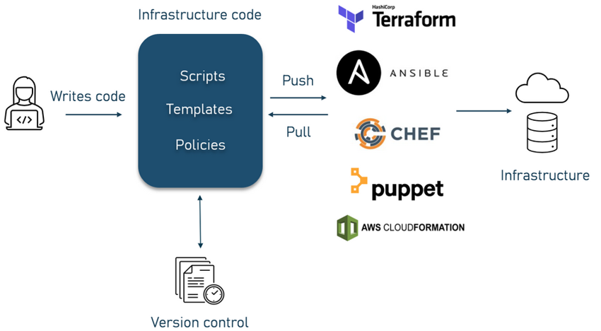

**# AWS CloudFormation – (CFT- JASON/YAML)**

* Used to create **new infra** resources in AWS environment.
* It will not duplicate the existing resources.
* GUI is also available
* Process : [CFT > Stacks > Provision]

1. Code infrastructure using CloudFormation template language in YAML or JSON format, or start from many available sample templates.
2. Use AWS CloudFormation via console/CLI/APIs to create a stack based on your template code.
3. AWS CloudFormation provisions and configures stacks and resources you specified in your template.

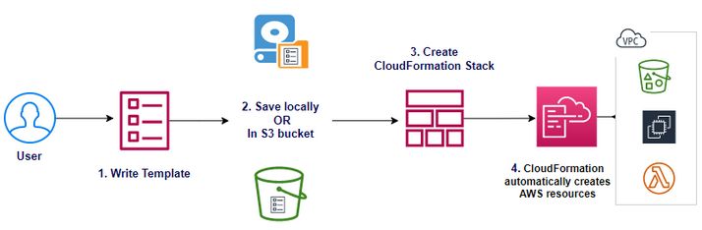

**1. AWS CF Templates – (CFT- JASON/YAML)**

* It is a simple program written in Jason/YAML language with infra info which we want to create.
* Important objects of templates-

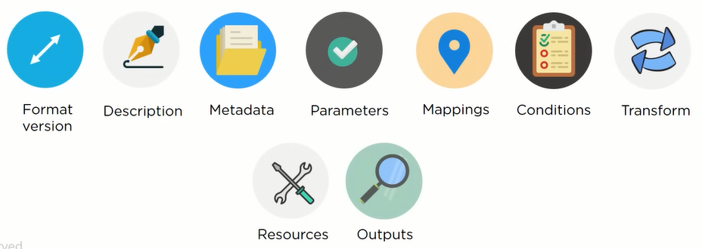 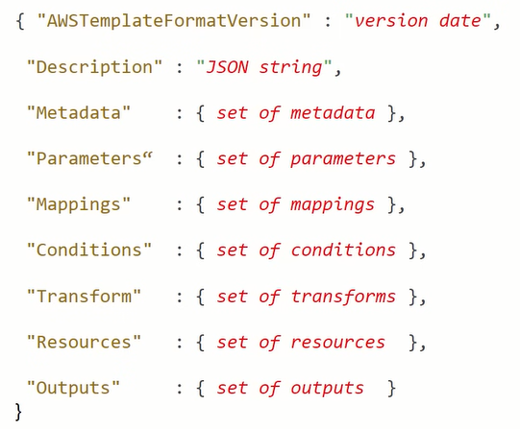

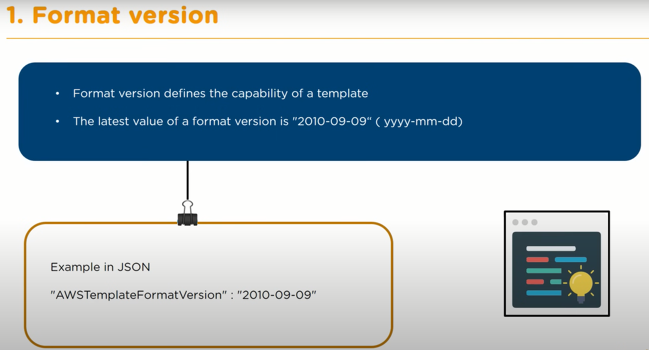

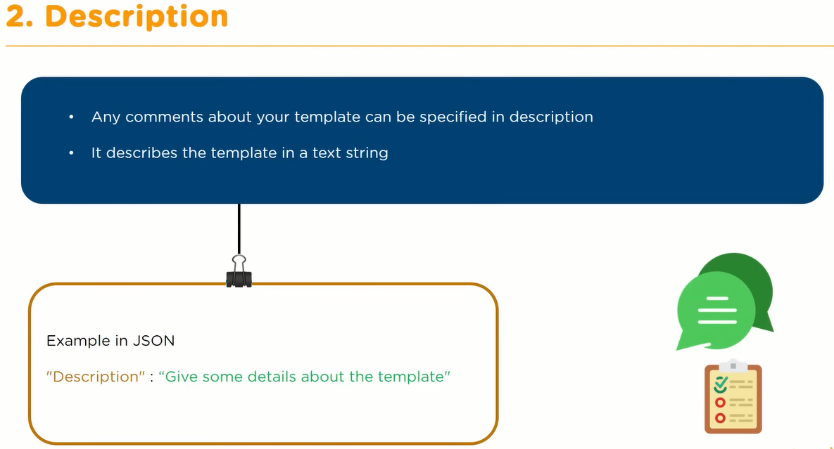

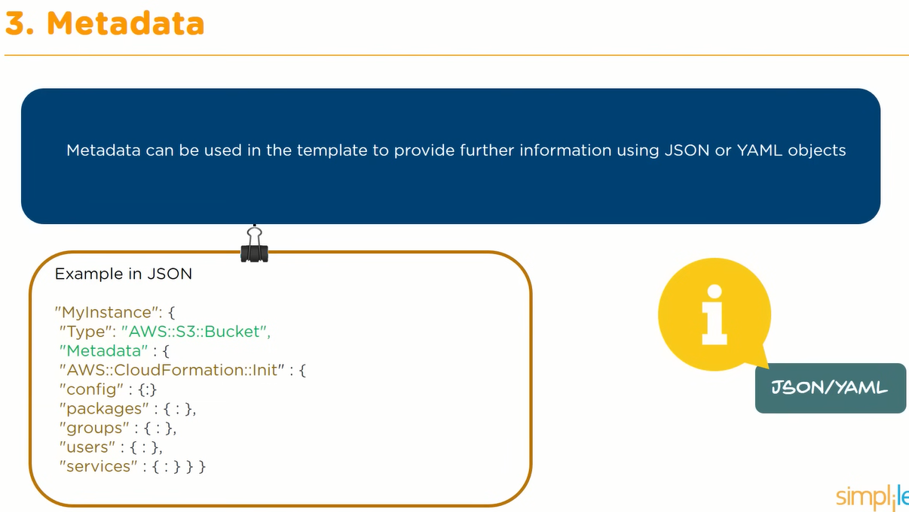

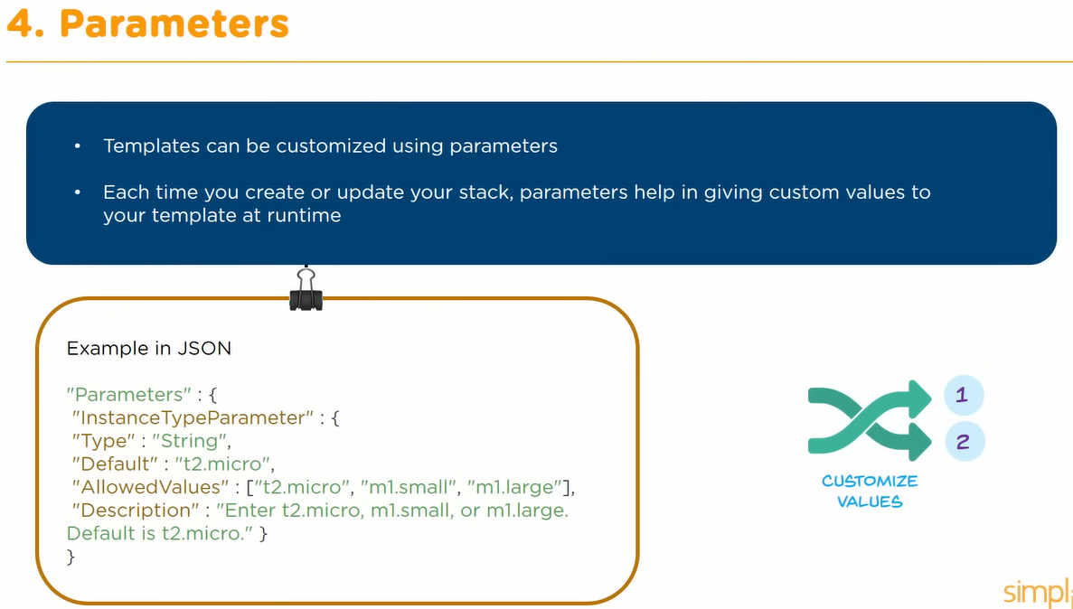

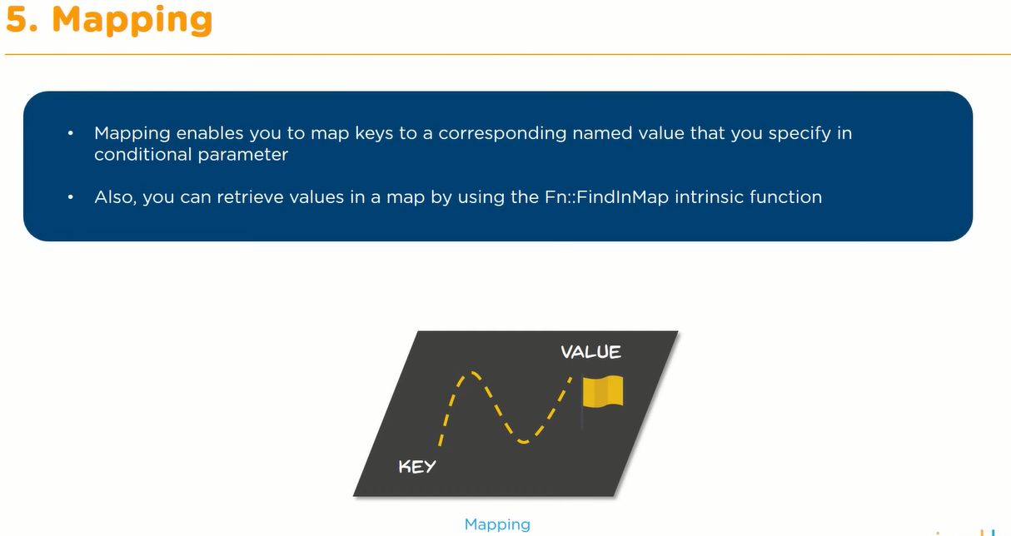

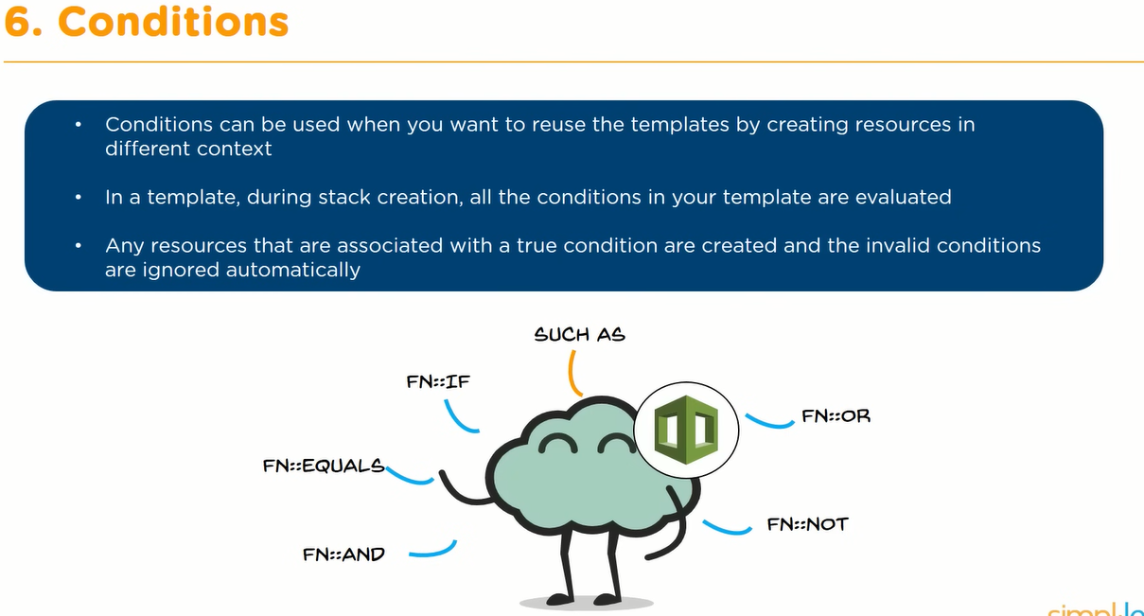

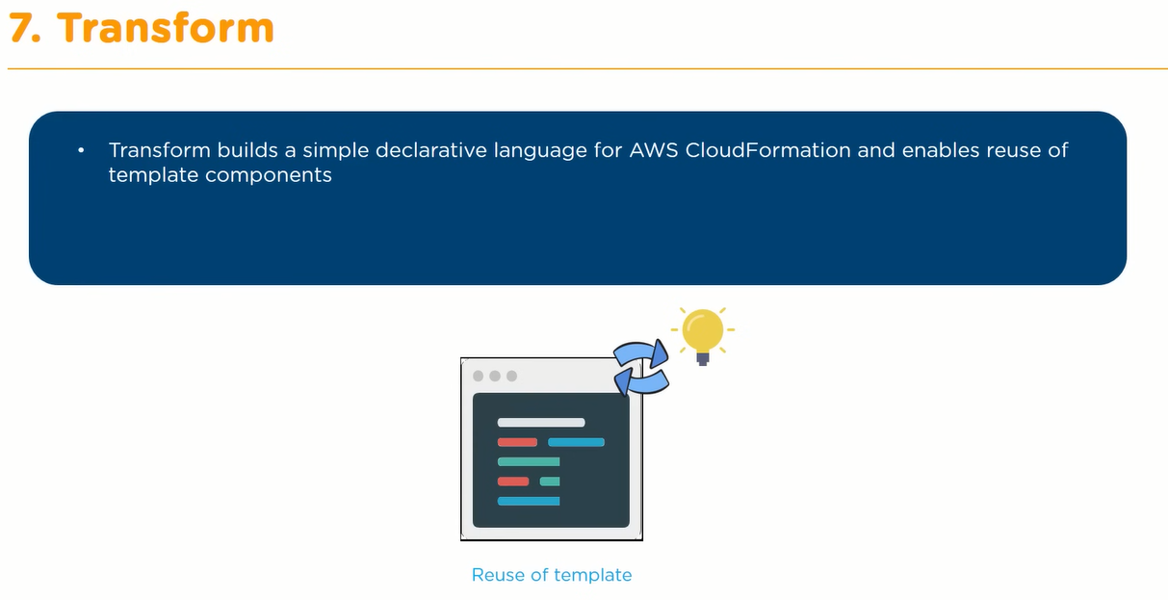

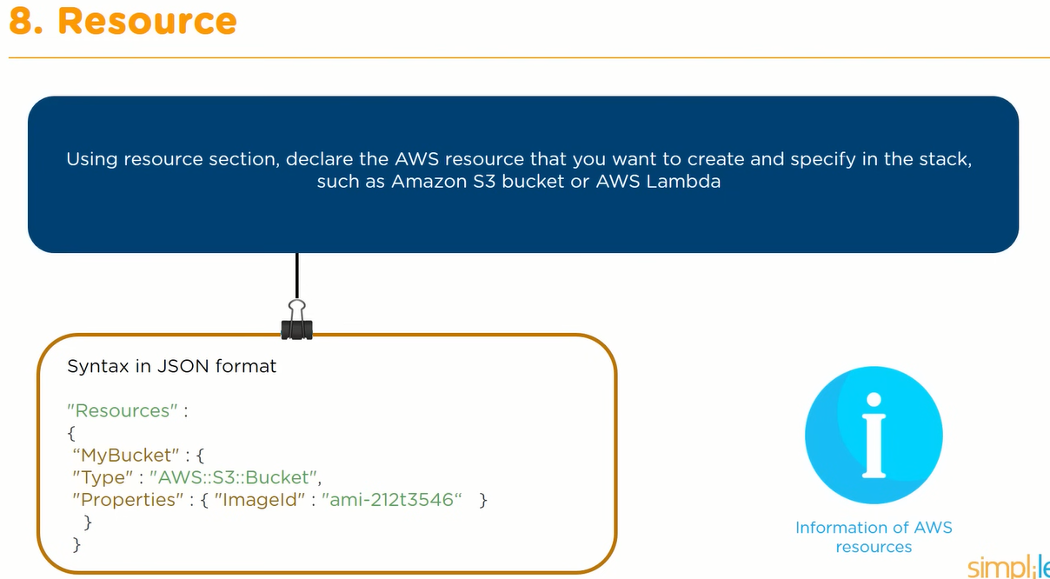

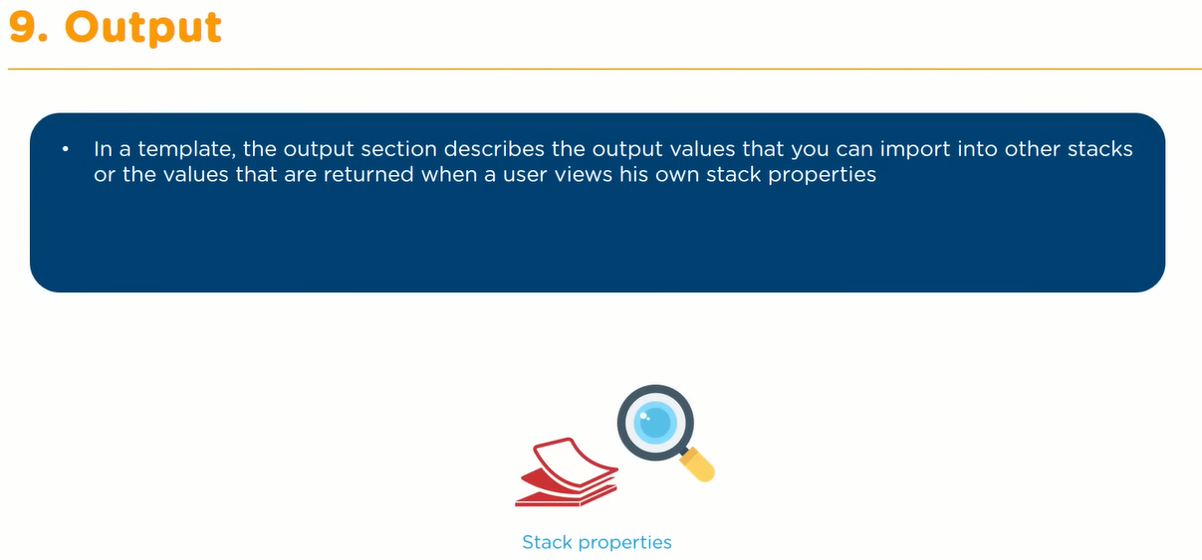

**# Terraform – (TFT- HCL/JASON)**

* Used to create **new infra** resources in muti-cloud environment.
* It is Open source third party tool (Hashicorp).
* It will not duplicate the existing resources.
* It is CLI managed (GUI is also available in enterprise version)

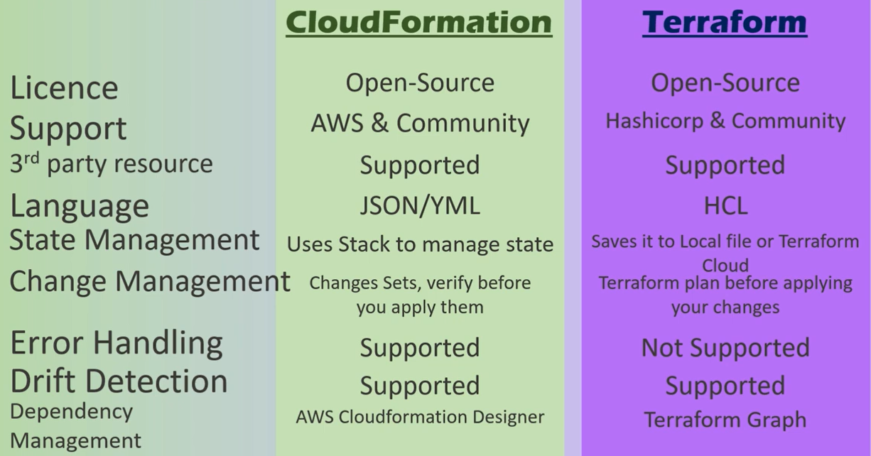

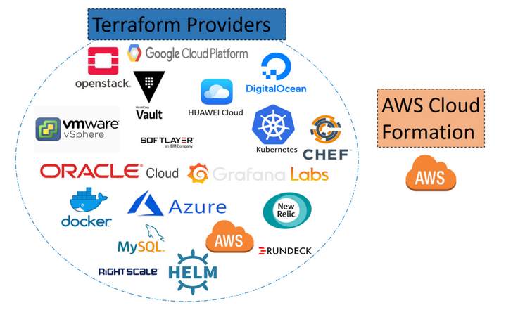

**# Python Boto3 – (AWS Access using Boto3)**

* Used to create **new infra resources as well as manage existing resources** in AWS environment.
* It is used to automate existing resources.
* While creating new infra – it will duplicate the existing resources.**(troubleshooting is not easy)**
* Install Boto3 library using – pip install Boto3
* Run scripts using – python file.py
* [Powershell + Shell script + Python script] – uses AWS CLI codes and commands, But python with Boto3 use Boto3 library with its objects & methods to access AWS Services.
* Core Concepts-

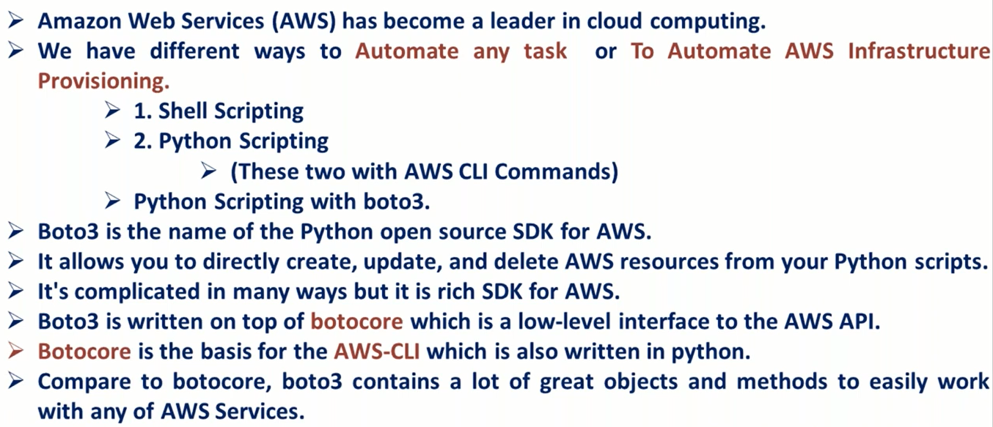

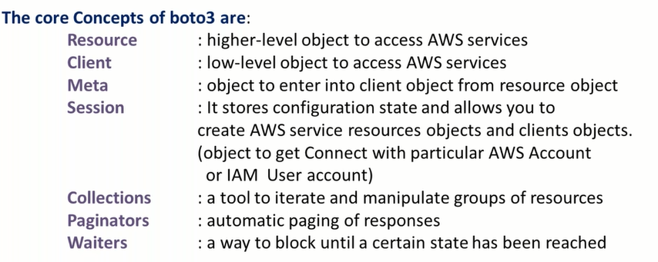

* **Steps to write any program using Boto3 library-**

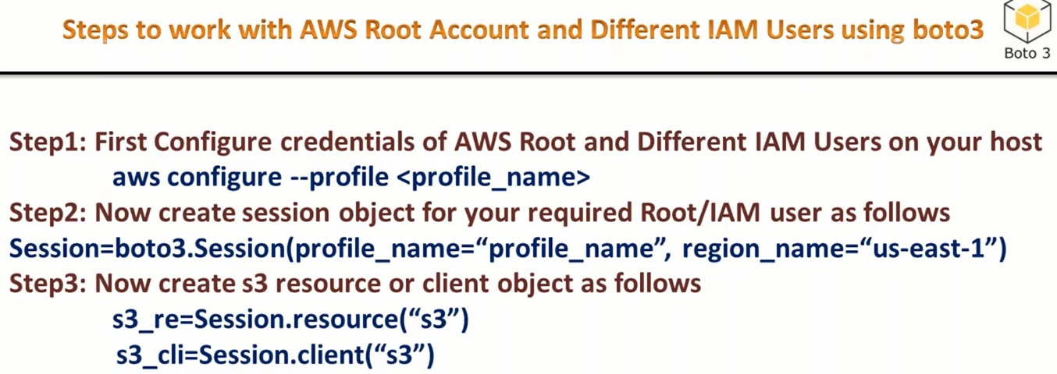

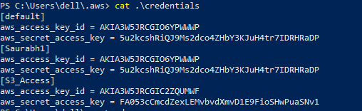

* **Session object can be created with or without session method -**

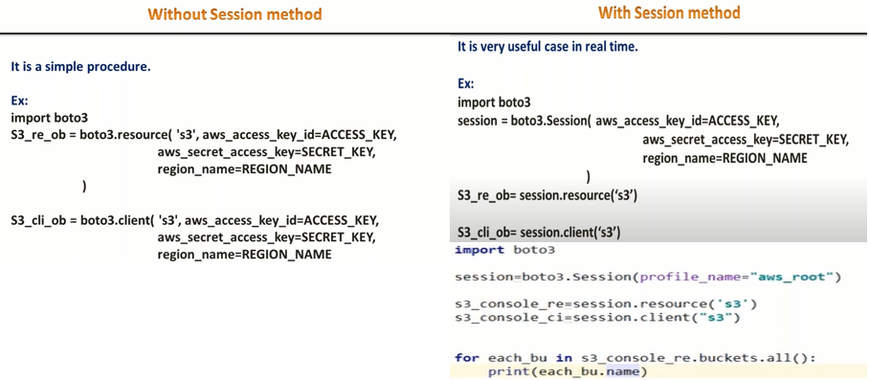

* **Do Not Hardcore Access key & Passwords in program – not good practice**

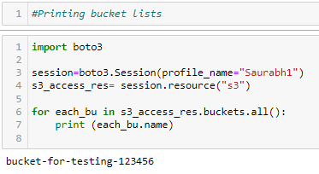 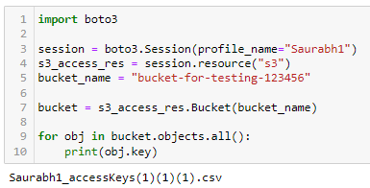

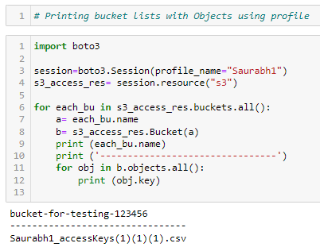

|  |
| --- |
| **Networking Basics** |

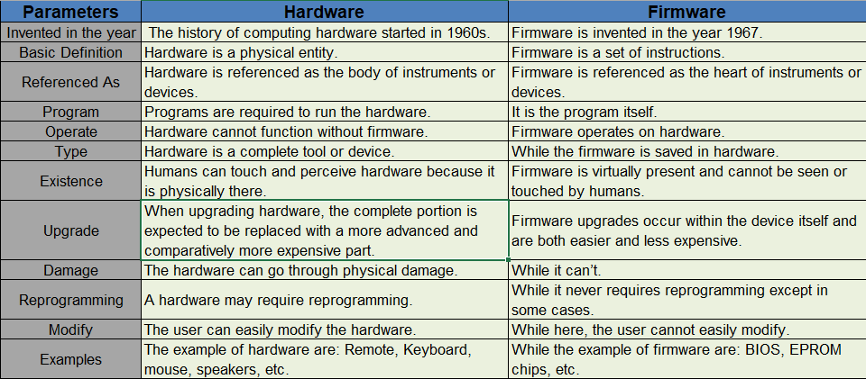

* **Hardware:** Hardware is the computer’s part that is seen and touched by us. These are the physical parts of the computer. Which make up the body of our computer. Like; Keyboard, mouse, cabinet, monitor, printer, etc. is all hardware.
* **Firmware:** Firmware is a type of software that is associated with your hardware, Firmware is software installed at the time of manufacturing any hardware, including hardware such as keyboards, hard drives, [BIOS](https://www.geeksforgeeks.org/bios-full-form/), graphic cards, and printers or moreover It comes embedded in any of your home appliances such as TVs, washing machines, etc. The firmware contains instruction programs to perform the basic functions of any hardware.

(This can’t be accessed by user)

* **Software:** It is simply a collection of a set of programs, procedures, data, or instructions used by a computer to perform specific tasks and allows the user to interact with the computer.

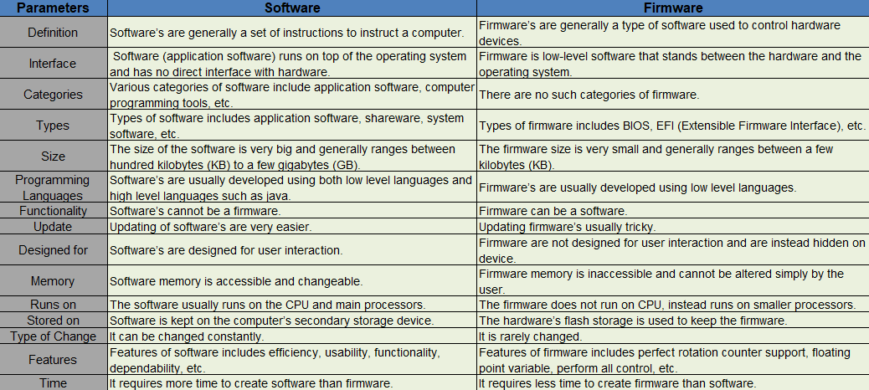

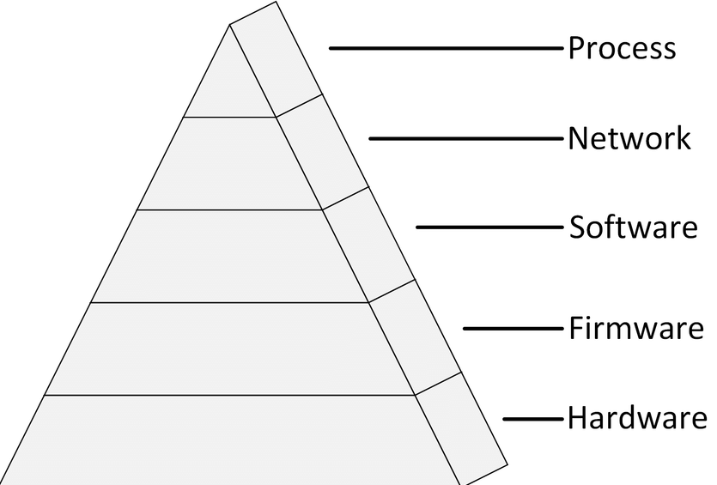 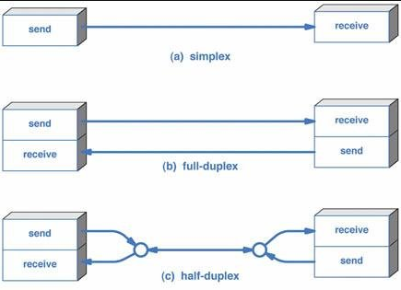

**>>> OSI Model – (Open Source Interconnection- 7 Layers)**

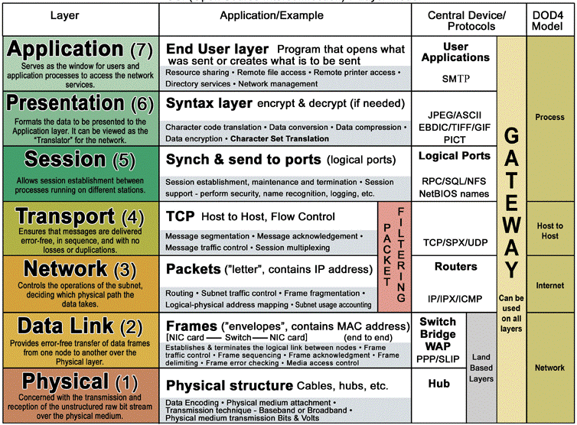

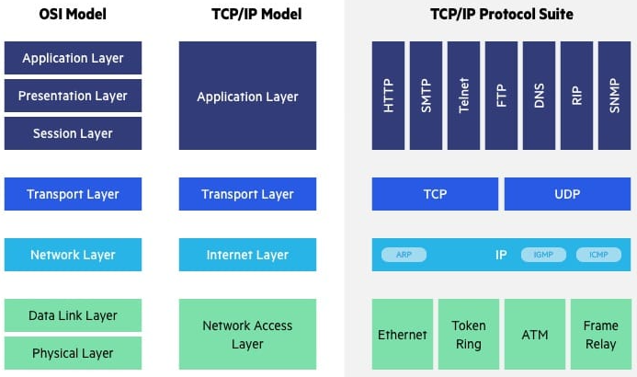 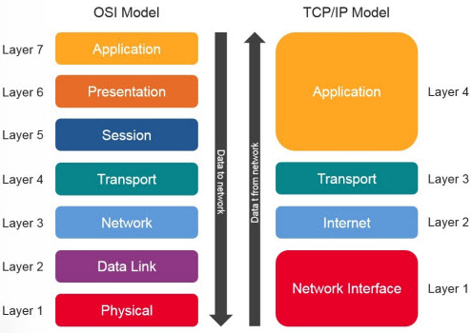

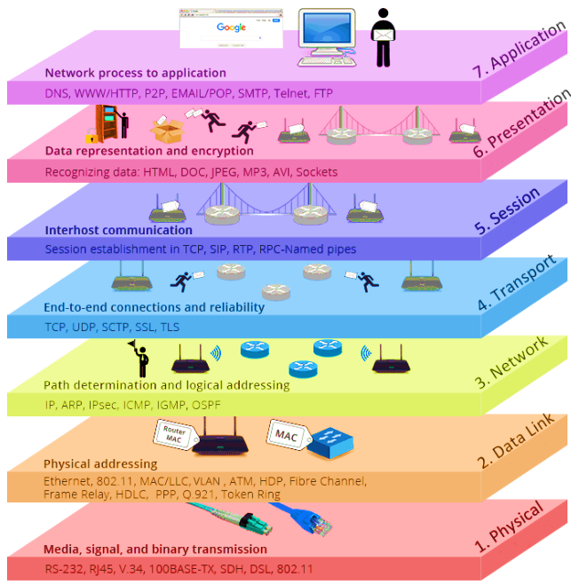

**>>> TCP/IP Model – (Transmission Control Protocol + Internet Protocol – 4/5 Layers)**

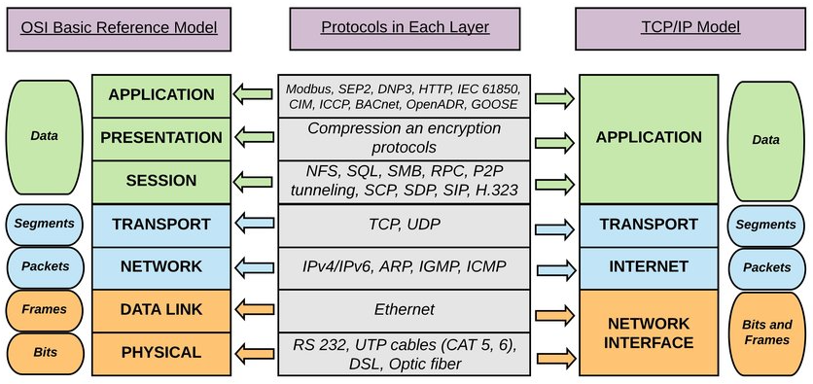

* **End Node Verification:** 2 endpoints of any data transfer are responsible for successful transmission of data.
* **Dynamic Routing:** End nodes can transfer data through multiple paths > N/w choose the route.

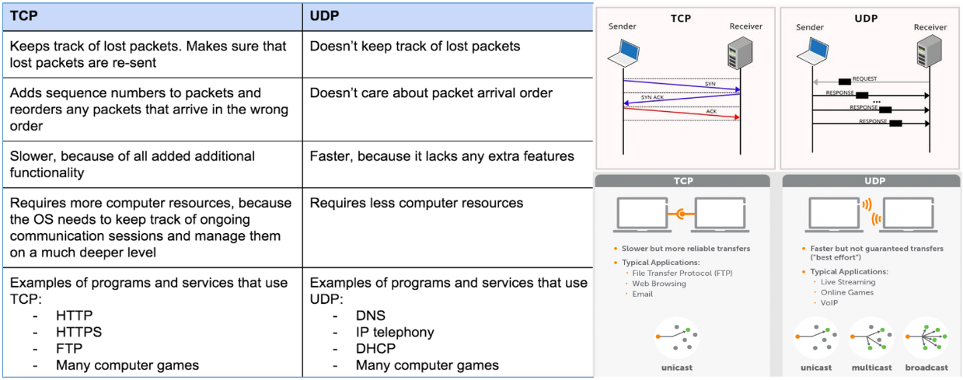

**>>> Network Devices –**

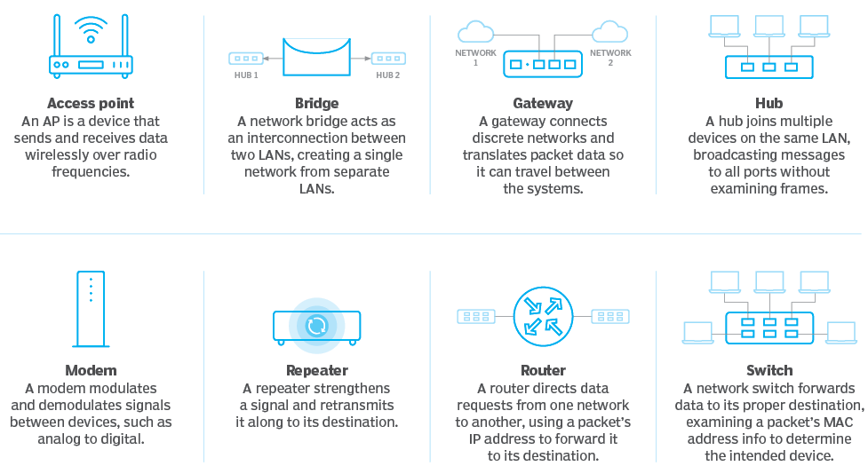 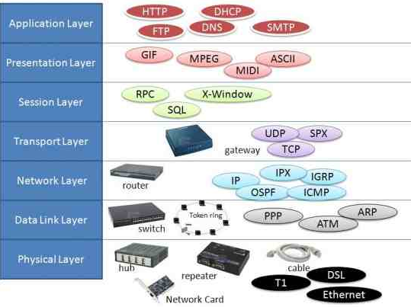

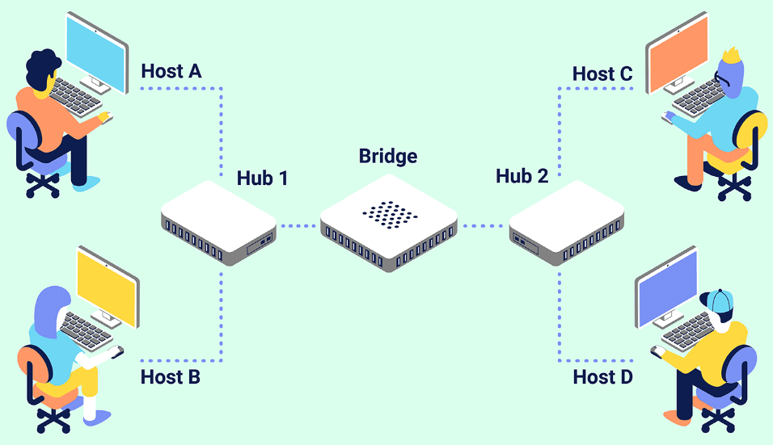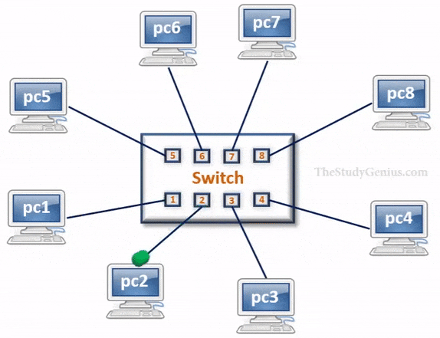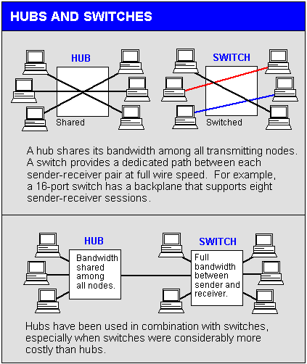

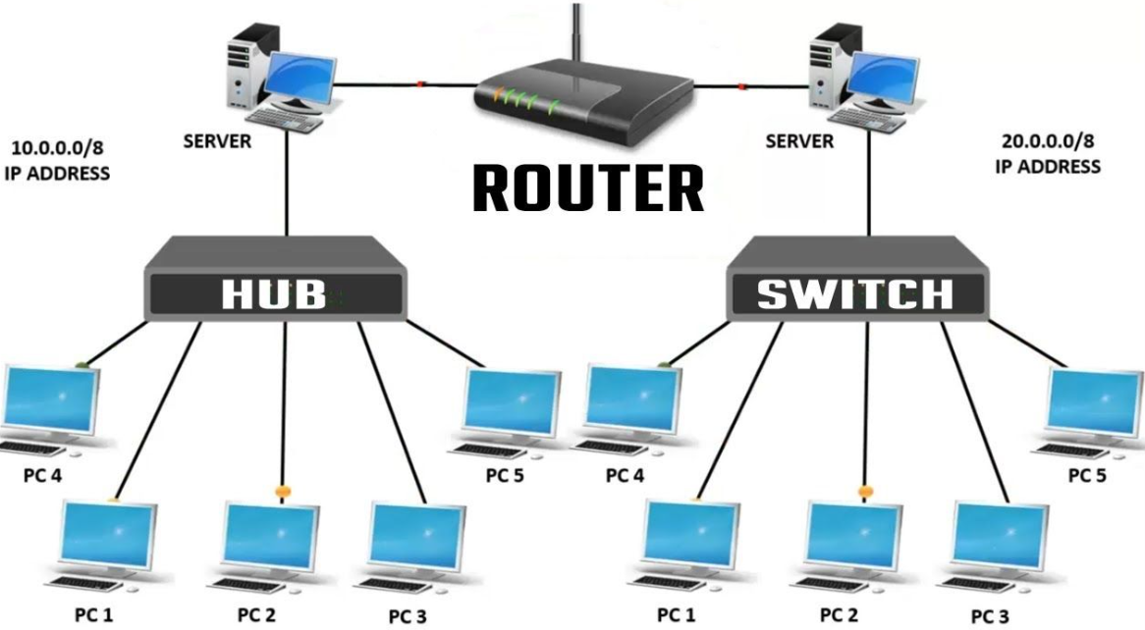 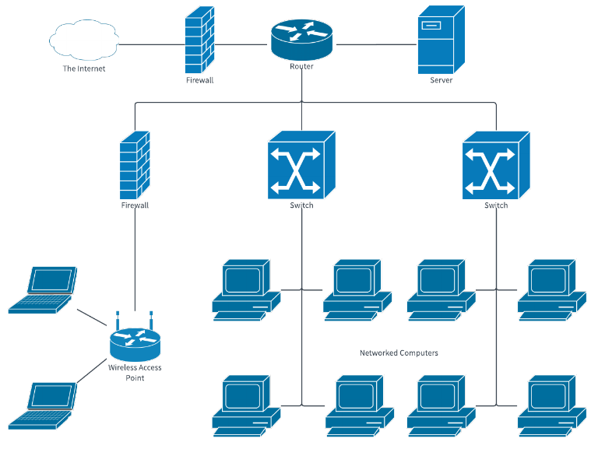

**>>> Network Topology –**

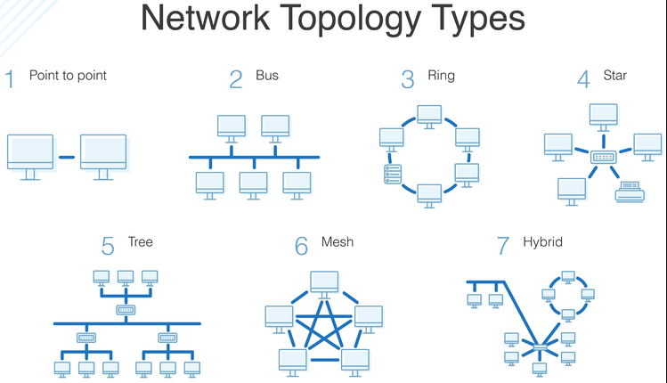

**>>> Network Types –**

* WAN – If comm. Is through **internet**, Require Routers + Satellite + Optical fibers, More vulnerable
* LAN – If comm. Is **not** through **internet**, Does not require Routers-but switches required, Most Secure
* MAN – If comm. Is in multiple buildings, use Ethernet

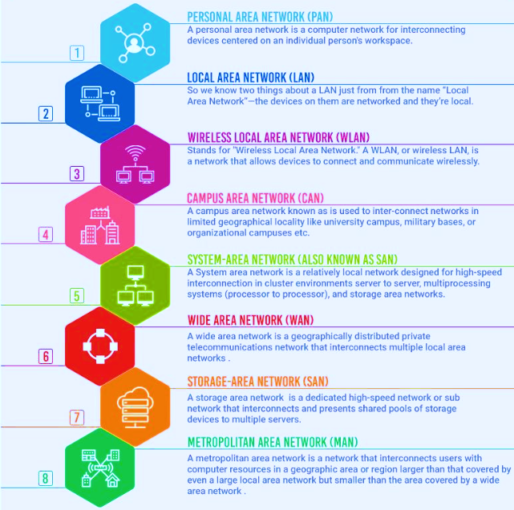 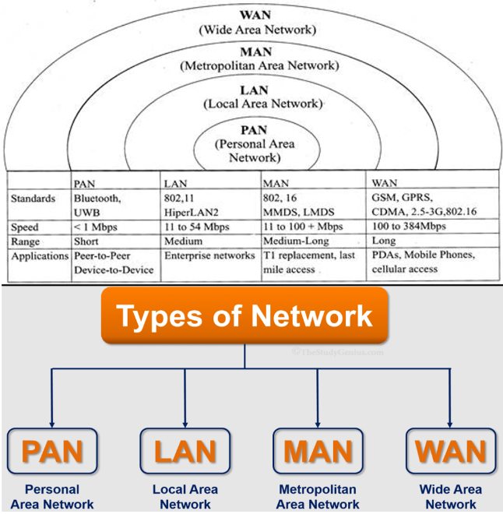

**>>> MAC Address – (Media access control / Physical address / Burnt-in-address)**

* It is globally unique (no. of MAC address in laptop = No. of Network Interface cards)
* Network Interface cards in a Network > Ethernet port + Wi-Fi + Bluetooth + Router/Switches
* MAC Address = 48 Bits Hexadecimal Code = 24 Bits (OUI) + 24 Bits (Vendor specific)

**OUI** (organization unique identifier) is managed by **IANA** (Internet Assigned Numbers Authority)

* Broadcast MAC address : FF:FF:FF:FF:FF:FF

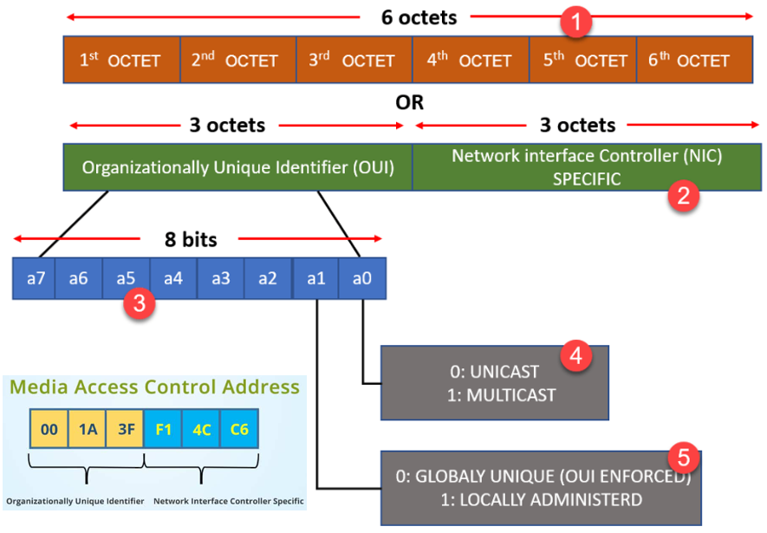 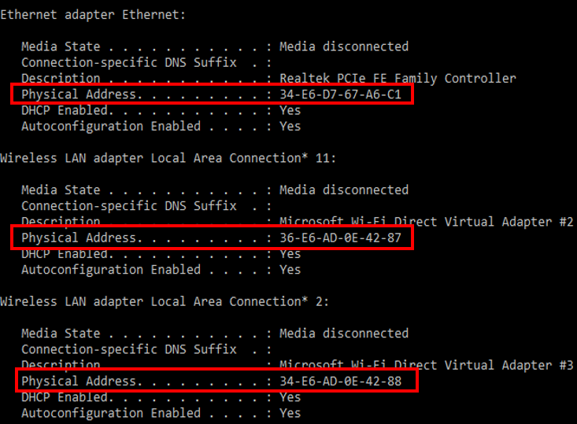

**>>> IP Address (Internet Protocol Address) – (It is combination of Network ID + Host ID)**

* IPv4 Protocol – Contains 32bits (150.10.20.30)
* Network ID – As per class make Host bits 0 and rest NET ID remains same. (150.10.0.0)
* Subnet Mask – Make Net ID bits = 1, Host ID bits = 0, as per class and calculate value. (255.255.0.0)
* Broadcast ID - As per class make Host bits 1 and rest NET ID remains same. (150.10.255.255)
* No. of usable IP = [2^(no. of Host Bits) – 2]
* Public IP we’ve to purchase, Private can be used normally.

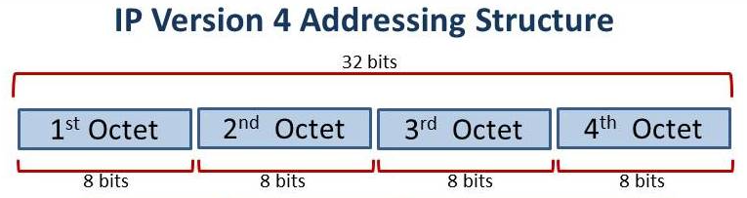

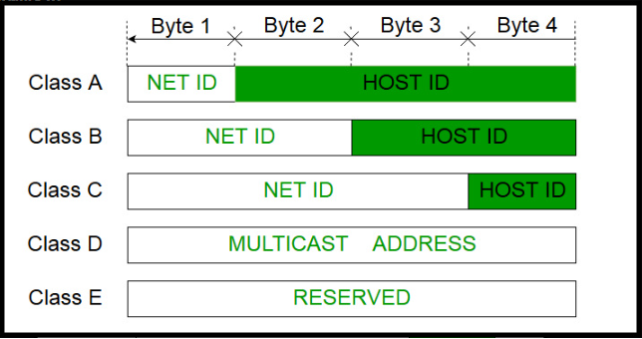 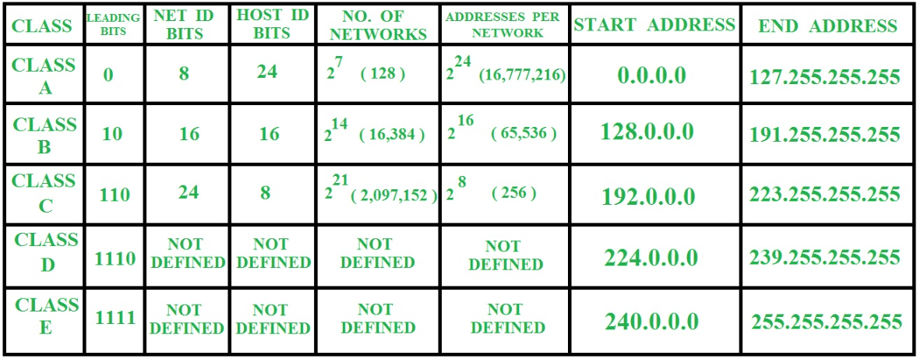 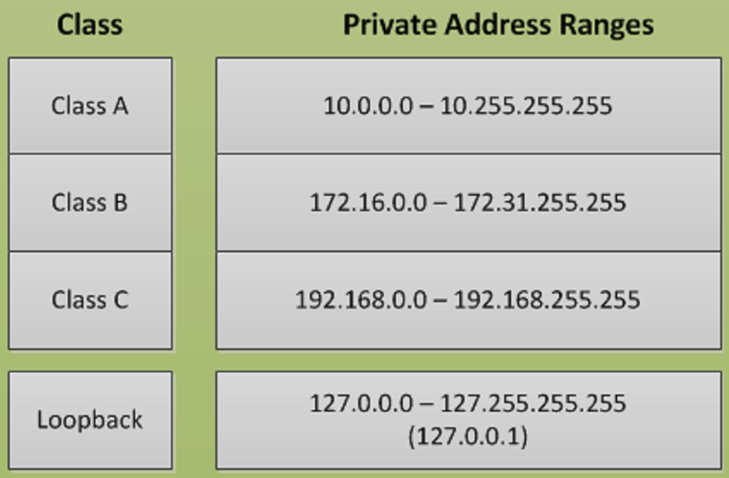

* IPv6 Structure and Types –

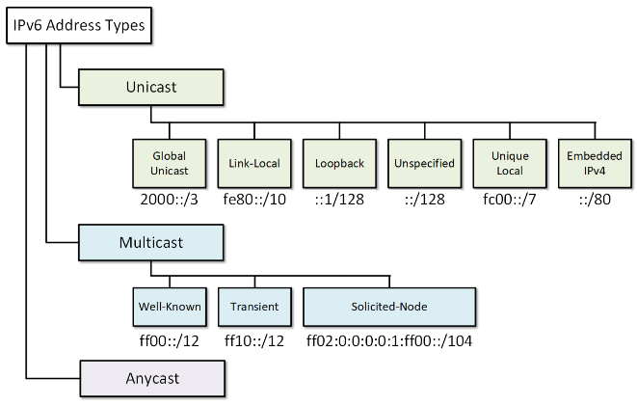 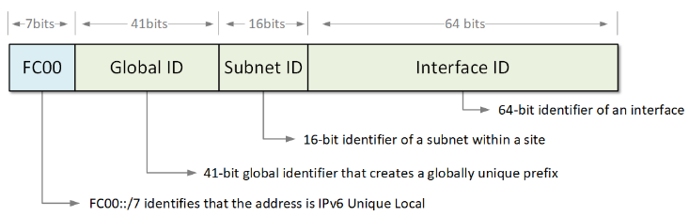

**>>> Subnetting – (Limited IP problem can be overcome using – IPv6, private IPv4 and Subnetting)**

* Network within a network / Logical Division of IP address
* Router’s each interface must have different Network ID i.e. different IP or Subnet ID
* Subnetting can be done on basis of- According to Host requirement and according to Network requirement.
* **CIDR (**Classless Inter-Domain Routing**) value = No. of bits assigned for network ID**

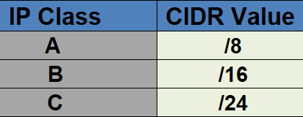 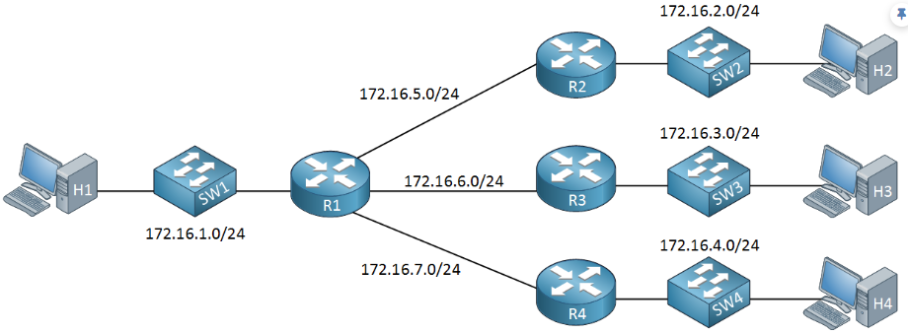

**>>> DNS Server – (Domain Name System –Provide User friendly Domain Names to IP/servers)**

* It is an **application layer protocol** and Uses **TCP Port 53** and **UDP Port 53**
* Forward & Reverse DNS Lookups
* DNS supports 13 Root name servers (**A to M**)
* 2 types of Namespace is supported by DNS: Flat namespace and Hierarchical Namespace(mostly used)

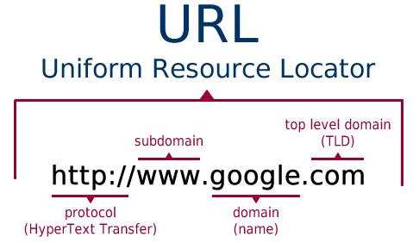 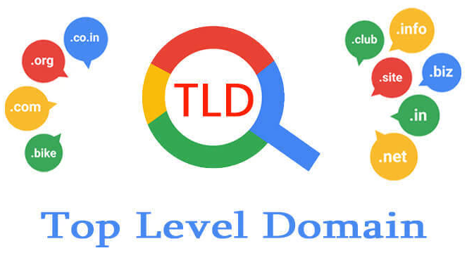 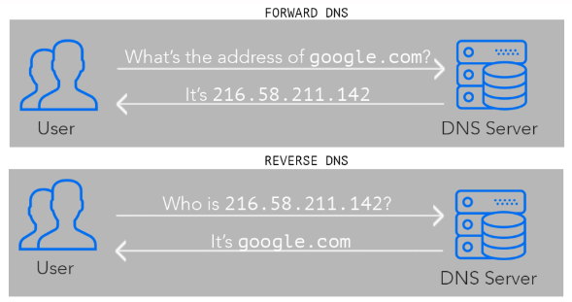 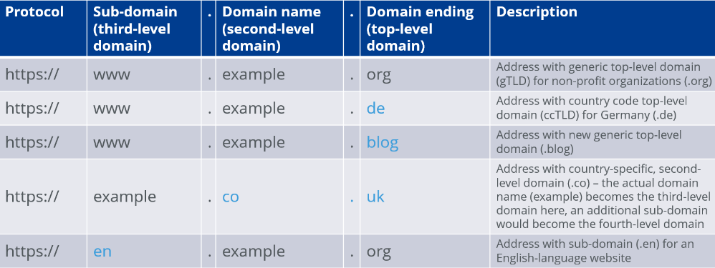

* **Hierarchical Namespace example -**

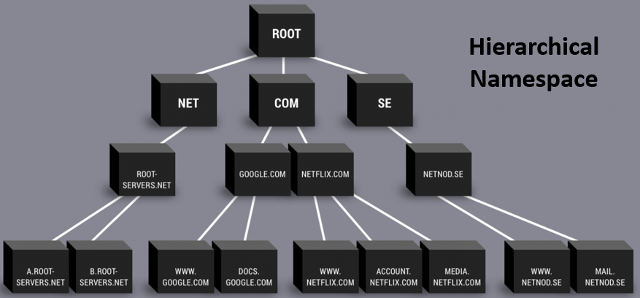 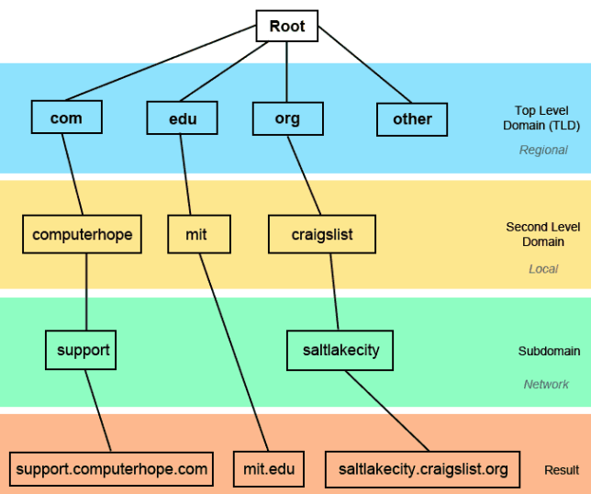

* DNS have following name servers –
  + Recursive Name Server: First stop for DNS query, respond with cache memory or request Root server for IP.
  + Root Name Server: 13 root servers are known for DNS, managed by ICANN, request TLD for IP of domain.
  + Top Level Domain (TLD) Name Server: request Authoritative for IP of domain
  + Authoritative Name Server: Provides the IP of domain name to the DNS resolver.

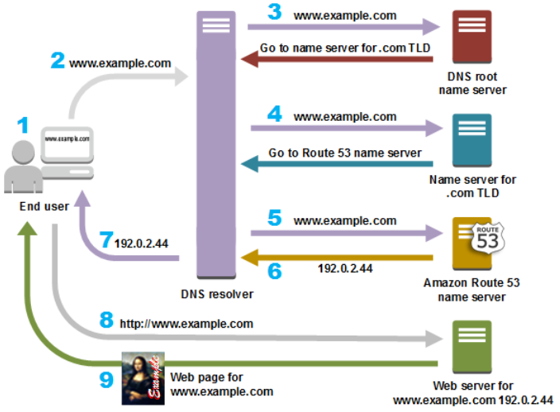 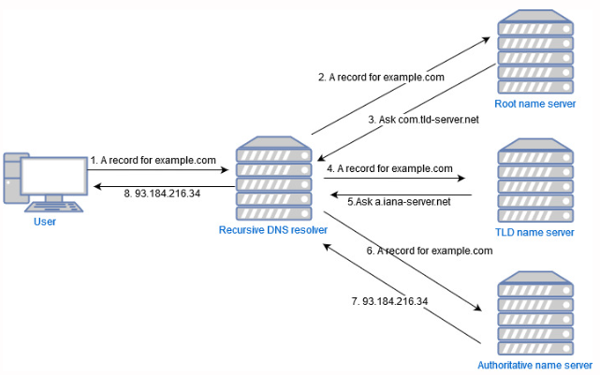

* FQDN and PQDN -

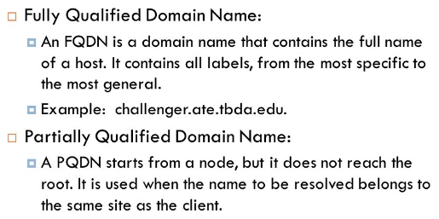 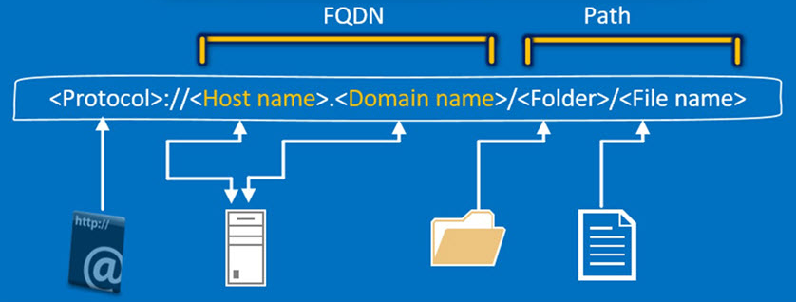

* DNS Record Types -

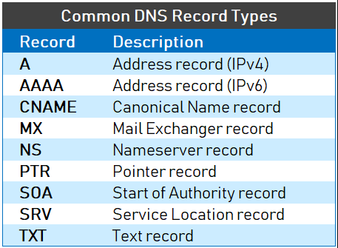 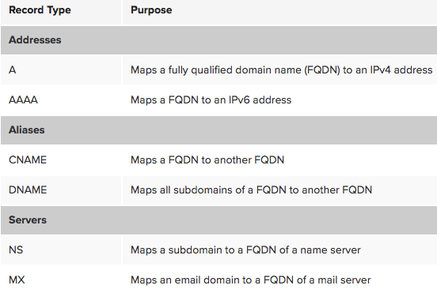

**>>> DHCP Server – (Dynamic Host Configuration Protocol – RFC2131)**

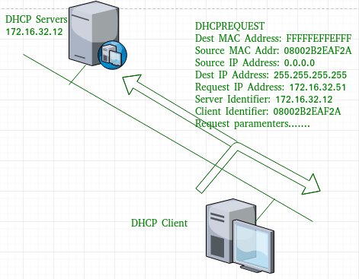

* DHCP server automatically assign IP to DHCP client(client – server model)
* It works on Application Layer of Model.
* Scope: DHCP server IP range available in server (set by Admin)
* It uses **UDP Port 67 and 68 at Transport Layer**
* **DHCP Server can Provide –**
  + **IP Address + Subnet mask + Domain Name**
  + **Default Gateway + DNS server address**
  + **WiNS server (Windows Naming Server)**

Broadcast Flag [(BCF) = 0 (Unicast), (BCF) = 1 (Broadcast)]

* DORA Process – (Discover > Offer > Request > ACK) **DHCP Client & Server Handshake**

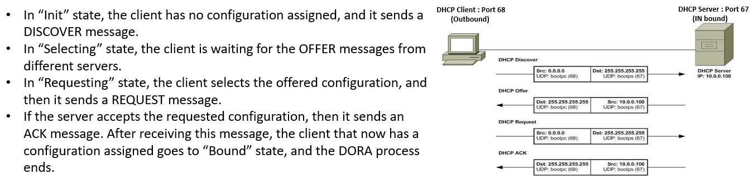

**>>> SMTP (Simple Mail Transfer Protocol) – (IMAP or POP3 protocol is used to receive mail)**

* SMTP is used to send mails to server, It works on **Application Layer**
* SMTP uses **TCP Port 25** for communication and it is a **push protocol**.
* It sends message in 7bit ASCII format.

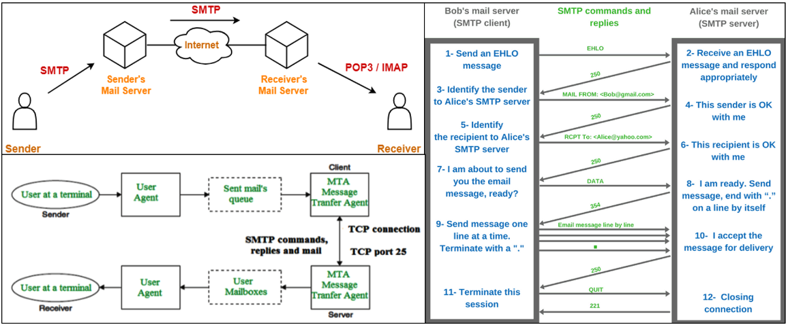

**>>> Message Access Protocols – [IMAP (Internet Message Access Protocol-V4.0)] / [POP3 (Post Office Protocol-V3.0)]**

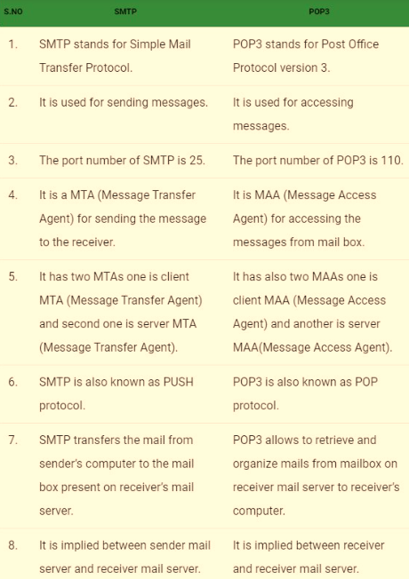 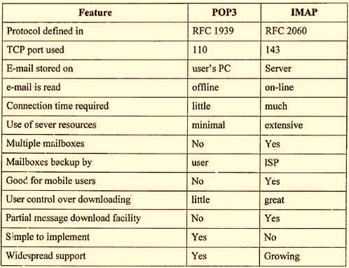

**>>> FTP (File Transfer Protocol) –**

* FTP is used to transfer file to client, work on **Application Layer**
* It uses **TCP Port 21** for control process and uses **TCP Port 20** for Data Connection.
* It is not secure as data is not encrypted during transmission.
* Data Transmission Modes in FTP-

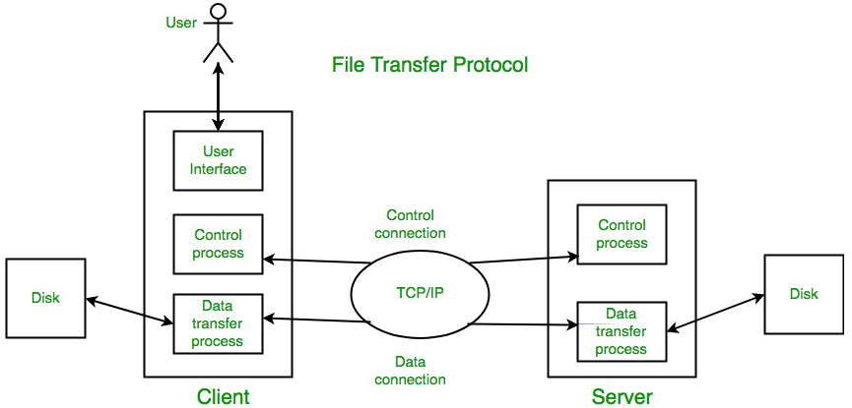 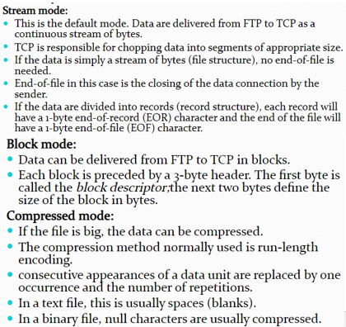

* FTP popular clients – Filezilla, WinSCP, AndFTP, Free FTP
* Types of data structure allowed in FTP and CLI (command line interface) commands to control FTP server.

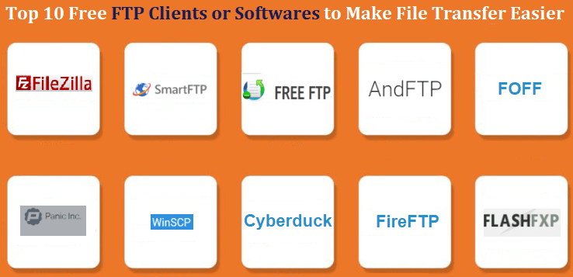 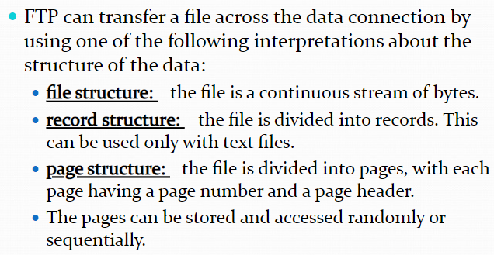

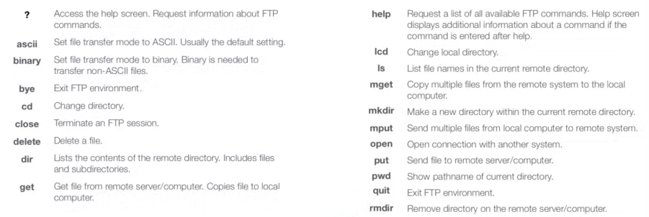

* **SFTP (Secure File Transfer Protocol) / TFTP (Trivial File Transfer Protocol)**

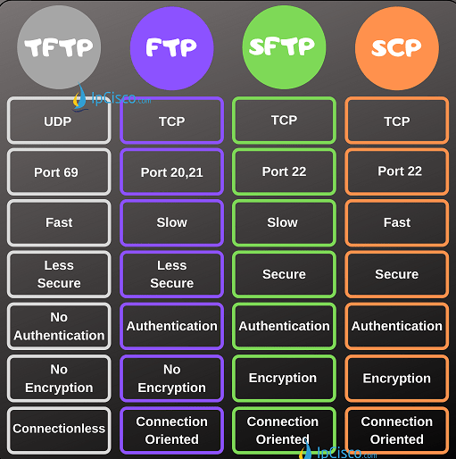 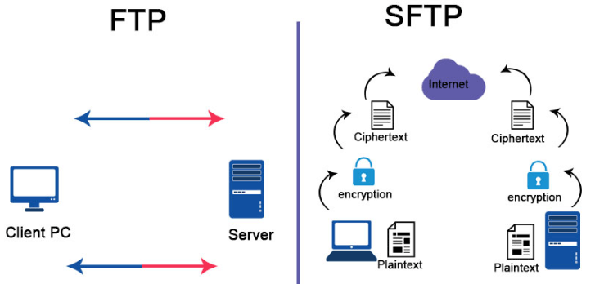

**>>> HTTP/ HTTPS (Hyper Text Transfer Protocol/Secure) –**

* This protocol is used to exchange information between Web Server and Web Browsers.
* It is a Client-Server Protocol, mostly request is done by client/user agent/proxy through web browser.
* It is a Stateless Protocol: Cause session break due to refresh
* HTTPS is secured protocol and use TLS/SSL security certificates.

**Client > < Proxy > < Proxy > < Server**

**Proxy Uses – Caching (history/pass), Filtering (Firewall), Load Balancer, Authentication, Logging**

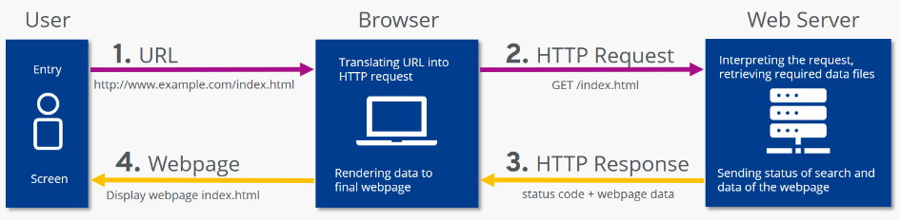

* HTTP and HTTPs difference –

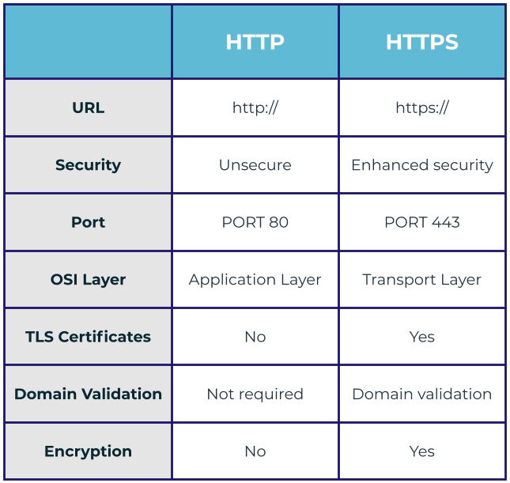 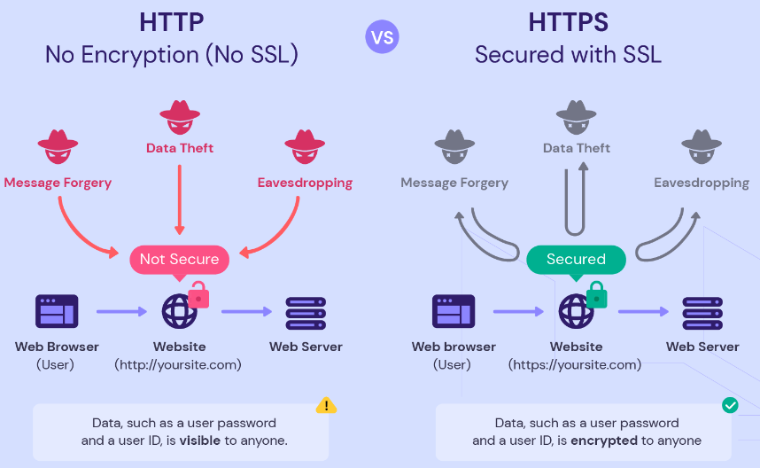

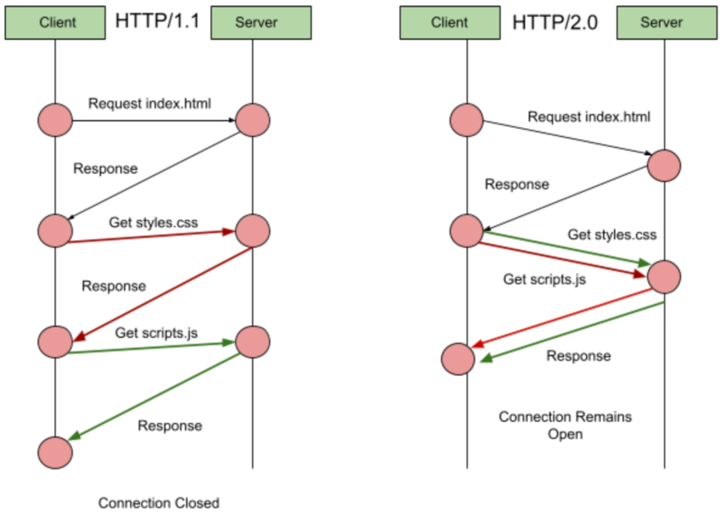 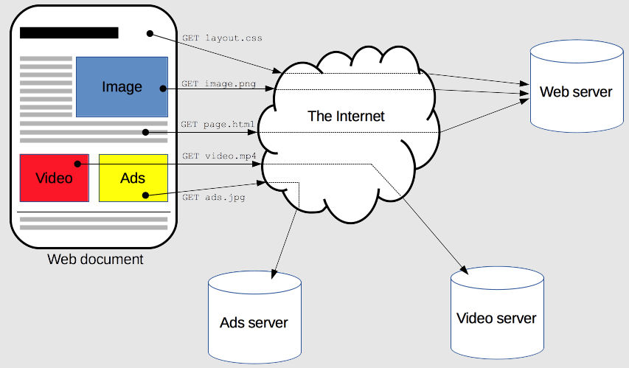 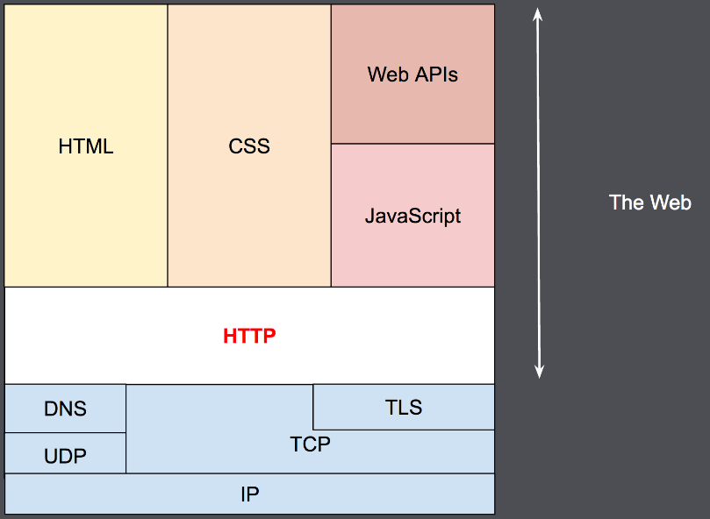

* SSL/TLS Handshake Protocol – (Secure Socket Layer / Transport Layer Security Protocol)

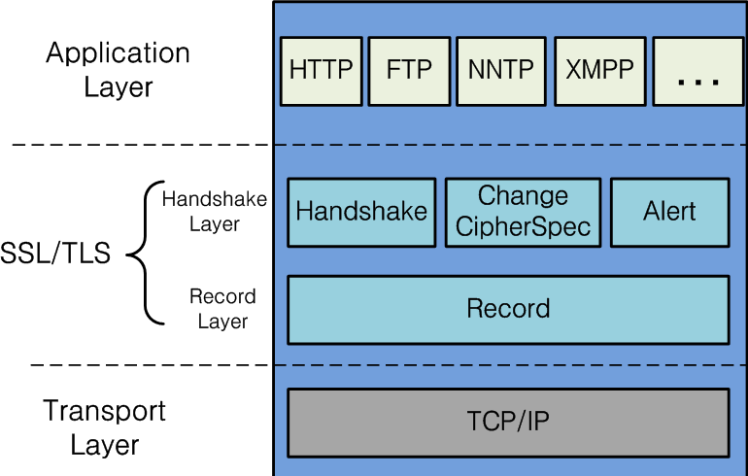 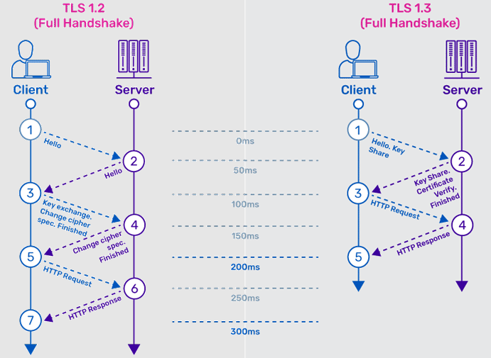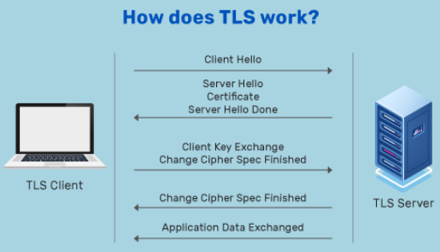

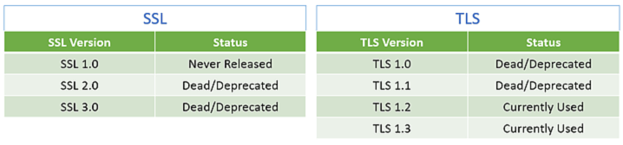

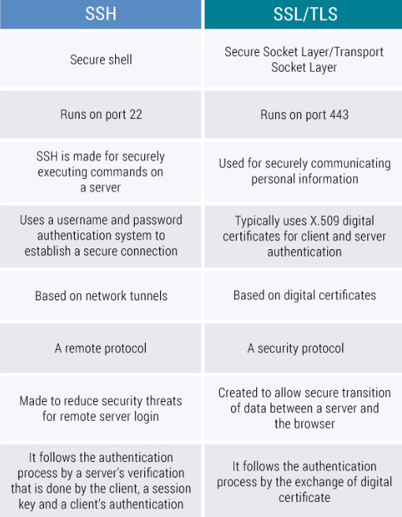

**>>> Wi-Fi (IEEE 802.11 Protocol) –**

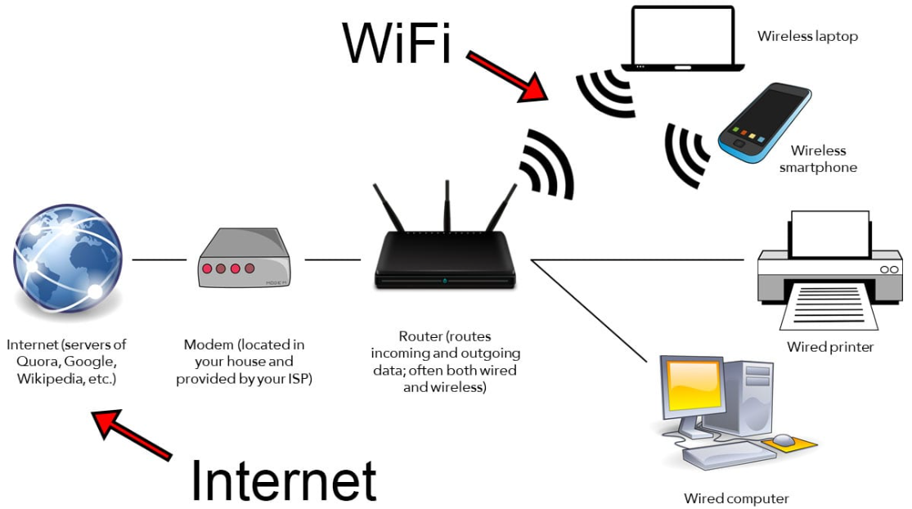 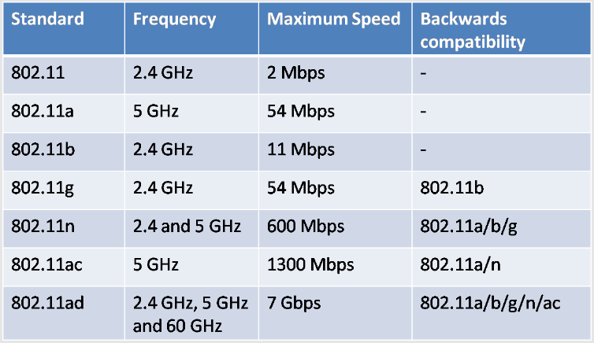

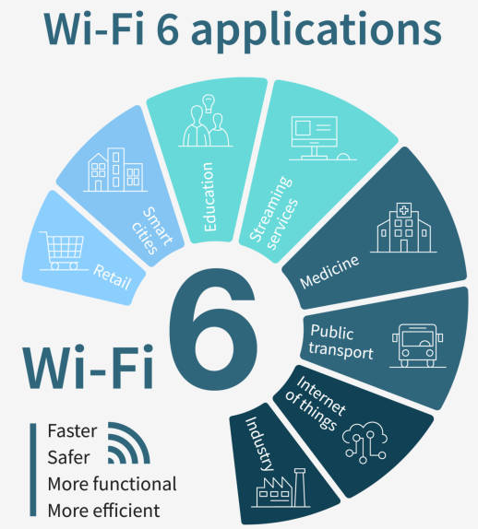

**>>> Port Types and Examples –**

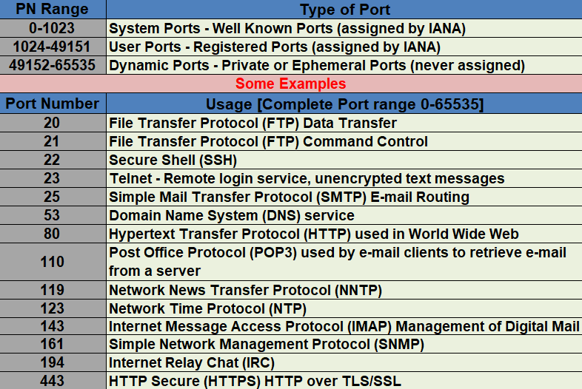

**>>> Base64 (Encryption and Decryption) –** <https://www.base64decode.org/>

|  |
| --- |
| **Extra** |

**>>> RPO, RTO, RCA (root cause analysis)**

**>>> ACM – certificate management (3rd party or AWS purchased)**

**>>> ACL (Access Control List) –**

* **AWS services price calculator -** [**https://calculator.aws/#/addService**](https://calculator.aws/#/addService)

**>>> Static Vs Dynamic Website –**

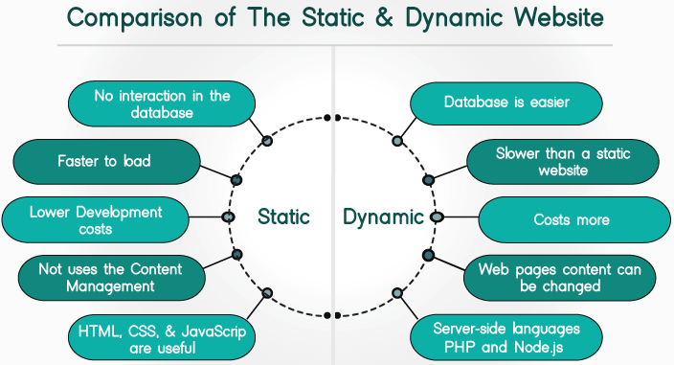

**>>> Types of Storages –**

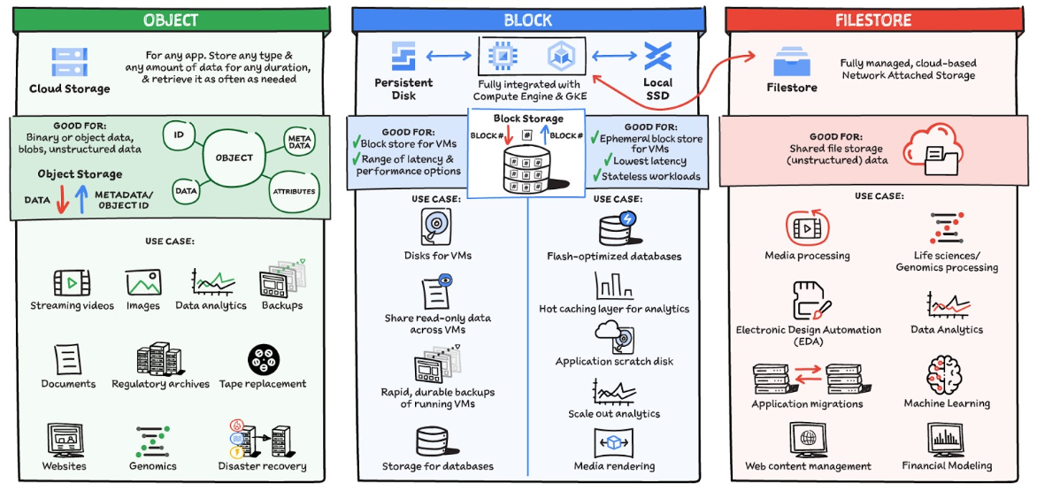

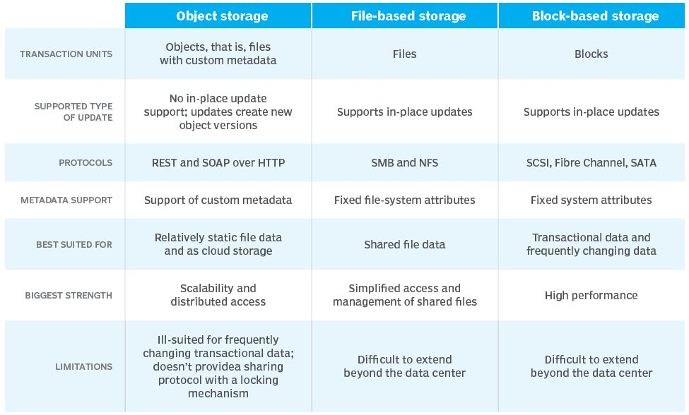

**>>> VM Virtualization (Hypervisors) –**

* Benefits –

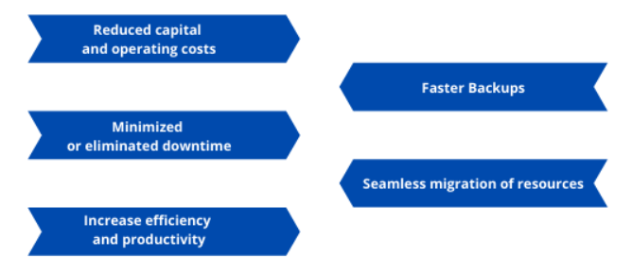 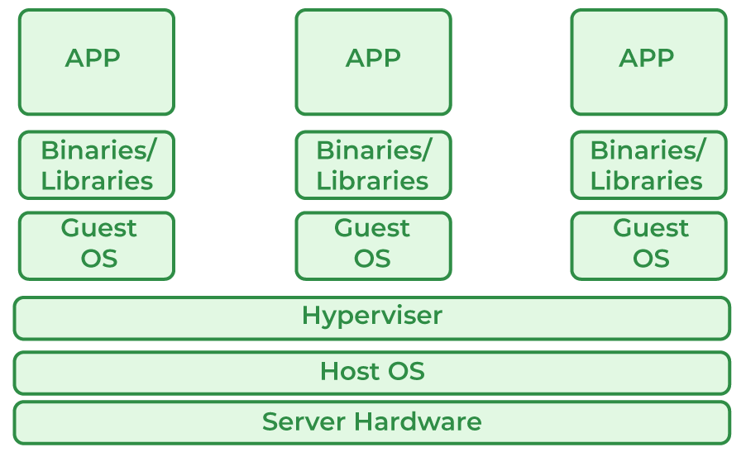

* Types – **[AWS Uses Xen Hypervisors]**

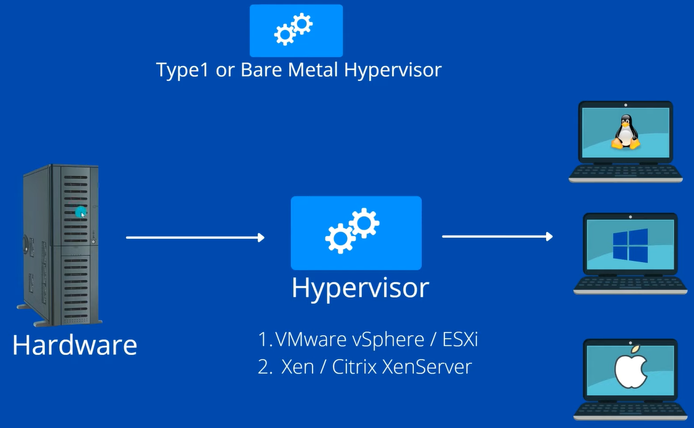 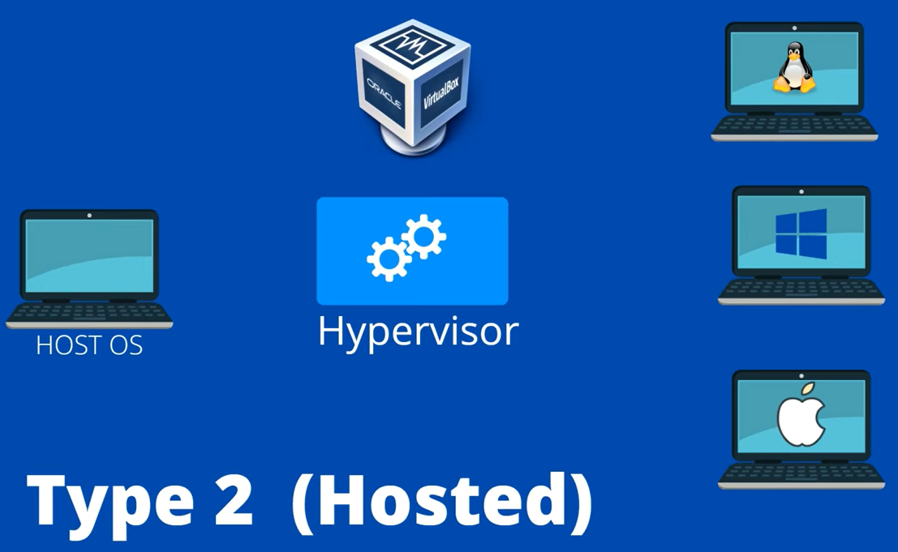

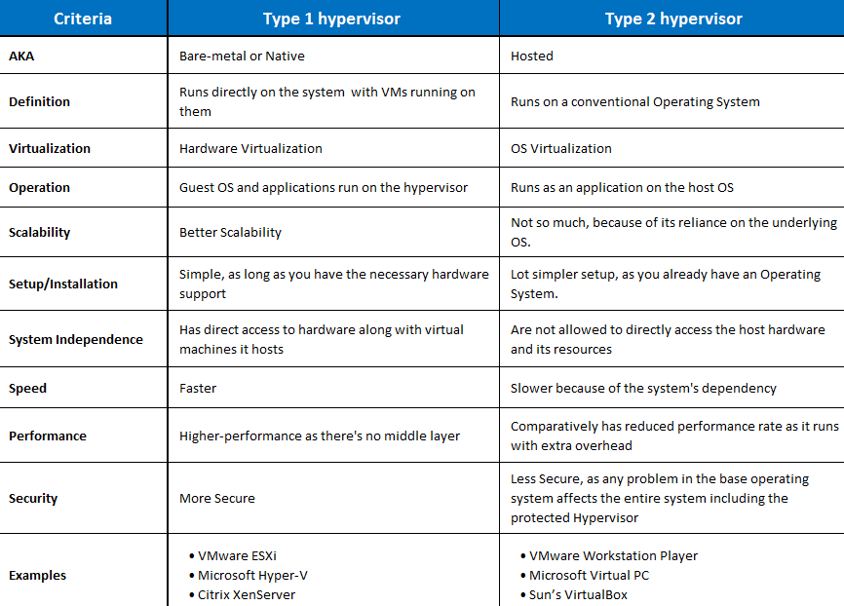

**>>> VPN (Virtual Private Network) –**

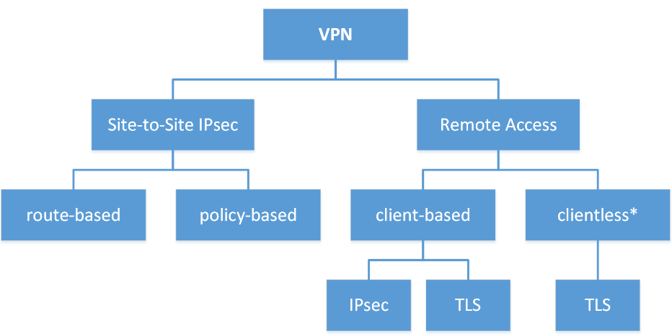

* Types of VPN connections –

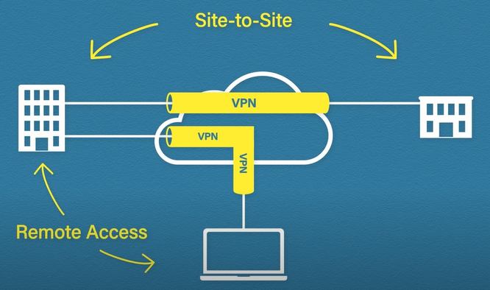

* **Site to Site VPN connection** – [Data packets are transmitted in encrypted form inside tunnels]

Eg- Openswan, Globalprotect, Paloalto, pulse.

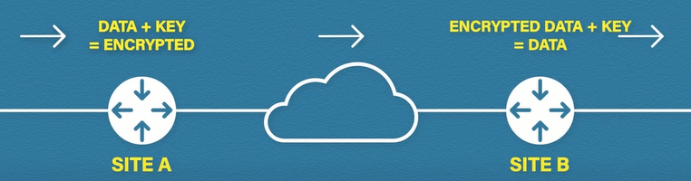 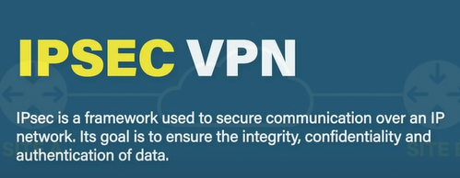

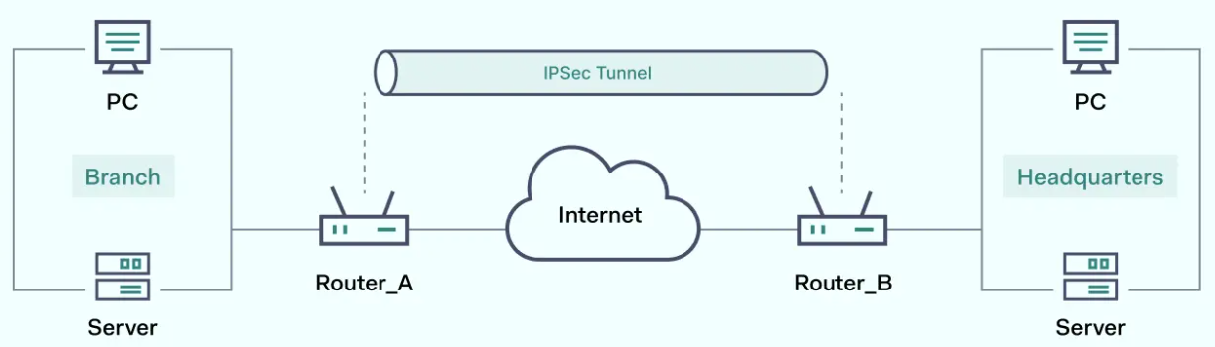

* **Remote Access –** [Eg. Cisco anyconnect, OpenVPN]

 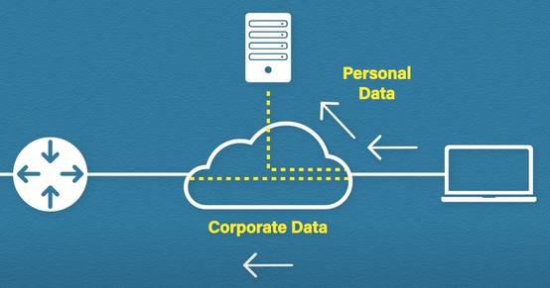

* **Remote Access – full tunnel + Split tunnel**

**\* Types of Virtual Private Network (VPN) Protocols:**

1. **Internet Protocol Security (IPSec):** Used to secure Internet communication across an IP network. IPSec secures Internet Protocol communication by verifying the session and encrypts each data packet during the connection. IPSec runs in 2 modes: (i) Transport mode, (ii) Tunneling mode
2. **Layer 2 Tunneling Protocol (L2TP):** It is often combined with another VPN security protocol like IPSec to establish a highly secure VPN connection. L2TP generates a tunnel between two L2TP connection points and IPSec encrypt data.
3. **Point–to–Point Tunneling Protocol (PPTP):** It is used to encrypt the data between the connection. PPTP is one of the most widely used VPN protocol and has been in use since the early release of Windows.
4. **Secure Shell (SSH):** It generates the VPN tunnel through which the data transfer occurs and also ensures that the tunnel is encrypted. SSH connections are generated by a SSH client and data is transferred from a local port on to the remote server through the encrypted tunnel.
5. **IKEv2 (Internet Key Exchange version 2):** A VPN protocol that provides fast and secure connections, but not widely supported by VPN providers.
6. **OpenVPN:** An open-source VPN protocol that is highly configurable and secure, widely supported by VPN providers and considered one of the most secure VPN protocols. 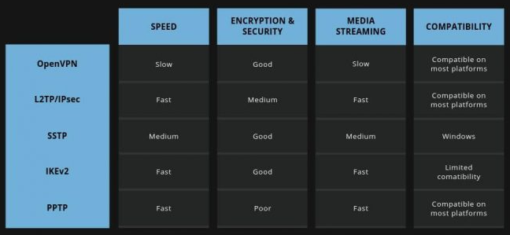

**\*OpenSwan** provide complete IPsec solution, It allows for the creation of Virtual Private Networks (VPNs) and secure communication channels between network nodes, ensuring confidentiality and integrity of data transmitted over the network. **Some key features of OpenSwan include:** Encryption and Authentication, Key Management (Internet Key Exchange (IKE) IKEv2), Tunneling (IPsec tunnels- encapsulate and encrypt IP packets), Compatibility.

**>>> Amazon S3 Extra features –**

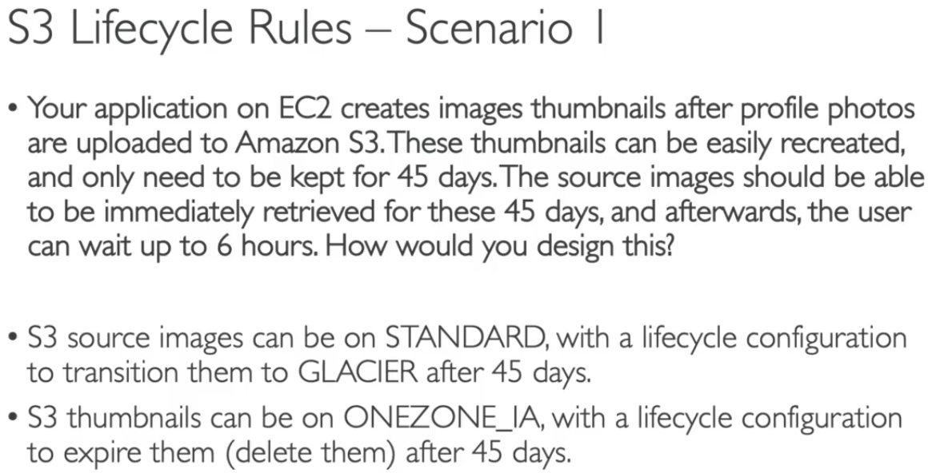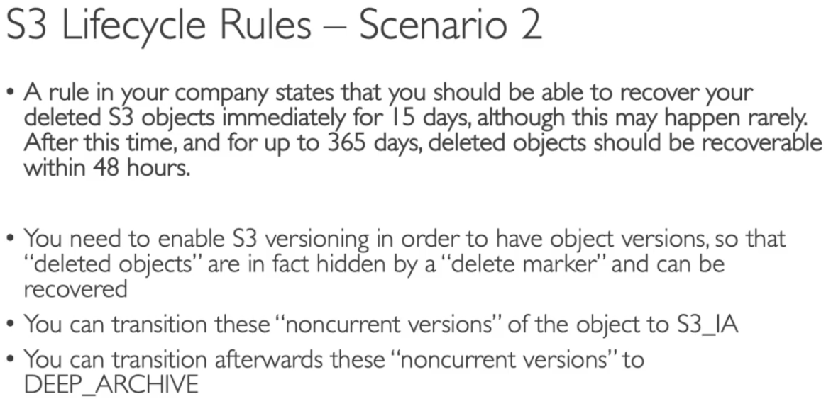

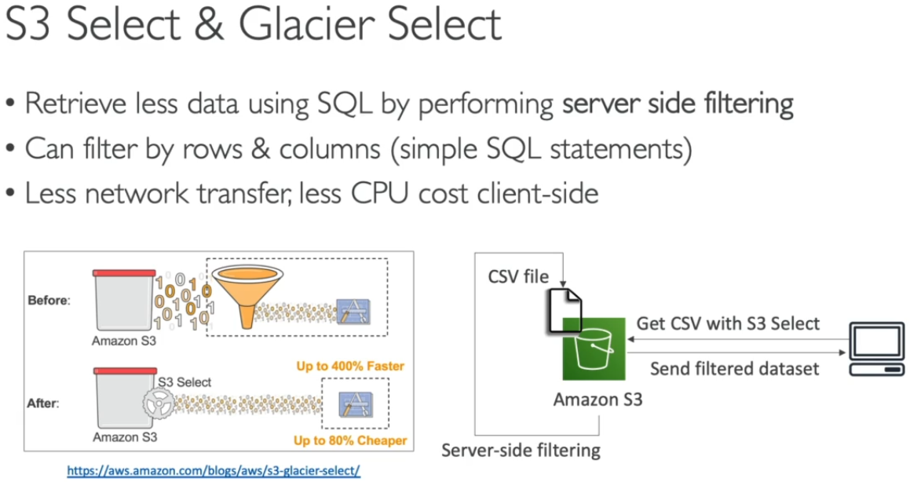 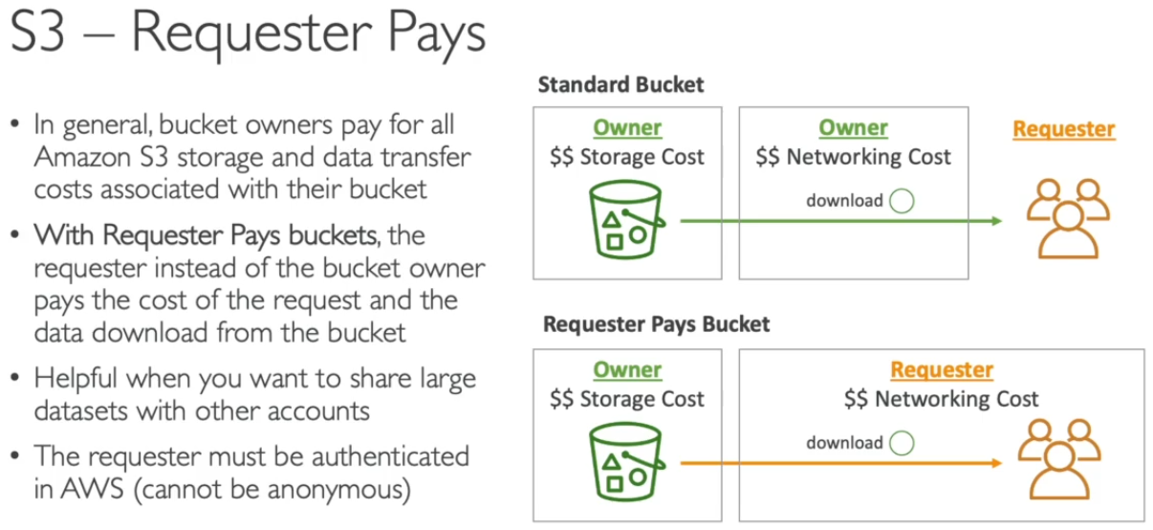

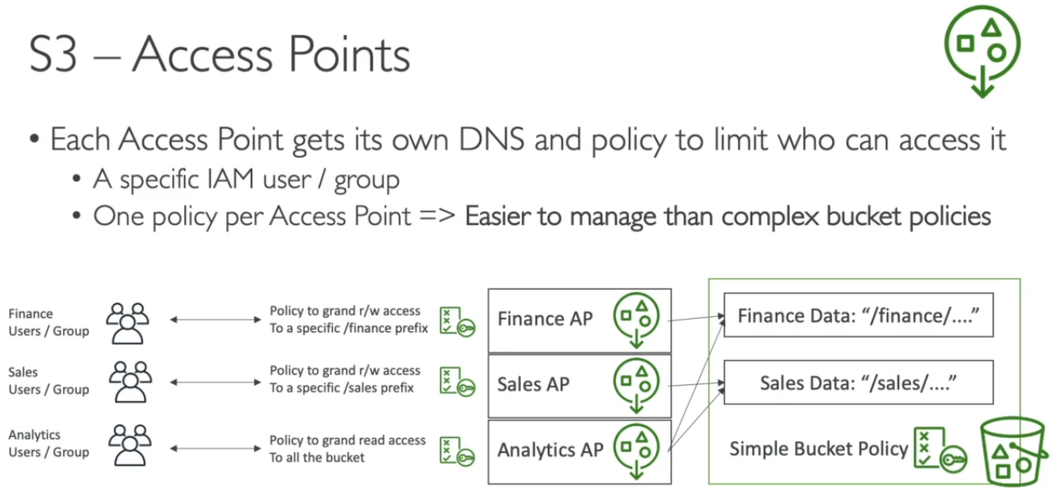 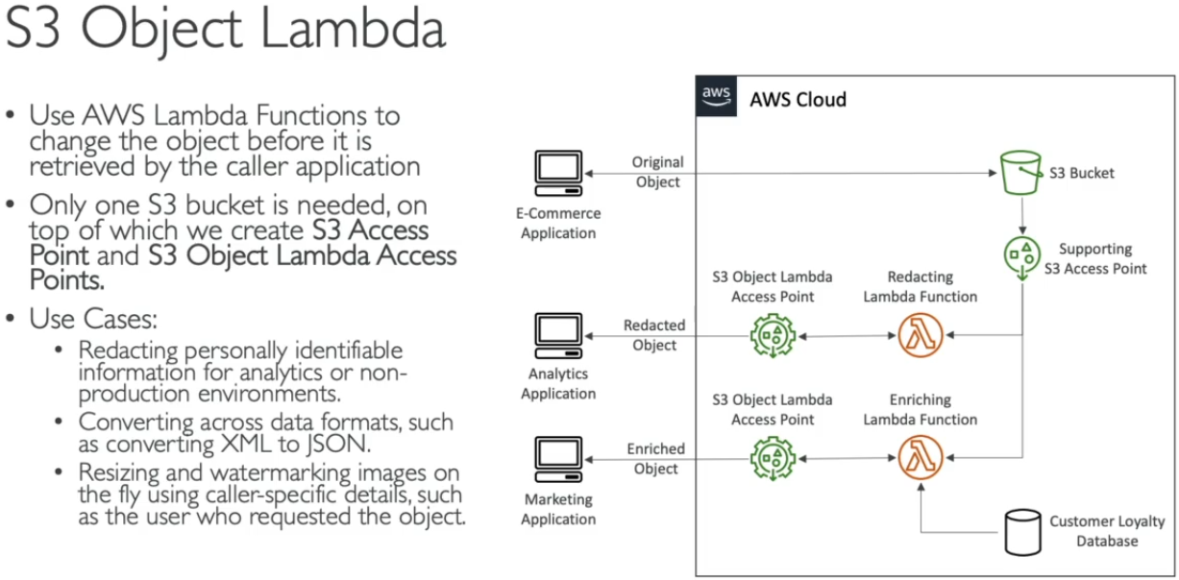

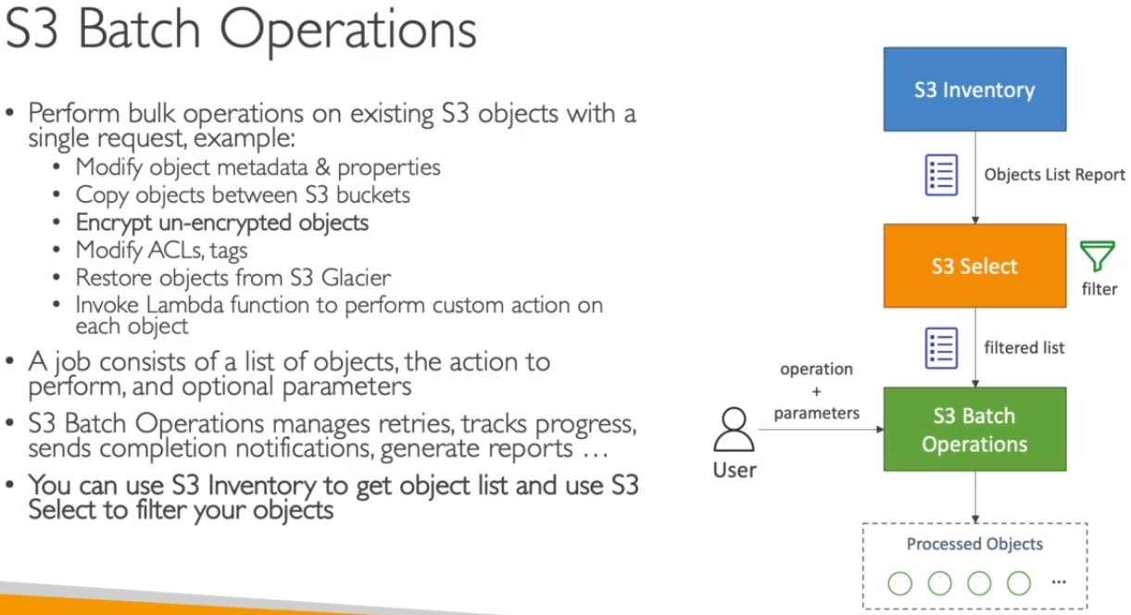

**>>> AWS account Organization –**

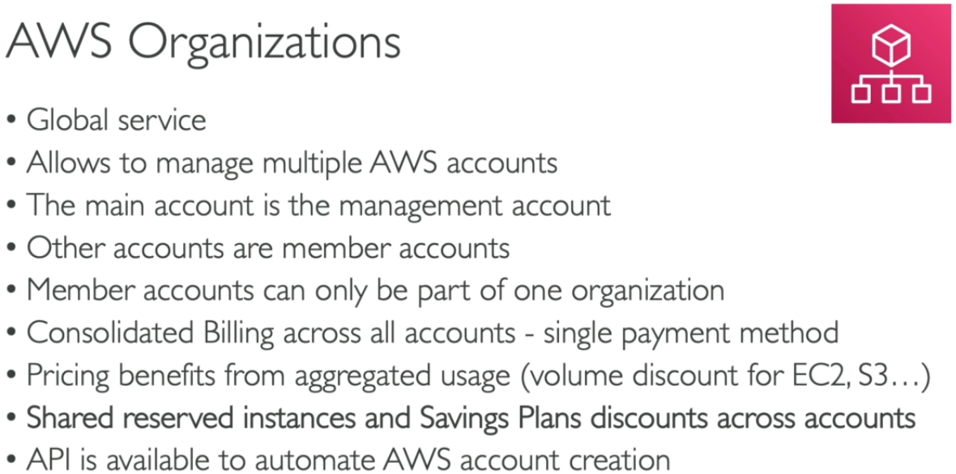 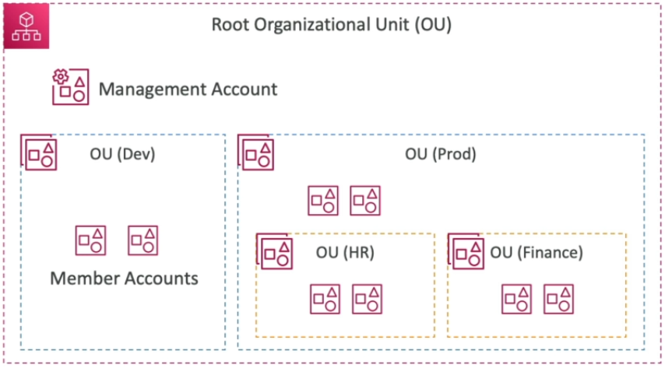

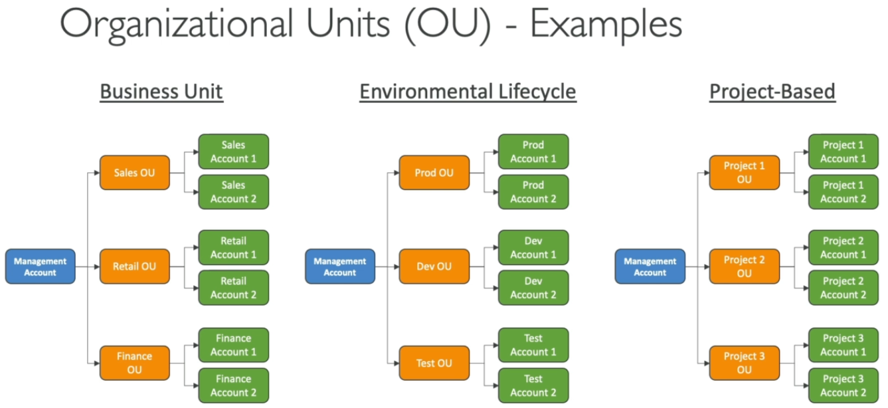 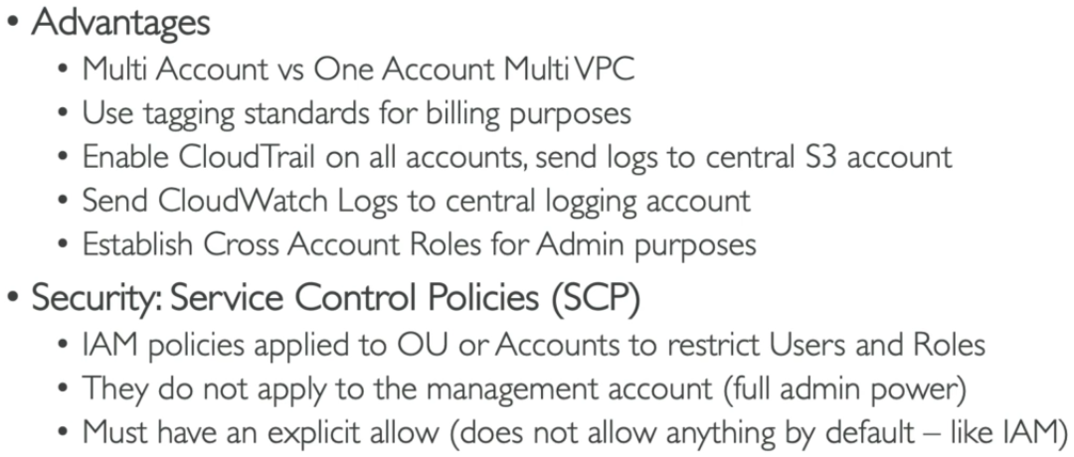

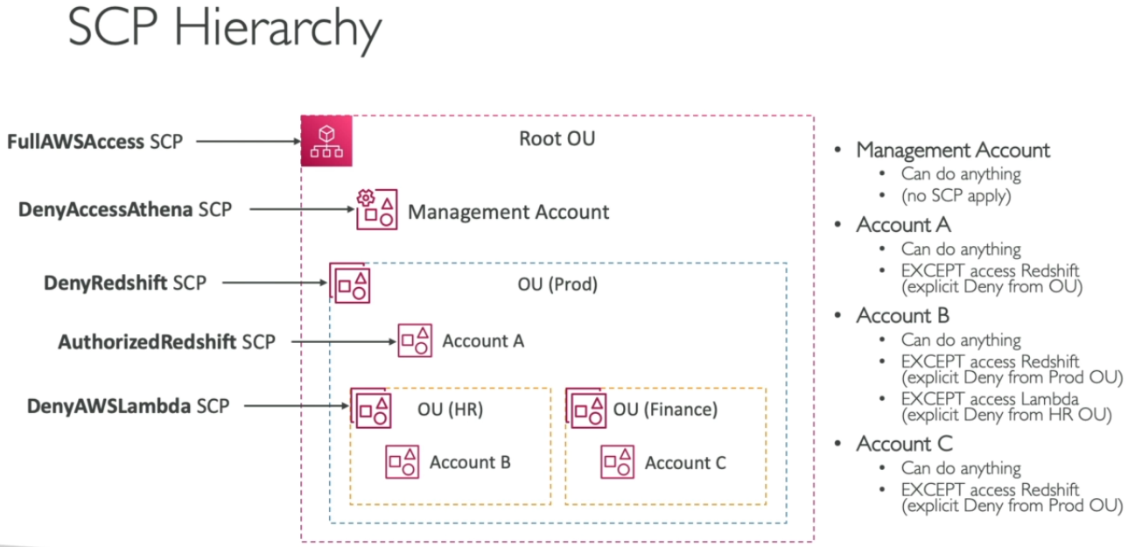 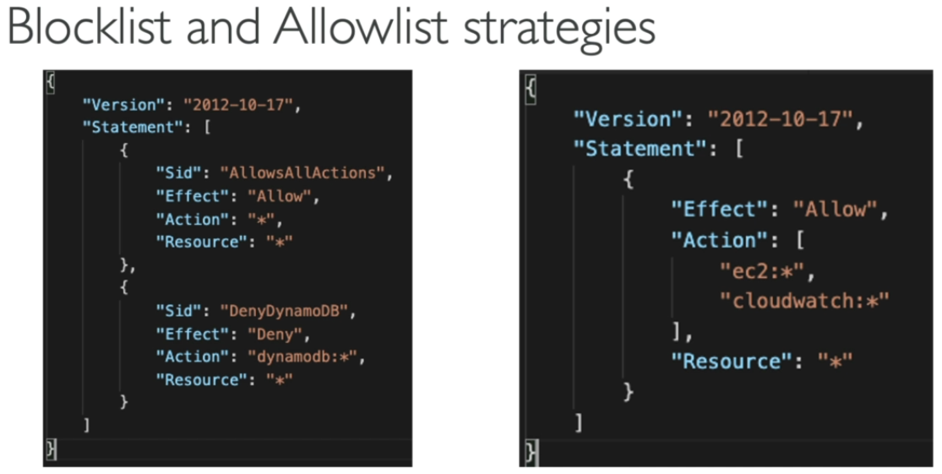

**>>> Project 1 – [VPC For Indonesia Factory]**

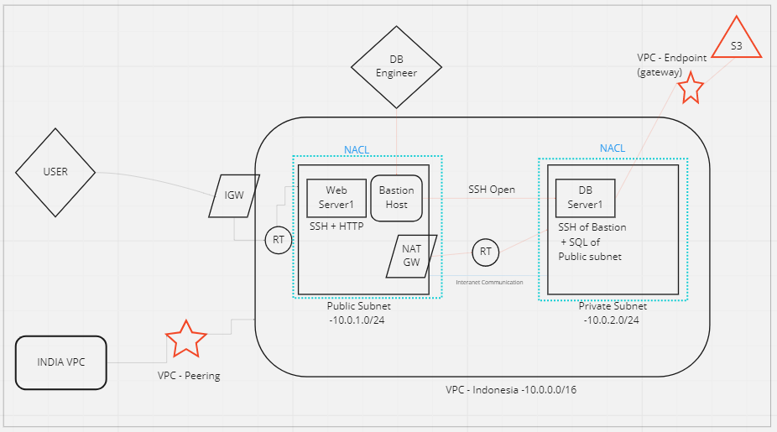

**>>> Project 2 – [Conversion of EBS volume types from gp2 to gp3]**

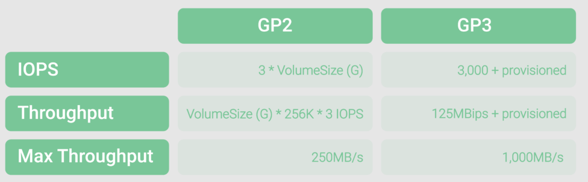

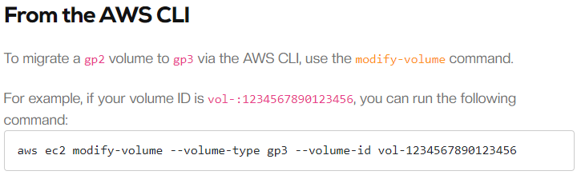

**>>> Project 3 – [Zero downtime activity]**

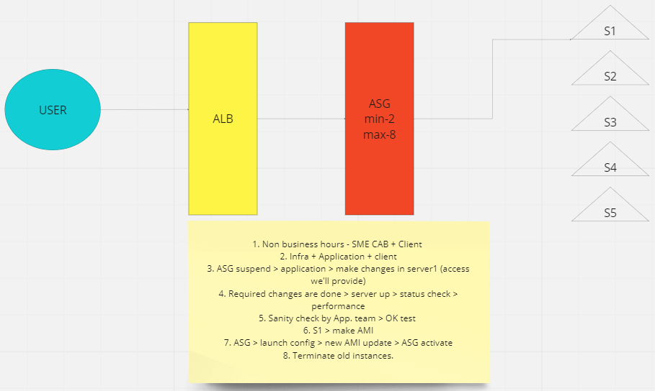

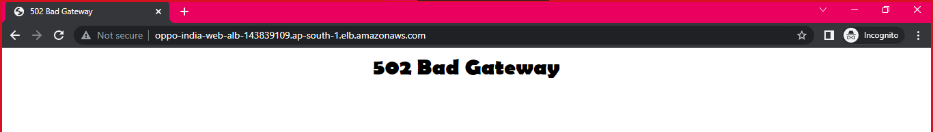

1. SG – Checked

2. NACL – Checked

3. Public IP not assigned at subnet level.

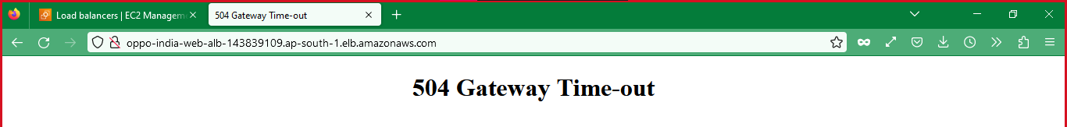

1. Issues with SG – channeling (check inbound rules)

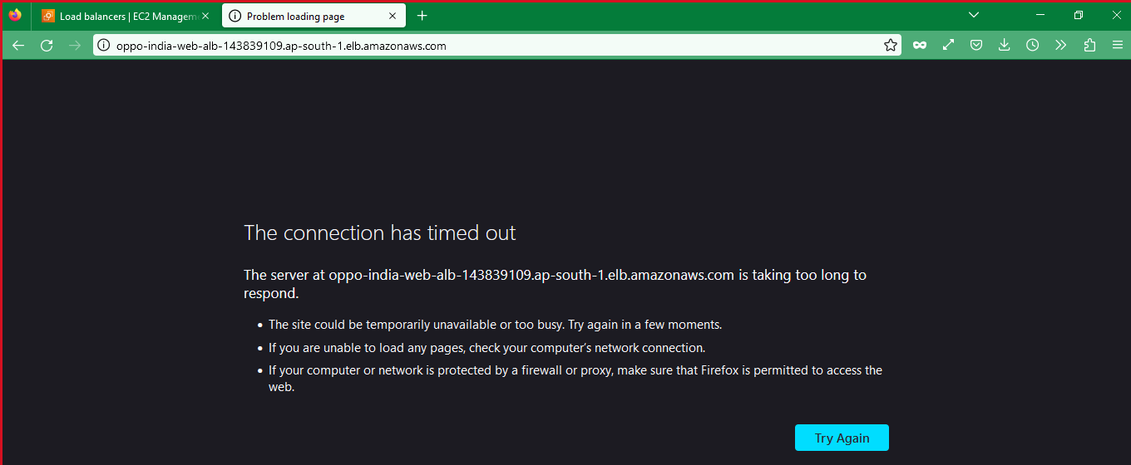

1. HTTP Traffic not allowed at Public-Route table.

